Polio Vaccine Communication on Twitter – Analysis Report

# Sentiment Overview

Sentiment Count  
 Positive 14  
 Neutral 12  
 Negative 8

# Figure 1: Sentiment Distribution

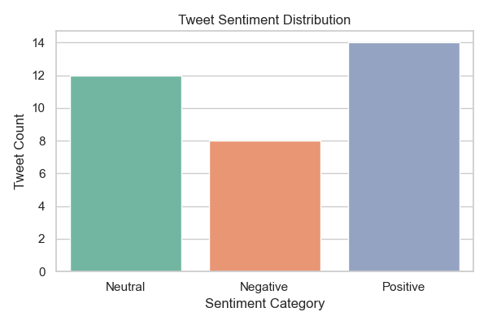

# Figure 2: Likes vs Sentiment

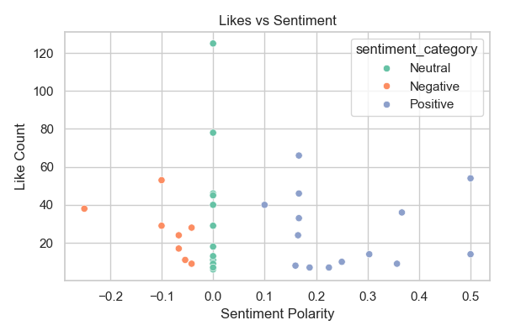

# Sample Tweets

[Neutral] 2024-11-09 20:00:34 — https://t.co/3N0TcjZjJV

[Negative] 2024-11-10 04:13:18 — @MOH_Kenya has reassured the public that the recent side effects linked to the polio vaccine are coincidental and unrelated to the vaccine.Any adverse events reported are typically short-lived and not a direct result of the #ENDPolioKE vaccine  
#VaccinesWork https://t.co/yPovxni3sM

[Positive] 2024-10-03 09:28:01 — The 5-day vaccination campaign against #polio will focus on 9 high risk counties:   
Busia, Bungoma, Trans-Nzoia, West Pokot and Turkana, Nairobi, Kiambu (Kabete, kikuyu,kiambaa, Kiambu town, Juja, Ruiru and Thika), Kajiado(Kajiado east and north in Kajiado) and Machakos https://t.co/2TyjJr5I8f

[Neutral] 2024-10-03 17:02:28 — Coming up…  
Understanding the role of Community Health Promoters in kicking polio out of Kenya  
  
#VaccinesWork  
@UNICEFKenya @MOH_Kenya https://t.co/G9hI6ULANU

[Neutral] 2024-10-03 17:24:37 — Eradicating Polio In Kenya.  
  
Join us now for this conversation: https://t.co/G7uPWVugrf  
  
#VaccinesWork @UNICEFKenya @MOH_Kenya https://t.co/t8CdVAklDa