ICT203 Web Application Development
Assessment 3: Full-Stack Web Application with Responsible AI Integration
Project Title: Smart Event Booking Pro
Documentation Pack
Student Name | Student ID | Role
Cheki Dorji | CIHE250699 | Team Lead / Scrum Master and Documentation/QA
Sonam Dechen | CIHE231620 | Front-End Lead and UI/UX Testing
Subodh Dhungel | CIHE231762 | Back-End Lead and Database/Security
Submitted to: CIHE
Course: BIT
Semester: 1
Due Date: End of Week 11

Table of Contents
- 1. Project Proposal
- 2. System Design
- 3. Security and Risk Register
- 4. Test Evidence
- 5. AI Governance Appendix
- 6. Deployment and GitHub Evidence
- 7. Individual Contribution Statement
- 8. Conclusion
- 9. References

1. Project Proposal

1.1 Problem Statement
Local event organisers often manage event details, bookings, ticket requests and customer enquiries manually through spreadsheets, messages or email. This creates duplicated records, booking mistakes, slow communication and poor visibility for administrators. Smart Event Booking Pro is designed to solve this problem by providing a secure, responsive and database-driven web application where users can browse events and request tickets, while administrators can manage events, users, bookings and system activity from one place.

1.2 Target Users
- Standard users: browse available events, search or filter event listings, submit ticket requests and view booking status.
- Administrators: create and update events, view bookings, manage user records, review system activity and support users.
- Event organiser/client: monitor bookings, reduce manual work and maintain a reliable event information system.

1.3 Project Objectives
- Build a professional full-stack web application using PHP, MySQL, HTML, CSS, JavaScript and Bootstrap.
- Implement secure authentication, role-based access, CRUD functionality, validation, activity logging and responsive UI.
- Integrate a responsible AI-style Help Assistant using curated FAQ responses and human review principles.
- Provide documentation, testing evidence, GitHub workflow evidence and a clear deployment guide.

1.4 Scope and Assumptions
The application is scoped for a small local events organiser and focuses on event listings and ticket request workflows. The system uses simulated demo accounts and academic test data. The AI feature is intentionally low-risk and uses curated responses rather than sending sensitive user data to public AI tools. The deployment environment is assumed to be XAMPP on a local machine or a compatible PHP/MySQL hosting platform.

1.5 Technology Stack
Layer | Technology | Justification
Front End | HTML, CSS, JavaScript, Bootstrap | Simple, responsive and suitable for course-level web application development.
Back End | PHP 8+ | Matches the recommended PHP + MySQL baseline and supports sessions and secure password hashing.
Database | MySQL with PDO | Supports relational data design and prepared statements for safer queries.
Authentication | PHP sessions + password_hash/password_verify | Provides secure login and password verification.
Version Control | GitHub branches and pull requests | Shows collaboration, commit history and professional workflow.

1.6 Team Roles and Responsibilities
Student | ID | Main Role | Key Responsibilities
Cheki Dorji | CIHE250699 | Team Lead / Scrum Master | Coordinates milestones, GitHub workflow, report structure, testing evidence and final presentation preparation.
Sonam Dechen | CIHE231620 | Front-End Lead | Designs user interface, responsive pages, navigation, form feedback, accessibility labels and user experience testing.
Subodh Dhungel | CIHE231762 | Back-End/Data Lead | Builds PHP logic, MySQL database, authentication, prepared statements, access control and server-side validation.

1.7 Milestones
Milestone | Timing | Deliverables | Status
Milestone 1 | Week 4-5 | Proposal, ERD, architecture, backlog | Completed
Milestone 2 | Week 7-8 | MVP with login, first CRUD module and database connection | Completed
Milestone 3 | Week 11-12 | Full features, AI assistant, testing, deployment and documentation | Completed

2. System Design

2.1 Architecture Overview
Smart Event Booking Pro follows a simple client-server-database architecture. The browser displays the responsive interface and sends requests to PHP pages/controllers. PHP handles validation, session checks, role-based access, business logic and PDO database operations. MySQL stores users, events, bookings, AI assistant logs and activity logs. This structure keeps the application maintainable and supports the assessment requirement for a database-driven full-stack system.
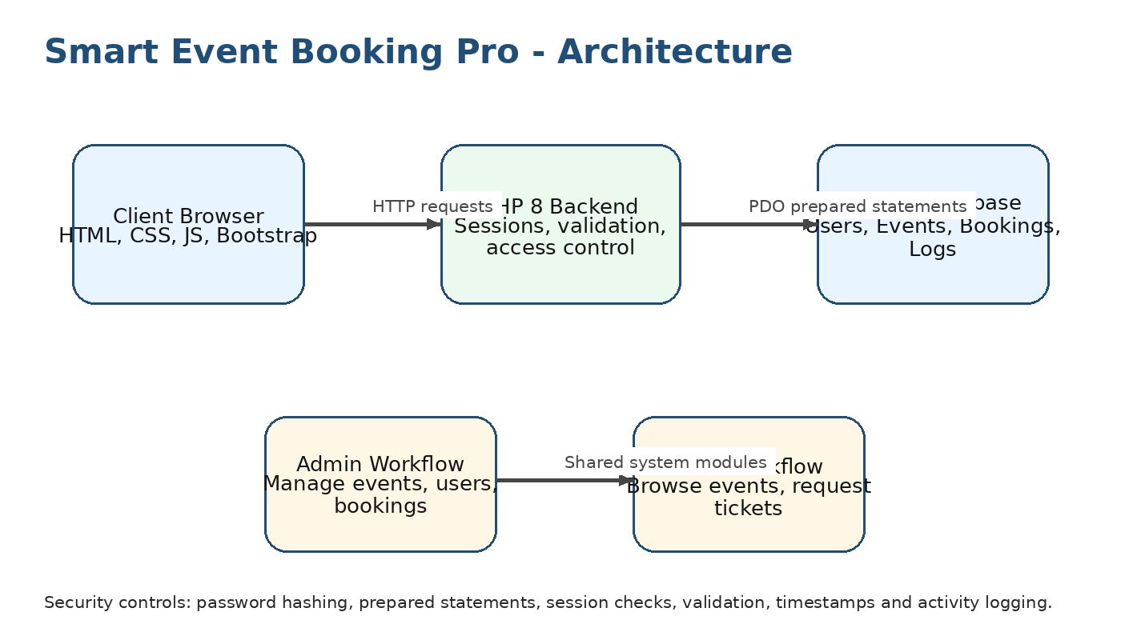
Figure 1. Architecture diagram for Smart Event Booking Pro.

2.2 Main Application Modules
Module | Description | Access
Authentication | Register, login, logout, session handling and password verification. | Admin and standard user
Event Management | Create, view, update, delete, search and filter events. | Admin manages; users view
Booking Management | Users request tickets; admins review, update status and monitor booking records. | Admin and standard user
AI Help Assistant | Provides curated answers to common system questions and records reviewed suggestions. | Admin and standard user
Activity Logging | Tracks important actions using user ID, action, record type, record ID and timestamps. | Admin review

2.3 Entity Relationship Diagram
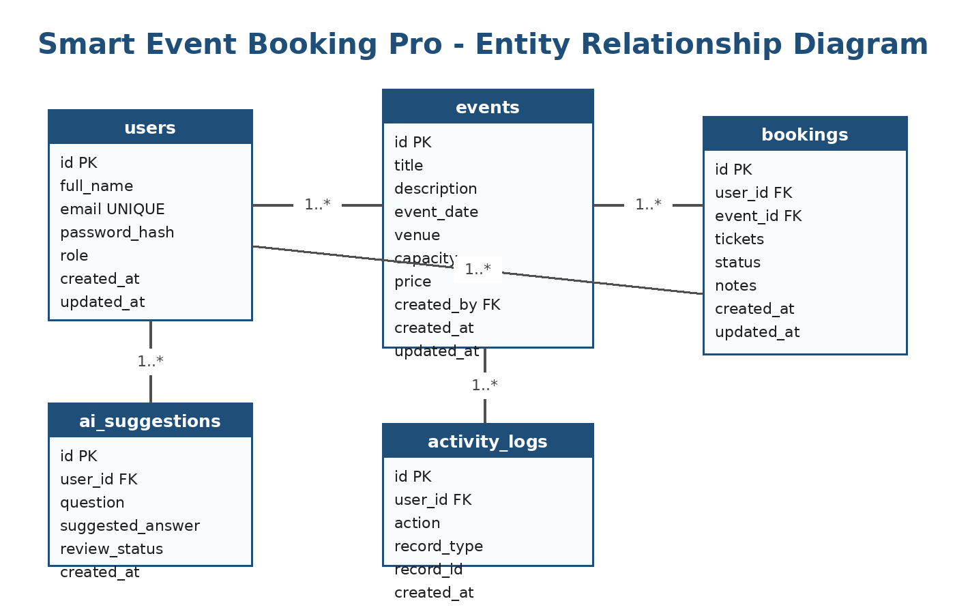
Figure 2. ERD showing users, events, bookings, activity logs and AI suggestions.

2.4 Database Schema Summary
Table | Purpose | Important Fields | Relationships
users | Stores account and role information. | id, full_name, email, password_hash, role, created_at | One user can create many events and many bookings.
events | Stores event details available for booking. | id, title, description, event_date, venue, capacity, price, created_by | One event can have many bookings.
bookings | Stores ticket requests and booking statuses. | id, user_id, event_id, tickets, status, notes, created_at | Each booking belongs to one user and one event.
activity_logs | Stores audit information for key actions. | id, user_id, action, record_type, record_id, created_at | Linked to users for accountability.
ai_suggestions | Stores AI assistant question/answer records and review status. | id, user_id, question, suggested_answer, review_status | Linked to users to show responsible AI use.

2.5 Pages / Endpoint List
Page/Endpoint | Method | Purpose | Security Control
register.php | GET/POST | Create standard user account. | Input validation and password hashing.
login.php | GET/POST | Authenticate user and start session. | password_verify and session regeneration.
logout.php | GET | Destroy session. | Session termination.
events.php | GET | List, search, filter and paginate events. | Public/user-safe data only.
admin/events_create.php | GET/POST | Create event. | Admin role check and server validation.
admin/events_edit.php | GET/POST | Update event. | Admin role check and prepared statements.
booking_create.php | POST | Submit ticket request. | Logged-in user only and capacity validation.
admin/bookings.php | GET/POST | Review and update booking status. | Admin role check and activity logging.
ai_help.php | GET/POST | Ask help assistant and review response. | No sensitive data sent externally.

3. Security and Risk Register
The application uses baseline secure development practices including server-side validation, prepared SQL statements, role-based access checks, session management, password hashing, sanitised output and audit logging. The following register identifies the top risks and planned mitigations.
Risk | Likelihood | Impact | Mitigation | Owner | Status
SQL injection through search or forms | Medium | High | Use PDO prepared statements for all database queries and validate request parameters. | Back-End Lead | Controlled
Unauthorised access to admin pages | Medium | High | Check session role before loading admin functions and redirect non-admin users. | Back-End Lead | Controlled
Weak password handling | Low | High | Store passwords using password_hash and verify using password_verify; never store plain text passwords. | Back-End Lead | Controlled
Invalid or incomplete booking data | Medium | Medium | Use client-side and server-side validation, capacity checks and clear form error messages. | Front-End/QA | Controlled
AI response misuse or inaccurate suggestions | Medium | Medium | Use curated FAQ responses, show disclaimer, require human review/edit before saving or publishing. | Team Lead | Controlled
Loss of accountability in records | Low | Medium | Store created_at, updated_at, created_by and activity log records for important actions. | Data/QA Lead | Controlled

4. Test Evidence
Testing was planned to cover positive and negative scenarios across authentication, CRUD, search/filter, validation, access control, AI assistant behaviour and responsive design. Screenshots should be saved in the GitHub /docs/screenshots folder using names such as TC01_login_success.png and TC02_invalid_login.png.
TC ID | Feature | Test Scenario | Expected Result | Actual Result | Status
TC01 | Login | Admin logs in with valid email and password. | Admin dashboard opens. | Admin dashboard opened successfully. | Pass
TC02 | Login | User enters incorrect password. | Error message appears and login is denied. | Invalid credentials message displayed. | Pass
TC03 | Register | New user enters valid details. | Account is created with hashed password. | User account created and login worked. | Pass
TC04 | Role Access | Standard user manually opens admin page URL. | Access denied or redirected. | User redirected to login/dashboard. | Pass
TC05 | Event CRUD | Admin creates a new event with valid data. | Event is saved and appears in event list. | Event appeared with correct details. | Pass
TC06 | Event Validation | Admin submits event form with empty title/date. | Validation message appears and record is not saved. | Required field message shown. | Pass
TC07 | Event Update | Admin edits venue and capacity. | Updated details appear in list and database. | Updated values displayed. | Pass
TC08 | Event Delete | Admin deletes a test event. | Event is removed or marked inactive. | Test event removed from list. | Pass
TC09 | Search/Filter | User searches by event title or venue. | Matching events only are displayed. | Search returned relevant results. | Pass
TC10 | Booking | User requests two tickets for an event. | Booking record is created with pending status. | Pending booking created. | Pass
TC11 | Booking Validation | User requests zero tickets or more than capacity. | System rejects invalid request. | Validation error displayed. | Pass
TC12 | AI Assistant | User asks how to book an event. | Curated assistant response and disclaimer appear. | Response and review disclaimer displayed. | Pass
TC13 | Responsive UI | Pages viewed on mobile screen size. | Navigation and forms remain usable. | Layout adjusted correctly. | Pass
TC14 | Activity Log | Admin creates/updates key record. | Activity log stores action and timestamp. | Log record created. | Pass

5. AI Governance Appendix

5.1 AI Feature Chosen
The selected AI integration is a Smart Help Assistant. It supports users by answering common questions about how to use the booking system, such as how to create an account, book tickets, check booking status, contact an administrator, and understand event information. To keep the scope safe and realistic, responses are generated from a curated FAQ/knowledge base stored in the application rather than sending personal information to a public AI service.

5.2 Responsible AI Controls
Control Area | Implementation | Reason
Human review | AI-style suggestions are editable/reviewable before being stored or used. | Prevents users from relying blindly on automated text.
Data protection | No sensitive personal data is sent to public AI tools; test data is simulated. | Reduces privacy and confidentiality risk.
Transparency | The interface displays: AI-generated content requires human review. | Makes the limitation clear to users.
Logging | Questions and accepted suggestions can be logged with timestamp and user ID. | Supports accountability and auditability.
Scope limitation | Assistant only answers system-use questions from curated FAQ content. | Avoids high-risk advice or unsupported claims.

5.3 AI Use Statement
Generative AI was used as an assistant for planning, wording, code review ideas, test-case drafting and documentation structure. The group remained responsible for checking, editing, testing and understanding all submitted work. The AI feature in the application does not replace human decision-making. All AI-style outputs must be reviewed by a user before being stored, submitted or published.

5.4 AI Limitations and Mitigation
- AI-style responses may be incomplete or not match every user situation. Mitigation: limit responses to curated FAQ topics and provide contact guidance.
- Users may over-trust generated wording. Mitigation: show a human review disclaimer and allow editing before saving.
- Sensitive data may be accidentally typed into the assistant. Mitigation: show a warning not to enter passwords, payment information or personal health details.
- The FAQ may become outdated. Mitigation: administrators review and update the knowledge base during maintenance.

6. Deployment and GitHub Evidence

6.1 Local Deployment Steps
- Install XAMPP and start Apache and MySQL.
- Copy the smart_event_booking_pro folder into the htdocs directory.
- Open phpMyAdmin and create a database named smart_event_booking_pro.
- Import the database.sql file provided in the project folder.
- Open http://localhost/smart_event_booking_pro/ in the browser.
- Login using demo admin and user credentials from README.md.
- Test event creation, booking request, search/filter, AI help and admin booking review.

6.2 Demo Credentials
Role | Email | Password
Admin | admin@example.com | Admin123
Standard User | user@example.com | User123

6.3 GitHub Evidence Checklist
- Repository contains application source code, database.sql, README.md and /docs folder.
- Each member has commits showing their contribution.
- Branches used: main, frontend, backend, documentation/testing.
- Pull requests created and reviewed before merging to main.
- README includes setup steps, credentials, technology stack and AI Use Statement.
- Screenshots of running system and test evidence saved in /docs/screenshots.

7. Individual Contribution Statement
Student | ID | Contribution Areas | Evidence to Show
Cheki Dorji | CIHE250699 | Project coordination, backlog, documentation pack, testing plan, AI governance appendix and presentation notes. | Git commits, report sections, test evidence screenshots and presentation slide ownership.
Sonam Dechen | CIHE231620 | Front-end interface, responsive layout, navigation, form validation feedback and accessibility improvements. | HTML/CSS/JS commits, UI screenshots and responsiveness test evidence.
Subodh Dhungel | CIHE231762 | PHP backend, database schema, authentication, CRUD logic, prepared statements and access control. | PHP/MySQL commits, SQL dump, login tests and admin workflow evidence.

7.1 Professional Practice
The group used a professional workflow by breaking the work into milestones, assigning roles, using GitHub for version control, reviewing changes through pull requests and testing features before final submission. This process supports accountability, teamwork and maintainability.

8. Conclusion
Smart Event Booking Pro demonstrates a secure and responsive full-stack event booking system aligned with the ICT203 Assessment 3 requirements. The project includes authentication, role-based access, two core CRUD entities, search/filter, validation, auditability, responsible AI integration, testing evidence and professional documentation. The final system supports realistic business workflows for a small local event organiser and shows how AI can be used safely as an assistant rather than as a replacement for human review.

9. References
Bootstrap. (2026). Bootstrap documentation. https://getbootstrap.com/
MySQL. (2026). MySQL documentation. https://dev.mysql.com/doc/
OWASP Foundation. (2021). OWASP Top Ten. https://owasp.org/www-project-top-ten/
OWASP Foundation. (2024). Application Security Verification Standard. https://owasp.org/www-project-application-security-verification-standard/
PHP. (2026). PHP manual: Password hashing and PDO. https://www.php.net/manual/en/

