1. You may want to peek at the code first...but do what you want.
2. Go to a linux box, place files in folders and compile like this:

g++ -o xsh \*.cpp

1. then… type in:

$> ./xsh

1. you should see:

TEST

“xsh>>”

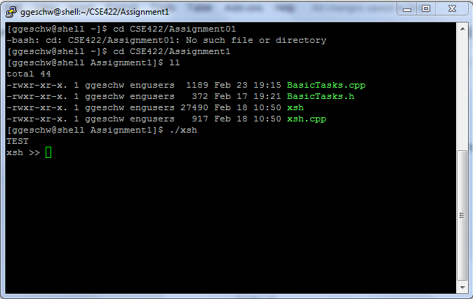

or prompt…

MORE→

1. test it! type in a sentence:

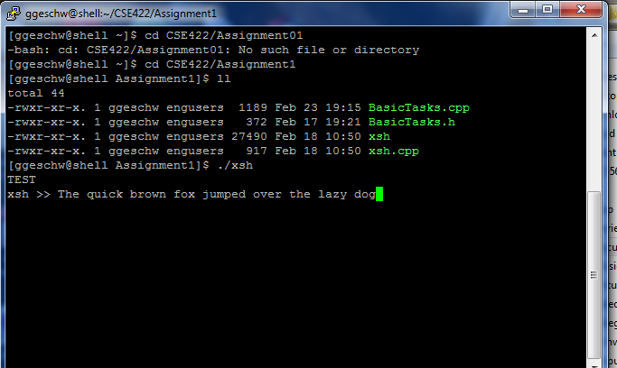

Hit Enter…

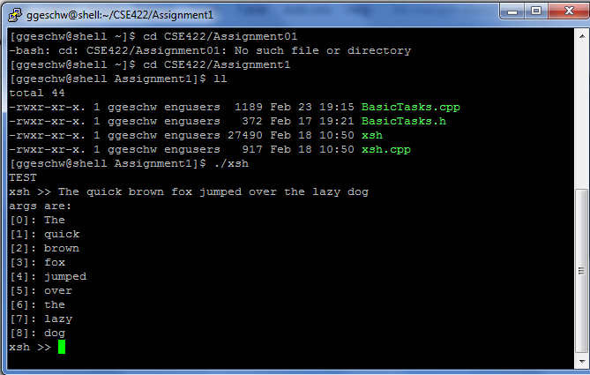

* That is all it does right now is. start up, shows a command line prompt (xsh >>) and parses the words into a vector.
* Still have a lot of work to do!
* Read the code and see if after you read the instructions this will work.
* I stopped there because we will have to implement functionality closer to what Dr. Miller has on his notes.
* Also, didnt really need to put some of the functions in a C++ style .h or .cpp but I did, selfishly to see what I could remember.