Grace Seiche (geseiche)

Prof. Wong

CS 3431/A Term 2017

18 September 2017

Assignment 4

Problem #1

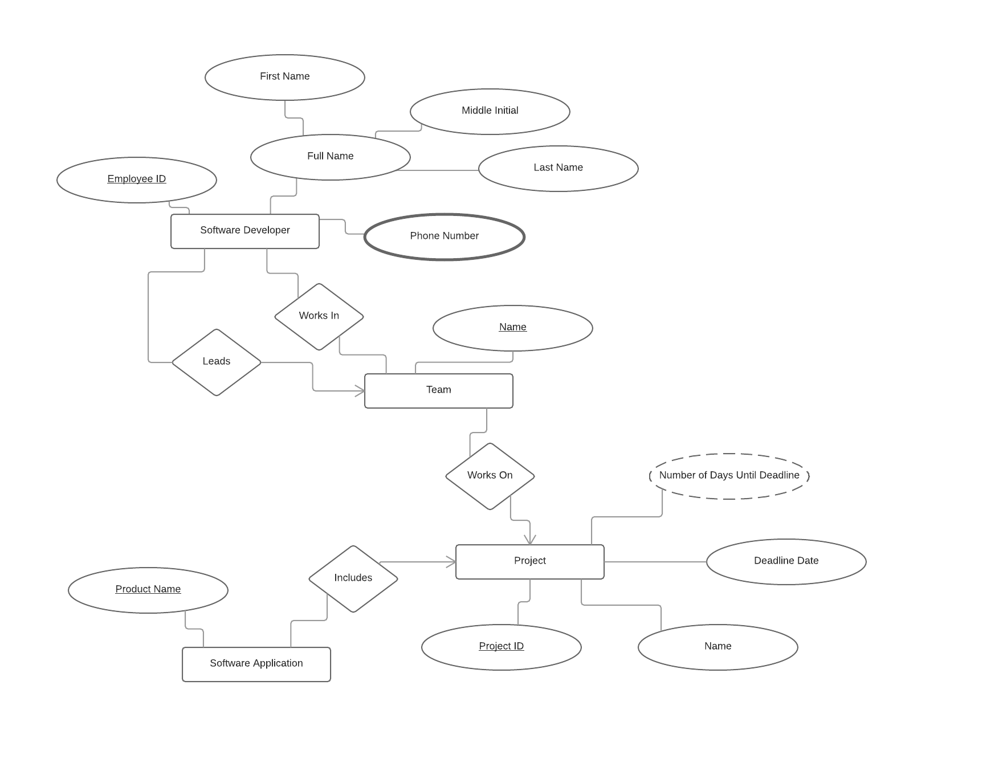

Assumptions:

* Teams must be working on a project
* Software applications must belong to a project

Problem #2 – With Weak Entity

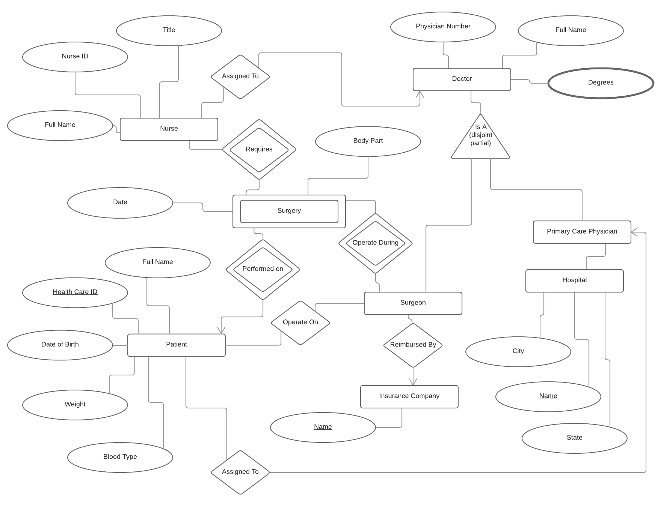

Assumptions:

* Nurses are always assigned to doctors.
* Hospitals can have many primary care physicians.
* Patients can have multiple surgeons.

Problem #2 – with Strong Entity

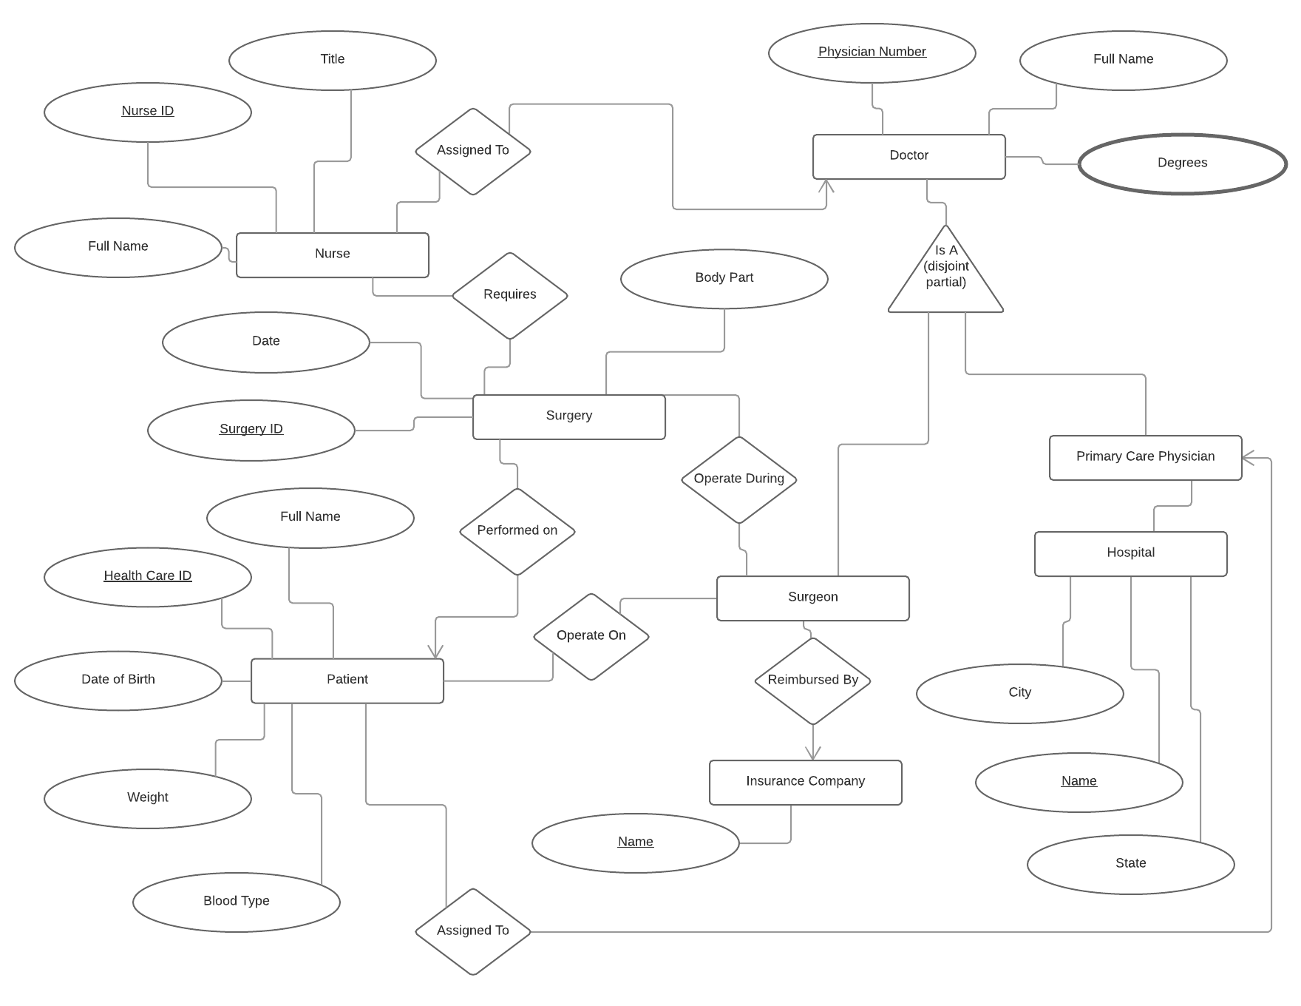

Assumptions:

* Nurses are always assigned to doctors.
* Hospitals can have many primary care physicians.
* Patients can have multiple surgeons.
* Surgery ID is a unique ID to label each surgery.