Eduardo Moguillansky

MOIRE

for amplified ensemble

DURATION
12 min.
INSTRUMENTATION

Flute – Doubles in Piccolo and Melodica
Clarinet
Saxophone – Baritone and Soprano.
Percussion – MOIRE device + Tuning-fork
Piano + MIDI Keyboard
Violin – Scordatura: D string down to C#
Cello – Scordatura later in the piece: C string down to Ab

Waveguide x 2

DISPOSITION

SETUP

Flute, Clarinet, Saxophone, Piano, Violin, Cello and Percussion need to be microphoned. These signals are sent to three different “buses”:
- Bus M: sent to the MOIRE device
- Bus A: sent to the first loudspeaker inside the waveguides
- Bus B: sent to the second loudspeaker inside the waveguides

Each player has a MIDI pedal switch. The microphones are only activated when the player pushed his pedal (notated as “ON” in the score)

GENERAL NOTATION
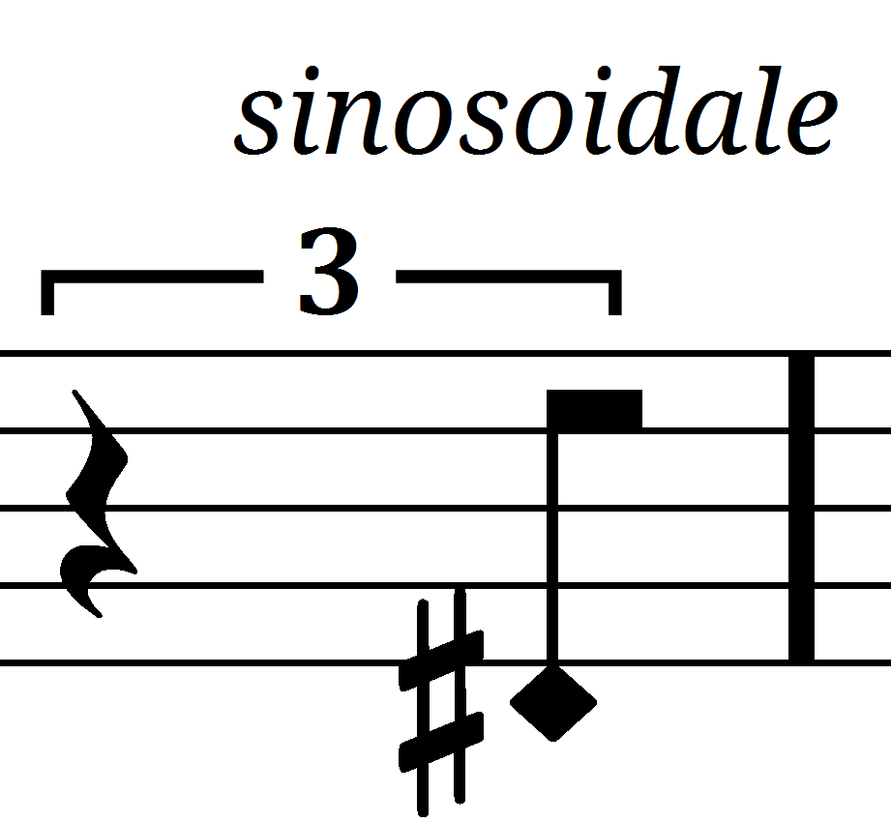 | Very pure sound, as close as possible to a sinus tone
ON | Press the pedal to send the signal to one of the buses.
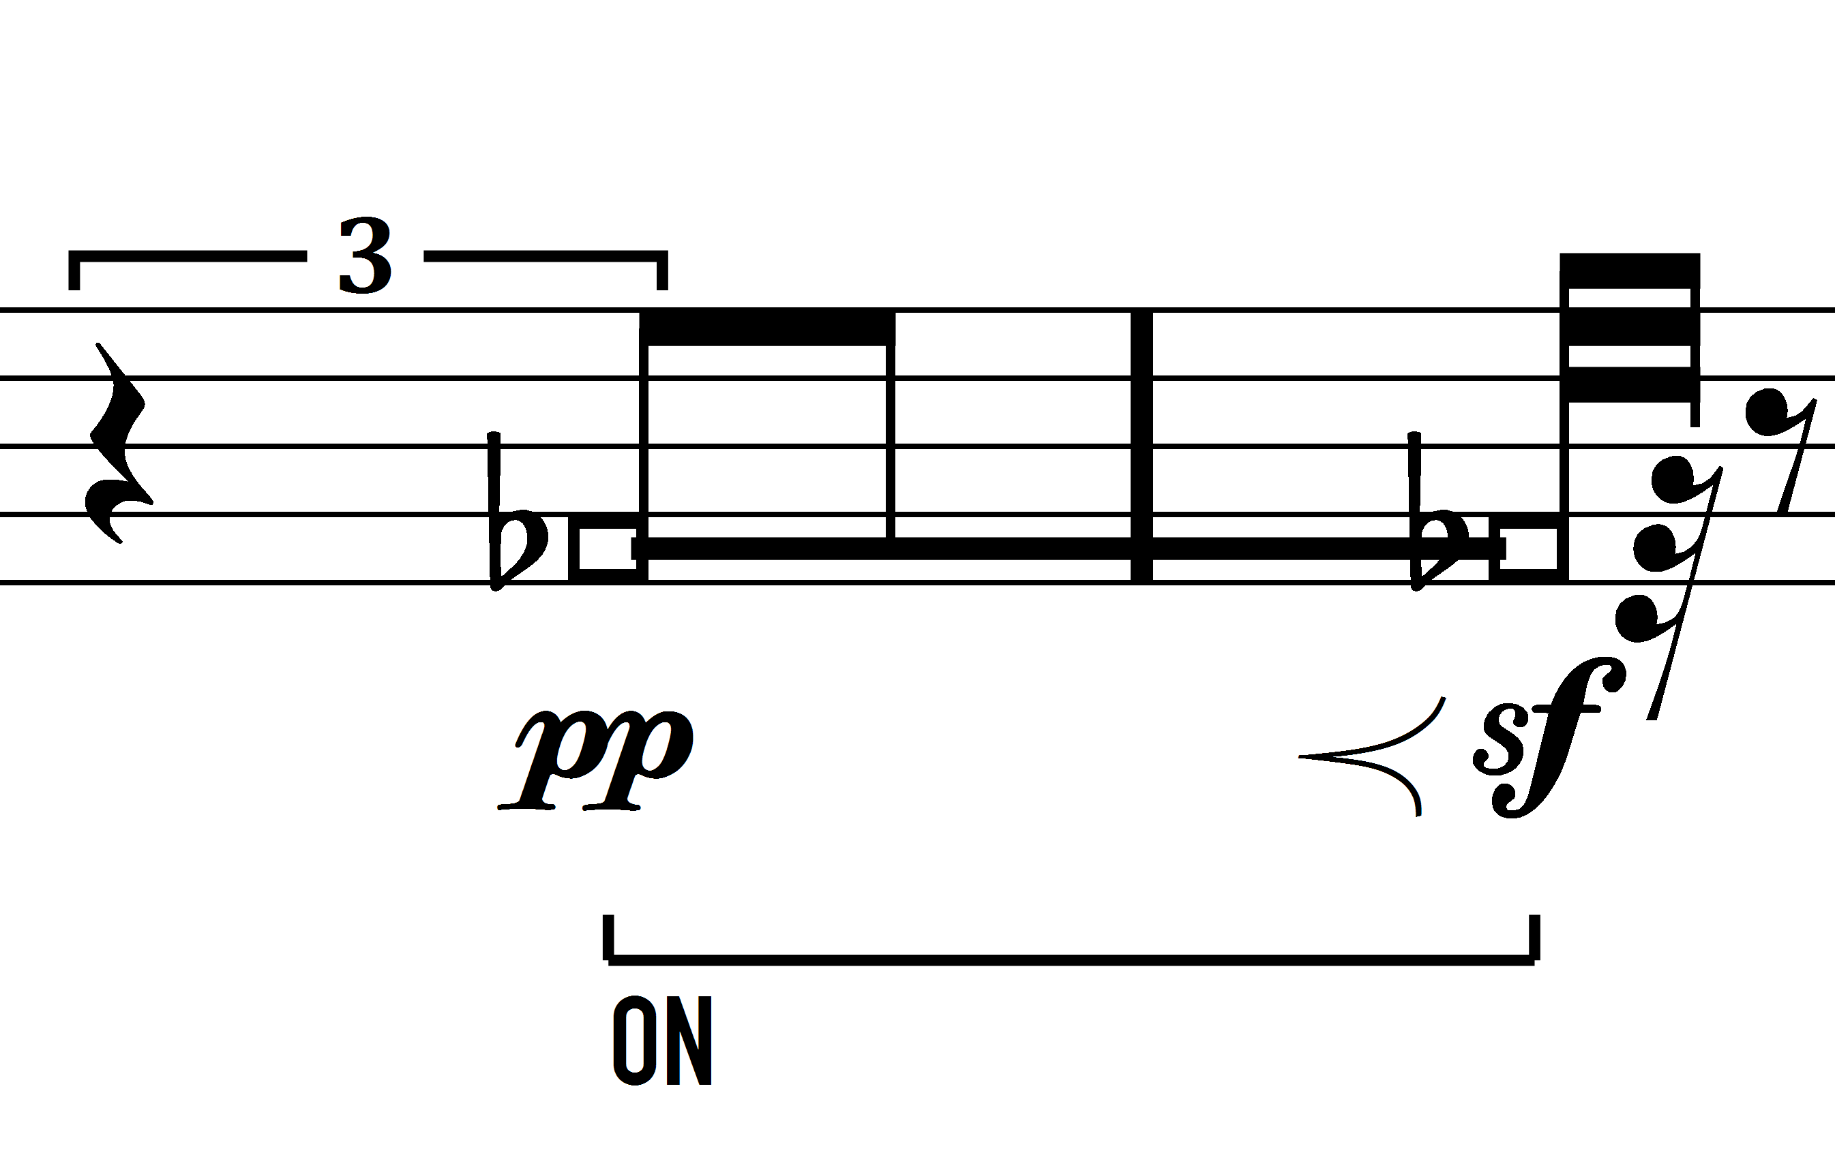 | Air tone, no pitch. As steady as possible
DYNAMICS
When playing in the “ON” position, it is desirable to listen as little direct sound as possible. For that purpose, the gain of the microphones should be generous, allowing to play “pp” and still have a good signal to feed to the filtering instruments.
MOIRE DEVICE
One musician plays a “moire”-device. This device works by modulating light through a series of light-sensitive resistors. The device is placed on stage under a light.
An overhead camera projects the images of the moire device to a screen in front of the audience
CONTROLS
The following controls are present in the device:
- Pedal: a pedal is attached to the device and controls the level of the light pointing at the device and, by doing so, the general gain of the instrument. If not otherwise indicated, the pedal is to be used as a gate, opening it all the way when an action is asked for, and closing it when a rest is notated.
- Knob: a round knob, labelled 1 to 10 is present on the top of the device. This knob controls a circuit inside the device which implements a feedback loop. This loop is not linear and has different effects to sound at its different positions. The position of the knob is notated, together with a brief description of the expected modification to the sound.
- Right button: when pressed (the light will go on), the original sound is mixed together with the light-modulated sound. Because the modulation by the light sensors is not linear, when mixed together with the original version an interference takes place, in the forms of beatings. The result is somewhat similar to a doppler effect, and it is notated in the score via “DOPPLER: ON” or “DOPPLER: OFF”.
- Left button: the left button activates a smoothing circuit, so that the transition between darkness and light is easier to control. Use it at will.
- Front slider: the front slider controls the mixing between the light sensors. In the present version of the device, there are 4 sensors. Two of these sensors are sent directly, two are modified by the feedback network. By moving the slider, it is possible to cross-fade between these sensor-pairs. If not otherwise indicated, use at your own discretion. By default, the expected position is around 100% (fully to the right)
MOIRE EFFECT
A moiré effect is an interference present when a regular pattern is supperimposed to itself. When one of the patterns is shifted (either translated or rotated), an interference occurs.
One sheet with a pattern is fixed to the device, the other sheet is placed on top. The main movement is the shifting of the sheet up or down, which shifts the interference pattern right or left.

[=] | Place the sheet parallel to the device
[-2], [-4], [-6], etc | Rotate the sheet clockwise, so that interference stripes appear. The number indicates the approximate number of stripes.
[+2], [+4], [+8], etc | The same as above, but in the opposite direction
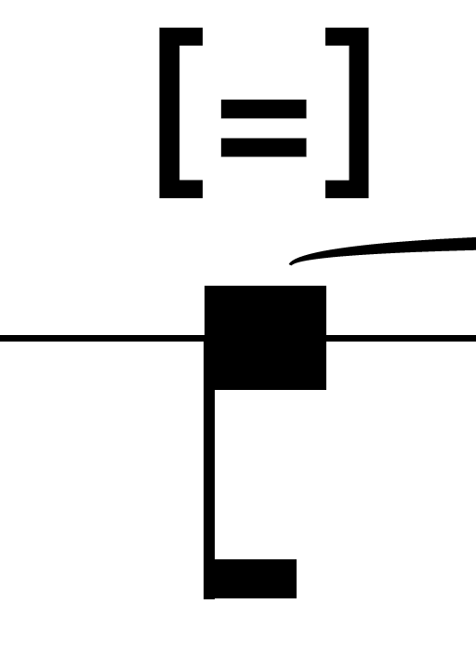 | When in the parallel position [=], it is possible to place the sheet so that the result is total darkness.
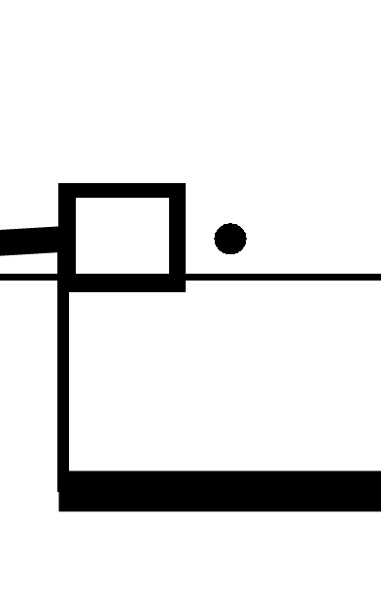 | As white as possible
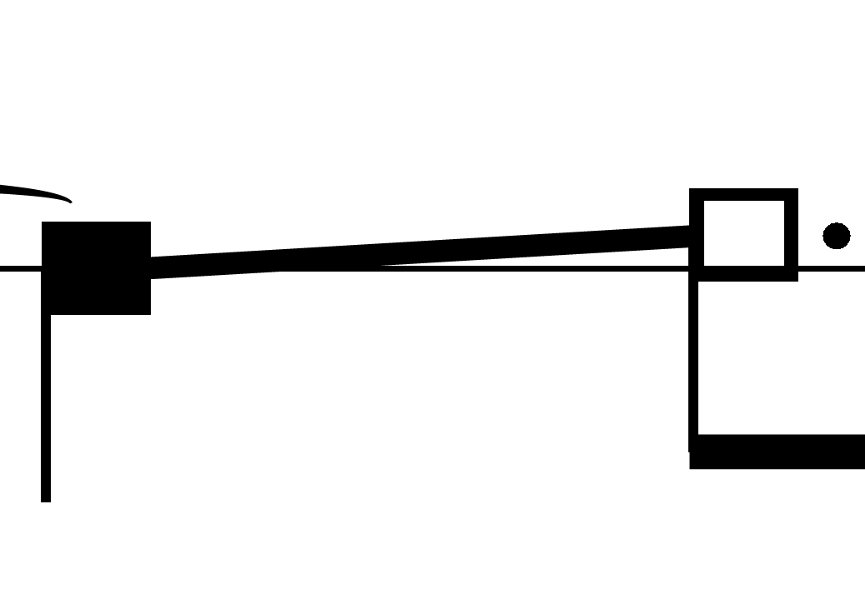 | Transition between black and white. The direction of the line indicates the direction of the movement. There is no absolute position for the sheet. All movements are relative to your current position.
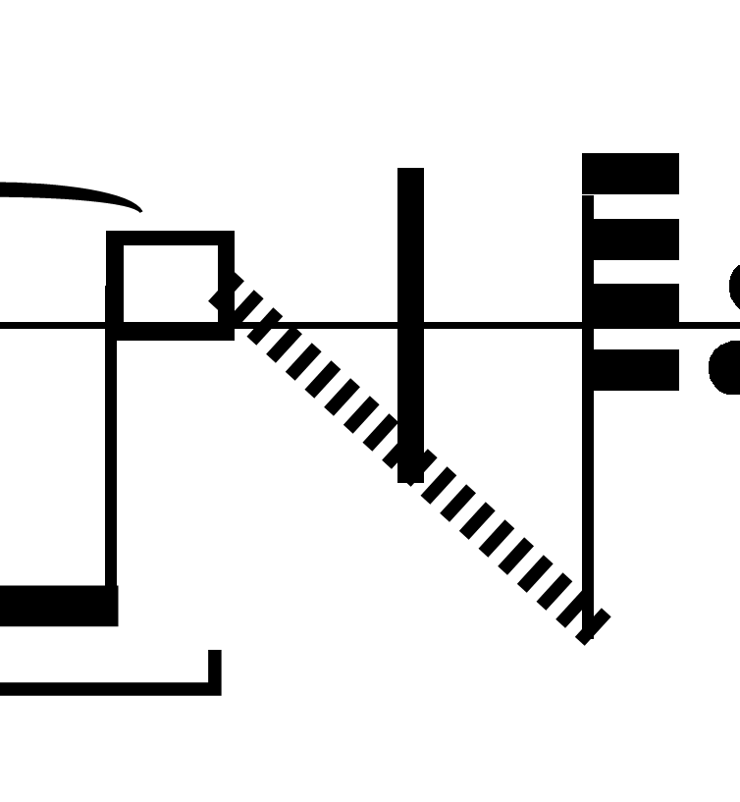 | Move the moire fast in the direction indicated. If the source being modulated is of middle or high pitch, a ring-modulated effect will be audible, its pitch depending on the speed of the movement
KNOB: 7.5 | The number indicates the position of the knob between 0-10.
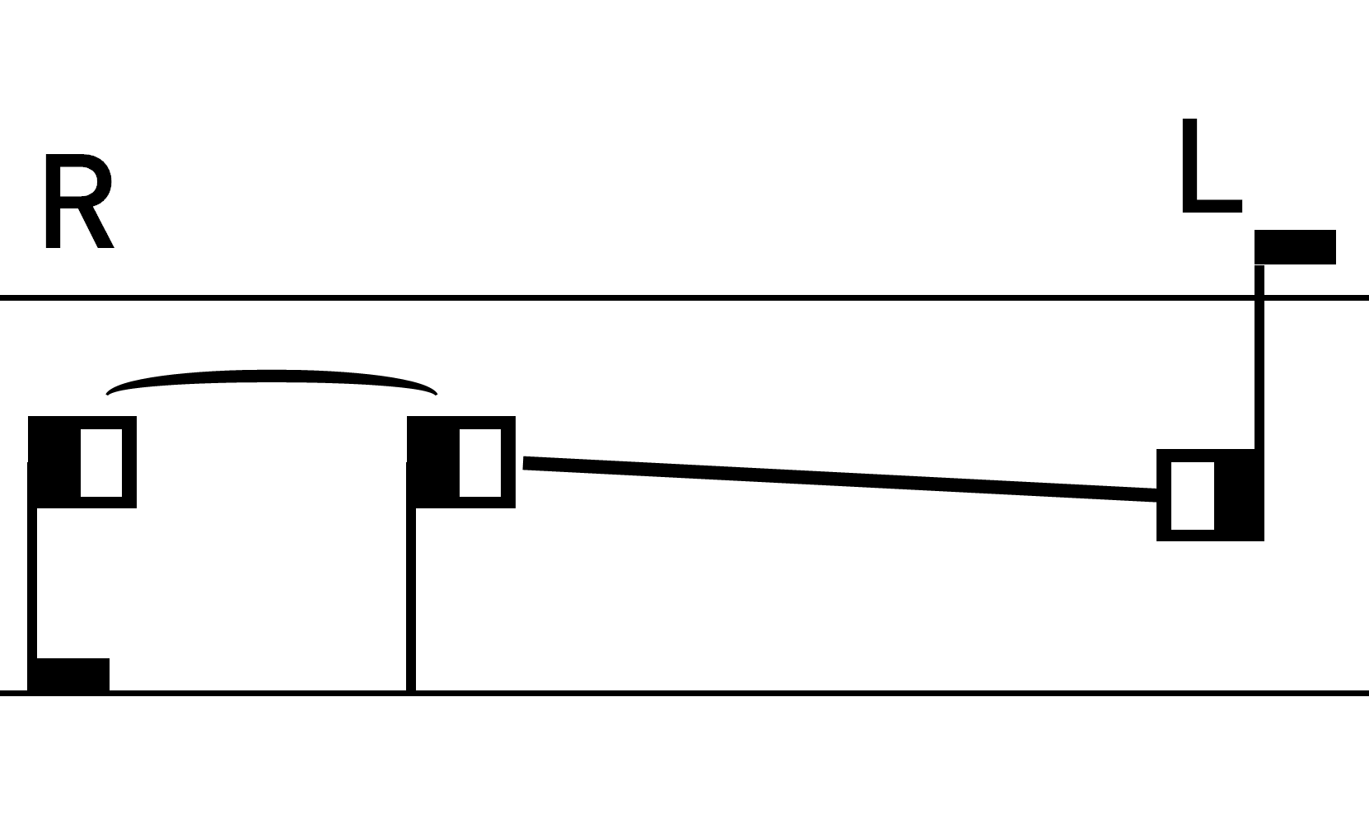 | When the pattern is rotated the instrument acts as a panning device. The square with white on the right, means that light should be able to go through to the sensor on the right while the sensor on the left should be under a dark zone.
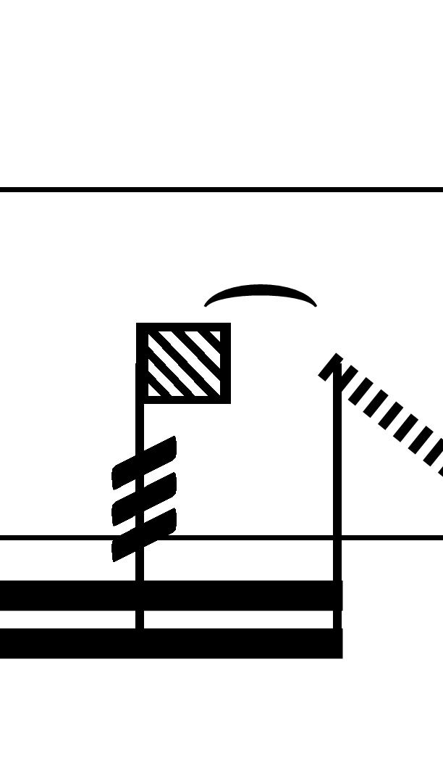 | When performing a tremolo or a fast movement, where the initial or ending position is irrelevant, this notehead is used to indicate that the action is performed from or to whatever position the sheet might be in.
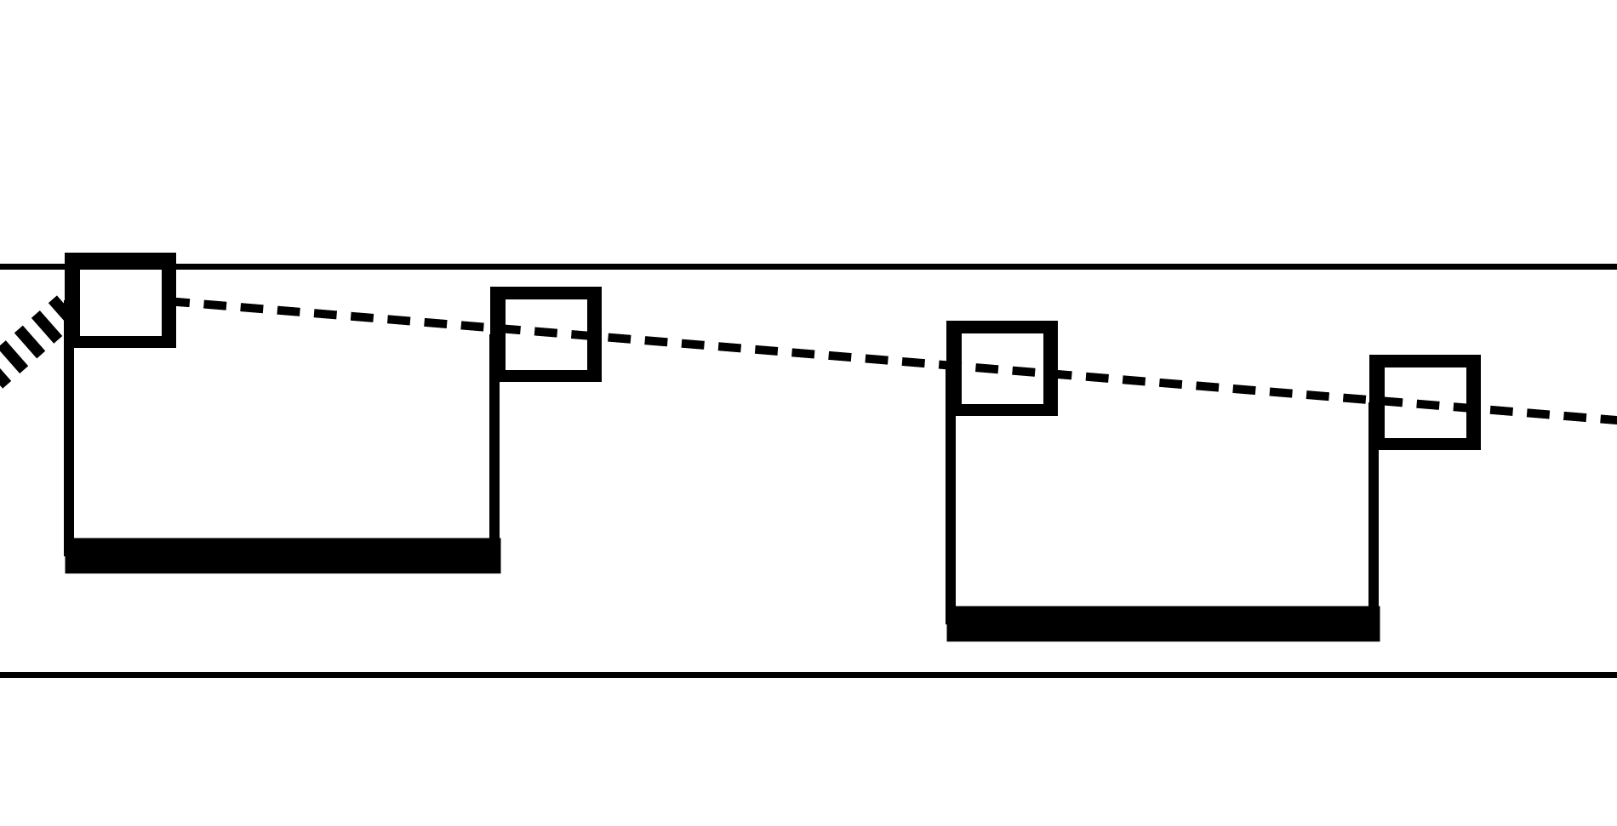 | Move the sheet in the indicated direction (down in this case). The rhythms is only approximative and indicates the speed of the alternation between white and black stripes (only the white are notated).

WAVEGUIDE
The waveguide (WG) implemented in this piece consists of two trumpets placed in series. A sound is projected inside the tubes with a small loudspeaker and collected at the end of the tubes with a small microphone. This small excursion through the tubes generates a delay (the tubes are between 4 and 20 meters, which results in a delay between 10 and 60 millisecons), which is in itself hard to perceive, but when combined with the original sound, generates an interfence pattern audible as a filter.
SOURCES
Two sources are fed to the waveguide, via two small loudspeakers. Source A is fed directly and will be audible without pressing any valve. Source B is fed to a loudspeaker connected to V1, so when V1 is pressed, only the air coming from Source B will go through the tubes.

VALVES

V1: When up, sound from Source A will flow through. When down, sound from Source B will flow through. In many cases, this valve is used as dynamics controller. If only one source is beeing used, this valve can perform a fade-in/fade-out, shifting between the source and silence.
V2: A reentrant loop of tubing is attached to this valve, which results in a doppler effect, slightly shifting the pitch of the sound and thus resulting in beatings when mixed with the original source.
V3: The normal tubing of the trumpet, can be finely adjusted by moving the slide with your thumb.
V4: extra tubing (around 12 meters) is attached to this valve. When pressed, the level of the sound diminishes. If not indicated explicitely, this valve can be used at will as a sort of “sordino”, to finely control the resonance of the system.
V5: the normal tubing of the trumpet (around 4 cm).
V6: when up, sound flows through and goes to the “normal” microphone. When down, sound goes through subsequent tubing, through a resonator and ultimately to a second microphone. The result is a resonance chamber, acting as a “room” within the system. Can only be activated briefly, since the feedback loop quickly builds up when this extra resonance is allowed in the path.
NOTATION
The waveguide is notated in two staffs. The lower staff is the “tablatura”, indicating the actions on the valves. In some situations, the resulting “resonance” of the instrument instead of the precise valve action is notated, since the specific position of the valves is to be found by the player and is likely to change slightly from setup to setup. The “resonance” is notated in the upper staff, in the form of normal musical pitches. These pitches indicate the sound or sounds which should be made prominent by finding the right position of the valves.
PEDAL
The player uses a pedal to control the feedback of the system and to mute its instrument when needed. The normal position is with the pedal in the middle. When fully pressed, the feedback is increased, which can be used for a brief amount of time as a form of accent. When fully up, the instrument is muted. Normally the peda is not notated.

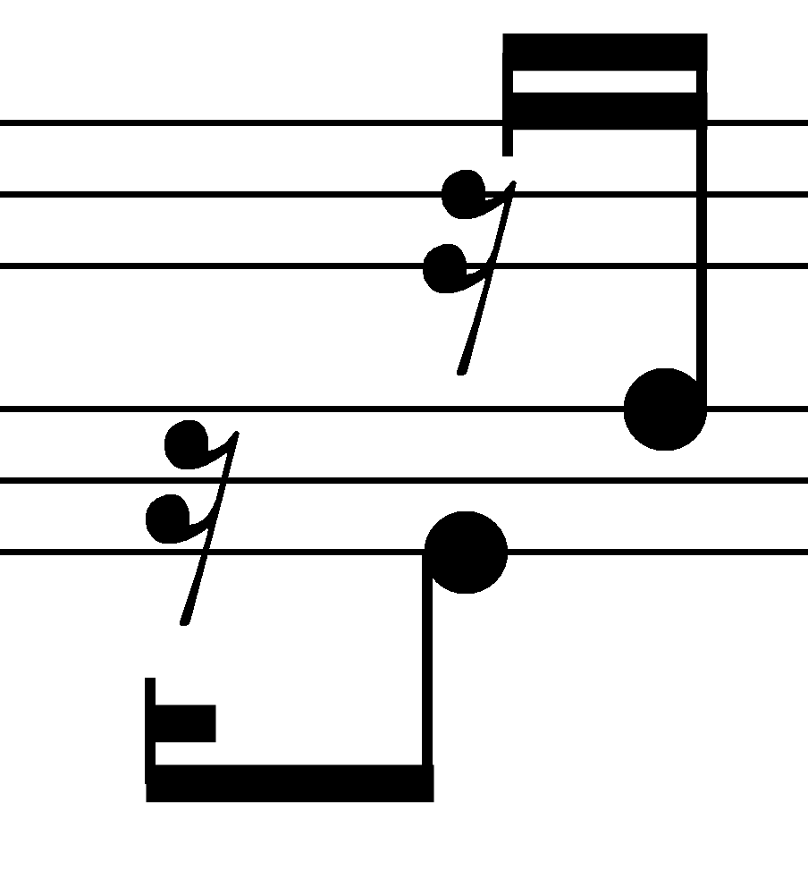 | Press the indicated valves fully down. A silence indicates no valves depressed.
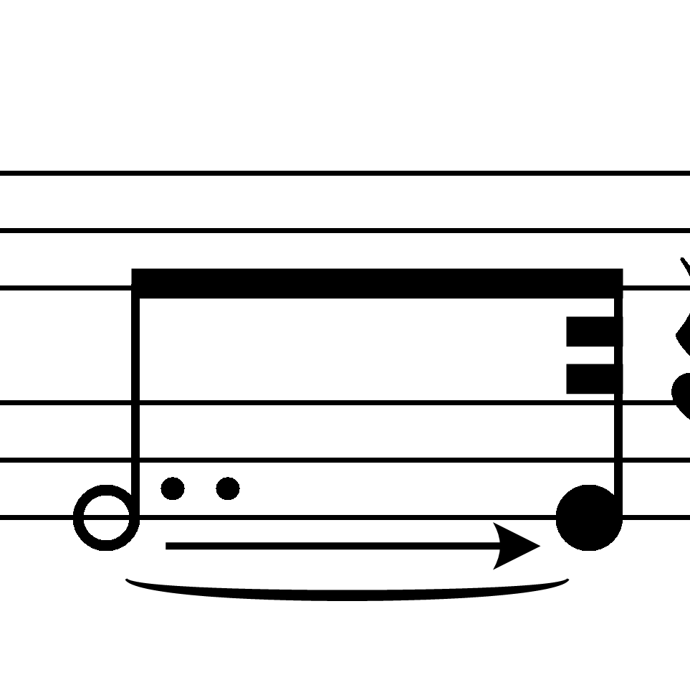 | In some cases it is more intuitive to indicate the undepressed valve instead of using a rest. In such cases a white circle is used, as here, indicating the slow pressing of V1 to produce a fade-in.
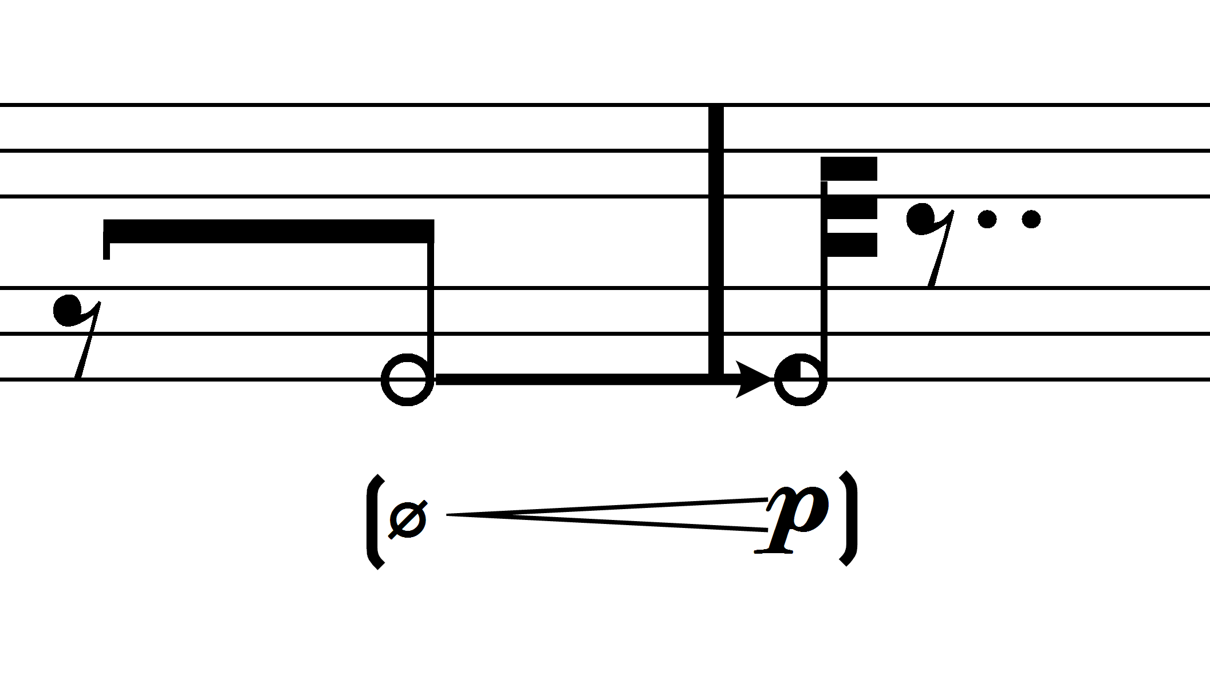 | In the case of V1, because it is often used to control the dynamics, when a specific dynamic is desired, this is notated together with the valve movement.  The circle with a ¼ black indicates ¼ valve (valve slightly down)
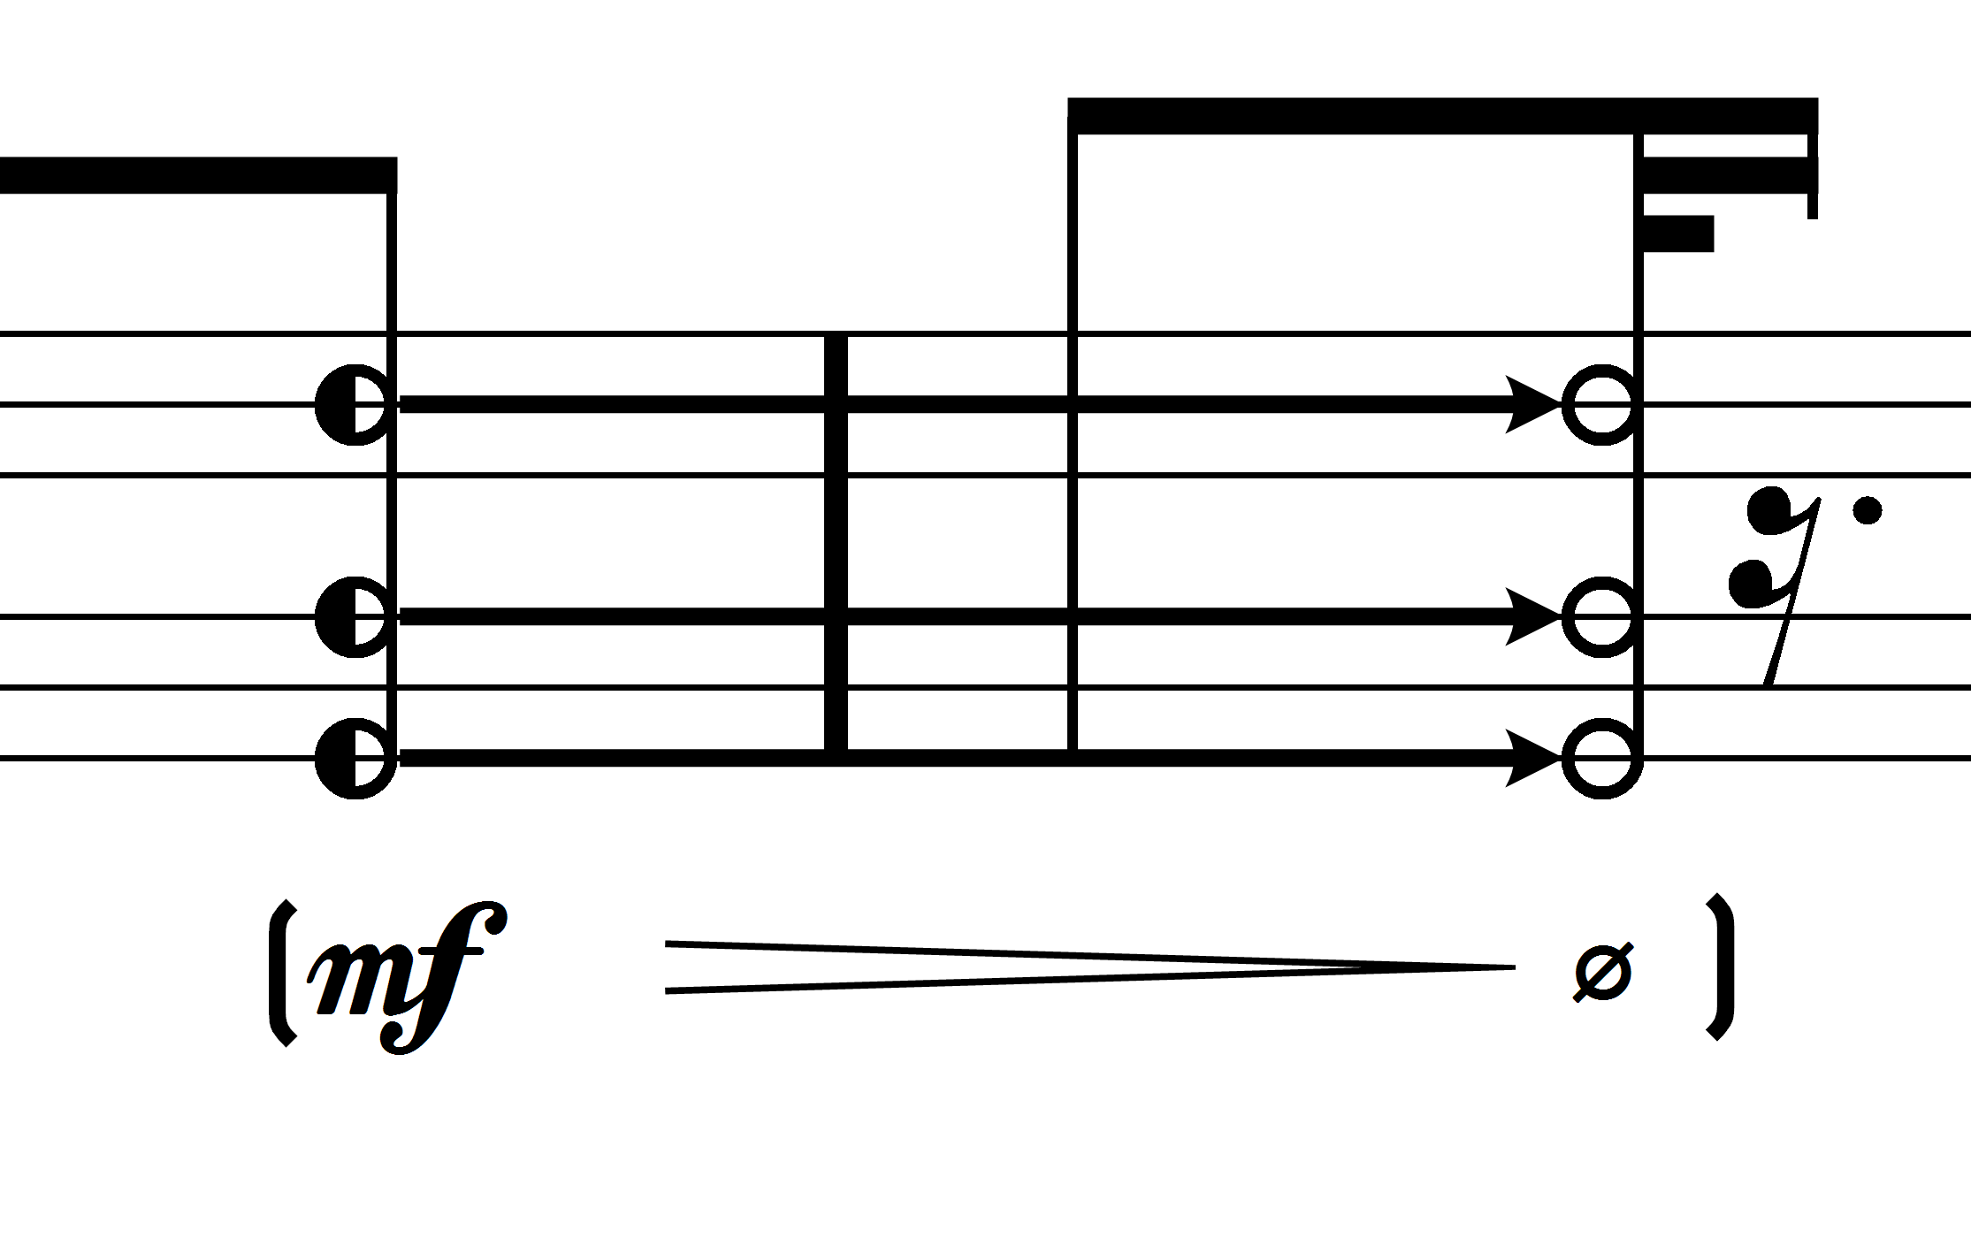 | ½ Valve. Not fully depressed valves have a quite different effect as fully depressed valves because air is allowed to flow through both paths.
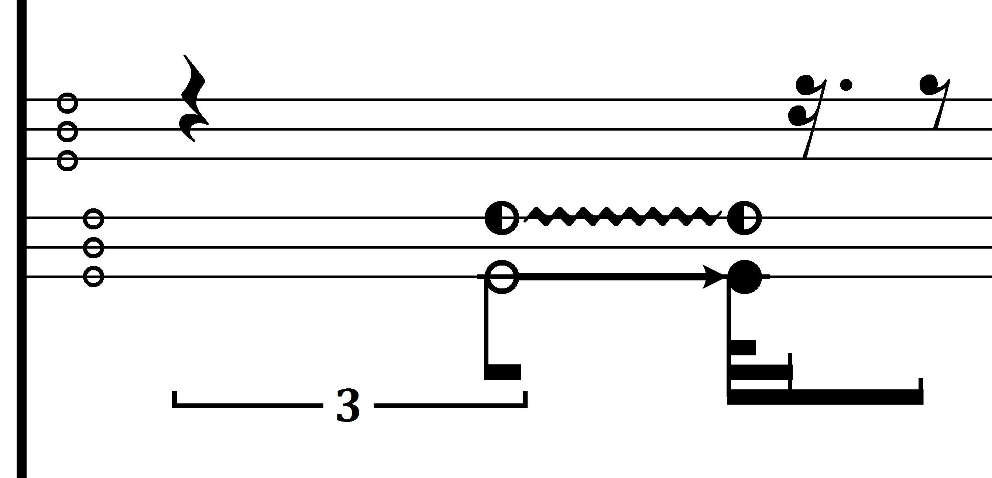 | While V1 performs a fade-in, V3 trills between unpressed and ½ position.
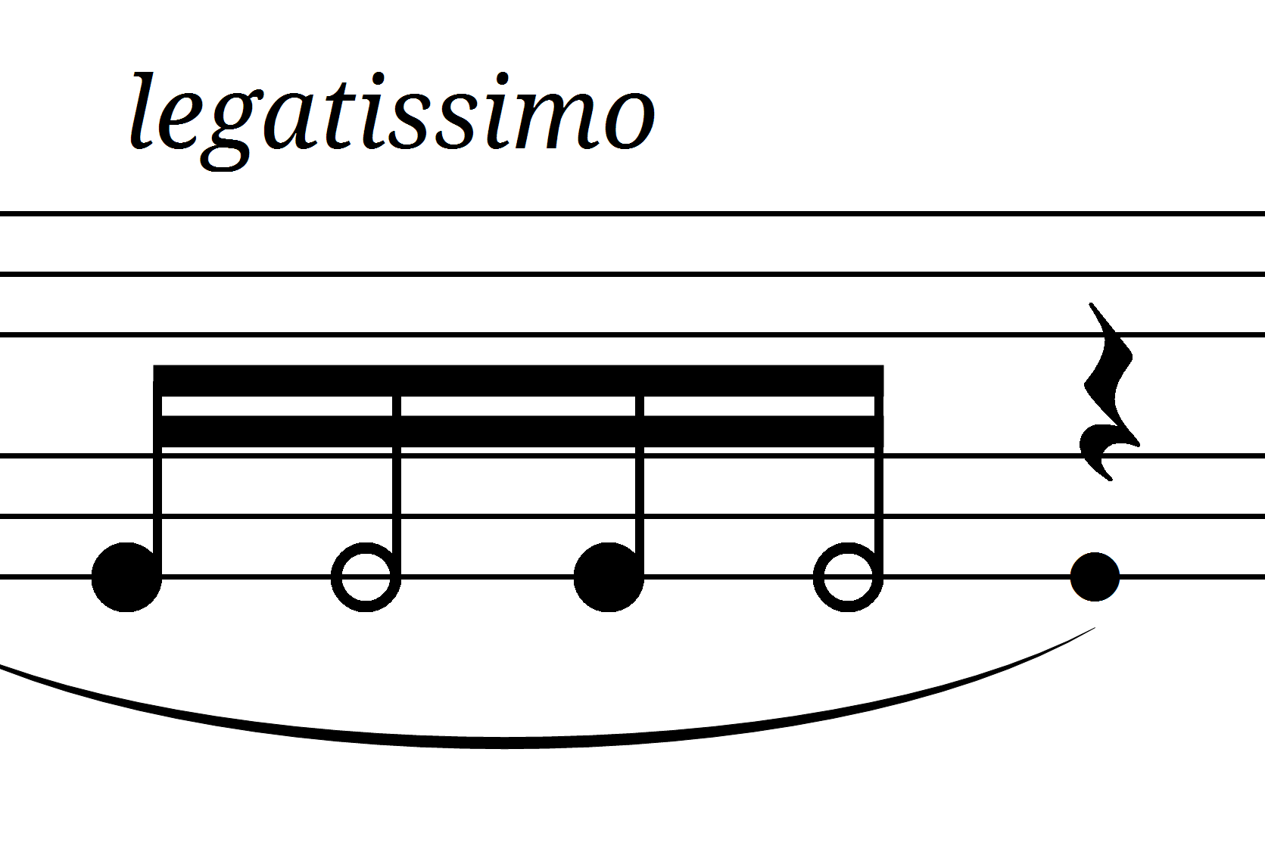 | Legatissimo: a very smooth movement of the valves is desired. In this case, the wageguide is receiving sound in two sources, and acts as a cross-fader.
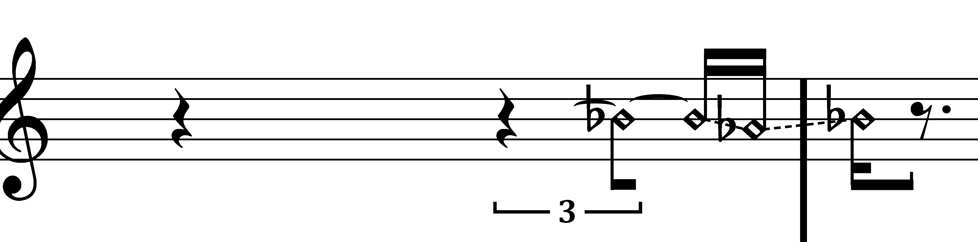 | Resonance notation: the upper staff is used to notate the resonance of the key movements. The two pitches indicated (in this case Bb and Ab) are being fed to the wageguide. Find two fingerings which bring out either of the pitches, and play these fingerings in the indicated rhythm. The resulting effect is always an approximation.
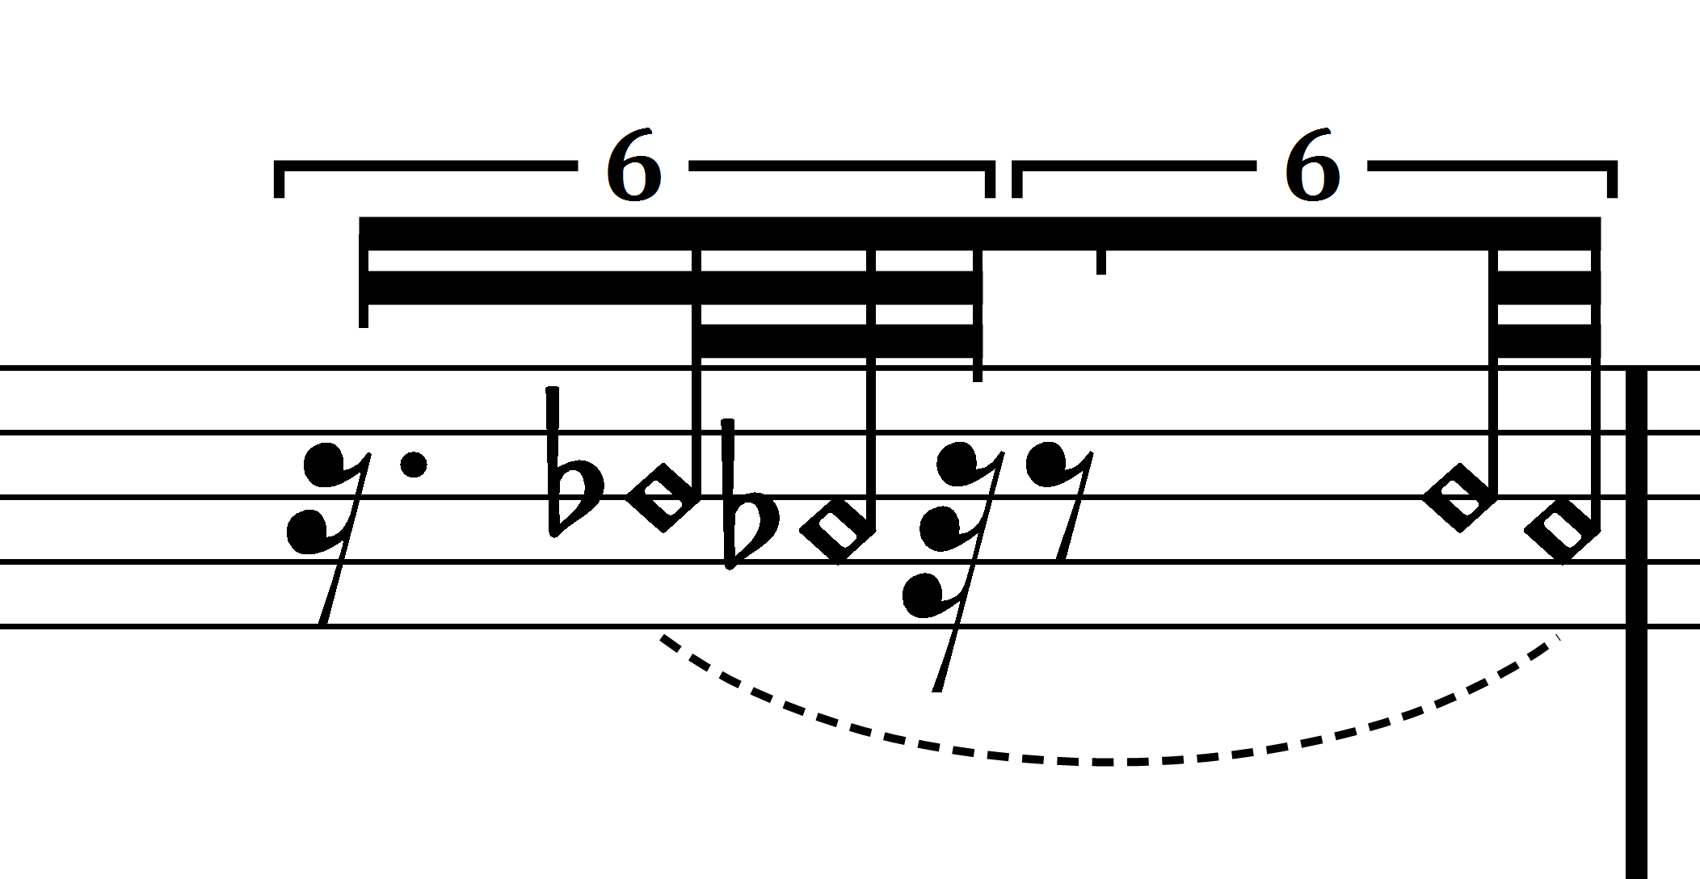 | A variation on the previous situation. The wageguide is being fed a continuous source. The rests are to be achieved by pressing V1 to let sound through, and closing V1 to produce a rest.
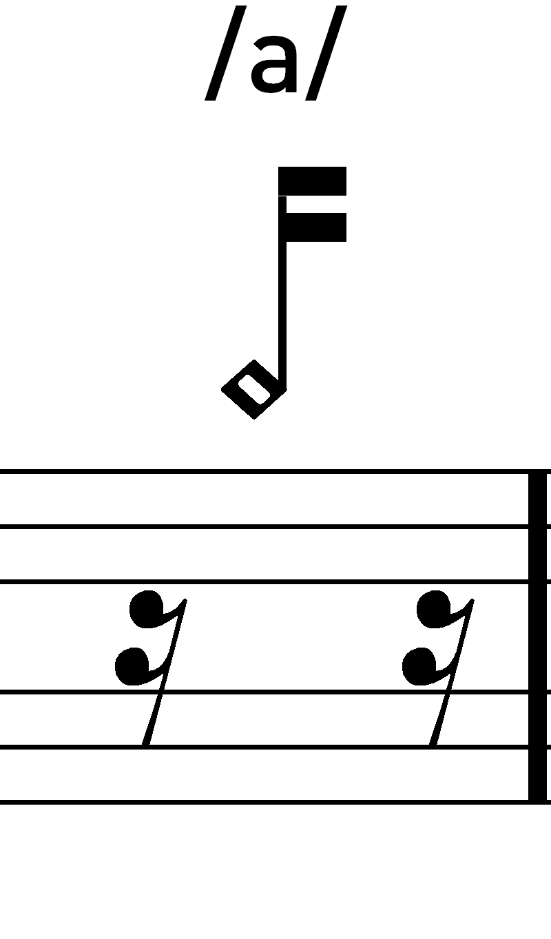 | With certain sources (low synthesizer tones, white noise) it is possible to give the resonance of the wageguide a vocal quality. By a combination of the valves V3, V5, V6, predominantly in half pressed positions, different vocals can be played. When such an effect is desired, the result rather than the action is notated.
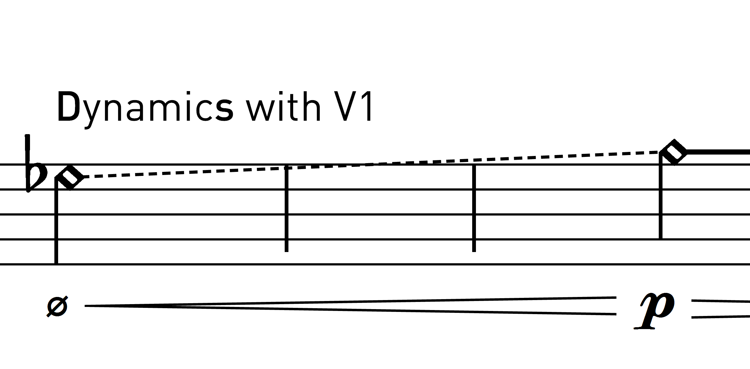 | Transition between two overtones

FLUTE
The flute player doubles on piccolo and melodica

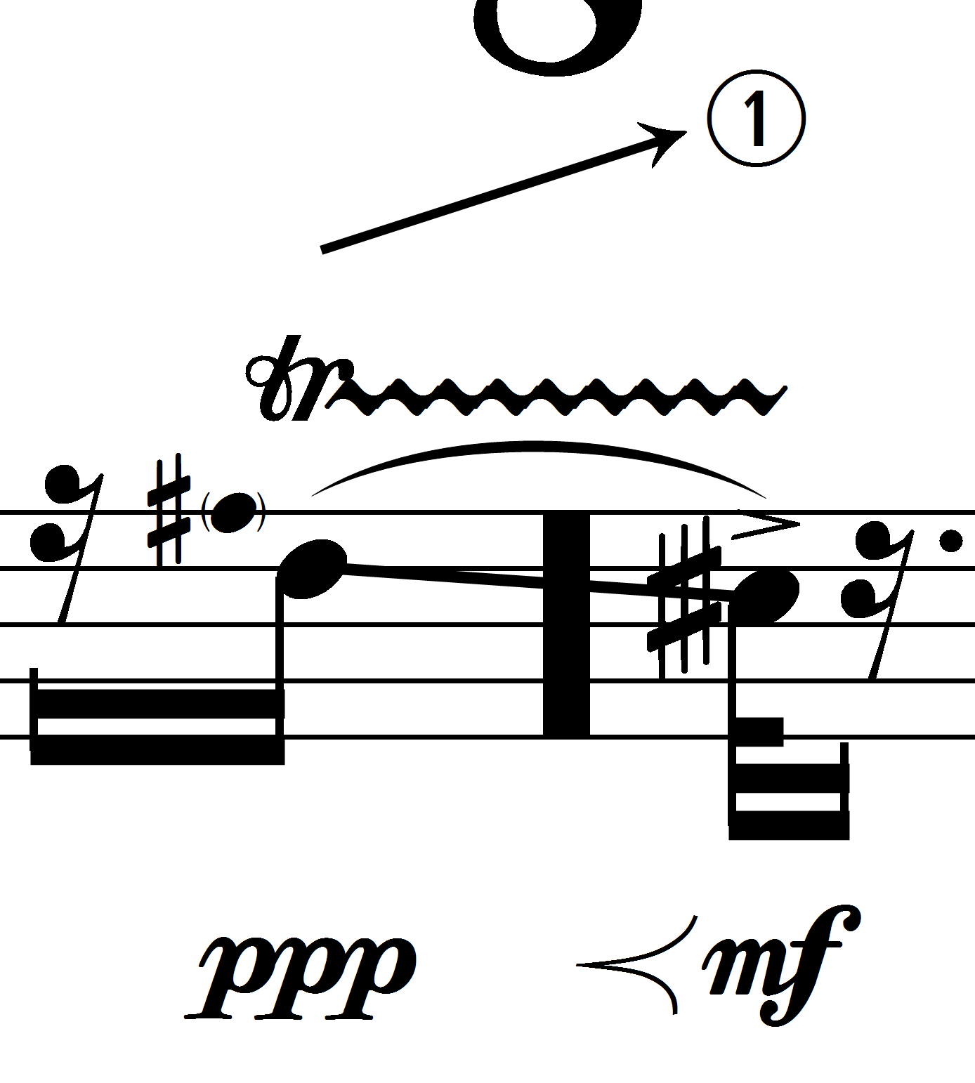 | The circled number indicates the overtone, where 0 is the fundamental. In this case, a transition to the octave overtone is indicated.
MELODICA
A 37-key melodica is used. The melodica should be amplified with a small lavalier microphone attached to the back and isolated to avoid feedback. The amplified sound should be projected from a small loudspeaker in place, in front of the player.
The melodica is used for its possibility to make difference tones audible. The difference tone (an approximation) is notated always in the lower staff. When increasing dynamics, the intonation of these tones can vary quite dramatically. These variations are not indicated.
KEYBOARD
A 88 key MIDI keyboard is needed, with a pedal to control the volume, a sustain pedal, a pitch wheel and a mod-wheel. A very simple synthesizer patch is used, which generates either a sinus or a sawtooth wave.
- The patch is tuned to 442 Hz.
- The pitch-wheel shifts pitch by 1 semitone up or down.
- The wave type is controlled by the mod-wheel: 0 means sinus, 127 means sawtooth.
The keyboard is never heard live, it is always routed to one of the buses and does not need a pedal to turn it in the “ON” position.
TUNING FORK DEVICE
The percussionist also plays a tuning fork device, which consists of two tuning forks, 440 and 1024 Hz. These tuning forks are mounted on a wooden bar and this bar is amplified with a contact microphone. The tuning-fork device is always routed to Bus M.

