GESER DUGAROV, Ph.D. |  | 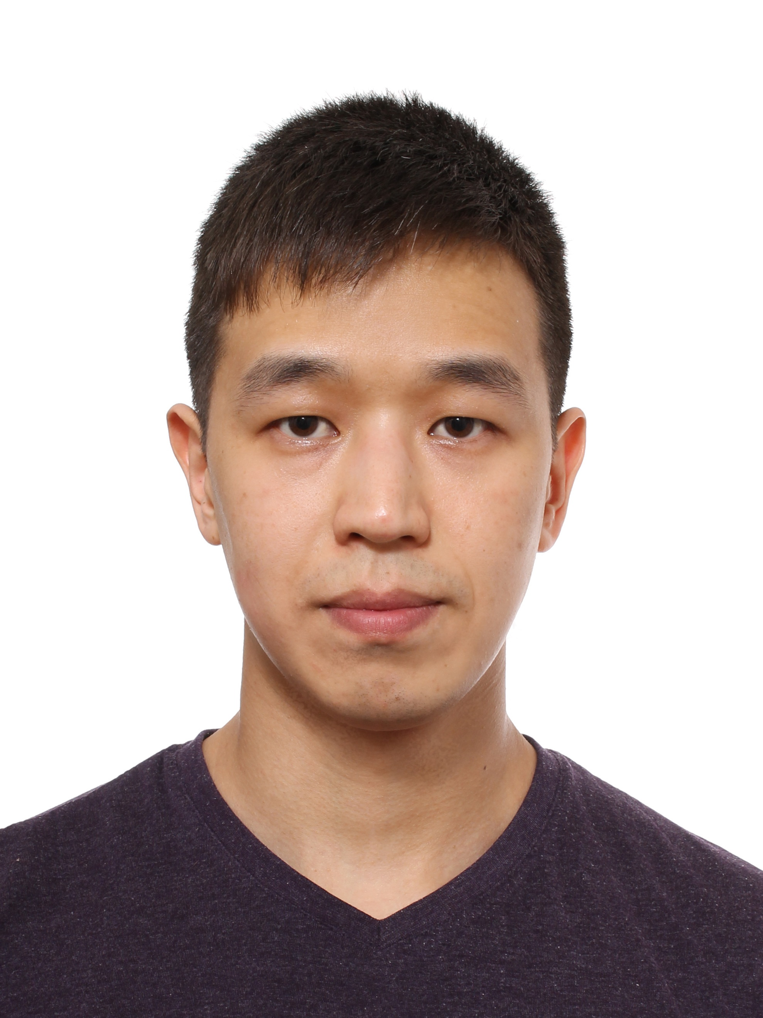
email:  mobile:  languages:  location: | geserdugarov@gmail.com  +7-913-703-1014  English (advanced), Russian (native)  Novosibirsk, Russia
SUMMARY
Helping professionals to work smarter, not harder by creating automatic systems for their routine. Made transition to data-driven R&D in the IT industry after 12 yrs in fundamental research. Holds a degree of a Doctor of Philosophy (Ph.D.) in Geophysics. Experienced in project and research management.
TECHNICAL SKILLS
Python, Docker, Git, Linux, Matlab
WORK EXPERIENCE
ML Research Engineer,  Digital Research (spinoff of Digital Clouds) | II/2022 – current
▪ Time-reporting system for vehicles monitoring in the construction industry (project manager role).
Python, Docker, Git, Linux
Senior Researcher,  Trofimuk Institute of Petroleum Geology and Geophysics SB RAS | X/2009 – current
▪ 5 years in a row of personal projects supporting by main foundations (Russian Foundation for Basic Research, 2017-2018, 2019-2021; Russian Science Foundation, 2019-2021).
▪ Plugin for AVAZ inversion embedded in Petrel, Schlumberger, the most used software for interpretation. Project manager role. Transfer of the technology from fundamental research to business.
▪ 4 graduate students: 3 MSc (2022*2, 2020), 1 BSc (2020).
▪ «The best young researcher in Earth science organizations» award from The Government of Novosibirsk (2019).
▪ Trofimuk Memorial Medal Award from the employer (for significant contribution in the institute work, 2021).
Python, Matlab, Git, Wolfram Mathematica (symbolic computation).
Research Associate (II/2014 – IV/2019), Research Assistant (X/2009 – II/2014)
Engineer  Nuclear Safety Institute RAS, Novosibirsk Branch | IX/2013 – V/2017  (4 years)
▪ Developed automated testing system with visualization of modelling results (comparing with experimental data).
▪ Updated closure relationships for two-phase coolant flow leading to more robust numerical modelling.
C++, Python, SVN.
EDUCATION
PhD, Geophysics,  Trofimuk Institute of Petroleum Geology and Geophysics SB RAS | X/2009 – XII/2013  (4 years)
MSc, Computational and Applied Mathematics,  Novosibirsk State University | IX/2004 – VI/2009  (5 years)
CERTIFICATES
- Deep Learning Specialization, Coursera (2021).
- Machine Learning, Coursera (2021).
PROJECTS
- XII/2019 – VIII/2021 AVAZ inversion of local object anisotropy parameters from 3D seismic data
Role: project manager. Team size: 7. Customer: NTC NIS-Naftagas, Serbia.
- VII/2019 – VI/2021 Acoustic properties and internal structure of hydrate-bearing coal samples
Role: head of the project. Team size: 5. Supported by RSF, grant No. 19-77-00068.
HONORS AND AWARDS
- Trofimuk Memorial Medal Award from Trofimuk Institute of Petroleum Geology and Geophysics SB RAS (2021).
- “The best young researcher in Earth science organizations” from the Government of Novosibirsk (2019).
PUBLICATIONS
Author and coauthor of more than 50 scientific publications. Full publication track record could be found on https://geserdugarov.github.io, also in WoS and Scopus databases.
HOBBIES
- Going to the gym on a regular basis (since 2019).
- Reading developmental psychology and business management books.

Updated: 15.07.2022
The last updates could be found on https://geserdugarov.github.io

