**SISTEME DISTRIBUITE**

**Assignment 2**

**Asynchronous Communication and Real-Time Notification**

**Student: Gesica Goron**

**Grupa: 30242**

1. **Conceptual Architecture of the Distributed System**

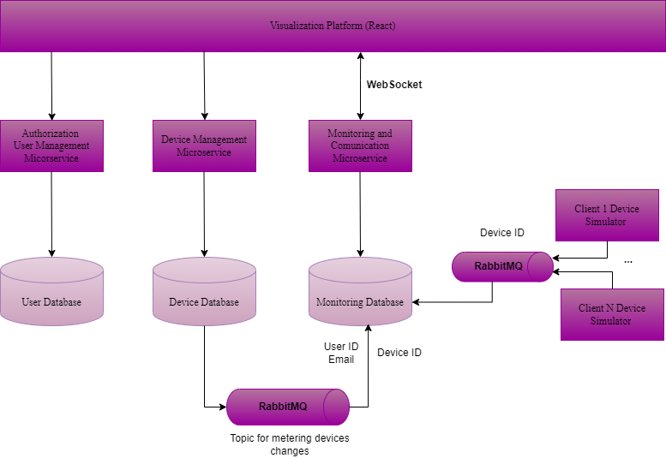

The distributed system is composed of **three primary microservices** and a **React-based visualization platform**. It is designed to manage users, devices, and monitor energy consumption. Communication between microservices occurs via **HTTP APIs** and **RabbitMQ** for asynchronous messaging.

**Components and Responsibilities**

1. **Authorization and User Management Microservice**
   * Handles user authentication, authorization, and user CRUD operations.
   * **Database**: MySQL (User Database).
2. **Device Management Microservice**
   * Manages devices, including adding, editing, and deleting devices.
   * Provides APIs for fetching devices assigned to users.
   * **Database**: MySQL (Device Database).
3. **Monitoring and Communication Microservice**
   * Collects and stores hourly energy consumption data from device simulators.
   * Processes alerts when devices exceed the maximum hourly energy consumption.
   * Publishes device energy consumption changes to **RabbitMQ** for communication with other services.
   * Provides a WebSocket endpoint to send notifications to the React application.
   * **Database**: MySQL (Monitoring Database).
4. **Visualization Platform (React App)**
   * User interface for interacting with the system.
   * Admin users manage devices and users.
   * Client users view their assigned devices and energy consumption data in charts.
   * Receives **real-time alerts** via WebSocket from the monitoring service.

**Communication**

* **Synchronous Communication**: Microservices use RESTful HTTP APIs to interact with each other.
* **Asynchronous Communication**: Device simulators send energy consumption updates to RabbitMQ.
* **WebSocket**: Real-time notifications are pushed to the front end.

1. **UML Deployment Diagram**

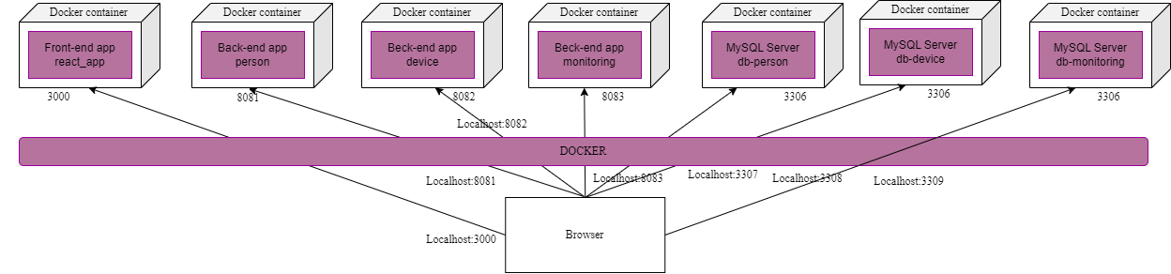

The following diagram illustrates the deployment architecture of the distributed system. The system runs inside Docker containers for isolation and scalability.

**Description**

* **Front-end Application**: Runs on port **3000** and communicates with the back-end services via HTTP APIs.
* **Back-end Microservices**:
  + User Management (person) on port **8081**.
  + Device Management (device) on port **8082**.
  + Monitoring Service (monitoring) on port **8083**.
* **Databases**:
  + Each microservice has a dedicated MySQL database.
  + Ports: 3306 for individual databases, exposed as 3307, 3308, and 3309 for external access.
* **Message Broker**: RabbitMQ is used for communication between device simulators and the monitoring service.
* **Device Simulators**: Simulate the energy consumption data and send updates to RabbitMQ.

**3. Readme file containing build and execution considerations**

**1. Prerequisites**

Ensure the following tools are installed on your machine:

1. **Docker** and **Docker Compose** (for container orchestration)
2. **Node.js** (for frontend development, optional for containerized execution)
3. **Java 17** (for local development of Spring Boot services)
4. **RabbitMQ** (included in Docker, no manual setup required)
5. **MySQL Client** (optional, for direct database access and debugging)

**2. Project Structure**

* **frontend/**: React application for managing users, devices, and monitoring energy consumption.
* **person-service/**: Spring Boot microservice for user management.
* **device-service/**: Spring Boot microservice for device management.
* **monitoring-service/**: Spring Boot microservice for monitoring energy consumption.
* **docker-compose.yml**: Orchestrates all containers, including databases and RabbitMQ.
* **device-simulator/**: Simulates devices sending energy consumption data via RabbitMQ.

**3. Running the System with Docker**

**Step 1: Build and Run Containers**

Run the entire system with **Docker Compose** from the project root directory:

**docker-compose up --build**

This command will:

* Build and launch all services (React frontend, microservices, databases, and RabbitMQ).
* Expose necessary ports on your localhost.

**Step 2: Verify Running Services**

The following services will be accessible:

1. **Frontend (React App)**:
   * URL: <http://localhost:3000>
2. **User Management Service (person-service)**:
   * URL: <http://localhost:8081>
   * Endpoints: /person
3. **Device Management Service (device-service)**:
   * URL: <http://localhost:8082>
   * Endpoints: /devices
4. **Monitoring Service (monitoring-service)**:
   * URL: <http://localhost:8083>
   * Endpoints: /devices/{deviceId}/energy-consumption
5. **RabbitMQ Management Interface**:
   * URL: http://localhost:15672
   * Username: guest, Password: guest

**Step 3: Database Configuration**

Each microservice uses a separate MySQL database. Ports are mapped as follows:

* **User Service Database**:
  + Port **3307**
  + Database: user_db
* **Device Service Database**:
  + Port **3308**
  + Database: device_db
* **Monitoring Service Database**:
  + Port **3309**
  + Database: monitoring_db

**Step 4: Run Device Simulators**

To simulate devices sending energy consumption data:

1. Build the device simulator Docker image:

**cd device-simulator**

**docker build -t device-simulator**

1. Run the simulator:

**docker run -d --name device-simulator device-simulator**

The simulator sends energy data to the **RabbitMQ queue**, which the Monitoring Service processes and stores in the Monitoring Database.

**4. Inter-Service Communication**

* **User-Service** (person) provides user information.
* **Device-Service** (device) retrieves devices and their assignment to users.
* **Monitoring-Service** (monitoring) fetches energy consumption data for devices.
* **RabbitMQ** handles communication between the **Device Simulators** and the **Monitoring Service**.

**Example Workflow**:

1. Devices publish energy consumption data to a RabbitMQ queue.
2. Monitoring Service consumes this data, saves it to the Monitoring Database, and notifies the React Frontend via WebSocket.

**5. Stopping the System**

To stop all containers and clean up volumes:

**docker-compose down -v**