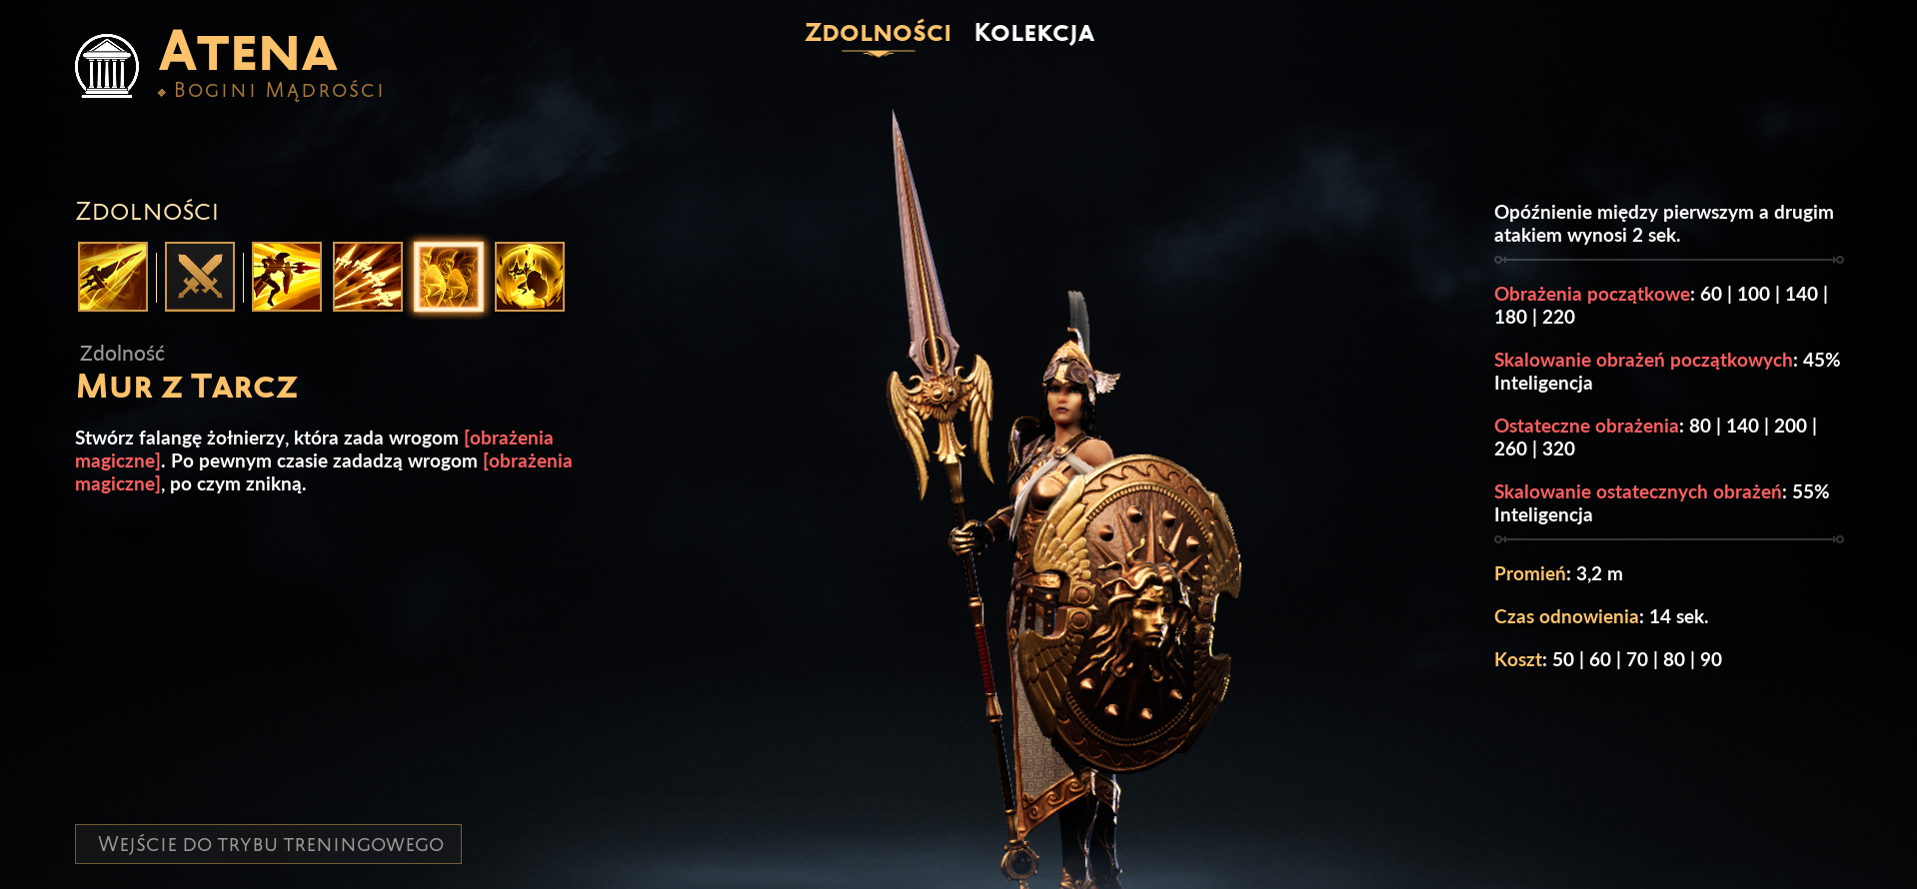
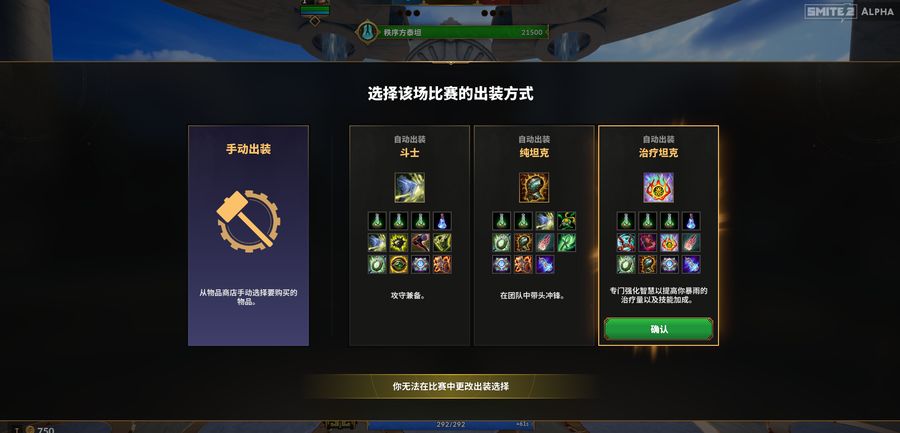
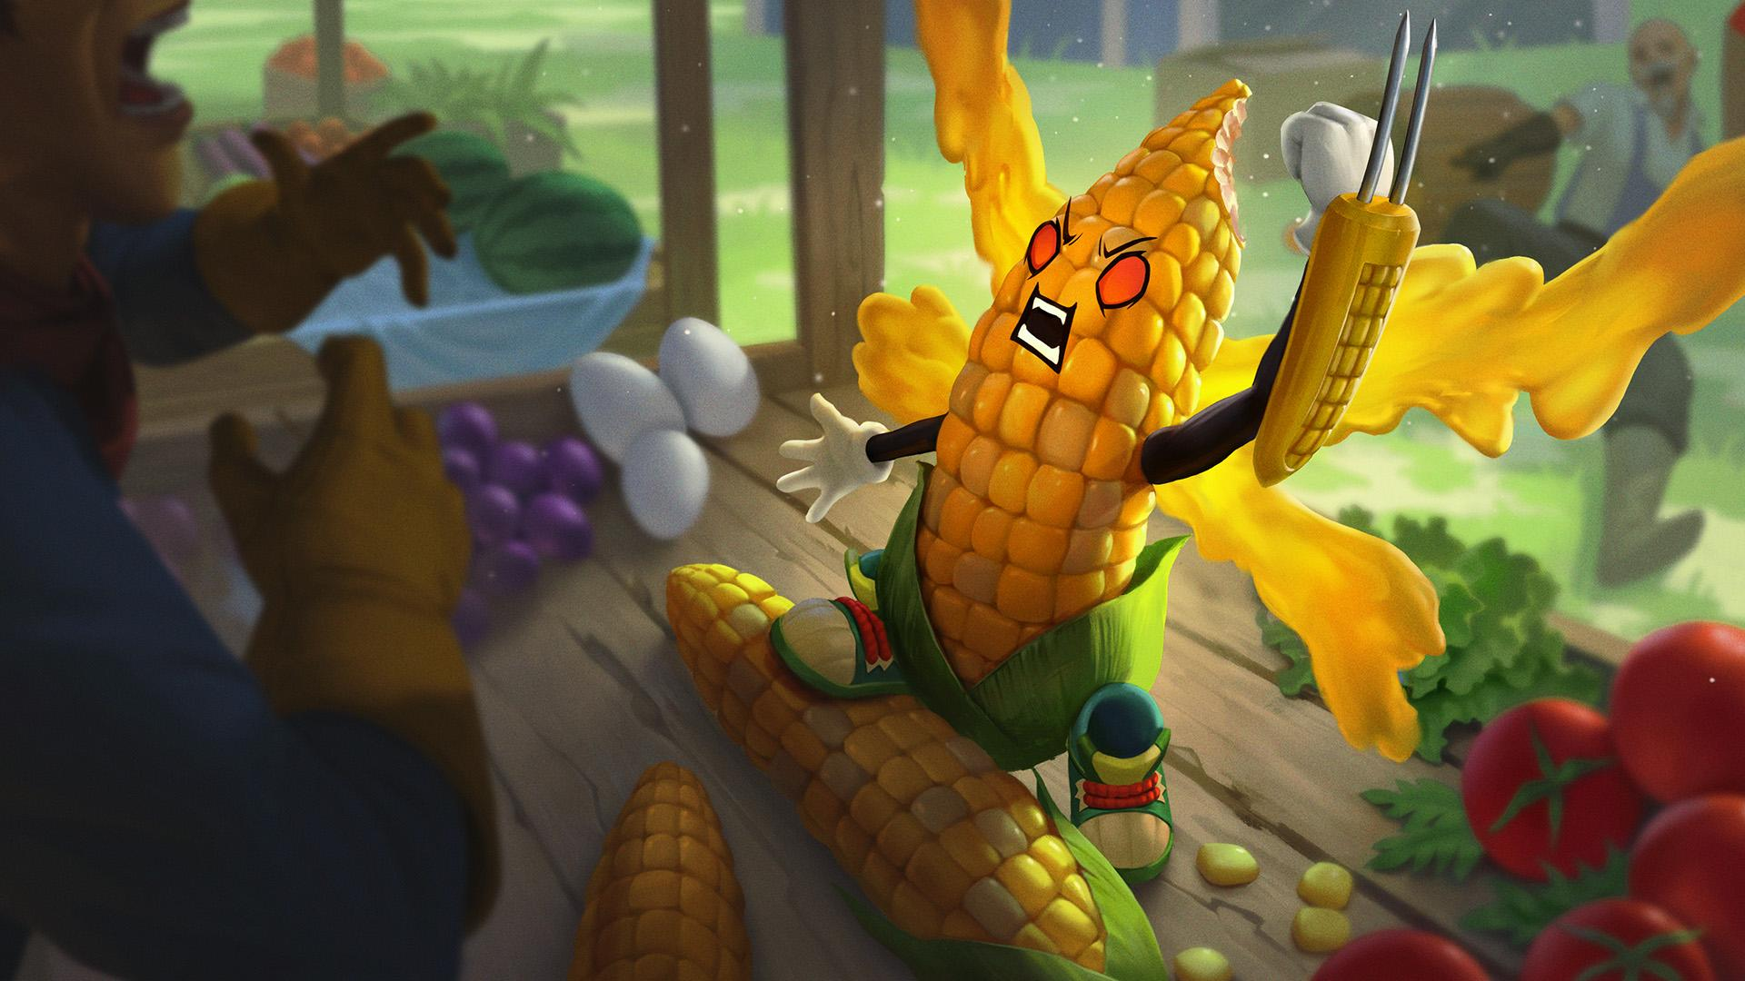
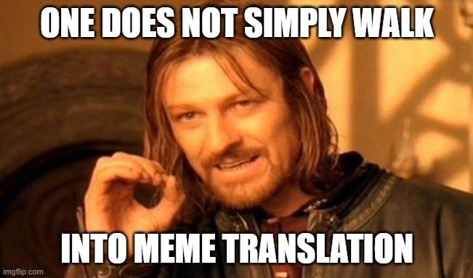
SMITE 2 Developer Deep Dive: Localizing SMITE 2

Divine deities!

My name is Gaëtan—also known as GG. I’m the Localization Producer for SMITE 2 and part of the team translating the game. For those interested, here is a little tour backstage regarding game translation, both in general and for SMITE 2 in particular.

Even now during the Alpha Weekend phase, SMITE 2 is available to a global community. Titan Forge Games has fully translated the game in 10 languages for the benefit of the many players whose primary language isn’t English.

So you can play SMITE 2 in:
- Turkish
- Polish
- French
- German
- Russian
- Chinese – simplified
- Japanese
- Spanish from Latin America
- Portuguese from Brazil
- Ukrainian – our latest addition

Athena in SMITE 2 and in Polish

Just like everything else in SMITE 2, we aim for translations to be strictly better than in SMITE 1. They are a work-in-progress and we'd love your feedback on non-English content to help us make it better. So please, keep an eye out for our player survey during Alpha Weekends. That’s the main way for us to collect and analyze your feedback. Not just regarding translations, but also on all the other things that make SMITE 2 great! You can also tag us on social media with your comments.

___________
How we work

Over the years, a lot has changed with how Titan Forge Games translates games. Right now, SMITE 2 translations are provided by both internal linguists and external ones – all of them long-time SMITE enjoyers!

Selecting your autobuild – with a Chinese twist

It’s easy to translate “Please nerf Loki” or “Kukulkan deals 15,000 damage”, but harder for sentences like “+10% reduced basic attack movement penalty on fall-off range scaling with protections from items”. Especially because I just made that up and it doesn’t mean anything. But you get the idea.

Translators everywhere work out of context: they don’t write directly inside game clients. At Titan Forge, internal linguists have access to all sorts of tools, like development game clients. That allows us to know the exact context of each text string and try to come up with relevant translations. We take screenshots, gather details, test things, etc. then we share it with external linguists. Before each update goes live, testers from each language check translated clients – just like regular QA.

The process of translating software, including games such as SMITE 2, is called ‘localization’. That’s because it implies going beyond translation and adapting some things to each target culture. And some of those can be really fun to work with.

___________
Puns and cultural references

From time immemorial, SMITE has been renowned for the fantastic quality of its skins – and SMITE 2 is now the rightful heir. Skin names themselves are not lacking, ranging from high-fantasy epic to gloriously silly puns and cultural references. Their translated names need to be just as inspired and creative. So we need to brainstorm and iterate around ridiculous word plays!

For instance, take Ah Muzen Cob – that’s Ah Muzen Cab as a corn on the cob. Cob is Épi in French. No worthy pun in sight between that and Ah Muzen Cab. But corn is Maïs, so we named this yummy little guy Ah Maïzen Cab.

Ah Muzen Cob – Ah Maïzen Cab in French

Some puns can be hard to reproduce, and for others it’s simply not possible. How could you ever convey the sheer radiance of “Hot Diggity Odin” through a translation? Thankfully, you can always come up with an entirely different pun or let it go altogether and focus on the skin theme instead.

Hot Diggity Odin – Just “Odin Hot Dog” in French

___________
Memes

SMITE sometimes refers to memes and memes are all about readers being familiar with it and knowing that everyone else is too. Only in such conditions can you bask in that soothing feeling of meme acknowledgement and community belonging.

An illustration of the damage bad memeing can do
And how should you translate a meme—if at all? If you’re the first person to do so, readers may not recognize the original meme. That poor translated meme risks losing its entire purpose in life. There are various, preferential ways to work around that.

___________
Other loc things

Other aspects of game localization—aka l10n or loc—may not be as entertaining as puns and memes. I won’t go into detail but here are just a few examples:

- Dates and times – they need special treatment.
For instance, 4/5/2024 may be April 5th if you’re Americans, but for many others it refers to May 4th. The MM/DD/YY format is unique to the US but most other countries use DD/MM/YY instead.
- Structural programming sometimes conflicts with non-English linguistic requirements, for instance when strings are “concatenated”.
- Technical stuff involves font compatibility and support of special characters. For instance, French includes curious double letters like œ and Æ, 。is a Japanese period, and in Turkish I-ı, İ-i, and L-l can get mixed up due to automatic capitalization.

That’s it for this post! I hope you found that overview interesting. You’ll get to see more of our team’s work in the next Alpha Weekends. Make sure you’re following SMITE 2 on X, TikTok, YouTube, Instagram and Facebook to find out those dates.

And please allow me this final reminder: use our player survey to send your feedback on non-English text, and on everything else that makes SMITE 2.

Whatever language you play in, we’ll see you on the Battleground of the Gods during the next Alpha Weekend!

