
Module A2 Implementing Security Configurations
54 Cyber Security

Contents
Contents 2
Introduction to Test Project 3
Introduction 5
Physical Topology 5
Logical Topology 6
Table 1. VM Finished Configuration Summary 7
Description of project and tasks 9
ISP 9
Firewall configuration 9
Table 1. Firewall settings 10
PKI 12
WINSRV1 12
LINSRV1 14
LAN clients 14
WinClient3 15
Instructions to the Competitor 15
Table 2. GPO Policy Recommendations 15

Introduction to Test Project
Our friends over at skill 39 have built a network for a client, and everything works as expected, but things are not as secure as they need to be. The network when first examined was as follows:
Pre-project topology:
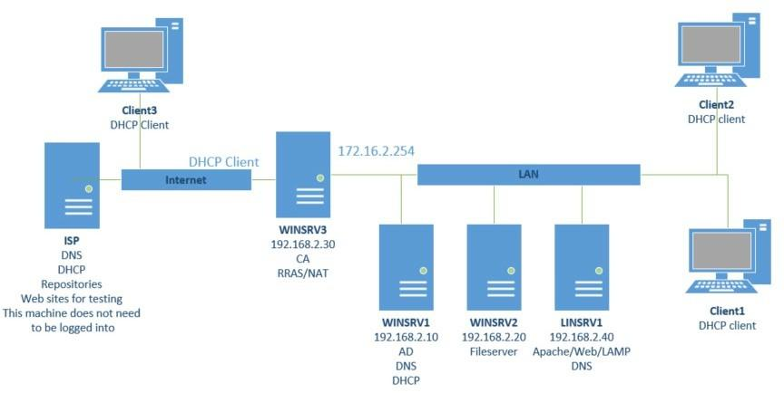

Following a security assessment, a number of changes needed to be made in order to make the network more secure: installation and configuration of a proper firewall, hardening of the domain and the Linux machines, management of a Public Key Infrastructure, and segmenting the network into different subnets, amongst other things, all need to be accomplished. In order to do the assessment and simplify the network, the File Services requirements were moved to WinSRV1.
You will be given a list of tasks to implement to work towards hardening the network and the systems on it, you and your partner will have to best decide how to spend your time to get all the configurations done. You will be assessed on the completeness of these tasks based on both a configuration and functional standpoint, so remember to test your configurations as you go.
Use the following login credentials to log onto the ESXi server for the afternoon portion of the activity:

IP Address: 192.168.1.1
User:pmuser Password:Paul Bocuse
Login credentials for the competitor Laptops are as follows: User:Competitor0
Password:CharterDressing

Introduction

Physical Topology
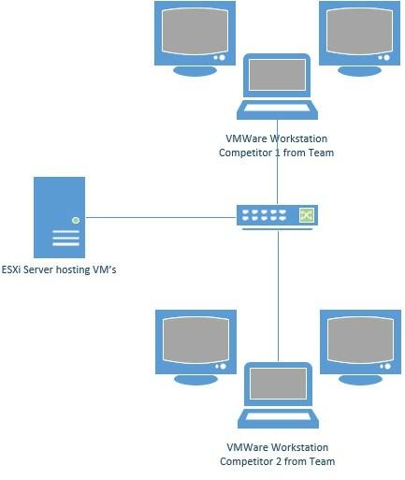
The physical topology of this project is as follows: competitors from each team will use VMWare Workstation to access VM’s hosted on a local ESXi server. All teams will have the same configuration and VM’s, but only have access to their own VM’s. As per the following diagram:

Logical Topology
The logical topology of the VM’s provided on the ESXi server is as follows with the following Network configuration:
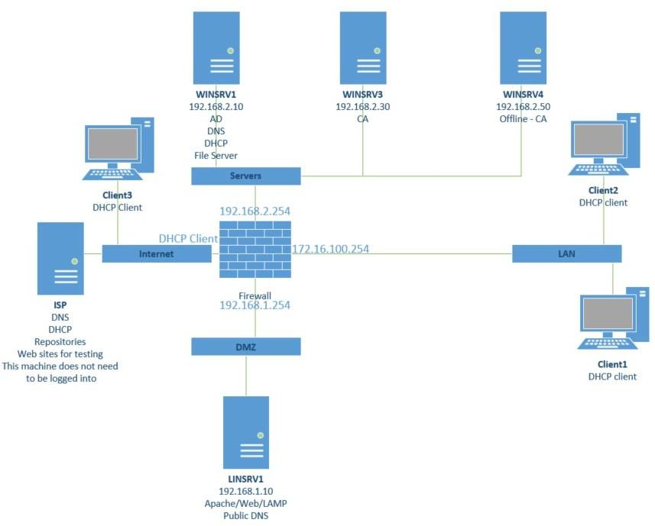
The VM’s should all be preset with the correct IP addresses, subnet masks, and gateways, but it is the Competitor’s responsibility to verify or identify any errors or discrepancy between the VM’s provided and this documentation, and to correct them if necessary.

Table 1. VM Finished Configuration Summary

VIRTUAL MACHINE | VLAN | IP ADDRESS | NOTES | CREDENTIALS
ISP | Internet |  | Offers DNS and website access to locally connected machines – serves as the “fake Internet” for connection testing. Competitors should not need access to this machine for any reason. | N/A
Client1 and Client2 | LAN | DHCP Client | Internal access and testing | Two machines have been provided to allow testing of different settings in the event competitors need to be testing different things at the same time.  Access via any existing Domain Users with a password of P@ssw0rd
Client3 | Internet | DHCP Client | For testing VPN and Websites in DMZ – can be moved to LAN if required but should be left as DHCP client on Internet VLan | Can use a domain account or local administrator or competitor account – both with a password of P@ssw0rd
WINSRV1 | SERVERS | 192.168.2.10/24 | DC for AD, DNS and DHCP for Internal Clients and servers | All Users in AD have a password of “P@ssw0rd” – do not modify the passwords unless required by the project
WINSRV3 | SERVERS | 192.168.2.30/24 | Issuing CA | CA servers have been installed, but you will need to finish the installation as per the project
WINSRV4 | SERVERS | 192.168.2.50/24 | Offline Root CA

VIRTUAL MACHINE | VLAN | IP ADDRESS | NOTES | CREDENTIALS
LINSRV1 | DMZ | 192.168.1.10/24 | Public facing DNS entries Website hosting | root/P@ssw0rd  competitor/P@ssw0rd  Access to be setup as per the project  All required software is pre-installed but may need to be configured
FIREWALL | Connected to all vLANS | 192.168.2.254  (Server)  DHCP Client (Internet)  192.168.1.254 (DMZ)  172.16.100.254 (LAN) | All traffic except that specified in the project is blocked. | Admin/pfsense

Description of project and tasks
Configure and test the settings for the following systems:

ISP
This machine is simulating the Internet. It is running a DHCP server which will service the WAN interface on the router and Client3, the external client. This machine will operate as the “upstream” DNS server and hosts two websites to test the Firewall configuration from Internal clients. The two websites are:

https://www.nationalmuseum.gov.ph https://www.starcity.com.ph
The purpose of these websites is for testing firewall configuration and have been created intentionally with a self-signed certificate.
Competitors will not need to logon to this machine, and do not have logon credentials for it. It needs simply to be on to provide DHCP/DNS/web services for testing.

Firewall configuration
The firewall is installed in its base configuration, with IP and interfaces connected to the proper subnets, and IP’s assigned no other configurations have been done. Default logon to PFSense is admin/pfsense.
It is important to functionally test firewall configuration from the machines on various networks to verify functionality and not rely strictly on configurations.
- Set admin user password to be “P@ssw0rd”
- Setup DHCP for LAN clients on PFSense – WinSRV1 should be the DNS Server
Block all traffic except as listed:

Table 1. Firewall settings

SOURCE NETWORK  LAN | DESTINATION NETWORK  Internet | PORTS/SERVICES ALLOWED  Outbound and return traffic to WAN allowed | NOTES
LAN | DMZ | Ssh, http, https, DNS allowed to LINSRV1
LAN | Servers | For AD TCP/UDP - 53,
 |  | 88, 135, 137-139, 389,
 |  | 443 445, 464, 636,
 |  | 3268-3269
 |  | For PKI: TCP – 9389
WAN | Inbound WAN traffic to website and DNS in DMZ allowed | http, https, DNS
Servers | As necessary for services
DMZ | Servers/AD | TCP/UDP - 53, 88, 135,  137-138, 389, 445,  464, 636, 3268-3269

In addition to traffic restrictions, implement the following on the firewall as well
- OpenVPN
  - Set up a VPN connection using OpenVPN where the client queries AD and uses a certificate produced by WinSRV3 as the CA cert. Packages have been pre-downloaded.
  - Members of the VPN Users group would be able to connect from WinClient3 to OpenVPN – can use a self signed certificate if you cannot get a CA signed certificate.
- Snort
  - Install SNORT as IDS – should log all traffic going out to the Internet. Package has been pre-downloaded
  - Attempts to access www.starcity.com.ph should be logged in Snort.
  - modify this custom rule in snort as appropriate and apply it to the WAN interface:

drop tcp any any <> a.b.c.d/24 and (flags: FPU; msg: “Possible XMAS scan”; sid: 100001)
  - This rule can be tested by initiating a port scan in nmap from Client3 Internet access:
- Set rules that will allow your Internal clients to access the www.nationalmuseum.gov.ph site on the Internet, but will block access to www.starcity.com.ph.

PKI
2 Tier PKI
WinSRV4 will be offline RootCA, this is already configured and powered off. You should not need to turn this on unless you wish to troubleshoot an issue, it is included for completeness and in industry would be completely powered off and removed from network access.
WinSRV3 will be the issuing CA.
This machine is already configured as the subordinate (issuing) CA for the domain. Complete the following tasks:
- Create a new Group Policy Object called “certenroll” so that computers on the domain will automatically receive a certificate from the issuing CA through application of the GPO. These GPO’s should be set to autoenroll.
- When an internal client browses to either of the following websites, it should not be prompted with a certificate error on connection, since the root-ca should be recognized as a trusted CA via policy.
  - Through autoenrollment, WinSRV3 should receive a certificate for the Web server in the IIS installation.
  - Also install a certificate onto the LINSRV1 for the Website there.

WINSRV1
Note – wireshark has been installed on this machine for troubleshooting purposes.
- Create a password policy that requires all domain user’s passwords to be 8 characters in length, must be changed monthly
- Create a fine-grained password policy that requires members of the executive group to have a 10 character long password
- Create a login banner/title that says “WorldSkills ASEAN Manila”
- Create a login banner/text that says “authorized access only”
- Create a GPO called “control” that will restrict access to the control panel – which is only applicable to accounting users
- Create a GPO called “registry” that will prevent access to registry editing tools – only applicable to users in Manila.
- Import chrome policy – in the documents folder of the domain administrator account is the googleChromeEnterpriseBundle64. Extract the contents of this file, create a GPO called “google” and use the admx files to create a policy that will force all users to use the company website at http://w3.manila.com as the default home page.
- The client would like you to recommend three other GPO’s which should be created to help better secure the domain. Fill in table 2 in the appendix describing what the effect is of the GPO’s you have chosen, and why you chose these GPO settings over other possible GPO settings. This document should be saved on the desktop of the competitor computer and be sure when finishing that experts are able to find/collect the file.
- Create a share on WinSRV1 following best practices at the local path C:\shares\pictures shared as “pictures” that will allow the Read access to the customer service group, Modify (RW) for members of the Graphics group, FC for IT, no access for anyone else.
- In the C:\shares\picture folder, you will find a picture called “manila.jpg”, set auditing on this file so it is logged when read by a member of any group.

LINSRV1
- Join LinSRV1 to manila.com domain.
- All other domain machines should be able to resolve the name to the IP address of LINSRV1.
- access allowed for domain users C1 and C2 via ssh
If you cannot join LinSRV1 to the manila.com domain and cannot use the C1 and C2 domain user accounts, create matching local C1 and C2 accounts so any further assessments can be completed. Allow the C1 and C2 (either domain or local) users to have administrative rights through sudo.
  - Both C1 and C2 users should be able to use all root level administrative commands through the use of the sudo commands.
  - Other users which connect will not have elevated sudo privileges.
- Local firewall setup
  - Firewall should be running
  - Services for required operation permanently added to the firewall to be operational after a reboot
- Ssh configurations
  - Have ssh listen on port #2022
  - Root not allowed to connect via ssh
  - Only C1 and C2 users can connect via ssh
- Set the passwords for any locally created Linux users to match that in the domain
  - 10 characters in length
  - Password changed every month
  - Minimum password length of 25 days
  - Warn a user their password will expire after 25 days
  - Password must have lower case, upper case, numerical digit and symbol.
httpd is installed on the server and is set up to host the http:// website contained in /var/www/manila. This website should be available to both domain users in the LAN network, and from remote clients on the Internet.
- Set this site up to use https:// preferably using a certificate signed by WinSRV3, but if you cannot get this to work, use a self-signed certificate.
- enable SELinux but make certain the htttpd service is still fully operational.

LAN clients
Note – wireshark and putty have been installed on these machines for troubleshooting purposes.
- Use these machines to functionally verify requirements specified in other sections

WinClient3
Note - Nmap is installed if you wish to initiate a port scan on the firewall.
- Remote access to network via VPN
- Test website and DNS access for DMZ

Instructions to the Competitor
All existing user accounts have a password of P@ssw0rd including the root and administrator accounts.
We know that this is a weak password to use and have done this for ease of use and assessment at the competition and should not be considered a vulnerability. Please do not change or reset the passwords unless directed by the project as experts will be unable to login and assess your configurations.
All server VM’s have statically configured IP addresses. You are responsible verifying if these are set correctly in the case that a setting on a virtual machine is different from this document.
This document will be provided digitally on the competitor workstation.
combine the answer documents to a single file for submission. When you signal to experts that you are done it will be collected.

Table 2. GPO Policy Recommendations

NAME OF POLICY TO BE INCLUDED IN GPO RECOMMENDED | PATH TO SETTING IN POLICY | EFFECTS OF APPLYING THIS GPO | WHY DID YOU SELECT THIS GPO OVER OTHER POSSIBLE CHOICES?

