1. HASH_Calculator: https://www.pelock.com/products/hash-calculator
2. Anleitung: https://www.pycryptodome.org/src/signature/dsa
3. cmd

C:\Users\U2O8NH0>python -m pip install pycryptodome

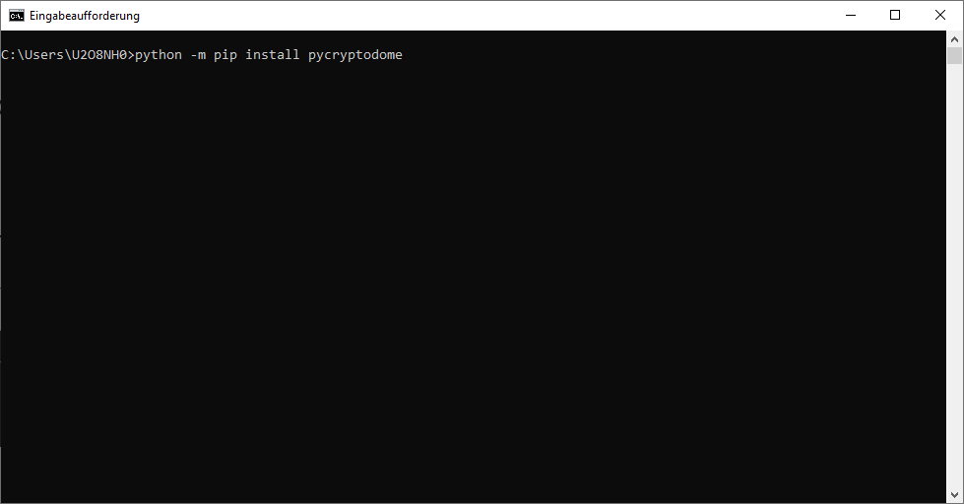

Ausschalten der CITRIX.

1. P8 Schlüssel

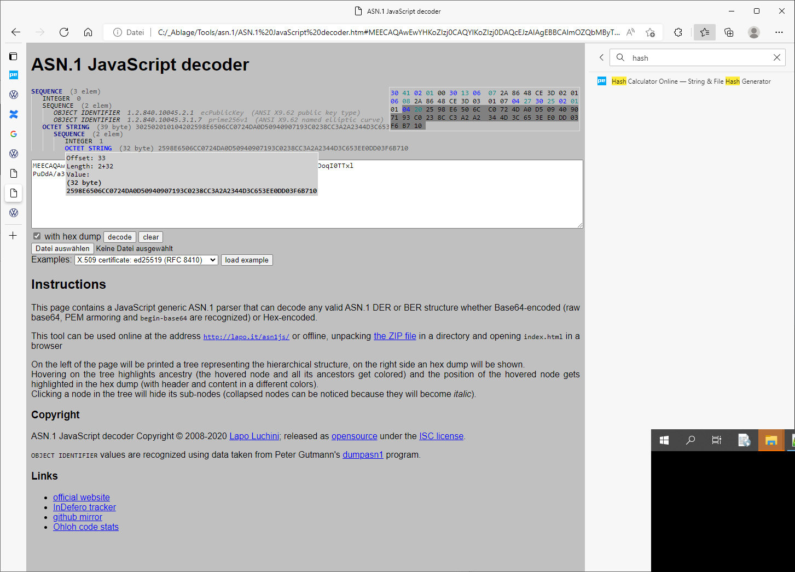

1. CERTIFIKATE:  
   