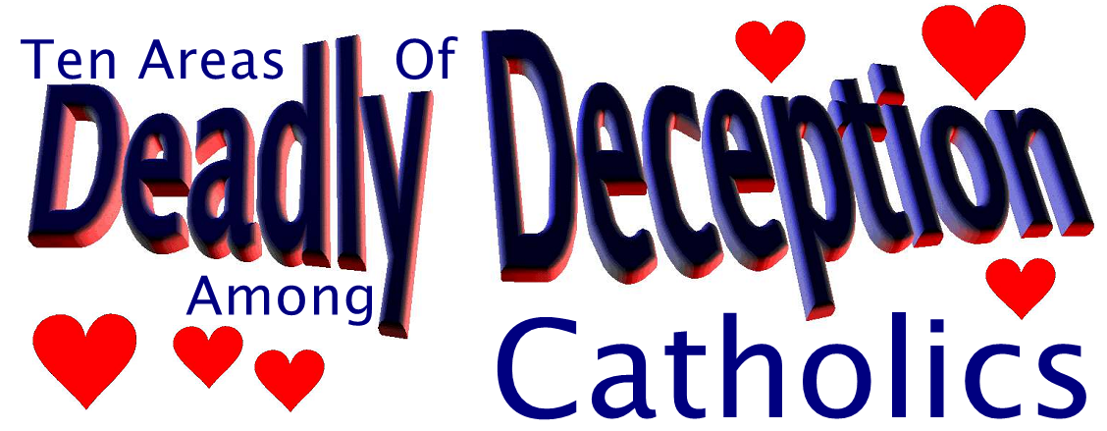
Ten Areas of Deadly Deception Among Catholics
IF you are acquainted with the teachings of Roman Catholicism and the message of the Bible, you are aware of the irreconcilable differences between the two. Some of the areas are lesser in significance and will not be cited here. On the other hand, some are clearly related to salvation. It is important, especially for Catholics, to know about the most serious false teachings they have been taught so they can make the vital needed changes and find the only salvation the Bible offers.
Below are the most dangerous false doctrines believed by millions of Roman Catholics, past and present:
Roman Catholics are dangerously taught they were born again at infant baptism.
♥
This single concept alone has been responsible for hundreds of millions of Catholics going to hell over the centuries. Folks, if you think you already have what is needed to enter God’s kingdom, you won’t be trying to find it. In their minds, Catholics got this when they were babies, without repentance and faith in Jesus.
The truth is, one gets Biblically born again only when he turns away from his sins and places his faith in the Lord Jesus to the point of dedication and commitment. The concept of infant baptism is not found anywhere in the Bible.
Roman Catholics dangerously think they receive Christ when they partake of the communion wafer.
♥
This false and deadly concept is the result of the bogus idea that the communion elements (bread and wine) have been transubstantiated by the priest into the literal body, blood, soul and divinity of Jesus Christ. This has also led people into the worship of the consecrated communion wafer as one would worship God himself. Hence, the fruit of this false doctrine is also idolatry, a soul-damning sin.
The truth is: one receives Christ when he believes on his name (John 1:12). This is another way of saying when one turns from his idols to serve the true and living God (1 Thess. 1:9). (No one receives Christ in his mouth, then swallows him to be digested.)
Roman Catholics wrongly think their church system was founded by Jesus on Peter the first pope.
♥
The superiority the Roman Catholic Church claims for itself comes from this fallacious concept, which has led people into increasing error especially as Catholicism has drifted further and further into darkness over the centuries. Most Catholics are not aware of the doctrines that were added over the centuries or that certain popes were denounced as heretics by other popes. The whole idea of a papacy itself is unscriptural.
After Jesus spoke Mt. 16:18, Peter was not recognized as the chief Apostle among the Twelve. Mk. 8:29 is the parallel account to Mt. 16:18. Less than one full chapter later, the disciples were arguing which of them was the greatest (Mk. 9:34). Hence, they didn’t understand Peter to be the chief. See also Acts 15 where Peter did not preside over the Jerusalem church council.
Catholics think Mary is their life, sweetness and hope and proclaim her as such when they recite the Rosary, which they say is the epitome of the whole gospel.
♥
The idea that Mary could possibly be our life, sweetness and hope is impossible, according to the pages of the New Testament. Catholicism has erected a false Mary, which has a primary role in people’s salvation. Such has misled many sincere people.
The truth is: Mary plays absolutely no role in our salvation. For one to become Biblically saved, he will have to place all 100% of his faith (a submissive faith) in the Lord Jesus or he will be damned. This means you cannot trust in being a Catholic, the sacraments and/or Mary along with the Lord Jesus. You must trust in Jesus alone (100%). That implies a turning away from your sins.
Catholics think if they die wearing the brown scapular they will not suffer the fires of hell.
♥
Such a teaching is so strange that it is hard to believe anyone would accept it, but this is what Catholics have been taught. Such a teaching also reflects the spiritual inabilities and darkness of their hierarchy (papacy) for allowing this dangerous concept to be taught as truth.
Catholics think the sacraments are a means of them receiving grace needed for salvation.
♥
Because Catholics have been taught this way, they are trusting in the sacraments for salvation instead of the Lord Jesus as the Bible declares. Such a false teaching has also placed the Catholic in the mind set of thinking he must remain in the Catholic system to go to Penance and get communion (Holy Eucharist), which they also think should be worshiped as God.
Catholics confess their sins to a priest instead of to God.
♥
This false concept goes back again to the false authority the papacy (and its priesthood) claims for itself. The Bible speaks of a royal priesthood for all believers (1 Pet. 2:9). There is no unique priesthood with the ability to forgive sins.
We can go directly to God, without a priest or Mary and get forgiven, if we go in repentance, sincerity and humility (Luke 18:13,14).
Catholics who read and believe the Fatima Visions are dangerously thinking that Mary is our refuge and the way that will lead us to God.
♥
There is no way to calculate how many sincere people have been misled by Roman Catholic Marian visions, which they have endorsed as being from God. Of all of these, perhaps the most misleading are the Fatima, Portugal visions, which would have one look to Mary for his refuge and the way to God. Such an error is a sure way to miss God’s paradise kingdom and end up in hell. God is our refuge and Jesus is the only way to God (Psa. 16:1; John 14:6; etc.).
Many Catholics are just hoping to enter Purgatory and there get purged of their sins to afterwards get to Heaven.
♥
Because the Catholic Church teaches the purging of sins after physical death in the fires of Purgatory, many Catholics are only hoping to get there and afterwards make their way to heaven. Folks, there is no such place as Purgatory. We can only get cleansed from our sins by contacting the blood of Jesus when we repent and have faith. After getting born again, we must forgive others who sin against us (Mt. 6:14,15) and confess the sins to God (1 John 1:9).
Catholics have been lethally misinformed about how to show their love for the Lord Jesus.
♥
Catholics think they show their love for Jesus by bowing before an image (they think is of him) and kissing that image.
The truth is: we show our love for Jesus by obeying his commands (John 14:15), and bowing before images is disobedience and idolatry (Exodus 20:4-6).
For any person, Catholic or non-Catholic, to find the vital truths about salvation, as found in the Bible, it will take a sincere heart-felt effort from a heart which loves God’s truth regardless what it says.
The clear message of salvation as found in the Bible centers around Jesus Christ. We must have a faith that will loyally following him until death for our salvation. (There is no once saved always saved.)
[Please make copies of this article and pass them on to your Catholic friends and family. Their souls are in the greatest danger because of these false teachings.] GOD BLESS YOU.
EOMin.Org
Evangelical Outreach
PO Box 265, Washington, PA 15301

