
Writing Report
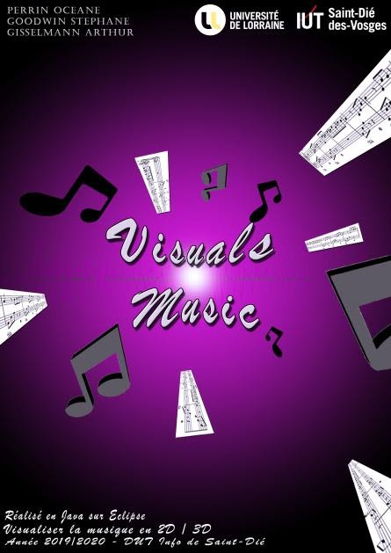
Perrin Océane
Gisselmann Arthur
Goodwin Stéphane
Years 2019-2020

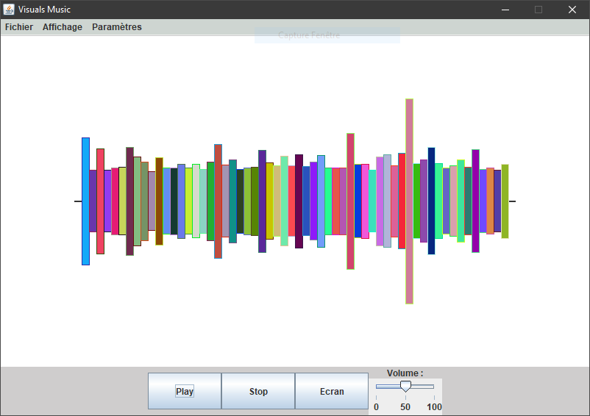
Summary
What did we have to do? 3
What did we do? 3
How did we do it ? 4
What did we use ? 5
What will we remember? 6
About us 6
About the project 6

What did we have to do?
The three of us had to develop an application for our PT3, entitled visualization of music that Ms. Boltcheva suggests. Therefore, Ms. Boltcheva is our tutor. She helped and guided us a lot thought our project. The purpose was to generate shapes in 2D and 3D while a music was played. For doing so, we had to developed a Java application using different software like: Eclipse, GitHub or also Discord. We started to develop the application in November, starting to create the early interface. We had about four mouths to familiarized with the subject, the programming language and complete this project. We, finally, decided to name our project “Visuals Music”.
We aim to entertain a young public (about 16-24) because the youngest are more prone to listen music and even more to listen it on their mobile phones. Of course, all can use the application because our graphic user interface is intuitive.
When our application will be complete, we will try to convert it for mobile use (smartphone) because usually Visuals Music is devoted to PC.

What did we do?
We have developed an application which permit to watch music. For doing so, we had to create 2D and 3D Visualizers and put them into a graphical interface.
Also, our application implements the general functionalities of a music player, which are:
- Play Button
- Pause Button
- Stop Button
- File Finder for open a file into the computer
Finally, we want to make more features, as:
- Next Button
- Previous Button
- Random Button
- Loop Button
- Volume Slider
- Progression Slider
Before starting programming, we had to define a framework to specify which elements will or will not belong to our project. As a conclusion, our application will not be published into a platform as App Store, Play Store or even Microsoft Store, it will not be linked within the Internet and it will be free of charge.
We also had constraints as lots of coming deadlines, unknown programming environment, agile methods which we had to apply. Indeed, agile approach was a constraint because we never apply it and we just learned them two weeks before the project started.
For the agile method, we choose to multiply three two-weeks sprints with one week to present our advancement to Ms. Boltcheva. Doing so we had be able to determine our next objectives. Unfortunately, Ms. Boltcheva was not always in Saint-Dié-des-Vosges when we had to present our project to her, so we made some videos available on:
https://www.youtube.com/playlist?list=PLUav5QNakljAY9G2W74ax9nhDw7ve02k4

How did we do it?
At the beginning we did a meeting between us for impose some rules (code commentary, good use of GitHub, no magical number in our application, …), do the provisional schedule and the UML diagram.
The preliminary studies began and was composed by:
- Needs analysis Océane
- Analysis of what currently exists Stéphane, Arthur
- Benchmarking Stéphane
- Preliminary schedule Stéphane
- Specifications Stéphane
- Guide interviews Stéphane, Océane, Arthur
- Interviews Stéphane, Océane, Arthur
- Slideshow Stéphane, Océane, Arthur
- UML diagrams Stéphane, Océane
At the first sprint, we were already late, so we made the programming, supposed to last two weeks, and the presentation to our tutor in the same week. We started to create the graphic user interface and to think about how read a music file. Because we could not find a way to did it, we asked our tutor how we could. We implemented a button Pause and a button Play. We cannot read something else than .wav files yet. After, the graphic user interface created, we presented our project to Ms. Bolcheva, sprint “one” was finished. After sprint “one”, we bound Pause and Play buttons to make one, and created a Stop button. Also we wrote the Javadoc (legit commentaries in Java) at the same time that we programmed. Stéphane did that that part.
During the second sprint, we made a backlog for prioritize all the tasks we had to do. Happily, we were on schedule. Arthur did the poster that was asked in Communication classes. And all together we started to write this report. For the IT part, we had to add a condition because the Stop button was not working. We asked help to Ms. Bolcheva to calculate a Fast Fourier Transformation (FFT) that we did not understand. We had to use a FFT to convert bytes into frequency. With the frequency we could displayed the music visualizers. As we implemented the 2D visualizer, we displayed it, but, sadly, we had a display issue. The display moved from right to left and the drawing repeated themselves. To resolve this issue, we had to draw over all the drawing a big white rectangle for clearing the screen. The first Stop button had a problem when we double clicked on it, we added a condition to have not this problem again. We asked help to our tutor to know how could we draw 3D rectangles. Sprint “two” was finished. Stéphane did also this part. Here again Stéphane wrote the Javadoc at the same time that he programmed.
For the third and last sprint, we were on schedule although we did not finished our project. Stéphane made the 3D Visualizer using JOGL, a Java library which extends GOGL, a C library which allow 3D shape drawing. He also made a Settings window allowing the users to change color, size, number of shapes on the screen. Océane programmed shortcuts for the keyboard (Space for pause/unpause, Echap for quit the application, …). As it is for the Javadoc, Stéphane and Océane wrote it alongside they programmed. As the third sprint ended, Océane and Stéphane started the final report and the slideshow needed for the presentation on the 14th January and Stéphane also wrote the English slideshow.

What did we use?
We use technical tools to carry out our project as Discord, Google Drive, GitHub or Eclipse – Java.
Discord is an application which permit to chat with people online. We can use it to chat, share image or even small files. We used it to gather information that we could split it in different specifics channels. This was organized in groups such as “archivé” (archived) or also “temporaire” (temporary).
Google Drive is a platform where the users can share data and work all together at the same time on a same file. We used Google Drive to the shared files that we can write and read simultaneously. We used Google Drive to work on project text part like this report, or the preliminary study. Like that we were able to work all on a different part on every writing file and to do the job quicker.
GitHub is similar than Google Drive but more programmer-focused. Indeed, there is a version control system that permit, if we do something wrong, to go back at a version which was working. It was a useful tool, because we could work on different version and finally merged them avoiding a lot of problems.
Eclipse – Java is an Integrated Development Environment (IDE). An IDE is a tool for programmer. With that we were able to program with a text editor, to compile with a compiler and to test our application, debugging the program doing so.

What will we remember?

About us
The working atmosphere between us was great although we did have a lack of commitment at first. One of our greatest asset was our communication. Indeed, we fantastically used all our communication tools, doing so we were able to pass information rapidly and effectively.

About the project
First we apply specific methods as agile approach or even file-sharing software (Git) that brought us achievements. Also, we had a lot of deadlines due to agile methods. Because of that, we learned a lot more of project management.
If we had to it again:
- We would make a backlog earlier
- We would be more invested

