A D S R A
Australian Digital Sovereignty Reference Architecture
Technical Reference for Engineering, Architecture, Security and Risk Teams
Version 0.1 — First Draft for Peer Review
Author: Duane · July 2026
Status: DRAFT — not for distribution beyond the review group

Document Control
Item | Detail
Title | ADSRA — Australian Digital Sovereignty Reference Architecture: Technical Reference
Version | 0.1 (first draft for peer review)
Author | Duane
Date | July 2026
Audience | Enterprise, solution and security architects; platform, cloud and AI engineering; risk and compliance partners
Companion artefacts | ADSRA Executive Briefing (PowerPoint); ADSRA White Paper and article series
Review status | Open items and peer-review questions are listed in Section 14

Draft integrity statement. Every regulatory claim in this document is anchored to a primary source in Section 13 (References) and traced in Section 12 (Evidence Register). Where a position is the author's professional judgement rather than a regulatory requirement, it is explicitly marked [Position]. Reviewers are asked to challenge both.

Contents

1. Introduction and Purpose
ADSRA is a reference architecture that enables Australian organisations to leverage global cloud and AI platforms while maintaining sovereignty over data, identity, cryptography, operations and AI, in accordance with Australian regulatory and business obligations. It treats digital sovereignty as a first-class enterprise architecture domain — with named capabilities, control objectives, reference patterns, a maturity model and operational metrics — rather than as a compliance afterthought.

1.1 Why this document exists
Existing frameworks each solve part of the problem: TOGAF provides architecture method; SABSA provides business-attribute-driven security architecture; the cloud providers' well-architected frameworks provide workload guidance; and the ASD Information Security Manual (ISM) provides a controls catalogue. None of them treats jurisdictional control — who can compel, administer, decrypt, observe or infer over an enterprise's digital estate — as an architectural domain in its own right. ADSRA fills that gap for Australian and Asia-Pacific regulated enterprises. [Position]

1.2 Audience and how to use this document
- Enterprise and solution architects: use Sections 4–8 as the target-state reference and Section 9 for capability planning.
- Platform, cloud, data and AI engineers: use the control objectives (ADSRA-XX-nn) and technology mappings in Section 6 as build requirements.
- Security, risk and compliance partners: use Section 3 (obligation matrix), Section 11 (KRIs) and Section 12 (evidence register).
- Architecture boards and design authorities: use the maturity model (Section 10) and the roadmap guidance (Section 11.3) to sequence investment.

1.3 Scope and non-goals
In scope: public cloud (AWS, Azure, Google Cloud), private cloud, SaaS, enterprise data and integration platforms, and AI systems (predictive and generative, including agentic patterns). Out of scope: national-security-classified systems (SECRET and above), defence-specific supply-chain regimes (e.g., DISP), and physical/personnel security beyond what SOCI CIRMP requires of the covered sectors.
Relationship to method frameworks. ADSRA is method-neutral. In TOGAF terms it supplies reference models and building blocks consumable in Phases B–D and governance in Phase G/H; in SABSA terms its pillars express as business attributes with traceable control objectives.

2. Definitions and Sovereignty Tiers

2.1 Working definitions
Term | Definition (as used in ADSRA)
Digital sovereignty | The demonstrable ability of an organisation to control who can access, administer, decrypt, observe, move or infer over its digital assets — and under which legal jurisdiction those actions occur.
Data residency | The physical/geographic location where data is stored and processed. Residency is necessary but not sufficient for sovereignty: jurisdiction follows the controlling entity, not only the data centre.
Jurisdictional exposure | The set of foreign legal instruments (e.g., the US CLOUD Act) that could compel a provider in the enterprise's supply chain to produce data or take action, irrespective of storage location.
Operational sovereignty | Control over who administers production systems, from which country, with what privilege, and with what evidence trail.
AI sovereignty | Control over where and how prompts, embeddings, retrieval corpora, inference, training/fine-tuning and model telemetry are processed, and by whom.
Sovereignty tier | A classification level (Low / Medium / High / Critical) that determines the mandatory control set a workload or data asset inherits.

2.2 Sovereignty tiers
Classification is the engine of ADSRA: it prices controls so that low-risk assets are not taxed with Critical-tier costs, and Critical assets are never under-protected.
Tier | Typical assets | Mandatory control posture (summary)
★ Low | Public content, product catalogues, marketing assets | Any region; provider-managed encryption; standard logging
★★ Medium | Pricing, commercial documents, non-identifying analytics | AU-region preferred; CMK optional; DLP monitoring
★★★ High | Customer profiles, loyalty behaviour, staff records | AU residency; customer-managed keys; tokenised identifiers; PIA; conditional access
★★★★ Critical | Payment credentials, health records, credentials/keys, regulated ledgers | AU residency and AU operations; HSM-backed CMK or HYOK; client-side encryption where feasible; privileged session recording; AU SOC; tested exit plan
Calibration guidance. Tier assignment should be justified against the obligation matrix in Section 3 and reviewed annually. Over-classification is a named anti-pattern (Section 11.4): it erodes delivery velocity and the credibility of the scheme.

3. Australian Regulatory Obligation Matrix
The matrix below maps the principal instruments to the ADSRA pillars they exercise. Dates are as at July 2026; verify currency before relying on this table for compliance decisions. Full citations appear in Section 13.
Instrument | Key obligations relevant to ADSRA | Key dates | Primary pillars
APRA CPS 230 Operational Risk Management [R1] | Identify critical operations and Board-approved tolerance levels; manage material service providers (MSPs) incl. fourth parties; notify APRA within 24 hours of a disruption to a critical operation outside tolerance, and within 72 hours of a material operational risk incident; maintain tested BCP and exit plans | In force 1 Jul 2025; pre-existing MSP contracts by earlier of renewal or 1 Jul 2026; targeted amendments Apr 2026 | Operations, Governance, Observability, Data
APRA CPS 234 Information Security [R2] | Board-accountable information security capability commensurate with threats; control assurance across third parties; 72-hour incident notification to APRA | In force since 1 Jul 2019 | Identity, Crypto, Operations, Observability
Privacy Act 1988 (Cth), as amended 2024 [R3, R4] | APPs incl. cross-border disclosure (APP 8); statutory tort for serious invasions of privacy; tiered civil penalties (up to the greater of $50m, 3× benefit, or 30% of adjusted turnover for serious interferences, per the 2022 amendment); automated-decision transparency in privacy policies (new APP 1.7–1.9) | 2024 Act assent 10 Dec 2024; tort live by Jun 2025; ADM transparency from 10 Dec 2026 | Data, AI, Governance
SOCI Act 2018 (Cth) + CIRMP Rules [R5] | Critical Infrastructure Risk Management Program across cyber, personnel, supply-chain and physical hazards; asset register; mandatory cyber incident reporting; enhanced obligations for Systems of National Significance. Covers 11 sectors incl. financial services, healthcare, energy, data storage/processing | CIRMP obligations phased from 2023 | Operations, Governance, Observability, Identity
ASD ISM & Essential Eight [R6] | Baseline control catalogue and maturity model for cyber hardening; IRAP assessments provide independent control assurance for cloud services against the ISM | ISM updated regularly (quarterly cadence) | All pillars (control baseline)
Hosting Certification Framework (DTA/Home Affairs) [R7] | Certified Strategic / Certified Assured tiers over ownership, control, operations and supply chain of hosting providers; required for sensitive government data and PROTECTED systems (applies to new contracts from 30 Jun 2022). Instructive for private-sector provider due diligence | Framework released Mar 2021 | Operations, Governance
My Health Records Act 2012 (Cth) [R8] | My Health Record system data must be held and processed in Australia; prohibitions on taking the data outside Australia | In force (2012) | Data, Operations, AI
US CLOUD Act 2018 [R9] | US authorities may compel providers subject to US jurisdiction to produce data in their possession, custody or control, regardless of storage location — the canonical reason residency ≠ sovereignty | In force (2018) | Data, Crypto
AI policy: Guidance for AI Adoption (Oct 2025), National AI Plan (Dec 2025) [R10] | Voluntary AI Safety Standard (2024) superseded by the Guidance for AI Adoption (six essential practices); National AI Plan relies on existing technology-neutral law plus an AI Safety Institute from 2026; earlier mandatory-guardrail proposals paused. High-risk AI expectations remain the design signal | GfAA Oct 2025; Plan Dec 2025; AISI 2026 | AI, Governance, Observability

Reading the matrix. No single instrument requires 'sovereignty' by name. The architecture obligation emerges from their intersection: CPS 230 makes provider dependency a Board matter; the Privacy Act prices data mishandling; SOCI extends hazard management beyond cyber; the CLOUD Act makes jurisdiction a design variable; and the AI instruments make evidence of control the price of AI adoption. [Position]

4. The ADSRA Layered Model
ADSRA deliberately does not start with technology. It starts with control domains, placing the sovereignty layer between the enterprise's obligations and its platforms, so that every workload inherits sovereignty controls rather than negotiating them individually.
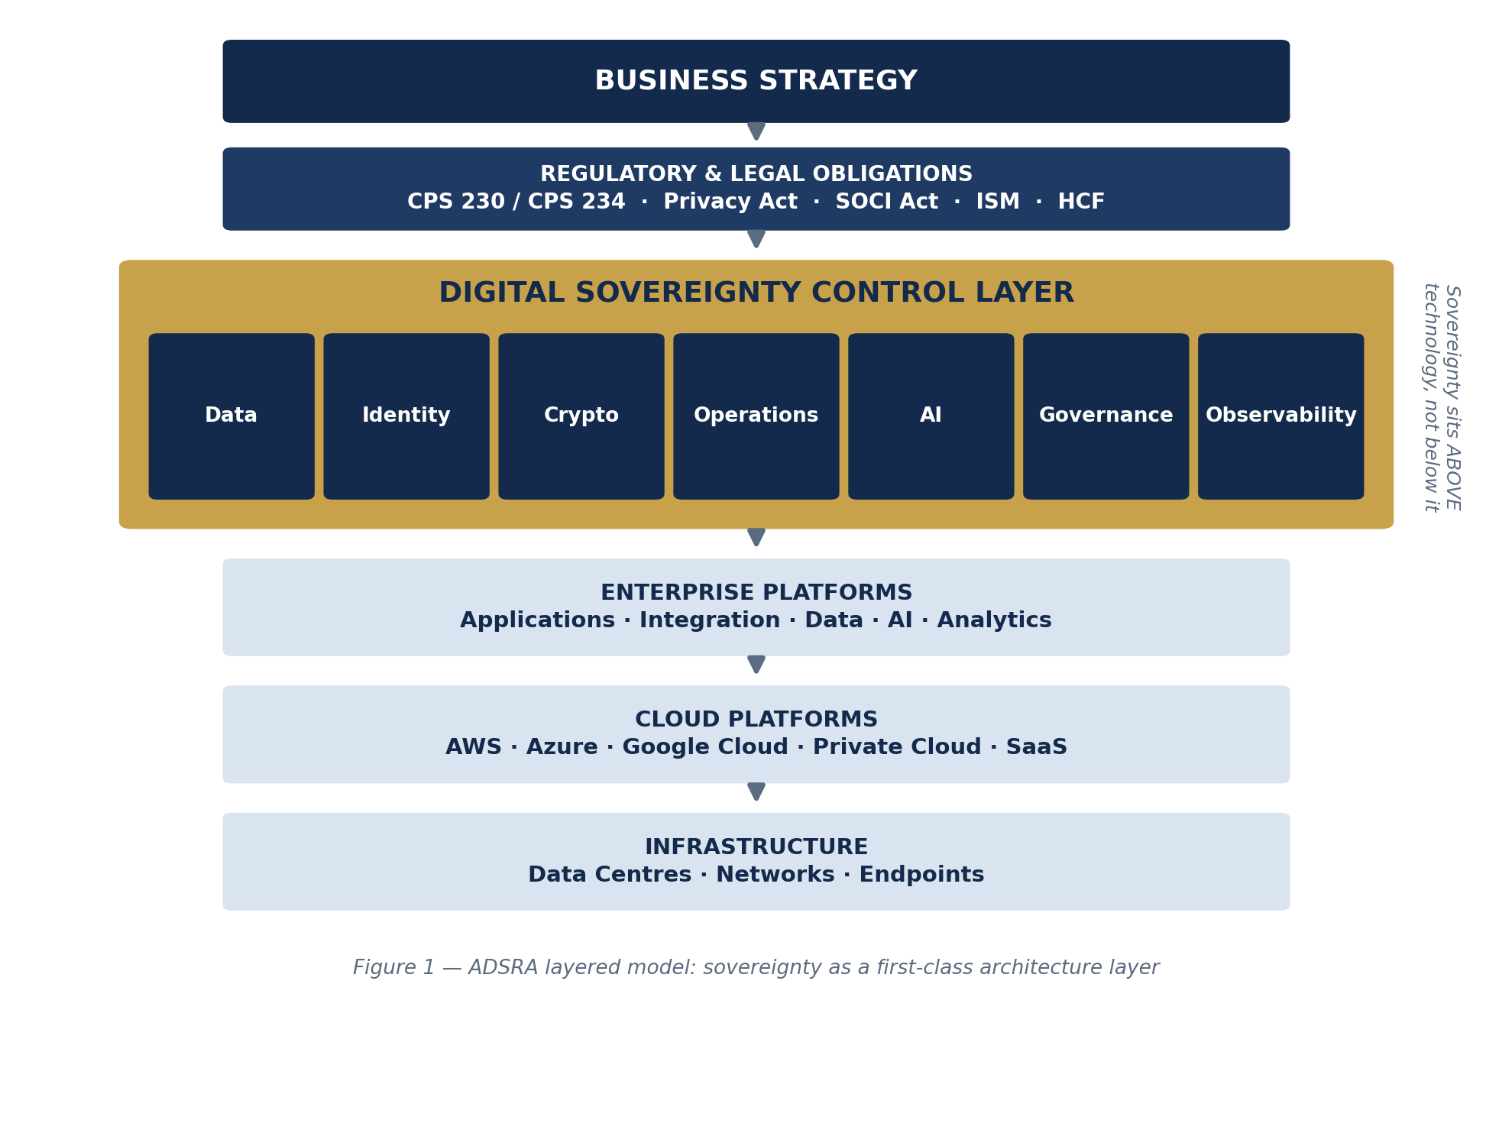
Figure 1 — The ADSRA layered model: sovereignty above technology, not below it.

4.1 Design principles
- Sovereignty above technology: controls are defined against obligations and classifications, then bound to platforms — never the reverse.
- Inheritance by default: workloads inherit the control set of their tier via landing zones, policy-as-code and shared services; exceptions are explicit, time-boxed and risk-accepted.
- Evidence or it didn't happen: every control emits telemetry to the observability pillar; a control without evidence is treated as absent.
- Price the premium: sovereign controls carry cost and capability trade-offs; classification exists to spend that premium only where obligations demand it.
- Method-neutral: ADSRA plugs into TOGAF/SABSA practice and coexists with cloud well-architected reviews.

5. Cross-Cutting Runtime Architecture
Every workload should traverse common enterprise services. The runtime path below is the reference: identity fronts everything, policy is evaluated centrally, data controls and encryption sit behind the application, and every layer emits sovereignty evidence.
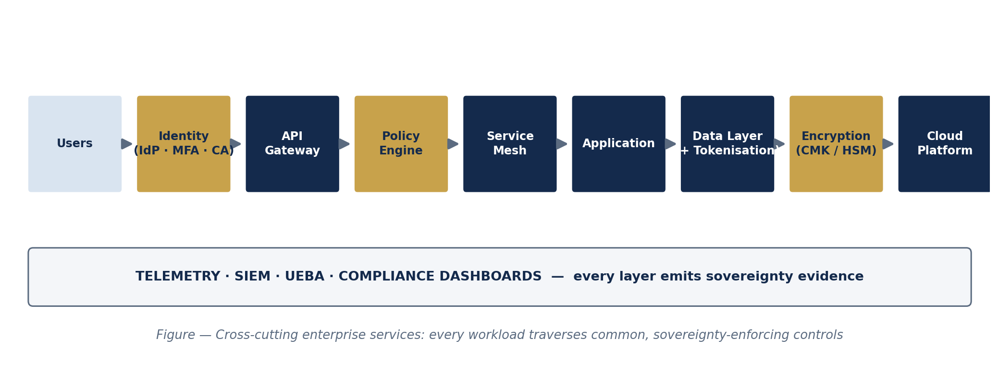
Figure 2 — Cross-cutting enterprise services: the reference runtime path every workload traverses.

5.1 Shared service obligations
Shared service | Sovereignty function | Owned by
Enterprise IdP + Conditional Access | Authenticates and risk-scores every request; enforces AU-only administration policies for Critical tier | Identity platform team
API Gateway | Terminates external trust; enforces schema, quota and data-classification headers | Integration platform team
Policy Engine (PDP) | Central authorisation decisions (e.g., OPA/Cedar-style); jurisdiction- and tier-aware | Platform engineering
Service Mesh | mTLS, workload identity, egress control (blocks unsanctioned cross-region calls) | Platform engineering
Tokenisation & DLP services | Substitutes high-value identifiers; detects and blocks exfiltration | Data platform / security engineering
Key Management (KMS/HSM) | CMK/BYOK/HYOK per tier; rotation; crypto-agility | Security engineering
Telemetry & SIEM | Collects control evidence; UEBA over privileged activity; feeds compliance dashboards | Security operations

6. The Seven Sovereignty Pillars
Each pillar is specified as: the question it answers, control objectives with stable identifiers (ADSRA-XX-nn), a reference pattern, indicative technology mappings, and the KRIs that evidence it. Technology mappings are indicative examples current at the time of writing, not endorsements; validate service capabilities and regions before design commitment.
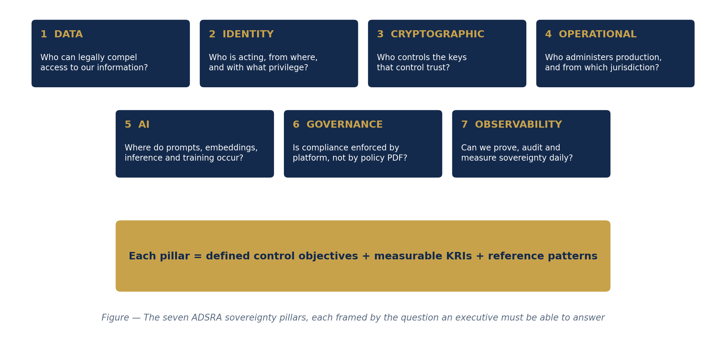
Figure 3 — The seven ADSRA pillars and the executive question each answers.

6.1 Pillar 1 — Data Sovereignty
Key question: Who can legally compel access to our information?

Control objectives
ID | Control objective
ADSRA-DS-01 | All data assets carry a sovereignty tier (Section 2.2) recorded in the enterprise data catalogue, with a named information owner.
ADSRA-DS-02 | High/Critical data is stored and processed in Australian regions; any cross-border transfer is assessed against APP 8 and recorded with a lawful basis.
ADSRA-DS-03 | Critical identifiers (payment credentials, health identifiers) are tokenised at the boundary; raw values never enter analytical or AI estates.
ADSRA-DS-04 | DLP policies enforce tier-appropriate egress controls across email, endpoints, SaaS and cloud storage.
ADSRA-DS-05 | Privacy Impact Assessments are embedded in the delivery lifecycle for High/Critical changes, including AI use cases.
ADSRA-DS-06 | Data lifecycle (retention, minimisation, deletion) is automated and evidenced per tier.

Reference pattern
Classification-driven landing zones: the data catalogue is the source of truth for tier; infrastructure-as-code consumes tier tags to bind residency, encryption and DLP policy at provision time. A retailer, for example, runs its product catalogue globally on a CDN (Low) while customer profiles and loyalty behaviour (High) are pinned to Australian regions with customer-managed keys, and payment credentials (Critical) are tokenised with HSM-backed keys.

Indicative technology mapping
Capability | AWS | Azure / M365 | Google Cloud / other
Classification & catalogue | Glue Data Catalog + Lake Formation tags | Microsoft Purview (labels, catalogue) | Dataplex / Data Catalog
Residency enforcement | SCPs + Region deny-lists | Azure Policy allowed-locations | Org Policy resource locations
Tokenisation | Payment Cryptography / partner vaults | Purview + partner tokenisation | DLP tokenisation, partner vaults
DLP | Macie + endpoint/CASB | Purview DLP + Defender for Cloud Apps | Cloud DLP + CASB

Key risk indicators
- % of data assets with an assigned tier and owner (target: 100% of High/Critical)
- Count of unassessed cross-border transfers detected per quarter (target: 0)
- % of Critical identifiers tokenised at boundary (target: 100%)
Industry note. Healthcare: My Health Record information must be held and processed in Australia [R8] — treat connected estates as Critical by default. Retail: loyalty behavioural data is High, not Medium; it is the primary tort exposure after payment data. [Position]

6.2 Pillar 2 — Identity Sovereignty
Key question: Who is acting, from where, and with what privilege?

Control objectives
ID | Control objective
ADSRA-ID-01 | A single enterprise IdP (Australian-controlled tenancy) fronts all workforce and workload identity; federation is governed and inventoried.
ADSRA-ID-02 | Phishing-resistant MFA for all users; conditional access evaluates user, device, location, and risk score on every request (Zero Trust).
ADSRA-ID-03 | Standing privilege is eliminated for Critical systems: just-in-time elevation via PIM/PAM with approval and session recording.
ADSRA-ID-04 | Identity governance: automated joiner/mover/leaver, quarterly access recertification for High/Critical scopes.
ADSRA-ID-05 | Workload identities (service principals, SPIFFE-style) are inventoried, short-lived and least-privileged.

Reference pattern
Every request answers: who, what, why, when, from where, at what risk score — replacing the legacy notion of a trusted network. For Critical-tier administration, conditional access additionally enforces jurisdiction (Australian location and managed device) before elevation is granted.

Indicative technology mapping
Capability | AWS | Azure / M365 | Google Cloud / other
Enterprise IdP / CA | IAM Identity Center (+ external IdP) | Entra ID + Conditional Access | Cloud Identity + Context-Aware Access
Privileged access | IAM + partner PAM | Entra PIM + partner PAM | PAM partners
Identity governance | Partner IGA | Entra ID Governance | Partner IGA
Session recording | Systems Manager Session Manager | Azure Bastion + partner | IAP + partner

Key risk indicators
- % privileged elevations that are just-in-time (target: 100% for Critical)
- % privileged sessions on Critical systems recorded (target: 100%)
- Mean age of unreviewed High/Critical entitlements (target: < 90 days)
Industry note. Banking: SOCI and CPS 234 both anticipate MFA, least privilege and monitoring of privileged activity; identity KRIs translate directly into CPS 234 control-assurance evidence.

6.3 Pillar 3 — Cryptographic Sovereignty
Key question: Who controls the keys that control trust?

Control objectives
ID | Control objective
ADSRA-CR-01 | High-tier data uses customer-managed keys (CMK); Critical-tier uses HSM-backed CMK, BYOK or HYOK per risk assessment.
ADSRA-CR-02 | Client-side (application-layer) encryption is applied where the threat model includes provider compulsion for Critical assets.
ADSRA-CR-03 | Key custody, rotation, dual control and split knowledge are documented and evidenced; rotation is automated.
ADSRA-CR-04 | Crypto-agility: algorithms and key hierarchies are abstracted so post-quantum migration is a configuration program, not a rebuild.

Reference pattern
Encryption is the last defence against jurisdictional uncertainty — but only if the enterprise, not the provider, controls the keys. The pattern is a tiered key hierarchy: provider-managed keys for Low, CMK for Medium/High, HSM-backed CMK or hold-your-own-key for Critical, with client-side encryption for the narrow set of assets whose threat model includes lawful compulsion of the provider. [Position: HYOK and client-side encryption break some native cloud features; apply them surgically, not universally.]

Indicative technology mapping
Capability | AWS | Azure / M365 | Google Cloud / other
Key management | KMS (+ External Key Store) | Key Vault / Managed HSM | Cloud KMS (+ EKM)
Dedicated HSM | CloudHSM | Managed HSM / Dedicated HSM | Cloud HSM
Client-side encryption | Encryption SDK | Always Encrypted / SDKs | Tink / client libraries
Certificate & secrets | ACM / Secrets Manager | Key Vault | Certificate Authority Service / Secret Manager

Key risk indicators
- % High/Critical data encrypted under CMK or better (target: 100%)
- Keys within rotation policy (target: 100%; alert at T-30 days)
- % Critical assets with documented key-custody model (target: 100%)

6.4 Pillar 4 — Operational Sovereignty
Key question: Who administers production — and from which jurisdiction?

Control objectives
ID | Control objective
ADSRA-OP-01 | Production administration of Critical systems is performed by personnel operating from Australia, under Australian legal employment or equivalent contractual control.
ADSRA-OP-02 | An Australian SOC (in-house or sovereign partner) monitors Critical estates; incident response runbooks nominate Australian responders and legal counsel.
ADSRA-OP-03 | Administrative separation: provider support access to Critical workloads requires explicit, logged, time-boxed enterprise approval (e.g., lockbox-style workflows).
ADSRA-OP-04 | Break-glass accounts are jurisdiction-aware, sealed, alarmed and tested quarterly.
ADSRA-OP-05 | Exit and substitution plans for material providers are documented and tested to CPS 230 expectations.

Reference pattern
Operational sovereignty is the fastest-growing discipline in this domain because regulators have shifted from asking where data lives to asking who can act on it. The reference pattern: privileged access workstations, just-in-time elevation, session recording, provider-access approval workflows, and evidence flowing to the observability pillar.

Indicative technology mapping
Capability | AWS | Azure / M365 | Google Cloud / other
Provider access control | n/a (support access policies) | Customer Lockbox (M365/Azure) | Access Approval / Access Transparency
Session recording | SSM Session Manager | Bastion + PAM partners | IAP + PAM partners
SOC tooling | Security Hub / partner SIEM | Microsoft Sentinel | Chronicle / partner SIEM
Sovereign operations options | AWS local zones/partners | Azure Australia regions + sovereign partners | GCP AU regions + sovereign partners

Key risk indicators
- % privileged sessions on Critical systems administered from Australia (target: 100%)
- % provider-access requests to Critical workloads explicitly approved (target: 100%)
- Exit-plan test recency for material providers (target: ≤ 12 months)
Industry note. Financial services: CPS 230 requires notification within 24 hours of a disruption to a critical operation outside tolerance [R1]; that clock is only meetable when detection, decision rights and responders are local and rehearsed. [Position]

6.5 Pillar 5 — AI Sovereignty
Key question: Where do prompts, embeddings, inference and training occur — and who governs the outputs?

Control objectives
ID | Control objective
ADSRA-AI-01 | All generative AI traffic traverses an enterprise LLM gateway; direct application-to-model integrations are prohibited for High/Critical data.
ADSRA-AI-02 | A model registry records approved models, versions, hosting regions, licences and evaluation results; deployment is only from the registry.
ADSRA-AI-03 | Prompt and retrieval pipelines apply PII detection/redaction and policy checks before any model call; High/Critical inference executes in Australian regions.
ADSRA-AI-04 | RAG corpora and vector stores inherit the tier of their source data, including residency and access controls; embeddings of Critical data are treated as Critical.
ADSRA-AI-05 | Enterprise data is excluded from provider training by contract and configuration; fine-tuning uses governed, tiered datasets only.
ADSRA-AI-06 | Outputs to customers or decisions significantly affecting individuals are validated, logged, and disclosed per the ADM transparency obligations effective 10 Dec 2026 [R3].
ADSRA-AI-07 | Agentic systems operate under scoped tool permissions, budget/turn limits, and human oversight proportionate to impact.

Reference pattern
The model is only one component. The reference flow places a prompt gateway, policy engine, PII detection, governed RAG, model registry and response validation around the model, with every hop evidenced in an immutable audit trail — the LLM never talks directly to users or raw data stores.

Indicative technology mapping
Capability | AWS | Azure / M365 | Google Cloud / other
Managed model hosting (AU) | Bedrock (AU regions/CRIS) | Azure OpenAI (Australia East) | Vertex AI (AU regions)
Gateway & guardrails | Bedrock Guardrails + API GW | APIM GenAI gateway + Content Safety | Apigee + Model Armor
Vector / RAG | OpenSearch / Kendra | AI Search | Vertex AI Search / AlloyDB pgvector
AI observability | CloudWatch + partner (e.g., Datadog LLM Observability) | Azure Monitor + partner | Cloud Monitoring + partner

Key risk indicators
- % AI inference on High/Critical data executed in-region via the gateway (target: 100%)
- % production AI use cases with registry-pinned model versions (target: 100%)
- PII redaction efficacy on sampled prompts (target: ≥ 99%, measured monthly)
- % AI decisions in ADM scope with transparency disclosures ready (target: 100% before 10 Dec 2026)
Industry note. Banking example: an AI pricing assistant for merchandising or product teams routes via prompt gateway → policy engine → PII detection → enterprise RAG → approved AU-region model → response filter → audit log. Healthcare: clinical-adjacent AI inherits Critical tier; inference outside Australia is a design non-starter where My Health Record data is in scope [R8].

6.6 Pillar 6 — Governance Sovereignty
Key question: Is compliance enforced by the platform, or by a policy document?

Control objectives
ID | Control objective
ADSRA-GV-01 | Sovereignty policies are expressed as code (e.g., Azure Policy, AWS SCPs, GCP Org Policy, OPA) and applied at management-group/organisation scope.
ADSRA-GV-02 | CI/CD pipelines validate infrastructure-as-code against tier policies pre-deployment; non-compliant deployments fail closed for High/Critical.
ADSRA-GV-03 | Guardrail exceptions are time-boxed, risk-accepted by the accountable executive, and auto-expire.
ADSRA-GV-04 | Compliance posture is continuously assessed (CSPM) and mapped to the obligation matrix in Section 3.

Reference pattern
Governance sovereignty converts 'developers should…' into 'the platform enforces…'. Every deployment inherits compliance from the landing zone; drift is detected and remediated automatically; exceptions are visible liabilities, not silent debt.

Indicative technology mapping
Capability | AWS | Azure / M365 | Google Cloud / other
Policy-as-code | SCPs + Config Rules | Azure Policy + Initiatives | Org Policy + Config Validator
Pipeline gates | CodePipeline + cfn-guard/Checkov | GitHub/ADO + PSRule/Checkov | Cloud Build + Checkov/OPA
CSPM / posture | Security Hub | Defender for Cloud | Security Command Center
Landing zones | Control Tower | Landing Zones (CAF) | Fabric/Foundation blueprints

Key risk indicators
- % deployments passing policy gates first time (target: ≥ 90%; investigate both tails)
- Open guardrail exceptions on Critical tier (target: trend to 0; none > 90 days)
- Mean time to remediate policy drift (target: < 24 hours for Critical)

6.7 Pillar 7 — Observability Sovereignty
Key question: Can we prove, audit and continuously measure sovereignty?

Control objectives
ID | Control objective
ADSRA-OB-01 | All sovereignty controls emit telemetry to central logging; High/Critical audit trails are immutable (WORM/retention-locked).
ADSRA-OB-02 | SIEM and UEBA cover privileged activity, cross-region data movement, and AI gateway traffic.
ADSRA-OB-03 | AI observability captures prompts, retrievals, model versions, token/cost, latency and jurisdiction of inference per request (subject to privacy minimisation).
ADSRA-OB-04 | Sovereignty KRIs (Section 11) are computed from telemetry — not attestations — and reported quarterly to the Architecture Board and Risk Committee.
ADSRA-OB-05 | Regulatory reporting artefacts (e.g., CPS 230 incident notifications, OAIC NDB assessments) are producible from evidence within notification windows.

Reference pattern
Observability is the currently underdeveloped pillar and, in the author's assessment, the highest-leverage investment: it converts sovereignty from an asserted property into a measured one, and it is the substrate for maturity Level 6 (autonomous assurance). [Position]

Indicative technology mapping
Capability | AWS | Azure / M365 | Google Cloud / other
Central logging / audit | CloudTrail + S3 Object Lock | Azure Monitor + immutable storage | Cloud Audit Logs + Bucket Lock
SIEM / UEBA | Partner SIEM (Splunk/Datadog) | Microsoft Sentinel | Chronicle
AI observability | Partner LLM observability (e.g., Datadog) | Azure AI Foundry tracing + partner | Vertex + partner
Dashboards | QuickSight/Grafana | Power BI | Looker/Grafana

Key risk indicators
- % sovereignty controls with live telemetry (target: 100% for Critical tier)
- Mean time to detect cross-jurisdiction data movement (target: < 1 hour for Critical)
- % KRIs computed from telemetry vs attestation (target: > 80%)

7. AI Sovereignty Reference Flow (Detailed)
Figure 4 details the Pillar 5 reference flow. Design intent: no user, application or agent ever addresses a model directly; every hop is policy-controlled; every request is reconstructable from the audit trail — prompt, retrieval set, model version, jurisdiction, output and validation outcome.
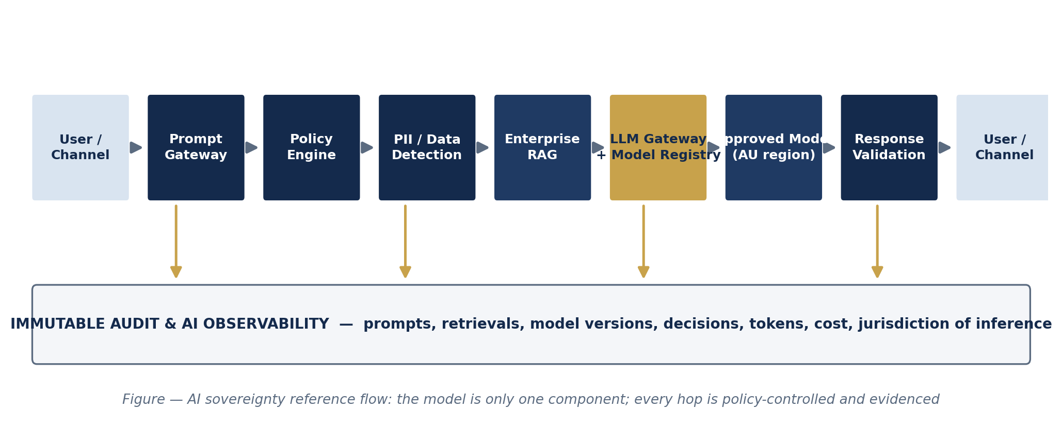
Figure 4 — AI sovereignty reference flow: every hop policy-controlled and evidenced.

7.1 Worked example — retail AI pricing assistant
A merchandising analyst asks for a price-elasticity recommendation. The prompt gateway authenticates the analyst and stamps the request with data-classification context. The policy engine confirms the use case is registered and the analyst is entitled. PII detection redacts any customer identifiers pasted into the prompt. Enterprise RAG retrieves only from the governed pricing corpus (Medium tier). The LLM gateway routes to the registry-pinned model in an Australian region. The response filter checks for leakage and policy violations before returning the answer. The audit log records the full trace. Elapsed overhead versus a direct model call: tens of milliseconds; governance value: the difference between an approvable and an unapprovable use case. [Position]

7.2 Worked example — bank customer-service copilot
Customer context (Critical: identity and account data) is tokenised before retrieval; the copilot's RAG corpus is the governed knowledge base, not raw core-banking records. Inference is pinned to an Australian region; outputs that constitute decisions with significant effect (e.g., hardship eligibility guidance) are flagged into the ADM-transparency register ahead of the 10 Dec 2026 obligation [R3], with human review in the loop.

8. The Reference Capability Model
Twenty enterprise capabilities operationalise the pillars. Each has a stable ID, an accountable owner archetype, a target maturity for a regulated enterprise, and the control objectives it realises.
ID | Domain | Capability | Owner archetype | Target maturity | Realises
ADSRA-C01 | Data | Data Classification | CDO / Data Governance | L4 | DS-01
ADSRA-C02 | Data | Data Residency Management | Cloud Platform | L4 | DS-02
ADSRA-C03 | Data | Privacy Engineering | Privacy / CDO | L4 | DS-03..06
ADSRA-C04 | Identity | Identity & Access Management | CISO / Identity | L4 | ID-01, ID-02
ADSRA-C05 | Identity | Privileged Access Management | CISO | L5 | ID-03
ADSRA-C06 | Identity | Federation & Workload Identity | Identity Platform | L4 | ID-01, ID-05
ADSRA-C07 | Crypto | Key Management | Security Engineering | L4 | CR-01, CR-03
ADSRA-C08 | Crypto | HSM Services | Security Engineering | L4 | CR-01, CR-02
ADSRA-C09 | Operations | Australian Operations | CIO / Ops | L4 | OP-01, OP-03
ADSRA-C10 | Operations | Incident Response (AU) | CISO / SOC | L4 | OP-02, OP-04
ADSRA-C11 | Governance | Policy-as-Code | Platform Engineering | L5 | GV-01, GV-02
ADSRA-C12 | Governance | Compliance Automation | Risk / Platform | L4 | GV-03, GV-04
ADSRA-C13 | AI | AI Gateway | AI Platform | L4 | AI-01, AI-03
ADSRA-C14 | AI | Prompt Management | AI Platform | L4 | AI-03
ADSRA-C15 | AI | RAG Governance | AI Platform / CDO | L4 | AI-04
ADSRA-C16 | AI | Model Registry & Evaluation | AI Platform | L5 | AI-02, AI-05, AI-06
ADSRA-C17 | Observability | Sovereignty Telemetry | SecOps / Platform | L5 | OB-01, OB-02
ADSRA-C18 | Observability | Immutable Audit | SecOps | L4 | OB-01, OB-05
ADSRA-C19 | Observability | AI Monitoring & Observability | AI Platform / SecOps | L5 | OB-03
ADSRA-C20 | Risk | Continuous Assurance | CRO / Architecture Board | L5→L6 | OB-04, GV-04

Using the model. Fund capabilities, not projects: each capability carries a backlog, an owner and KRIs. A maturity heatmap over these 20 capabilities is the recommended quarterly Architecture Board artefact.

9. The ADSRA Maturity Model
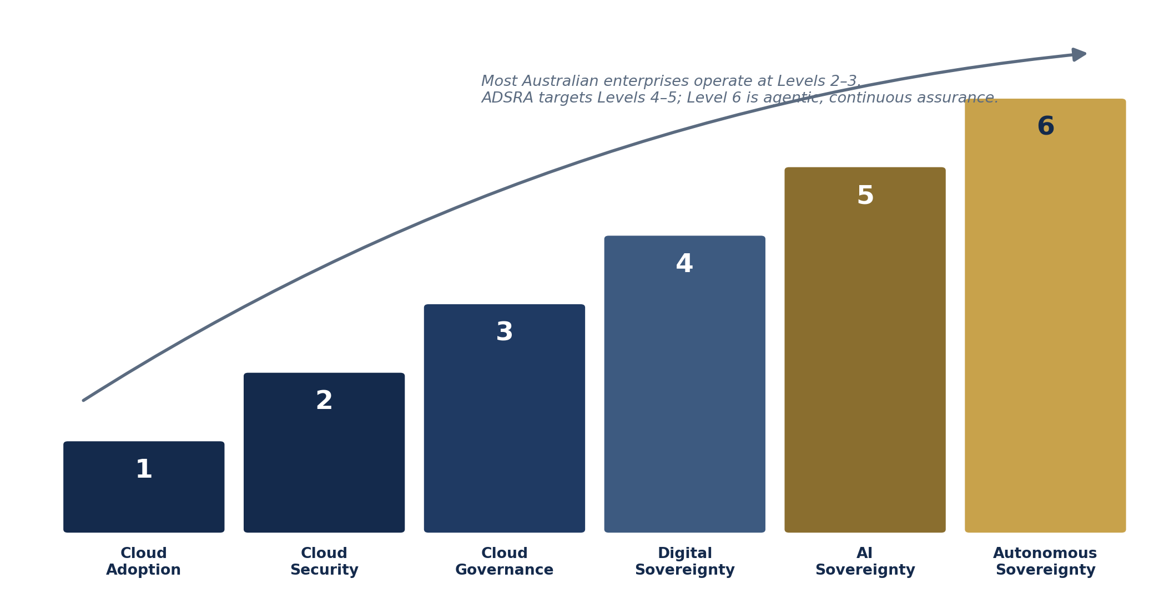
Figure 5 — Six maturity levels, from cloud adoption to autonomous sovereignty.
Level | Name | Defining characteristics | Assessment evidence
1 | Cloud Adoption | Workloads migrating; controls inherited ad hoc from providers | Cloud spend exists; no tiering; no sovereignty KRIs
2 | Cloud Security | Baseline hardening (Essential Eight aligned); perimeter and identity basics | ISM/E8 assessments; MFA coverage; SIEM ingesting cloud logs
3 | Cloud Governance | Landing zones, tagging, cost and policy governance emerging | Policy-as-code coverage; exception registers; CSPM scores
4 | Digital Sovereignty | Tiered classification drives residency, CMK, AU operations for Critical; obligations mapped to controls | ≥90% High/Critical tiered; CMK coverage; AU-ops evidence; obligation matrix live
5 | AI Sovereignty | All AI via gateway + registry; RAG governance; AI observability; ADM-transparency readiness | Gateway coverage; registry adoption; prompt-audit sampling; ADM register
6 | Autonomous Sovereignty | Agentic continuous assurance: platform detects and remediates sovereignty drift (jurisdiction moves, key expiry, offshore inference, anomalous admin locations) | Closed-loop remediation metrics; assurance agents in production with human oversight

Level 6 is the model's genuinely new contribution: sovereignty ceases to be an audit finding and becomes a continuously computed property of the platform. It is deliberately aspirational — pilots, not production, are the realistic 36-month target for most enterprises. [Position]

10. Industry Blueprints

10.1 Banking
- Anchor obligations: CPS 230 (critical operations, tolerance levels, MSPs) [R1]; CPS 234 [R2]; SOCI financial services sector [R5]; Privacy Act [R3].
- Critical-tier assets: payment systems, core banking ledgers, customer identity, fraud models.
- Signature patterns: sovereignty tiers mapped 1:1 to the CPS 230 critical-operations register; AU SOC with rehearsed 24-hour notification path; exit/substitution plans tested against hyperscaler and core-vendor scenarios; AI copilots on governed knowledge bases only.
- Worked example: customer-service copilot (Section 7.2).

10.2 Financial services and superannuation
- Anchor obligations: CPS 230 MSP register incl. fourth parties [R1]; member data under Privacy Act tiered penalties [R3].
- Signature patterns: provider-concentration KRIs to the Risk Committee; administrator (often outsourced) operations brought under ADSRA-OP controls contractually; advice/interaction AI logged for ADM-transparency scope from Dec 2026.

10.3 Retail
- Anchor obligations: Privacy Act incl. statutory tort [R3]; PCI DSS (contractual); SOCI applies to food & grocery among covered sectors [R5].
- Tiering example (national retailer): catalogue ★, pricing ★★, loyalty behaviour ★★★★ (High), customer profiles ★★★★, payment cards ★★★★★ (Critical).
- Signature patterns: checkout in Azure Australia East with CMK, tokenised payments and local SOC; catalogue on global CDN with no sovereignty premium; AI pricing assistant per Section 7.1; personalisation models reviewed for ADM-transparency scope.

10.4 Healthcare
- Anchor obligations: My Health Records Act AU data-handling requirements [R8]; Privacy Act sensitive-information provisions [R3]; SOCI healthcare sector [R5].
- Signature patterns: connected clinical estates Critical by default; client-side encryption for identifiable clinical data where feasible; AI (clinical documentation, triage assist) restricted to AU-region inference with clinician-in-the-loop validation; corporate estate (HR in M365) governed via sensitivity labels, DLP, conditional access and insider-risk tooling.

11. Metrics, Assurance and Implementation

11.1 KRI catalogue (Board-level subset)
KRI | Pillar | Target | Cadence
% High/Critical data under CMK or better | Crypto | 100% | Monthly
% privileged sessions on Critical systems from AU (recorded) | Operations | 100% | Monthly
% AI inference on High/Critical data in-region via gateway | AI | 100% | Monthly
% deployments passing policy gates first time | Governance | ≥ 90% | Per release / monthly
Mean time to detect cross-jurisdiction data movement | Observability | < 1 hr (Critical) | Quarterly test
% material providers with tested exit plans ≤ 12 months old | Operations | 100% | Quarterly
% ADM-scope AI decisions with transparency disclosures ready | AI / Data | 100% by 10 Dec 2026 | Monthly to deadline

11.2 Operating model
- Accountable executive owner for digital sovereignty (typically CIO or CISO), with the Architecture Board as design authority and the Risk Committee receiving KRIs quarterly.
- A Sovereignty Community of Practice connects platform, data, AI, security and privacy engineering — the pattern library and exception learnings live here.
- Every High/Critical solution design names its tier, inherited controls and exceptions on one page — the 'sovereignty passport' — reviewed at design authority. [Position]

11.3 Three-horizon roadmap
Horizon | Focus | Exit criteria
H1 · 0–6 months | Foundations: tier the High/Critical estate; baseline the 20 capabilities; stand up LLM gateway + model registry for all AI pilots; sovereignty KRIs to Risk Committee | Tiering ≥ 90% of High/Critical; first KRI report delivered; no untracked AI integrations
H2 · 6–18 months | Enforcement: CMK/HSM for Critical; policy-as-code gates in all pipelines; AU operations and session recording for critical ops; RAG governance and PII detection in production; provider exit plans tested | Level 4 assessed across Data/Identity/Crypto/Ops; ADM-transparency register complete before 10 Dec 2026
H3 · 18–36 months | Assurance: continuous sovereignty assurance pilots (Level 5→6); agentic compliance monitoring; publish and iterate the reference architecture | Level 5 assessed for AI and Observability; at least one closed-loop remediation pattern in production

11.4 Anti-patterns
- Sovereignty theatre: residency without key custody or operational control — satisfies a slide, not a subpoena. [Position]
- Over-classification: defaulting everything to Critical destroys the cost logic and delivery velocity that make the scheme sustainable.
- Gateway bypass: 'temporary' direct model integrations for pilots that become permanent, invisible AI estate.
- Attestation-based KRIs: metrics from surveys rather than telemetry — see ADSRA-OB-04.

12. Evidence Register (Claims → Sources)
For peer review: material factual claims and their anchors. [Position] items are the author's judgement and are argued, not cited.
Claim in this document | Source
CPS 230 in force 1 Jul 2025; pre-existing MSP contracts by earlier of renewal or 1 Jul 2026; targeted amendments finalised Apr 2026 | R1 (APRA)
CPS 230: notify APRA ≤ 24 hrs for disruption to a critical operation outside tolerance; ≤ 72 hrs for material operational risk incidents | R1 (CPS 230 paras 42, 33)
CPS 234 in force since 2019; 72-hour information-security incident notification | R2 (APRA)
Privacy amendment Act assent 10 Dec 2024; statutory tort commenced by Jun 2025; ADM transparency (APP 1.7–1.9) from 10 Dec 2026 | R3 (Act; OAIC; firm analyses)
Civil penalties up to greater of $50m / 3× benefit / 30% adjusted turnover for serious interferences | R4 (2022 penalty amendment)
SOCI covers 11 sectors incl. financial services, healthcare, energy, data storage; CIRMP spans cyber, personnel, supply-chain, physical hazards | R5 (CISC)
Hosting Certification Framework: Certified Strategic / Assured; applies to new contracts from 30 Jun 2022 | R7 (hostingcertification.gov.au)
My Health Record data must be held and processed in Australia | R8 (My Health Records Act 2012)
US CLOUD Act: production obligations regardless of data location | R9 (CLOUD Act 2018)
Voluntary AI Safety Standard (2024) superseded by Guidance for AI Adoption (Oct 2025); National AI Plan (Dec 2025) relies on existing law; AI Safety Institute from 2026; mandatory-guardrail proposals paused | R10 (DISR/NAIC; legal analyses)

13. References
[R1] Australian Prudential Regulation Authority, Prudential Standard CPS 230 Operational Risk Management (in force 1 July 2025; targeted amendments 30 April 2026) and Prudential Practice Guide CPG 230. https://www.apra.gov.au/operational-risk-management
[R2] Australian Prudential Regulation Authority, Prudential Standard CPS 234 Information Security (2019). https://www.apra.gov.au
[R3] Privacy Act 1988 (Cth); Privacy and Other Legislation Amendment Act 2024 (Cth) (assent 10 December 2024). See also OAIC guidance on the statutory tort and APP 1.7–1.9 automated-decision transparency (effective 10 December 2026). https://www.oaic.gov.au
[R4] Privacy Legislation Amendment (Enforcement and Other Measures) Act 2022 (Cth) — civil penalty regime for serious or repeated interferences with privacy.
[R5] Security of Critical Infrastructure Act 2018 (Cth); Critical Infrastructure Risk Management Program Rules. Cyber and Infrastructure Security Centre. https://www.cisc.gov.au
[R6] Australian Signals Directorate / Australian Cyber Security Centre, Information Security Manual and Essential Eight; Infosec Registered Assessors Program (IRAP). https://www.cyber.gov.au
[R7] Digital Transformation Agency / Department of Home Affairs, Hosting Certification Framework (March 2021; contract applicability from 30 June 2022). https://www.hostingcertification.gov.au
[R8] My Health Records Act 2012 (Cth) — Australian data-handling requirements for My Health Record information.
[R9] Clarifying Lawful Overseas Use of Data (CLOUD) Act, H.R. 4943, 115th Congress (2018) (US).
[R10] Department of Industry, Science and Resources / National AI Centre: Voluntary AI Safety Standard (2024); Guidance for AI Adoption (October 2025); National AI Plan (December 2025); Australian AI Safety Institute (from 2026). https://www.industry.gov.au
[R11] ISO/IEC 42001:2023 Artificial intelligence — Management system; NIST AI Risk Management Framework 1.0 (2023).
[R12] The Open Group, TOGAF Standard; SABSA Institute, SABSA framework; AWS Well-Architected Framework; Microsoft Azure Well-Architected Framework — positioning references.

14. Open Issues and Peer-Review Questions (v0.1)
- Tier boundaries: is a four-tier scheme right, or should Medium split (commercial vs personal)? Reviewers from retail and super especially.
- HYOK guidance: current text says 'surgical, not universal' — challenge with concrete workloads where the feature-loss trade was or wasn't worth it.
- Level 6 definition: what evidence would convince a regulator that agentic remediation is itself well-governed?
- Utilities and education blueprints are deliberately deferred to v0.2 — nominate contributors.
- Technology mappings: confirm AU-region service capabilities before publication; several evolve quarterly.

