WHITE PAPER
Sovereignty by Design
ADSRA — an Australian Digital Sovereignty Reference Architecture for the cloud and AI era
Duane — Enterprise Architect
July 2026 · Draft v0.1 — released for peer comment
Companion artefacts: ADSRA Executive Briefing (deck) and ADSRA Technical Reference (engineering document)

Abstract
Australian enterprises are being asked two questions at once: exploit global cloud and AI platforms faster, and prove — to APRA, the OAIC, the Cyber and Infrastructure Security Centre, and their own boards — that they still control what matters. Most frameworks treat the second question as a compliance exercise. This paper argues it is an architecture problem, and proposes ADSRA: the Australian Digital Sovereignty Reference Architecture. ADSRA defines digital sovereignty as a first-class enterprise architecture domain, expressed through seven control pillars, twenty fundable capabilities, a six-level maturity model culminating in autonomous (agentic) sovereignty assurance, and a small set of telemetry-derived key risk indicators a Risk Committee can govern. It is published as a v0.1 draft, with its evidence base exposed, explicitly to invite peer review.

1. The sovereignty moment
For a decade, 'data residency' was a checkbox on a cloud procurement form. Three forces have converted it into a board-level architecture concern.
Regulation converged. APRA's CPS 230 came into force on 1 July 2025, making critical operations, tolerance levels and material service providers a board accountability — with pre-existing provider contracts captured by the earlier of renewal or 1 July 2026, and notification of a tolerance-breaching disruption due within 24 hours. The Privacy and Other Legislation Amendment Act 2024 delivered a statutory tort for serious invasions of privacy (live since mid-2025) on top of the 2022 penalty uplift (the greater of $50 million, three times the benefit, or 30 per cent of adjusted turnover), and from 10 December 2026 requires privacy policies to disclose substantially automated decisions that significantly affect individuals. The SOCI Act extends risk-management and incident-reporting obligations across eleven critical-infrastructure sectors — including financial services, healthcare, energy and data storage.
AI changed the data flows. Prompts, embeddings, retrieval corpora, fine-tuning sets and model telemetry now move through supply chains most enterprises cannot map. Australia's policy posture consolidated in 2025: the Guidance for AI Adoption superseded the Voluntary AI Safety Standard, and the National AI Plan (December 2025) chose to rely on existing technology-neutral law, sector regulators and a new AI Safety Institute rather than a standalone AI Act. The practical consequence for enterprises is subtle but important: there will be no single AI statute to comply with — the obligation is to evidence control under existing law.
Jurisdiction became a design variable. The US CLOUD Act (2018) can compel providers subject to US jurisdiction to produce data in their possession, custody or control, regardless of where it is stored. Storing data in Sydney under keys and administrators the provider controls is residency; it is not sovereignty.
Residency answers 'where is the data?'. Sovereignty answers 'who can be compelled, and what can they actually produce?'

2. Why existing frameworks don't answer the question
TOGAF supplies architecture method; SABSA derives security architecture from business attributes; the hyperscalers' well-architected frameworks optimise individual workloads; the ASD Information Security Manual and Essential Eight supply a controls baseline; and the Commonwealth's Hosting Certification Framework demonstrates — for government — what a sovereignty-graded supplier regime looks like. Each is necessary. None treats jurisdictional control of data, identity, keys, operations and AI as an enterprise architecture domain with its own capabilities, reference patterns, maturity model and measures. That is the gap ADSRA fills, and it is a gap the author believes will close within this decade the way 'zero trust' closed the network-trust gap: first as thought leadership, then as procurement language, finally as regulatory expectation.

3. ADSRA: the organising idea
ADSRA deliberately does not start with technology. It starts with control domains, and places a digital sovereignty layer between the enterprise's obligations and its platforms. Everything below the line — enterprise platforms, clouds, infrastructure — inherits the controls of that layer. Sovereignty sits above technology, not below it.
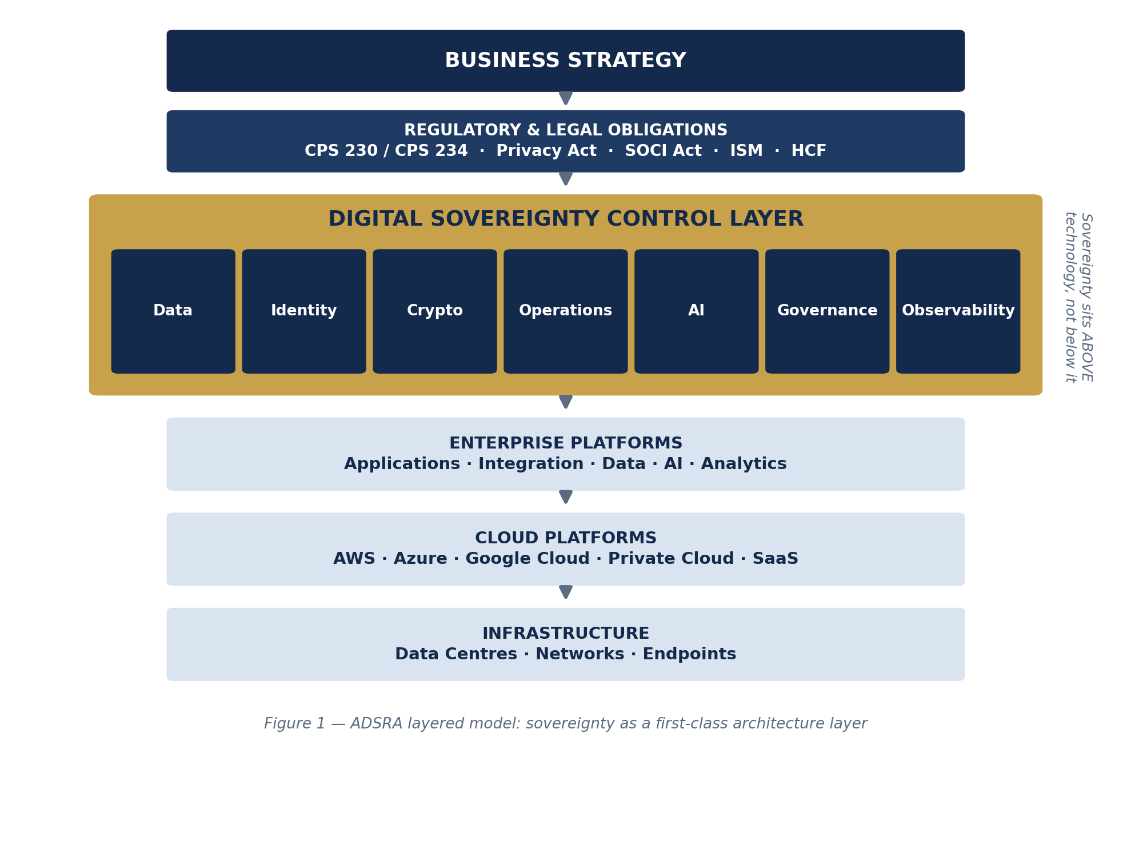
Figure 1 — The ADSRA layered model.
Inheritance is the operative word. In a mature ADSRA estate, a new workload does not negotiate its sovereignty posture; it declares its data classification, and the landing zone, policy-as-code and shared services bind the corresponding controls automatically. Exceptions are explicit, time-boxed and owned by an accountable executive.

4. The seven pillars
ADSRA decomposes sovereignty into seven pillars, each framed by the question an executive must be able to answer.
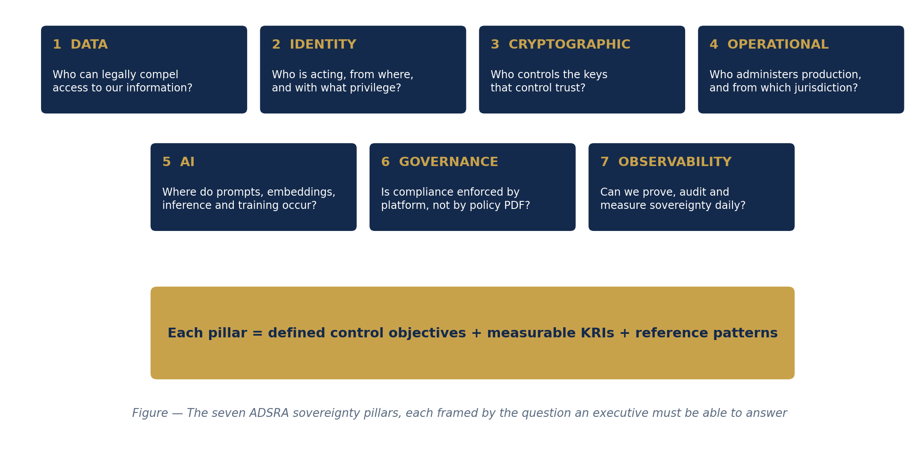
Figure 2 — The seven ADSRA pillars.
- Data — who can legally compel access to our information? Classification with sovereignty tiers, residency, tokenisation, DLP, lifecycle and privacy assessment.
- Identity — who is acting, from where, with what privilege? Australian-controlled identity, Zero Trust conditional access, just-in-time privilege.
- Cryptographic — who controls the keys that control trust? Customer-managed keys, HSMs, BYOK/HYOK, client-side encryption, crypto-agility. Encryption is the last defence against jurisdictional uncertainty — if, and only if, the enterprise holds the keys.
- Operational — who administers production, and from which jurisdiction? Australian operations and SOC, provider-access approval, session recording, tested exit plans.
- AI — where do prompts, embeddings, inference and training occur? Gateways, model registries, RAG governance, output validation.
- Governance — is compliance enforced by the platform or a policy PDF? Policy-as-code, pipeline gates, automatic inheritance.
- Observability — can we prove, audit and measure sovereignty daily? Central logging, SIEM/UEBA, AI observability, immutable audit, telemetry-derived KRIs.
Observability is deliberately listed last and weighted first: it is the currently underdeveloped pillar, and the one that converts sovereignty from an asserted property into a measured one. A control without evidence should be treated as absent.

5. AI sovereignty: the model is only one component
The most consequential design error in enterprise AI today is architectural: connecting applications directly to models. ADSRA's reference flow surrounds the model with enterprise services — a prompt gateway, a policy engine, PII detection, governed retrieval, a model registry pinning approved models and regions, and response validation — with every hop recorded in an immutable audit trail.
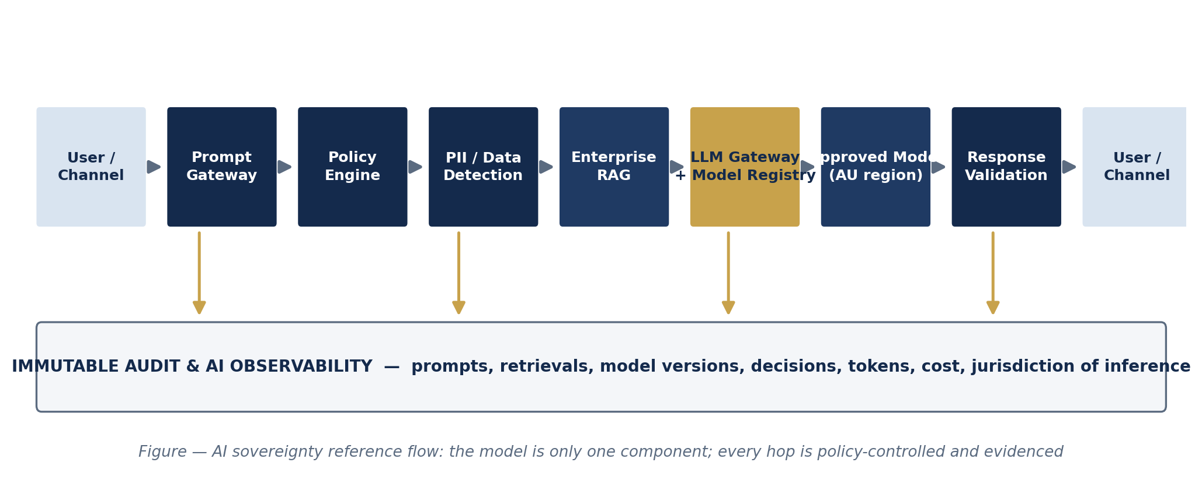
Figure 3 — The AI sovereignty reference flow.
Two vignettes make it concrete. A retailer's AI pricing assistant lets merchandising teams query elasticity and promotion effects: the gateway authenticates, policy confirms the registered use case, PII detection redacts stray customer identifiers, retrieval draws only from the governed pricing corpus, and inference runs on a registry-pinned model in an Australian region. A bank's customer-service copilot goes further: customer context is tokenised before retrieval, and outputs that could constitute significant automated decisions are flagged into the transparency register the Privacy Act will require from 10 December 2026. In both cases the model never talks directly to users or raw data — and the audit trail can reconstruct any interaction end-to-end.
The enterprises that industrialise AI first will not be the ones with the best models. They will be the ones whose governance made the models approvable.

6. Classification prices the control: industry vignettes
Sovereignty is not free. Sovereign controls add cost, can break native cloud features, and in-region AI can lag frontier model availability. ADSRA's answer is a four-tier classification (Low / Medium / High / Critical) that spends the sovereignty premium only where obligations demand it. A national retailer illustrates the spread: the product catalogue (Low) runs globally on a public CDN with no premium paid at all; loyalty behaviour and customer profiles (High) are pinned to Australian regions under customer-managed keys; payment credentials (Critical) are tokenised with HSM-backed keys, an Australian SOC, and client-side encryption.
- Banking: sovereignty tiers map one-to-one to the CPS 230 critical-operations register; the 24-hour notification clock is only meetable when detection and decision rights are local and rehearsed.
- Financial services and superannuation: provider-concentration KRIs give Risk Committees a quantified exit and substitution posture across material service providers and their fourth parties.
- Retail: the statutory tort and tiered penalties concentrate in exactly the data most retailers under-classify — loyalty and behavioural profiles; personalisation AI needs review against the automated-decision transparency obligation.
- Healthcare: My Health Record information must be held and processed in Australia; connected clinical estates default to Critical, and clinical-adjacent AI runs in-region with clinicians in the loop.

7. Measuring sovereignty: maturity and KRIs
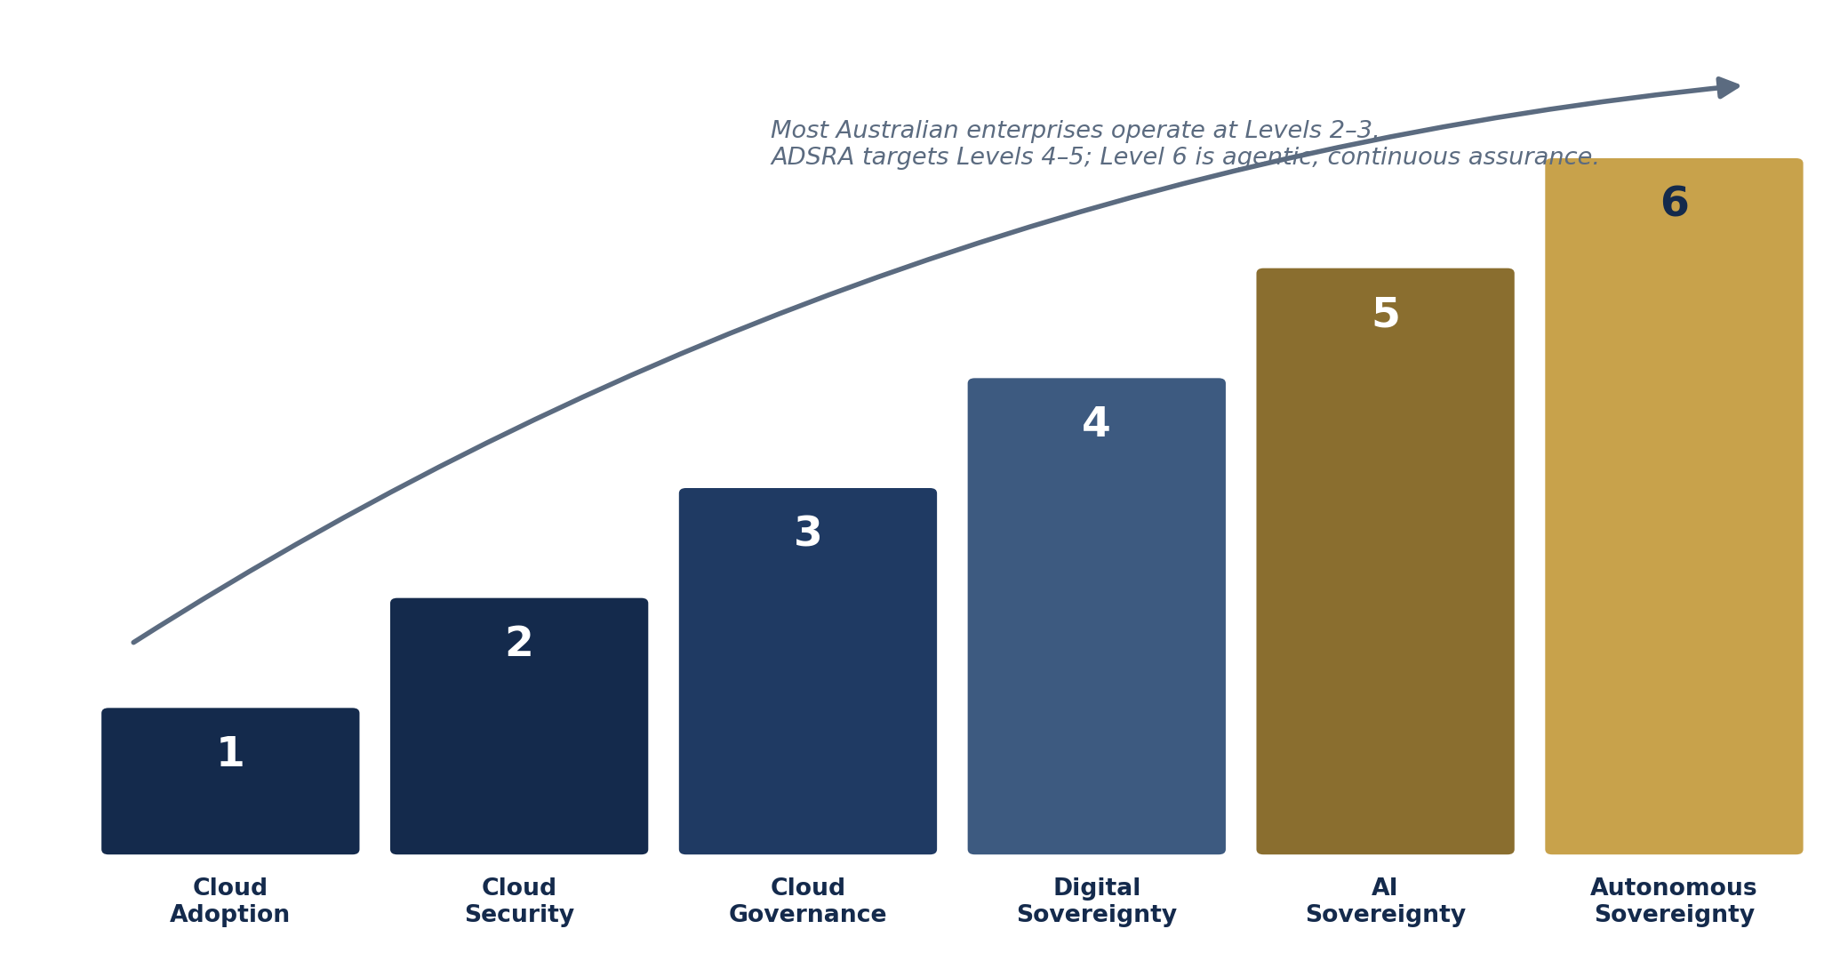
Figure 4 — The ADSRA maturity model.
Most Australian enterprises today sit at Levels 2–3: secure and increasingly governed cloud, with sovereignty handled workload-by-workload. ADSRA targets Level 4 (sovereignty engineered into the platform) and Level 5 (AI sovereignty) within roughly 36 months. Level 6 — autonomous sovereignty — is the model's genuinely new contribution: AI agents continuously interrogating the estate. Is every workload still compliant? Has data crossed a jurisdiction? Is a key nearing expiry? Has inference moved offshore? Is an administrator operating from an unexpected location? At Level 6 the platform does not merely monitor sovereignty; it assesses and remediates it, under human oversight.
Between board meetings, a handful of telemetry-derived indicators carry the story: the percentage of High/Critical data under customer-managed keys; the percentage of privileged sessions administered from Australia (and recorded); the percentage of AI inference executed in-region through the gateway; first-time pass rates through policy-as-code gates; mean time to detect a cross-jurisdiction data movement; and the recency of tested exit plans for material providers. None of these is an attestation. All of them are computable from the observability pillar — which is precisely why that pillar is the first investment.

8. The business case, stated honestly
The return side of the ledger: penalty and tort exposure avoided; faster risk approval of cloud and AI initiatives because patterns are pre-agreed; quantified provider-concentration risk instead of implicit acceptance; and — increasingly decisive — the licence to deploy customer-facing AI at all, because evidenced control is what boards and regulators now ask for first.
The cost side deserves equal candour: HYOK and client-side encryption break real cloud features and should be applied surgically; in-region model availability lags the frontier; over-classification taxes low-risk workloads; and policy-as-code and AI-governance engineering skills are scarce. The managed position is not maximal sovereignty — it is tiered sovereignty, consciously priced, with residual risk measured and accepted in the open.

9. A call to the profession
ADSRA is published deliberately as a v0.1 draft, with its evidence register exposed in the companion Technical Reference. The tier boundaries, the HYOK guidance, the Level 6 definition, and the technology mappings all carry open questions that practitioner review will improve. Just as the industry evolved from 'security' to zero trust as a first-class architectural principle, the author expects it to evolve from 'data residency' to digital sovereignty architecture as a formal enterprise architecture domain — and would rather Australian practitioners define that evolution than inherit it. Comments, challenges and contributed industry blueprints (utilities and education are explicitly invited for v0.2) are welcome.

References
- APRA, Prudential Standard CPS 230 Operational Risk Management (in force 1 July 2025; targeted amendments April 2026) and CPG 230 — apra.gov.au.
- APRA, Prudential Standard CPS 234 Information Security (2019).
- Privacy Act 1988 (Cth); Privacy and Other Legislation Amendment Act 2024 (Cth); Privacy Legislation Amendment (Enforcement and Other Measures) Act 2022 (Cth) — oaic.gov.au.
- Security of Critical Infrastructure Act 2018 (Cth) and CIRMP Rules — cisc.gov.au.
- ASD/ACSC, Information Security Manual and Essential Eight; IRAP — cyber.gov.au.
- DTA / Home Affairs, Hosting Certification Framework — hostingcertification.gov.au.
- My Health Records Act 2012 (Cth).
- Clarifying Lawful Overseas Use of Data (CLOUD) Act 2018 (US).
- DISR / National AI Centre: Voluntary AI Safety Standard (2024); Guidance for AI Adoption (Oct 2025); National AI Plan (Dec 2025); Australian AI Safety Institute (2026) — industry.gov.au.
- ISO/IEC 42001:2023; NIST AI RMF 1.0.
All regulatory dates as at July 2026. The companion ADSRA Technical Reference contains the full evidence register mapping every claim to its source.

