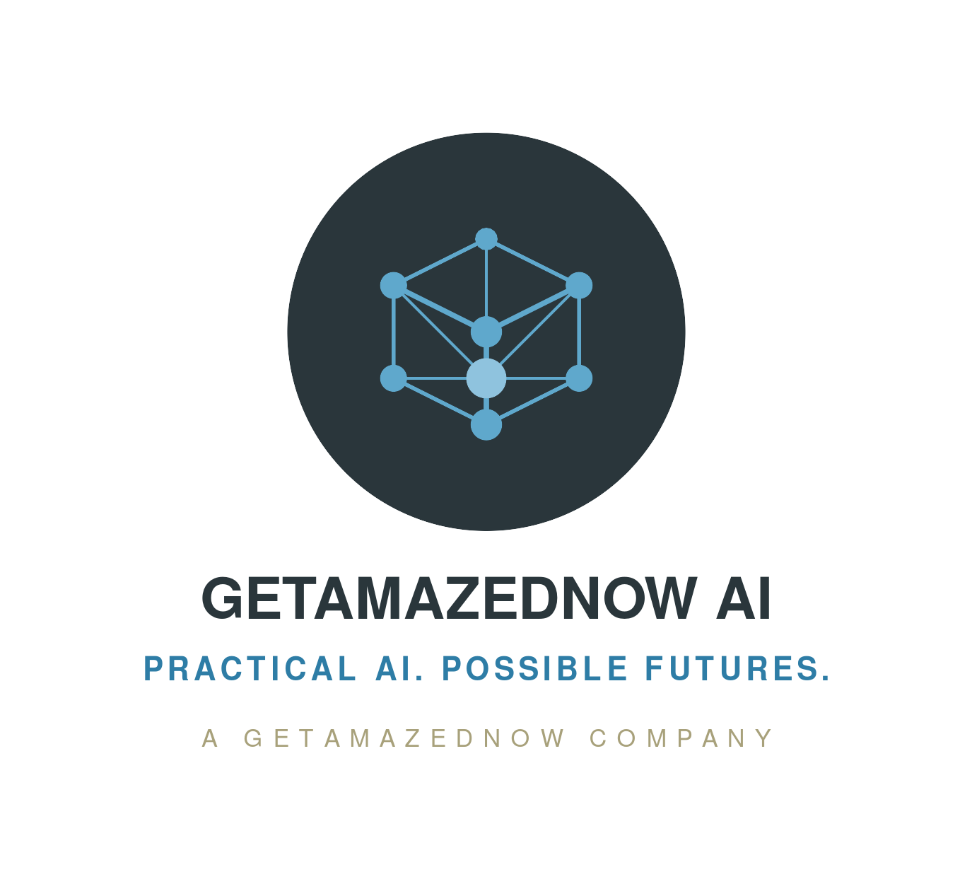
GETAMAZEDNOW AI
Brand & Design System
Version 1.0 | July 2026
getamazednow.ai
A Getamazednow Company
“Practical AI. Possible Futures.”

1. Brand Foundation

1.1 Brand Premise
Getamazednow AI is the technology and AI-advisory arm of Getamazednow, the parent company also home to the Getamazednow Photography brand. Where the parent brand's nature-inspired identity (“Be Naturesque,” the leaping tiger) speaks to precision and instinct, Getamazednow AI speaks to a different but related idea: the discipline of turning AI's technical possibility into governed, measurable business value.
The mark is a tensor node lattice — an isometric 3D cube built entirely from interconnected dot nodes rather than solid faces, with a brighter core hub wired to every corner. It reads simultaneously as a tensor (the core data structure of machine learning) and a network (nodes and connections), which is exactly the dual audience this brand speaks to: technical practitioners and the executives who fund them.

1.2 Positioning Statement
Working positioning
For enterprises across financial services, banking, retail, education, healthcare and utilities, Getamazednow AI is the advisory practice that separates practical, deployable AI from the hype cycle — pairing 30+ years of enterprise architecture rigor with a clear-eyed, evidence-based view of where AI actually creates measurable value.

1.3 Brand Pillars
- Practicality — every recommendation is deployable, governed, and tied to a business case; no science projects.
- Possibility — the core hub node signals genuine upside is real when AI is applied to the right problem.
- Rigor — the tensor/network structure of the mark reflects a data-driven, structured way of thinking, inherited from the parent brand's precision ethos.
- Trust through lineage — “A Getamazednow Company” signals an established parent, not a fly-by-night AI shop.

1.4 Voice & Tone
We are | Direct, data-driven, evidence-led, pragmatic, forward-looking
We are not | Hyped, jargon-heavy, vague, salesy, breathless about AI for its own sake
Talks & thought leadership | Confident and opinionated on where AI does and doesn't apply; always backed by a source, model, or number
Written documents (board/exec) | Formal, structured, decision-oriented — lead with the recommendation, then the evidence
Digital/app copy | Short, active-voice sentences; the tagline's rhythm (short. short.) is the house style

1.5 Relationship to the Parent Brand
Getamazednow AI deliberately shares three elements with Getamazednow Photography to signal common ownership, and deliberately differs on everything else to avoid market confusion between two very different offerings:
Element | Shared with Photography | Unique to AI
Color | Ink (dark surface), Stone (secondary/byline) | Signal Blue family (accent, replaces Gold/Bronze)
Typography | Poppins + Inter + JetBrains Mono pairing | No proprietary logotype font needed
Mark | Circular badge lockup grammar | Tensor node lattice (vs. leaping tiger)
Naming | “Getamazednow” root name | “AI” suffix + “A Getamazednow Company” byline

2. Logo System

2.1 Primary Mark
The primary lockup is a circular Ink badge containing the Tensor Node Lattice: 8 dot nodes (7 forming the vertices of an isometric cube, plus 1 brighter core hub) connected by 15 edges (9 cube edges + 6 core spokes). Node size and brightness graduate by depth — the farthest node is smallest and dimmest, the core hub is largest and brightest — so the mark reads as three-dimensional without any solid shading or gradients.

Unlike the Photography mark, this logo was built as native vector art rather than sampled from external artwork — there is no hidden-text-on-white gotcha. All four variants below are safe on their intended surfaces with no exceptions.

2.2 Clear Space & Minimum Size
Clear space | Minimum 1× the diameter of the badge circle on all sides
Min size — digital | 24px height (icon-only); 140px width if paired with the full wordmark lockup
Min size — print | 15mm width on collateral; below this, use icon-only
Favicon sizes | 32×32 (browser), 180×180 (iPhone), 196×196 (Android) — simplified 5-node version

2.3 Approved Variants & When to Use Them
Color, full lockup | Recommended default — web, documents, slide title/section pages, social avatars
Color, icon-only | App icons, favicons, small digital placements, watermarks
Monochrome white | Over dark or photographic backgrounds where the Ink badge fill would lose contrast
Monochrome Ink | Single-color print, letterhead watermarks, engraving, greyscale contexts

2.4 Do / Don't
DO | DON'T
- Use the supplied SVG files at native aspect ratio  - Maintain full clear space around the badge  - Preserve the depth graduation (core hub brightest) | - Stretch, skew or recolor the lattice outside approved variants  - Merge or confuse this mark with the Photography tiger badge  - Add extra nodes/edges or flatten the depth cues

3. Color System
Contrast ratios are calculated per WCAG 2.1 relative luminance; AA requires ≥ 4.5:1 for normal text and ≥ 3:1 for large text/graphics.

3.1 Brand Palette
Name | Hex | Usage | Accessibility
Ink (shared) | #2A363B | Primary dark surface, badge fill | White text: 12.4:1 AAA
Signal | #5FA8CC | Primary accent, nodes/edges on Ink, large text | On Ink: 4.7:1 AA
Signal Deep | #2E7DA6 | Accessible accent text on light surfaces | On white: 4.6:1 AA
Signal Core | #8FC3DE | Core-node highlight, hover glow | Decorative only
Stone (shared) | #A8A17B | Secondary accent, byline text | On Ink: 4.76:1 AA

3.2 Shared vs. Brand-Specific
Ink, Stone, the 10-step neutral ramp, and the semantic status colors (success/warning/error/info) are identical to Getamazednow Photography's palette — this is the parent-brand DNA. Only the Signal Blue family is unique to Getamazednow AI, replacing Photography's Gold/Bronze accent. Full values are in design-tokens.json.

4. Typography
Getamazednow AI uses the identical type system as Getamazednow Photography — shared typographic DNA across both brands:
Role | Font | Usage
Display / Heading | Poppins (700/800) | H1–H2, slide titles, wordmark lockup
Body | Inter (400/500) | Body copy, tables, UI labels
Code / Mono | JetBrains Mono | Code, tokens, agent/CLI surfaces

Unlike Photography (which has a logo-only proprietary font that cannot be used for body copy), the AI wordmark is set directly in Poppins ExtraBold — there is no separate logotype font dependency.

5. Design System Contents
This v1.0 kit contains everything needed to apply the Getamazednow AI brand consistently:
- design-tokens.json — source of truth for all colors, type scale, spacing, radius, elevation
- tokens.css — CSS custom properties (--gai- prefix) for web/app builds
- Logo files — full color, icon-only, monochrome white, monochrome Ink, favicon (SVG + PNG)
- Getamazednow_AI_Presentation_Template.pptx — slide template
- Getamazednow_AI_Report_Template.docx — Word report/document template
For how to apply this kit inside other Cowork projects, see the “How to Use These Design Systems” guide packaged alongside both brand kits.

