**Amazon IAP and BrainCloud Verification**

1. Make an amazon developer account if you don’t already have one here   
   <https://developer.amazon.com/>
2. Go to your developer console  
   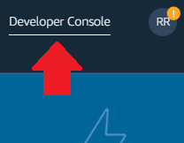
3. Under MyApps add a new app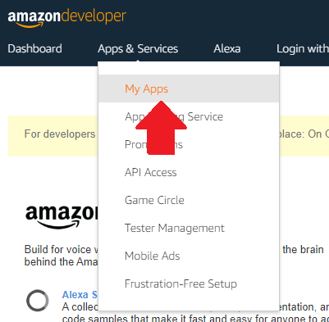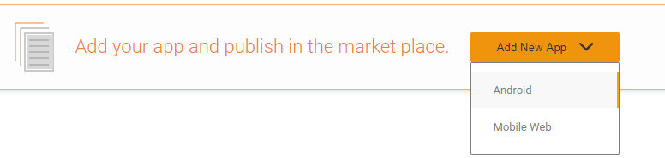  
   In this case we are doing Android.
4. Fill in the app info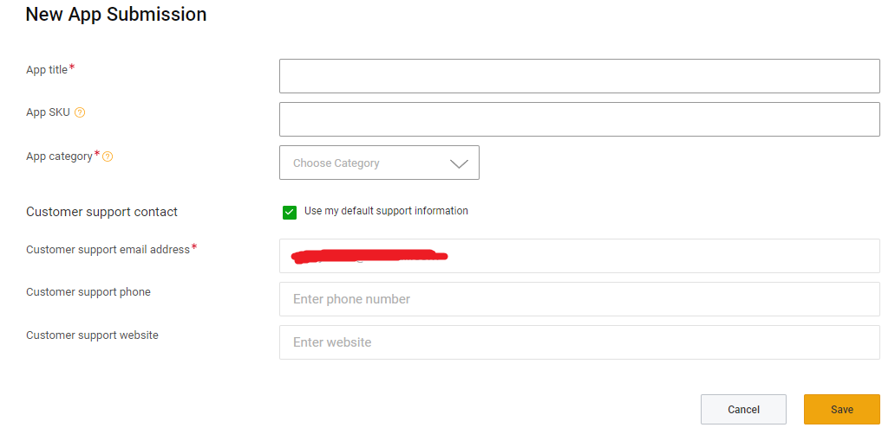
5. Fill out your apps data and make sure everything is checked off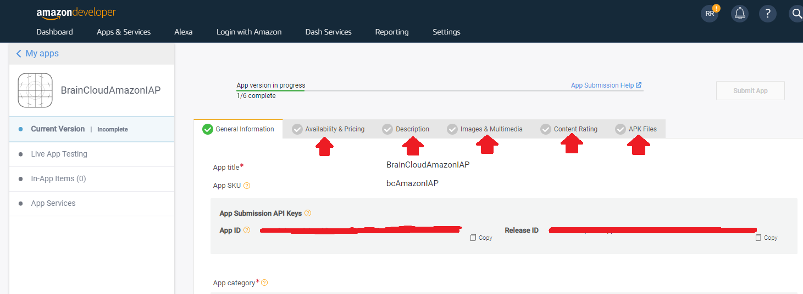
6. You’ll notice in Availability and Pricing, that “If you app offers items for In-App purchases”… You will want to add your IAP here. We’ll add a consumable for example. 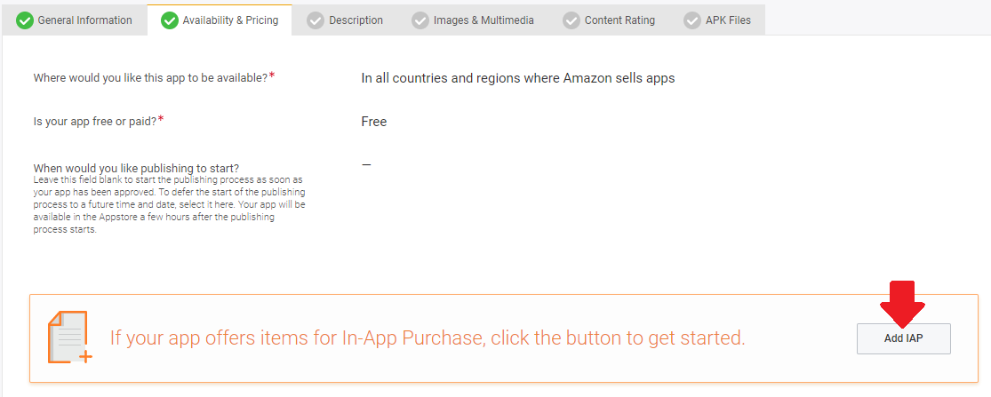  
     
   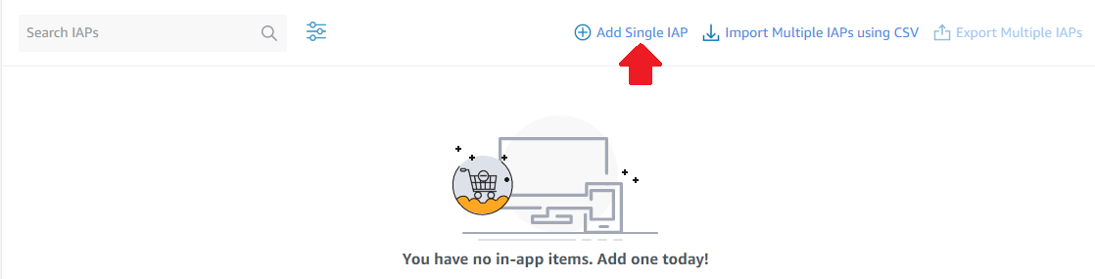  
     
   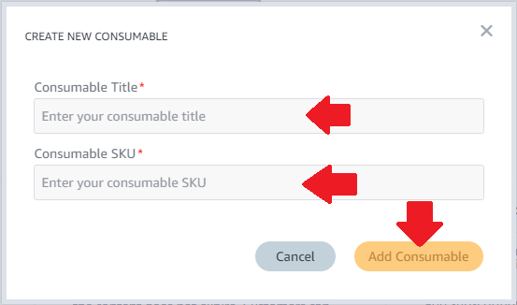  
   To complete your consumable, click on the newly created consumable in the list and fill in the details and pricing details and submit the IAP. For this example we are making it 0$ to purchase.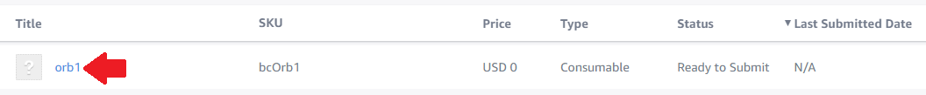
7. Now that you’ve added something a player can buy, keep filling out the rest of the app checklist (Description, Images and Multimedia, content rating and apk files)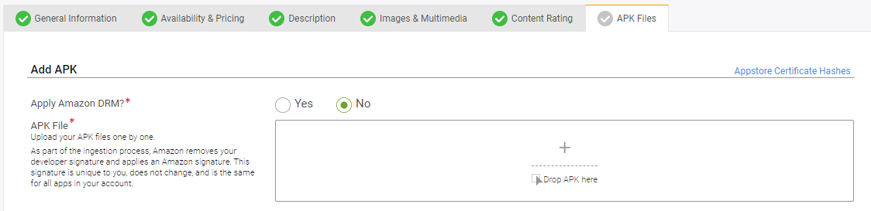  
   At the last step you’ll notice you’ll need an apk to finalize your app. So we’ll save that for later.
8. Time to open Unity. Make a new Unity project
9. Use unity plugin here <https://developer.amazon.com/docs/apps-and-games/sdk-downloads.html> and import it into Unity.
10. In File>Build Settings, change the platform to Android  
    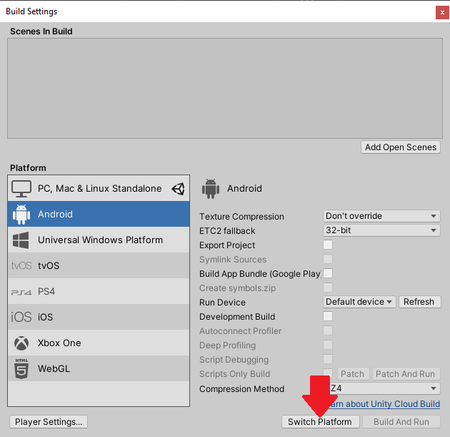
11. In File>Build Settings>Player Settings, in the Player tab go to Other Settings and under Identification you will find Package name. This can be changed by changing your Company Name and Product Name at the top of the Player tab. Change this now, because once you’ve uploaded an apk to Amazon it will always need to be the same package name for the app you upload it to.
12. Build the apk
13. Now Navigate to your project folder and go to Temp>StagingArea and open the UnityManifest.xml
14. Copy all the code in the UnityManifest.xml then add it to the AmazonIapV2SampleAndroidManifest.xml in Assets>Plugins>Android. This would have been added when you imported the plugin. This is mentioned here <https://developer.amazon.com/de/docs/cross-platform-plugins/cpp-add-plugin-to-unity-project.html>. ONLY DO THIS IF YOU DON’T ALREADY HAVE YOUR OWN ANDROID MANIFEST FILE, otherwise ADD THIS CODE TO YOUR ANDROID MANIFEST FILE!

Add this to the application part of your .xml  
<receiver android:name = "com.amazon.device.iap.ResponseReceiver"

android:permission = "com.amazon.inapp.purchasing.Permission.NOTIFY" >

<intent-filter>

<action android:name = "com.amazon.inapp.purchasing.NOTIFY" />

</intent-filter>

</receiver>

1. Rename AmazonIapV2SampleAndroidManifest.xml to AndroidManifest.xml, IF YOU DON’T ALREADY HAVE YOUR OWN ANDROID MANIFEST FILE.
2. Change the package name of your AndroidManifest to the package name matching your project. To confirm the package name matches go to Player Settings, and in the Player tab go to Other Settings and under Identification you will find Package name.
3. Build the apk again and check that the receiver was properly added. Drag your apk into Andorid studio and look at the AndroidManifest.xml and confirm the receiver is there and the package name is as desired.
4. This link gives a good idea of what you’ll need to do in order to get an in-app purchase going in code. Refer to their example if you’re trying to set up a simple purchase with amazon. You can also refer to our code example. Basically you simply need to make a Purchase call through the amazon instance, and listen for the purchase callback to get the userId and receiptId you need. <https://developer.amazon.com/de/docs/cross-platform-plugins/cpp-use-the-iap-plugin-for-unity.html>  
     
   *NOTE* One of the most key parts of getting in-app purchases to work without headaches is patience. The IAP you added to your Amazon Console has to first be approved and go LIVE before you can make any purchases with it. So make sure to submit it while you’re working away.  
   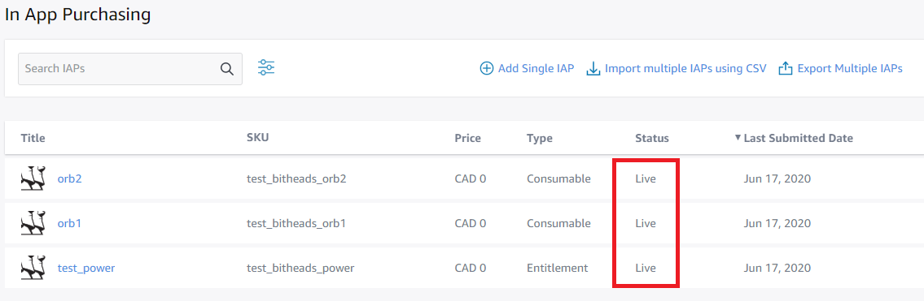
5. You can test your app by setting up Live-App Testing. To do this, first upload your APK and get your app ready to submit.  
   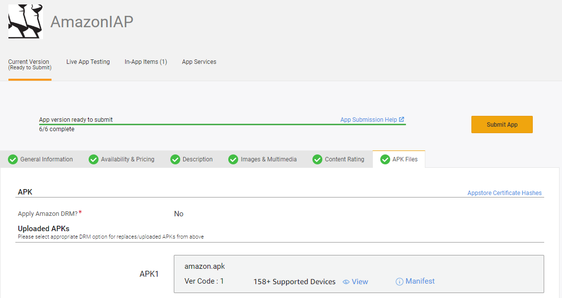
6. Then go to the Live-App testing tab, create a new test, set up testers with emails, then from your device, accept the invitation through the testers email, and download the app onto your device to test it. Make sure you are using the proper amazon localization for your app. For example if you’re in Canada, you would visit it on amazon.ca, respectively. Make sure your test says “Test In Progress” or else it will not be the proper test with the latest apk that you’ve uploaded. It could take more than 10 minutes for a test to get processed and say its in progress. 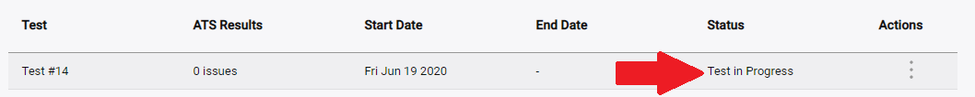

**IMPORTANT TIP WHEN SETTING UP TESTS**  
Make sure to **delete** your apk from both the current version of your app and the live app testing version of your app every time you want to set up a new test with a new apk. Delete, then drag and drop the new apk, this may avoid some headaches where only older versions of your app are being downloaded through testing.   
Also, it is a good idea to have a version number of some sort to see that you are actually working with your latest versions when testing,  
  
  
Now we’re ready to hook up **BrainCloud**!

1. Start by creating a new app on brainCloud portal or working off an already existing app  
   <https://portal.braincloudservers.com/loginfailed>
2. Under Core App Info > Platforms, be sure to check off Amazon
3. Under Core App Info > Application Ids go to Configure Platforms, select amazon, and in Shared Secret, you will need the Shared secret from your amazon developer console. That can be found under Settings > Identity in your developer console.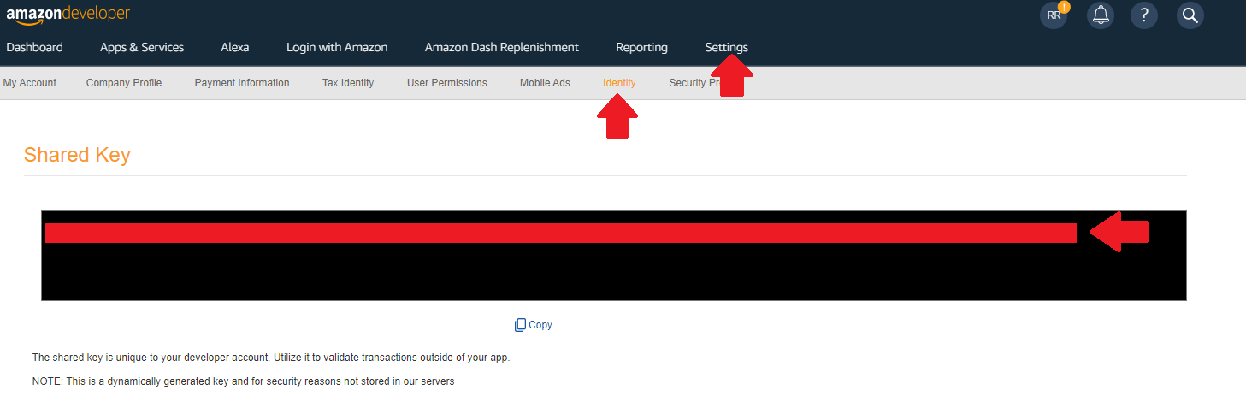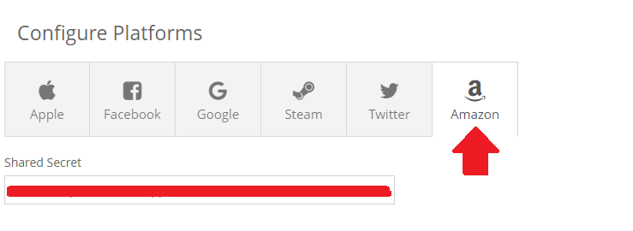
4. The next thing to do is to make braincloud products that match your amazon IAPs. To do this, go to MarketPlace>Products and add a Product. 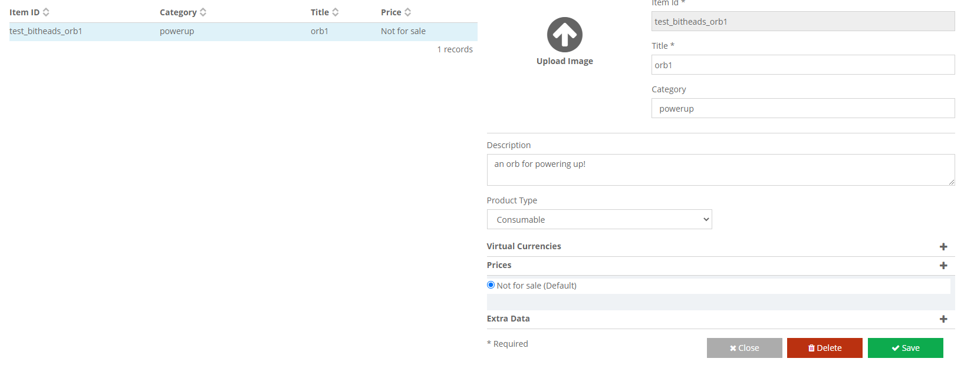
5. Save it then you can edit it and add a price to it, enable it for Amazon. Make sure the Amazon Product Id matches the SKU of the product and the price matches the price you have on Amazon. For proper practice I would also make the brainCloud Item ID match the SKU of the Amazon product you are linking with brainCloud.
6. Grab our plugin here and import it into Unity <https://github.com/getbraincloud/braincloud-csharp/releases>
7. Sign into your braincloud account and app though our select settings. You will want to set up a test similar to this example, where you Authenticate with brainCloud, Check the sales inventory for the list of products, then make an amazon purchase, and in the purchase response you will want to isolate the userId and receiptId so that you can verify the purchase with brainCloud!

And that’s it! Happy Coding!