Relay Test App - READ ME

Summary

This simple "game" is used to demonstrate how to integrate with brainCloud's relay server. It is a simple multiplayer game where players can see each other's mouse move on the screen and create little shockwaves by clicking.

The game can be played by right clicking the RelayTestApp.uproject and Launch Game once brainCloud portal settings are ready.

The mouse movement are sent using unreliable, ordered messages. The shockwaves are sent using reliable, unordered messages.

In Unreal Engine, the implementation uses WebSockets. Therefore, the unreliable messages are guaranteed reliable. But, the application can crossplay with other APIs (C#, Unity, Java, etc) which support unreliable UDP protocol.

Launching Unreal Engine Editor Instructions

1. Install Unreal Engine via Epic Games Launcher
- Make sure the version is the same as the project. To check, open file RelayTestApp.uproject with any text editor or IDE and look under "EngineAssociation".
2. During the install process, ensure you have all Visual Studio plugins needed to run Unreal Engine.
3. Double left click on RelayTestApp.uproject file to open project in the Unreal Engine Editor.

Setting up RelayTestApp for Braincloud

1. Create a new app in the portal: https://portal.braincloudservers.com/ Take note of the app id and app secret.
2. Create a new server with the following settings:
2a. Make sure to choose Relay Server (hosted) as shown in the image.
2b. After you set the Server Name and Server Type, go to the Regions tab and select a region. For example, we chose “ca-central-1” for our tests.

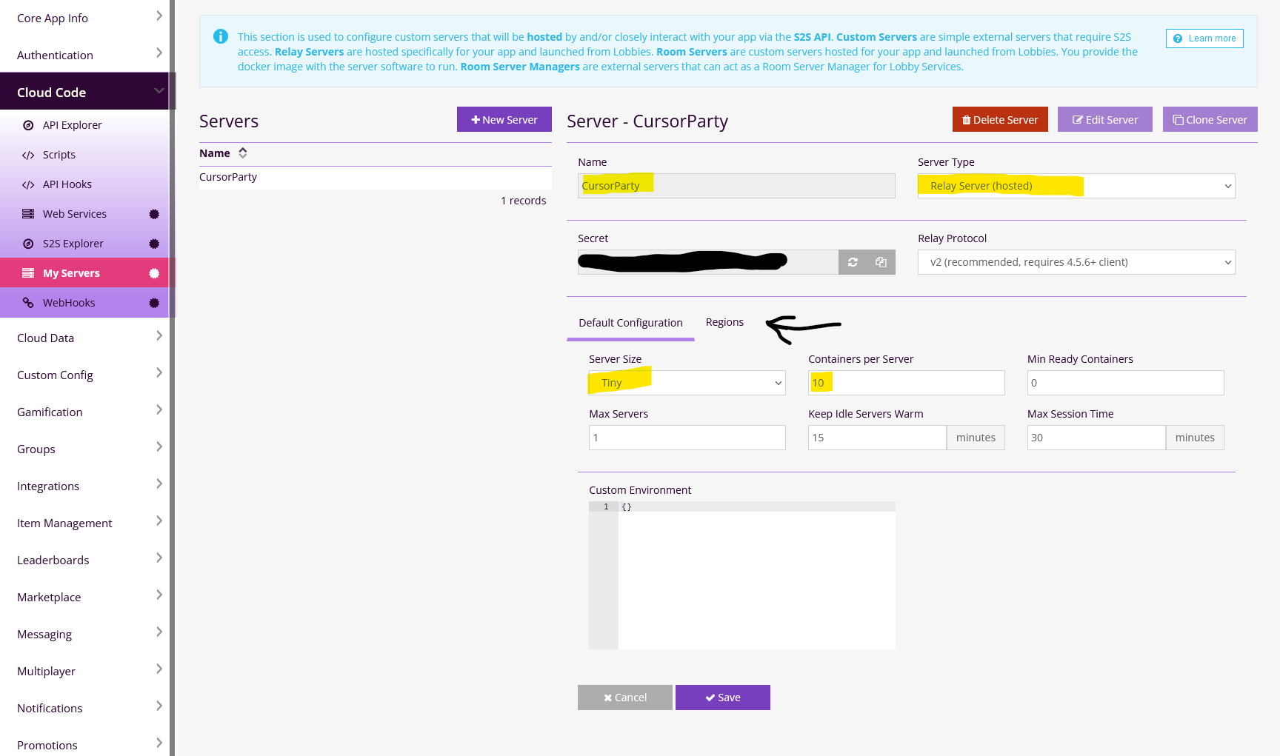
3.Create a lobby type with the following settings:
3a. Go to Core App Info -> Advanced Settings and enable “Real-time Tech (RTT) Enabled”
3b. Go to Multiplayer -> Lobbies and enable “Lobby Service Enabled”
3c. From Lobbies page, click on the “+” button to add a new lobby type.
3d.Within the Add New Lobby Type Configuration pop up, enter “CursorParty” in the Lobby Type Id and make sure the Server setting is set to "CursorParty". Leave the Teams tab as default.

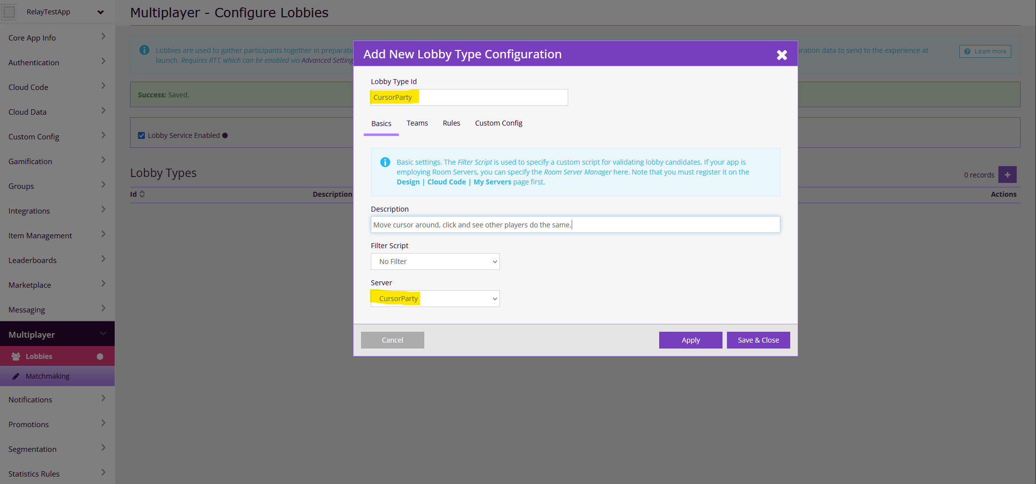
3e. Now adjust the rules settings which will start the game as soon as at least 1 player is ready. The application is built in a such way that only the room owner can ready up. In the Rules tab set the following settings:
      - Earliest Start = 1
      - On-time Start = 600
      - Too Late Start = 600
      - Minimum Percent = 15
      - Enable “Allow early start without max participants”

Getting ready to launch game in Unreal Engine

Once all settings for brainCloud portal is ready then you're able to enter the information needed to run the example. Follow these steps to have Unreal Engine ready to play with 2 players:
  - Before going into Unreal Engine, from the brainCloud portal go to Core App Info -> Application ID's. Keep this open because it will be used for the following steps.
  - With the Unreal Engine open on the Game map(this should open by default), navigate to the “World Outliner” and select “BP_RelayNetworkInterface” to bring up the details for that Actor. (Refer to picture below)
  - From the details panel, enter the following fields (Refer to picture below):
Server URL = “https://sharedprod.braincloudservers.com/dispatcherv2”.
Secret Key = From brainCloud portal, copy App Secret and paste it here.
App ID = From brainCloud portal, copy App ID and paste it here.
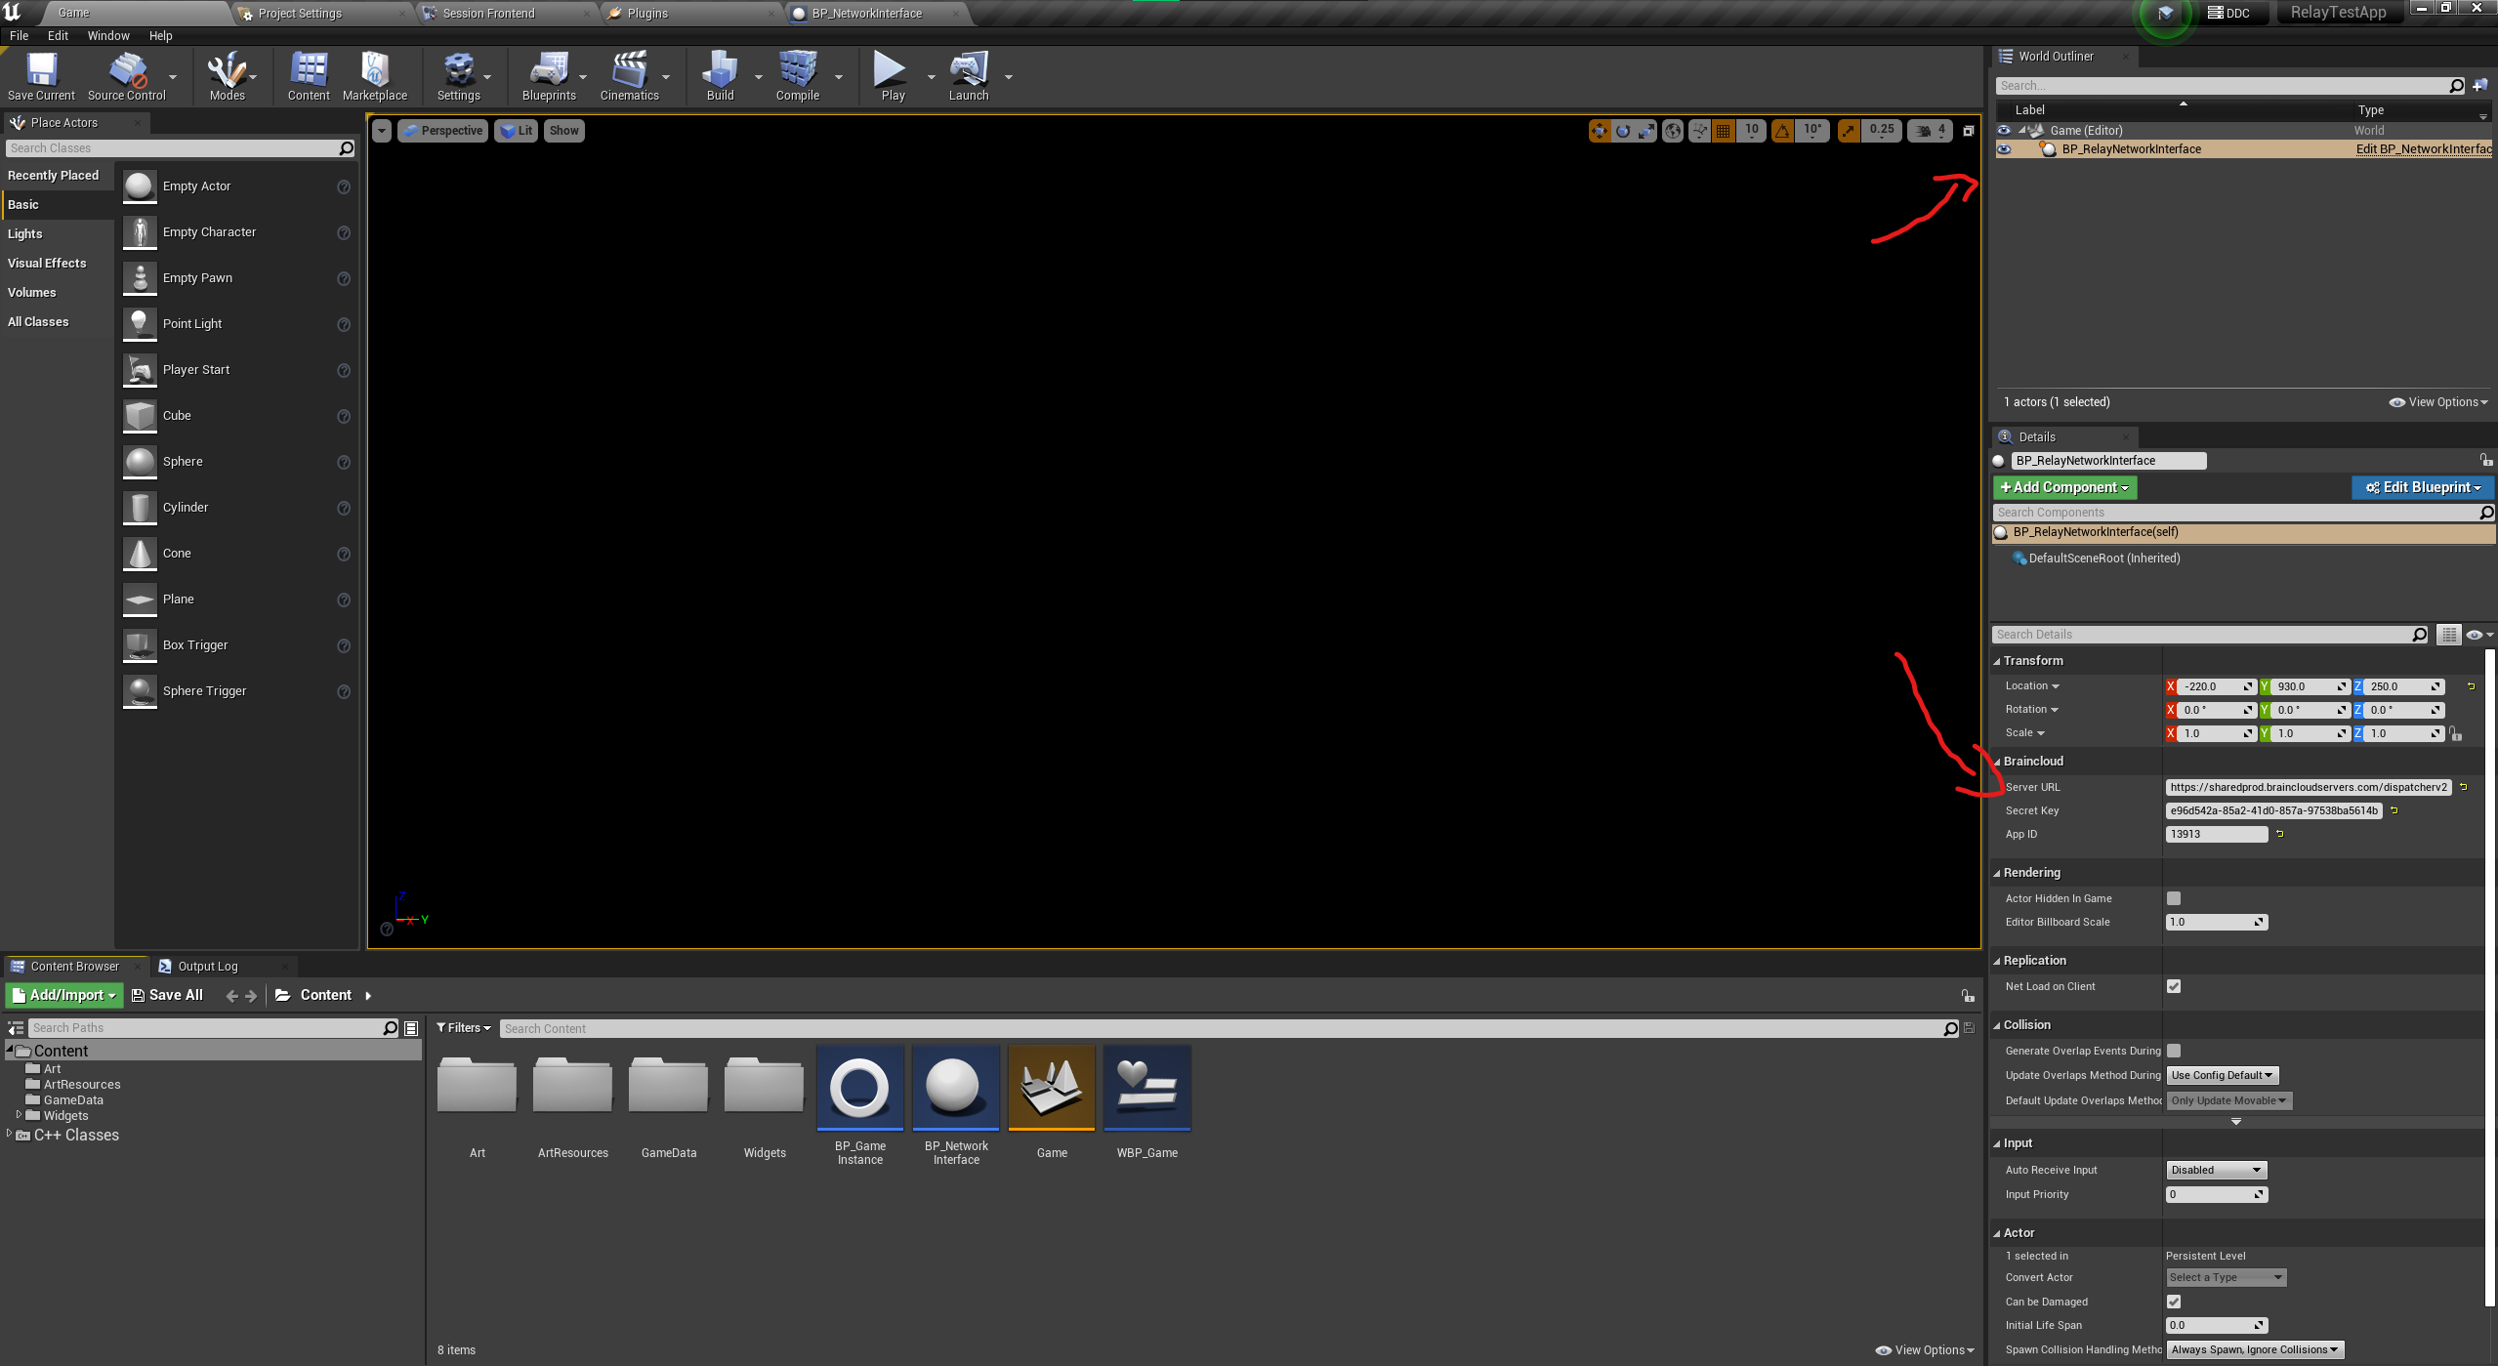
(Locating BP_RelayNetworkInterface and brainCloud details panel)

  - Now you can set the editor to be 2 players by hitting the arrow beside the Play button and adjusting “Number of Players” from 1 to 2. (Refer to picture below)
  - After you've set the number of players, from the drop down menu select “Standalone Game” and this will launch the game twice to simulate 2 players.
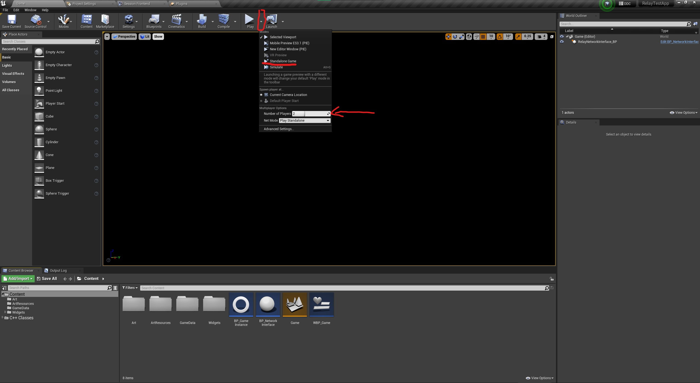
(Locating drop down menu to increase number of players and launch game from Standalone Game)
Enjoy the example game !

Unreal Assets Overview

BP_RelayNetworkInterface:
This class holds all the logic to communicate with brainCloud server and how to utilize the blueprint nodes with the brainCloud plugin. BP_RelayNetworkInterface holds the following examples:
  - Initialize brainCloud.
  - Universal Authentication.
  - Workflow to look for/create a lobby.
  - Lobby callbacks.
  - Users in lobby changing colour preference.
  - Host can start the game for the lobby
  - Handling inputs from members both local and network members.
  - Handling a user leaving a match or lobby.

BP_GameInstance:
- Game Instance holds references needed for other classes to communicate to eachother such as:
- Save data instance reference
- Local user reference
- Holds a list reference of all users in a match/lobby
- Error message handling
- Holds WBP_Game widget reference
- Function to adjust shockwave visibility for local user

Game.umap Level Blueprint:
- Sets up main widget for game and initializes the parameter such as:
- Sets game instance reference
    - Create WBP_Game widget and stores it as a local variable for Game Instance

Screen Widgets:
All screen widgets are children within the WBP_Game widget and using Widget Switcher component to alternate screens. The following can be found from Content -> Widgets -> Screens in order of appearance when playing the game (except for loading screen):
  - WBP_SignIn
  - WBP_MainMenu
  - WBP_Lobby
  - WBP_Match
  - WBP_LoadingScreen

Notes:
- “ArtResources” folder will appear blank within UE4 editior, this is intentional to get PNG files to swap cursors for other members in a lobby.

Known Issues:
- If you play from editor viewport, there will be a window size issue while in match screen, if you notice the ripple after clicking isn't near the mouse then its most likely the window being sized bigger than it should(excluding full screen), resize the window so no black filler is being shown.

