10/23/2019

**Name: Getaneh Tafere**

**ID: 110226**

**CS 311 Discrete Math and Data Structures:**

**Homework3**

1. List the members of these sets.

a) {x |x is a real number such that x2 =1}: {-1, 1}

b) {x |x is a positive integer less than 12}: {1,2, 3, 4, 5, 6, 7, 8, 9, 10, 11}

c) {x |x is the square of an integer and x<100}:{0, 1, 4, 9, 16, 25, 36, 49, 64, 81}

d) {x |x is an integer such that x2 =2}: ∅

2. Use set builder notation to give a description of each of these sets.

a) {0,3,6,9,12}: {x∈ N| x is a product of 3 which is less than 13}

b) {−3, −2,−1,0,1,2,3}: {x∈ Z| x is greater than -4 and less than 4}

c) {m, n, o, p}: {x| x is a letter in the alphabet from m to p}

4. For each of these pairs of sets, determine whether the ﬁrst is a subset of the second, the second is a subset of the ﬁrst, or neither is a subset of the other.

a) Let x: the set of people who speak English,

Let y: the set of people who speak English with an Australian accent.

y is the subset of x.

b) Let x: the set of fruits,   
Let y: the set of citrus fruits. y is the subset of x.

c) the set of students studying discrete mathematics, the set of students studying data structures. Neither is a subset of each other.

6. Suppose that A= {2,4,6}, B = {2,6}, C = {4,6}, and D = {4, 6, 8}. Determine which of these sets are subsets of which other of these sets.

B is the subset of A, C is the subset of both A and D.

9. Determine whether each of these statements is true or false.

a) 0∈∅: False

b) ∅∈ {0}: False

c) {0} ⊂ ∅: False

d) ∅⊂ {0}: True

e) {0} ∈ {0}: False

f) {0} ⊂ {0}: False

g) {∅} ⊆ {∅}: False

12. Use a Venn diagram to illustrate the subset of odd integers in the set of all positive integers not exceeding 10.

10 6 X

8 Y

1. 3

5 2 4

7 9

20. What is the cardinality (number of elements of sets) of each of these sets?

a) ∅ : 0

b) {∅}: 1

c) {∅, {∅}}:2

d) {∅, {∅}, {∅, {∅}}}: 3

21. Find the power set of each of these sets, where a and b are distinct elements.

a) {a}: {∅, {a}}

b) {a, b}: {∅, {a}, {b}, {a, b}}

c) {∅,{∅}}: {∅, {∅}, {{∅}}, {∅,{∅}}}

29. What is the Cartesian product A×B ×C, where A is the set of all airlines and B and C are both the set of all cities in the United States? Give an example of how this Cartesian product can be used.

A: all airlines

B: All cities in the United States

C: All cities in the United States

A x B x C = {(airline, city1, city2) | airline ∈ A and city1 ∈ B and city2 ∈ C

For example, if the only airlines are x and y

And the only cities are a and b,

A= {x, y}

B= {a, b}

C= {s, b)

A x B x C = {(x, a), (x, b), (y, a), (y, b)}

32. Let A= {a, b, c}, B = {x, y}, and C = {0,1}. Find

a) A×B ×C: {(a, x, 0), (a, x, 1), (a, y, 0), (a, y, 1), (b, x, 0), (b, x, 1), (b, y, 0), (b, y, 1), (c, x, 0), (c, x, 1), (c, y, 0), (c, y, 1)}

33. Find A2 if

a) A= {0,1,3}: A2  = Ax A: {(0,0), (0, 1), (0, 3), (1, 0), (1,1), (1,3), (3, 0), (3, 1), (3,3)}

34. Find A3 if

a) A= {a}: A3  =A x A x A: {(a, a, a)}

b) A= {0, a}: ={(0, 0, 0), (0, 0, a), (0, a, 0), (0, a, a), (a, 0, 0), (a, 0, a), (a, a, 0), (a, a, a)}

41. Translate each of these quantiﬁcations into English and determine its truth value.

a) ∀x∈ R (x2 ̸=−1): True

b) ∃x∈ Z (x2 =2): False

c) ∀x∈ Z (x2 > 0): False

d) ∃x∈ R (x2 =x): True

43. Find the truth set of each of these predicates where the domain is the set of integers.

a) P(x): x2 < 3: {-1, 0, 1}

b) Q(x): x2 >x: {…-4, -3, -2, -1, 2, 3, 4, …}

c) R(x):2x+1=0: ∅

1. Let A be the set of students who live within one mile of school and let B be the set of students who walk to classes. Describe the students in each of these sets.

a) A∩B: All students who live with in one mile of school and who walk to classes.

b) A∪B: All students who live within one mile of school or who walk to classes.

c) A−B: All students who live wit in one mile of school but who do not walk to classes.

d) B −A: All students who walk to classes but who do not live within one mile.

3. Let A= {1,2,3,4,5}and B = {0,3,6}. Find

a) A∪B: {0, 1,2,3,4,5,6}

b) A∩B: {3}

c) A−B: {1,2,4,5}

d) B −A. {0, 6}

12. Prove the ﬁrst absorption law from Table 1 by showing that if A and B are sets, then A∪(A∩B)=A.

A∩B

A B

A∪ (A ∩ B) = A

13. Prove the second absorption law from Table1 by showing that if A and B are sets, then A∩(A∪B) =A.

|  |  |  |  |
| --- | --- | --- | --- |
| A | B | A ∪ B | A ∩ (A ∪ B) |
| 0 | 0 | 0 | 0 |
| 0 | 1 | 1 | 0 |
| 1 | 0 | 1 | 1 |
| 1 | 1 | 1 | 1 |

48. Let Ai = {..., −2, −1, 0, 1, ..., I}. Find

Solution

1. An = {…, -2, -1, 0, 1, …, n}
2. An= {…, -2, -1, 0, 1}

52. Suppose that the universal set is U ={ 1,2,3,4, 5,6,7,8,9,10}. Express each of these sets with bit strings where the ith bit in the string is 1 if i is in the set and 0 otherwise.

a) {3,4,5}: 0011100000

b) {1,3,6,10}: 1010010001

c) {2,3,4,7,8,9}: 0111001110

53. Using the same universal set as in the last problem, ﬁnd the set speciﬁed by each of these bit strings. a) 11 1100 1111: {1,2,3,4,7,8,9,10}

b) 01 0111 1000: {2,4,5,6,7}

c) 10 0000 0001: {1,10}

6. Find the domain and range of these functions.

a) the function that assigns to each pair of positive integers the ﬁrst integer of the pair

Domain= (N-{0)} and Range= N-{0}

b) the function that assigns to each positive integer its largest decimal digit

Domain= {1, 2, …} and Range= N

c) the function that assigns to a bit string the number of ones minus the number of zeros in the string

Domain= set of all bit string and Range= Z

d) the function that assigns to each positive integer the largest integer not exceeding the square root of the integer

Domain= {1, 2, 3, …} and Range= N

e) the function that assigns to a bit string the longest string of ones in the string

Domain= set of all bit string and Range= {1, 11 ,… }

8. Find these values.

a) ⌊1.1⌋= 1

e) ⌈2.99⌉= 3

12. Determine whether each of these functions from Z to Z is one-to-one.

a) f(n)=n−1: one-to-one

b) f(n)=n2+1: Not one-to-one

33. Suppose that g is a function from A to B and f is a function from B to C.

a) Show that if both f and g are one-to-one functions, then f ◦g is also one-to-one.

f is one-to-one If f(x)= f(y), then x= y

g is one-to-one If f(x)= f(y), then x= y

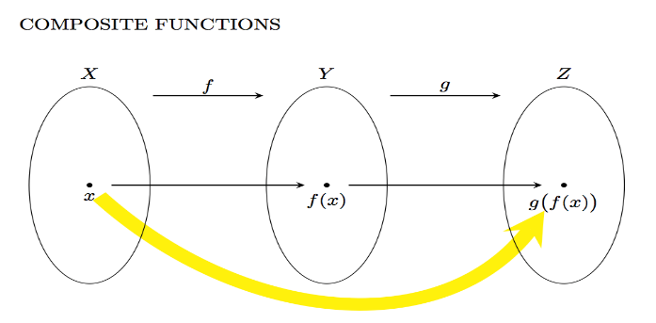

62. Draw the graph of the function f(n)=1−n2 from Z to Z.

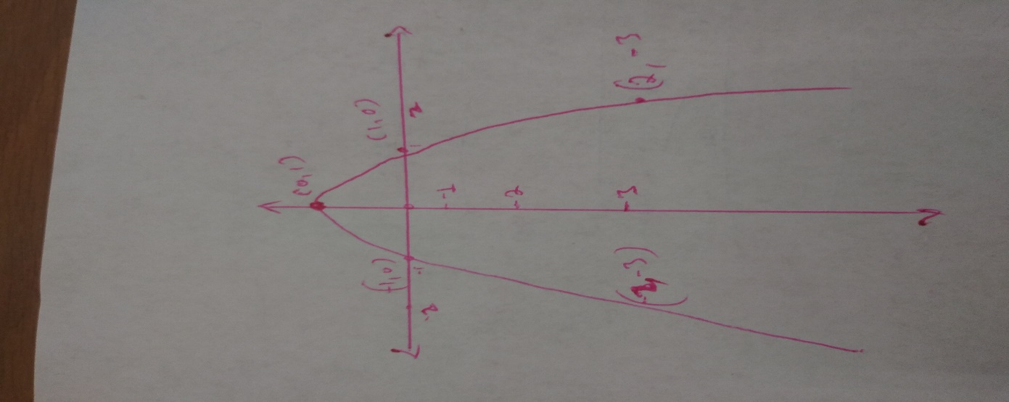

63. Draw the graph of the function f(x)=⌊2x⌋ from R to R.

