Antartica
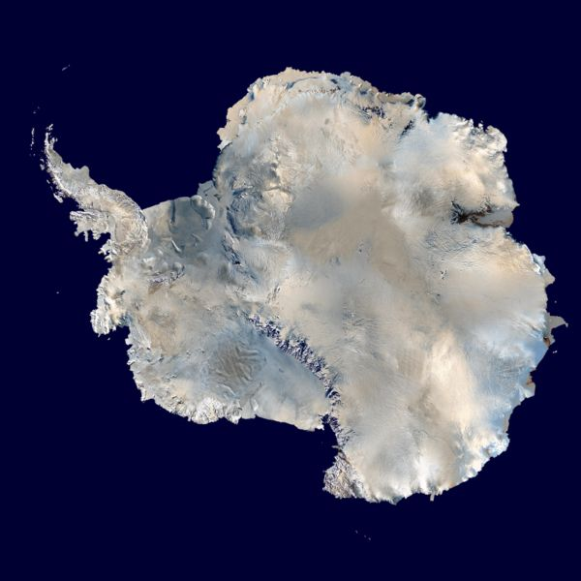
Centered asymmetrically around the South Pole and largely south of the Antarctic Circle, Antarctica is the southernmost continent and is surrounded by the Southern Ocean; alternatively, it may be considered to be surrounded by the southern Pacific, Atlantic, and Indian Oceans, or by the southern waters of the World Ocean. It covers more than 14 million km² (5.4 million sq mi), making it the fifth-largest continent, about 1.3 times larger than Europe. The coastline measures 17,968 kilometers (11,160 mi) and is mostly characterized by ice formations, as the following table shows:
Coastal types around Antarctica (Drewry, 1983)
Type | Frequency
Ice shelf (floating ice front) | 44%
Ice walls (resting on ground) | 38%
Ice stream/outlet glacier (ice front or ice wall) | 13%
Rock | 4%
Total | 100%

Antarctica is divided in two by the Transantarctic Mountains close to the neck between the Ross Sea and the Weddell Sea. The portion west of the Weddell Sea and east of the Ross Sea is called Western Antarctica and the remainder Eastern Antarctica, because they roughly correspond to the Western and Eastern Hemispheres relative to the Greenwich meridian.
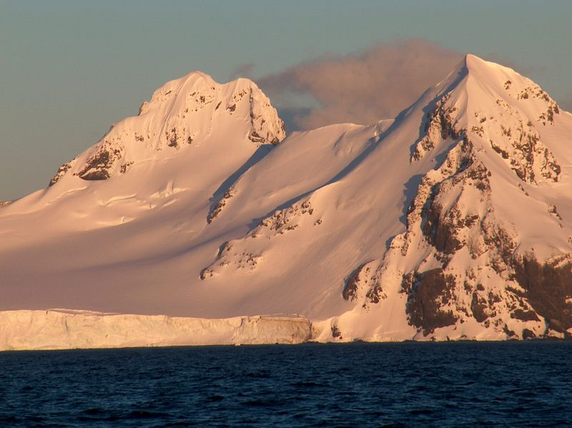
About 98% of Antarctica is covered by the Antarctic ice sheet, a sheet of ice averaging at least 1.6 kilometers (1.0 mi) thick. The continent has about 90% of the world's ice (and thereby about 70% of the world's fresh water). If all of this ice were melted, sea levels would rise about 60 meters (200 ft).[17] In most of the interior of the continent, precipitation is very low, down to 20 millimeters (0.8 in) per year; in a few "blue ice" areas precipitation is lower than mass loss by sublimation and so the local mass balance is negative. In the dry valleys the same effect occurs over a rock base, leading to a desiccated landscape.
Western Antarctica is covered by the West Antarctic Ice Sheet. The sheet has been of recent concern because of the real, if small, possibility of its collapse. If the sheet were to break down, ocean levels would rise by several meters in a relatively geologically short period of time, perhaps a matter of centuries. Several Antarctic ice streams, which account for about 10% of the ice sheet, flow to one of the many Antarctic ice shelves.

