Contents

Run webserver on the createjs code folder: 1

Open in browser: 2

Child index change 3

TASK1: 4

Class Work Jan 31st – COMP397 – Al Roben Adriane **Goh** – 300910584

# Run webserver on the createjs code folder:

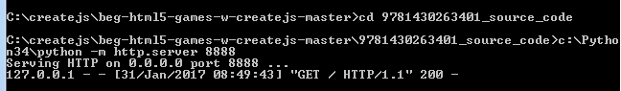

# Open in browser:

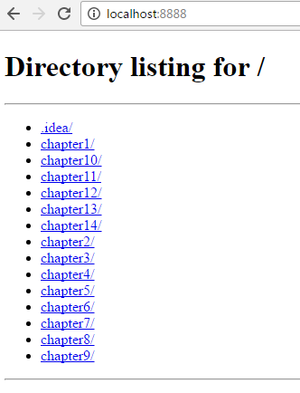

# Child index change

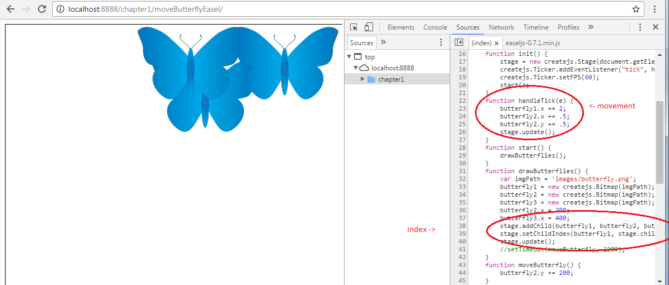

# TASK1:

. Copy folder moveButterflyEasel to moveButterflyEasel_Task1

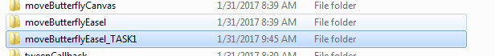

. Get an image from internet and put it in images subfolder (ex. A dog, cat, cow, horse, dragon etc)

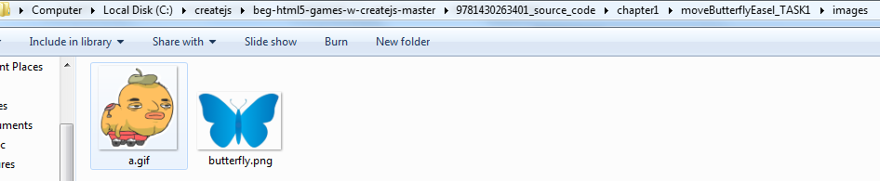

. Create a drawX function to draw 4 of them in a checkerboard pattern

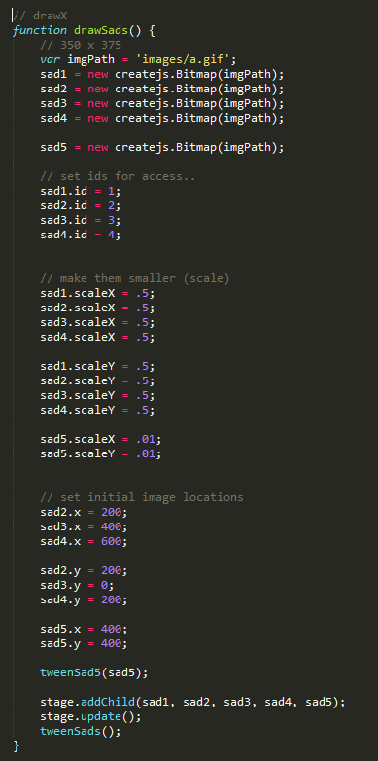

. Create a moveX function to switch places of

