**DevOps**

**Day 1**

**Activity 3: Pipeline execution in Jenkins**

Table of Contents

Table of Contents 2

Activity: Pipeline execution in Jenkins 3

Login to Jenkins 4

Make changes and triggering pipeline 4

Application Deployment 7

Troubleshooting 9

Activity: Pipeline execution in Jenkins

The list of steps to be performed in this activity is given below:

|  | **Task Description** | **Target Date for Completion** | **Supporting Documents/Personnel** |
| --- | --- | --- | --- |
|  | Login to Jenkins | Day1 | Faculty, Participants |
|  | Making changes and triggering pipeline | Day 1 | Participants |
|  | Application Deployment | Day 1 | Participants |

**Activity Duration:** 45 minutes

**Activity Description:**

Activity Type: Individual

Purpose: In this module, the activity aims in triggering pipeline execution by making changes in an existing project and perform manual deployment of pipeline.

**Technical Overview:** In this activity, you will clone the project, make changes and trigger pipeline execution.

**Activity Inputs/Templates:** NA

**Activity Instructions:**

Login to Jenkins

Follow the below steps to login to Jenkins.

1. Go to the DevOps Academy Jenkins instance http://<public-IP>/jenkins  
   <public-IP> can be found from the EC2 instances public IP.
2. After login you should be directed to the Jenkins dashboard which looks like as shown below with "Admin User" in the top right.

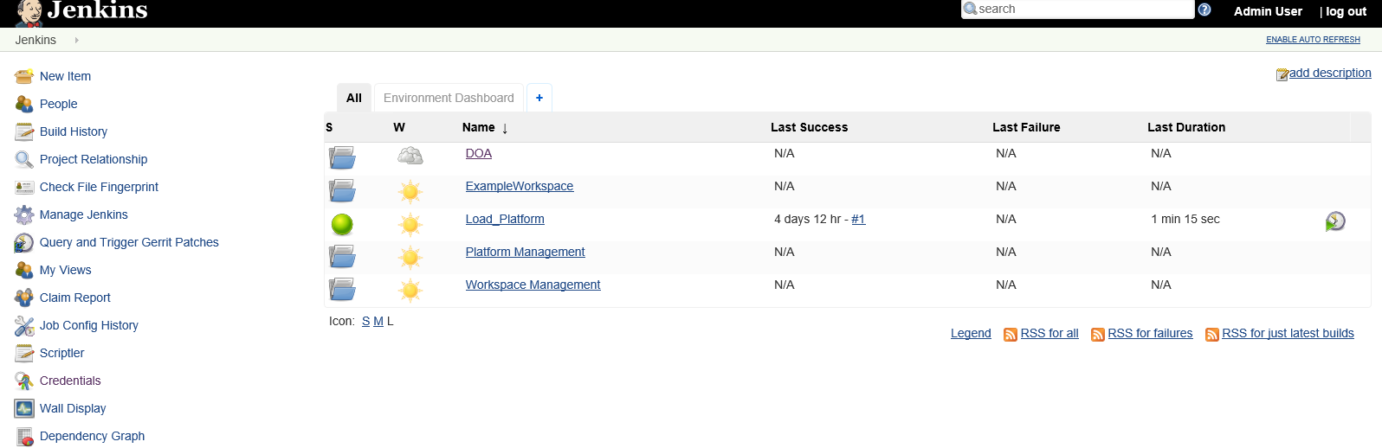

Make changes and triggering pipeline

1. Navigate to your Gerrit server by typing <http://public-ip/gerrit/> URL or this link is available from ADOP home page also.
2. Click 'Sign in' in the top right corner of the screen



1. Sign in using the Username (**training**) / Password (**accenture123**) you specified in previous activity
2. Click "**Projects**" and then click “**List”** to browseavailable projects
3. Click "**Projects**" and then click on “DOA/Labs/Modue2_Module3_FOSS_Java/spring-petclinic”

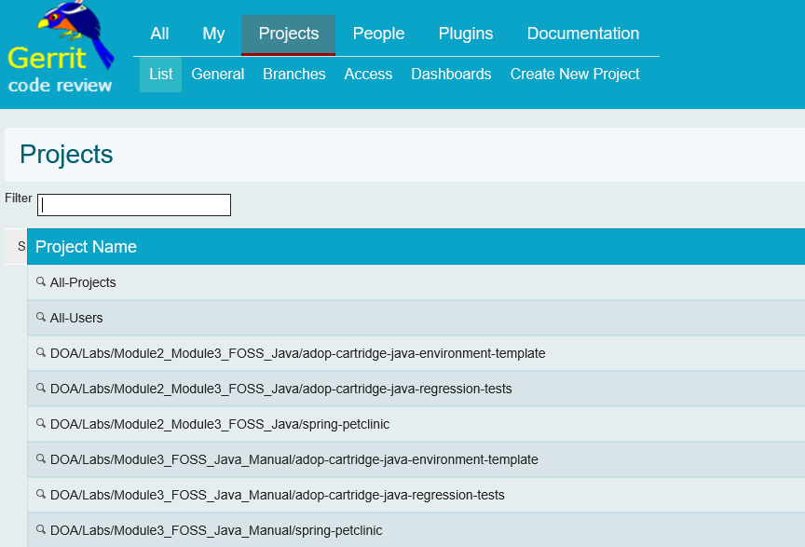

1. Copy the clone command which is visible in Gerrit as shown below

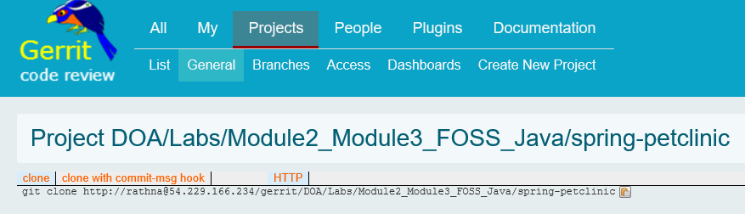

1. Navigate to Git and execute the clone command
2. Move to spring-petclinic directory

cd spring-petclinic/

1. Create and switch to the development branch

git checkout -b develop

1. Make a change to the code
   1. Manually open messages.properties file which exists in the folder path of “c:/Data/DevOpsAcademy/spring-petclinic/src/main/resources/messages”
   2. change "welcome=Welcome” in message.properties file to "welcome=Welcome to my petclinic!“
2. Commit and push changes
   1. git add .
   2. git commit -m "Updated welcome banner"
   3. git push --set-upstream origin develop
3. Merge the changes to master
   1. git checkout master
   2. git merge develop
   3. git push
4. Navigate to the Jenkins dashboard page and click on

DOA->Labs->Module2_Module3_FOSS_Java-> Java_Reference_Application tab

1. View the new build and watch it progress through the pipeline

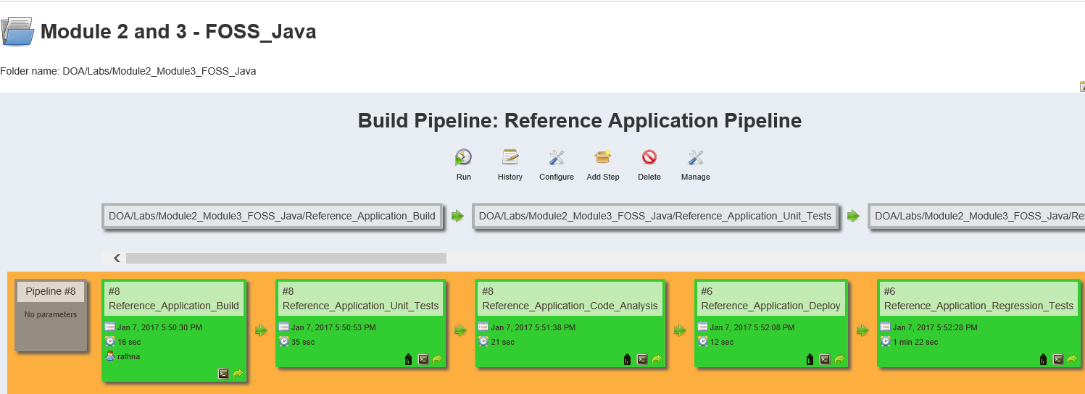

1. Once the Reference_Application_Deploy job was successful (green), navigate to the CI environment to view the deployed application

<http://DOA_Labs_Module2_Module3_FOSS_Java_CI.publicip.xip.io/petclinic>

*change the* ***publicip*** *to the ADOP page ipaddress.*

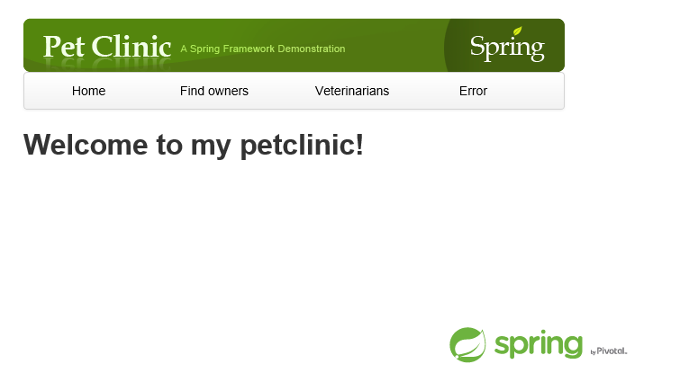

Troubleshooting

1. If Pipeline fails at performance testing job, follow the below steps:
   1. Click on “Reference Application Performance Test” Job
   2. Click on “configure” link to open the configuration
   3. Go to the Jmeter configuration as shown below in execute shell section and make sure that the link to get Jmeter is as

wget <https://archive.apache.org/dist/jmeter/binaries/apache-jmeter-2.13.tgz>

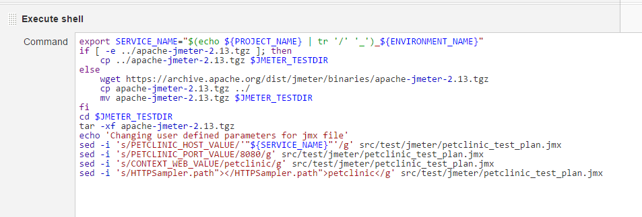

* 1. Execute the pipeline again.