**Step 1:**

Make sure you execute the Module 3 Java Manual Pipeline successfully

Case 1:

If the pipeline is executed successfully then you can proceed to Step no 5:

Else

Follow the below steps

Step 1.1

Go to DOA -🡪 LABS 🡪 MODULE 3 FOSS JAVA MANUAL and execute the pipeline manually.

The pipeline would not execute completely and hence you need to follow the below seqential steps

1. Go to job Reference Application Code Analysis
2. Click Configure option
3. Go to Post build Actions (Delete the previous post build action if any )
4. Click on Add Post build Actions 🡪 Select “Trigger Parameterized build on other projects”
5. And in Projects to build text box : Type the below path

DOA/Labs/Module3_FOSS_Java_Manual/Reference_Application_Deploy

1. In Trigger when build is drop down box : select the below one

Stable or unstable but not failed

1. In Text box of “Parameters” : Put the below parameters in the parameters text box

B=${B}

PARENT_BUILD=${PARENT_BUILD}

After completed the above steps your screen in jenkins should like below (screen shot for your reference)

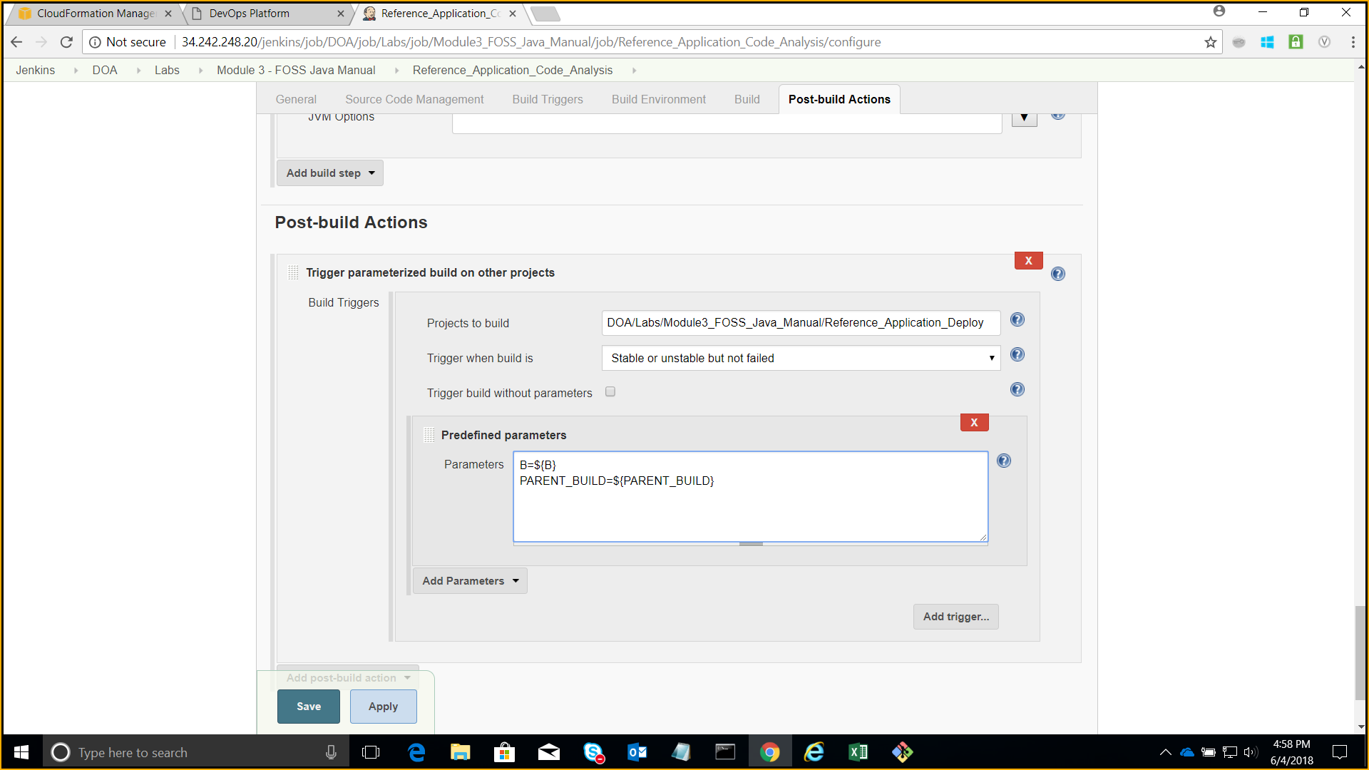

After finishing the above steps your pipeline would execute till “Reference Application Performance tests”

**Step 2:**

From the Module 3 - FOSS Java Manual folder in Jenkins select the **Create_Environment** job, then select **"Build with Parameters"** as shown in screen capture below:-

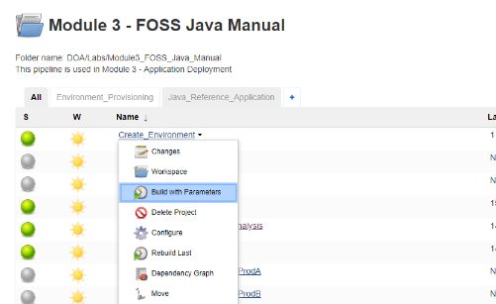

**Step3:**

From the drop-down list select **PROD**, then click on **"Build"** button

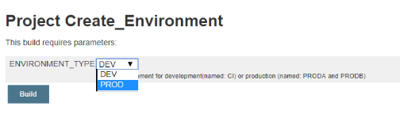

**Step4:**

1. Once the build is succeeded, go back to the Module 3 - FOSS Java Manual pipeline view and trigger the **Reference_Application_Deploy_ProdA** first.
2. You need to trigger the condition manually and then the set the value of build option to prod.
3. Once the above step (a) is executed successfully, trigger the **Reference_Application_Deploy_ProdB second**

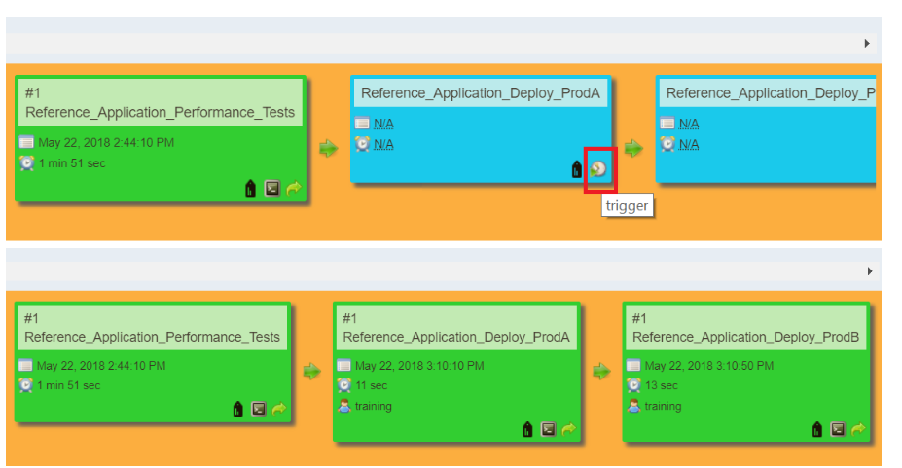

Once the Prod A and Prod B jobs have been completed successfully and green in color.

1. Click on the Console button on Reference_Application_Deploy_ProdA job and copy the URL as shown in the screen capture and replace the **PUBLIC_IP** with your stack IP address
2. As shown in the below screen shot

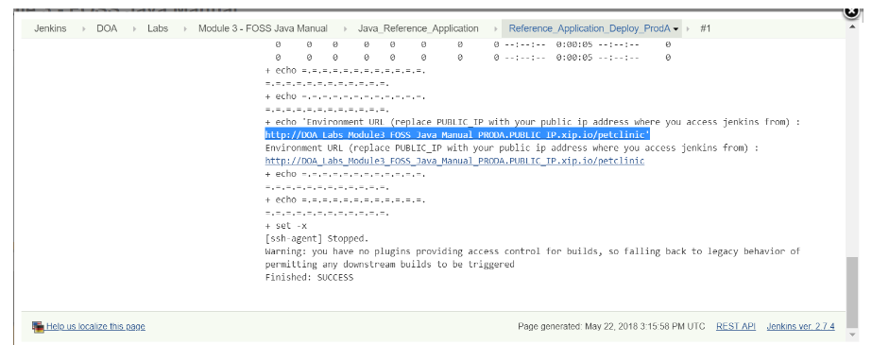

1. Use the updated URL with your stack IP address for accessing the prod version of spring petclinic application over http protocol.

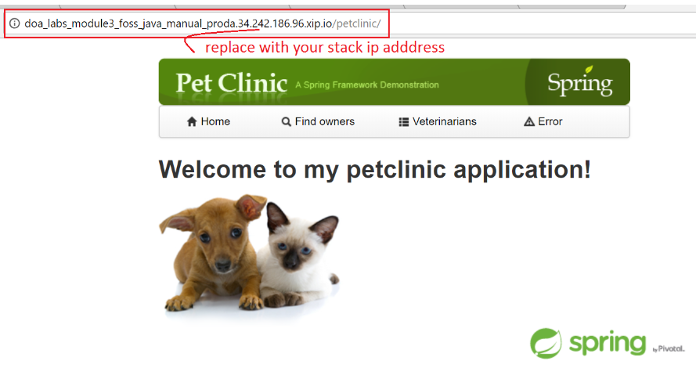

1. Similarly, you can access the URL for Reference_Application_Deploy_ProdB job through its console and replace the **PUBLIC_IP** with your stack IP address to access the application

**STEP 5)**

a) Log in to Gerrit server using your ADOP username and password.

b) Select Project -> List and then filter project on "ansible" select "DOA/Labs/Module5_Ansible/adop-cartridge-ansible-demo-scenario-playbook"

c) Clone the repository to your local machine

d) After the cloning has completed successfully

STEP 6)

Modifying ansible demo scenario playbook repository content.

1.Open the playbook.yml file in the repository for editing

* 1. Assign your stack ip address to **"host_ip"**
  2. Change the **"env_name"** variable value from   
     DOA_Labs_Module2_Module3_FOSS_Java_CI   
     to   
     **DOA_Labs_Module3_FOSS_Java_Manual_PROD**

Sending the playbook.yml file (updated) as an attachment in the mailer for your reference as the YAML file should be properly indented and we need to add the code in the playbook file. It would be easy for you to directly copy the playbook.yml file in the local repository.

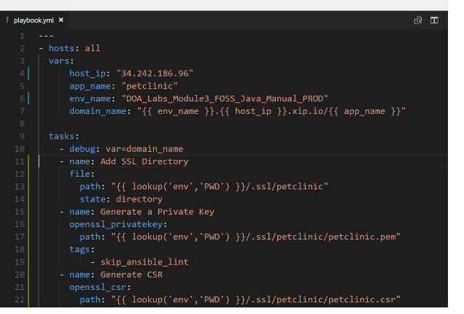

1. Rename the file from DOA_Labs_Module3_FOSS_Java_Manual_CI.conf in your adop-cartridge-ansible-demo-scenario-playbook/nginx folder to   
   **DOA_Labs_Module3_FOSS_Java_Manual_PROD.conf**
2. Look for the file **prod-tomcat.conf** as shown in the screen capture at the location   
   http://<public-IP>/jenkins/job/DOA/job/Labs/job/Module3_FOSS_Java_Manual/job/Create_Environment/ws/

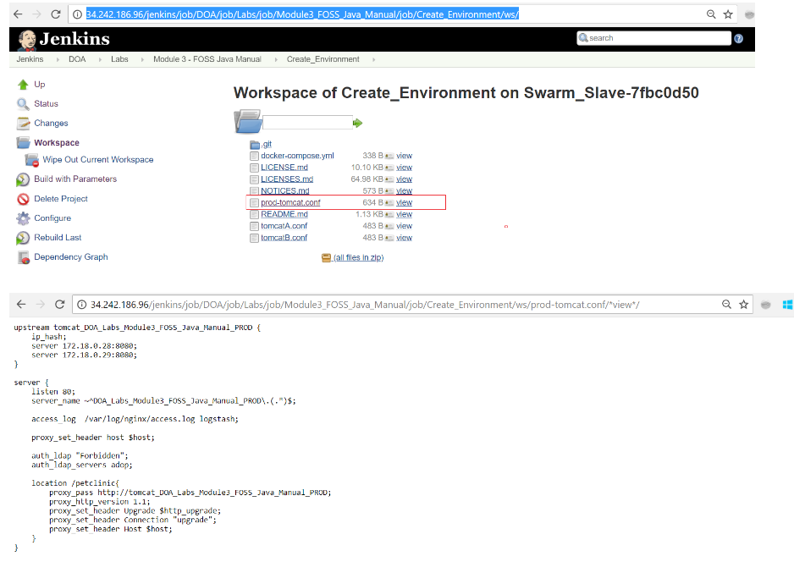

1. Replace the content of DOA_Labs_Module3_FOSS_Java_Manual_PROD.conf in your repository nginx directory with the content of the prod-tomcat.conf that you viewed in previous step.

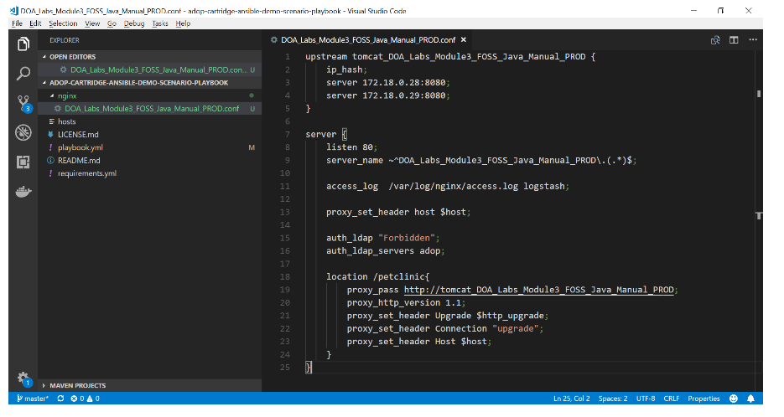

1. Add the following code snippet before the server block in the DOA_Labs_Module3_FOSS_Java_Manual_PROD.conf to redirect the http calls on port 80 to secure layer.

server {

    listen 80;

    server_name ~^DOA_Labs_Module3_FOSS_Java_Manual_PROD\.(.*)$;

    return 301 [https://$host$request_uri;](https://$host$request_uri;/)

}

1. Add the following line of codes to listen on secure layer and using the ssl certificates.

listen 443 ssl;

server_name ~^DOA_Labs_Module3_FOSS_Java_Manual_PROD\.(.*)$;

ssl_certificate /etc/nginx/ssl/petclinic.crt;

ssl_certificate_key /etc/nginx/ssl/petclinic.pem;

1. The final DOA_Labs_Module3_FOSS_Java_Manual_PROD.conf looks like below after making the necessary changes:

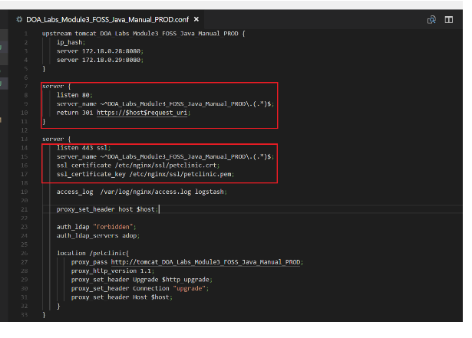

STEP 7:-

**Pushing the changes of ansible demo scenario playbook repository through GIT BASH Prompt.**

1. **Once the changes are pushed you can view the playbook pipeline in Jenkins at:   
   *http://<public-IP>/jenkins/job/DOA/job/Labs/job/Module5_Ansible/view/Playbook_Pipeline/***

<http://34.242.248.20/jenkins/job/DOA/job/Labs/job/Module5_Ansible/view/Playbook_Pipeline/>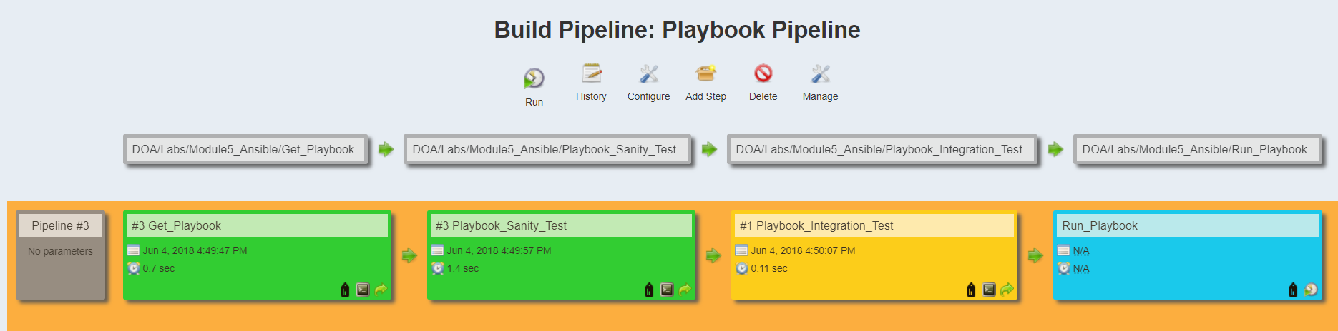

**NOTE:** **Playbook_Integration_Test** job will be yellow since test cases are not available

1. **Execute the "Run_Playbook" job manually.**

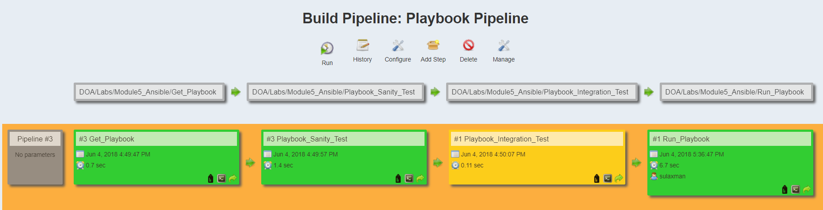

**Viewing the spring petclinic application on HTTPS.**

1. **Open the console output of Run_Playbook and verify at the end status as NGINX reloaded**
2. **Copy the domain_name value from the log to new browser window and based on the new NGINX configuration it is redirected from HTTP to HTTPS.**

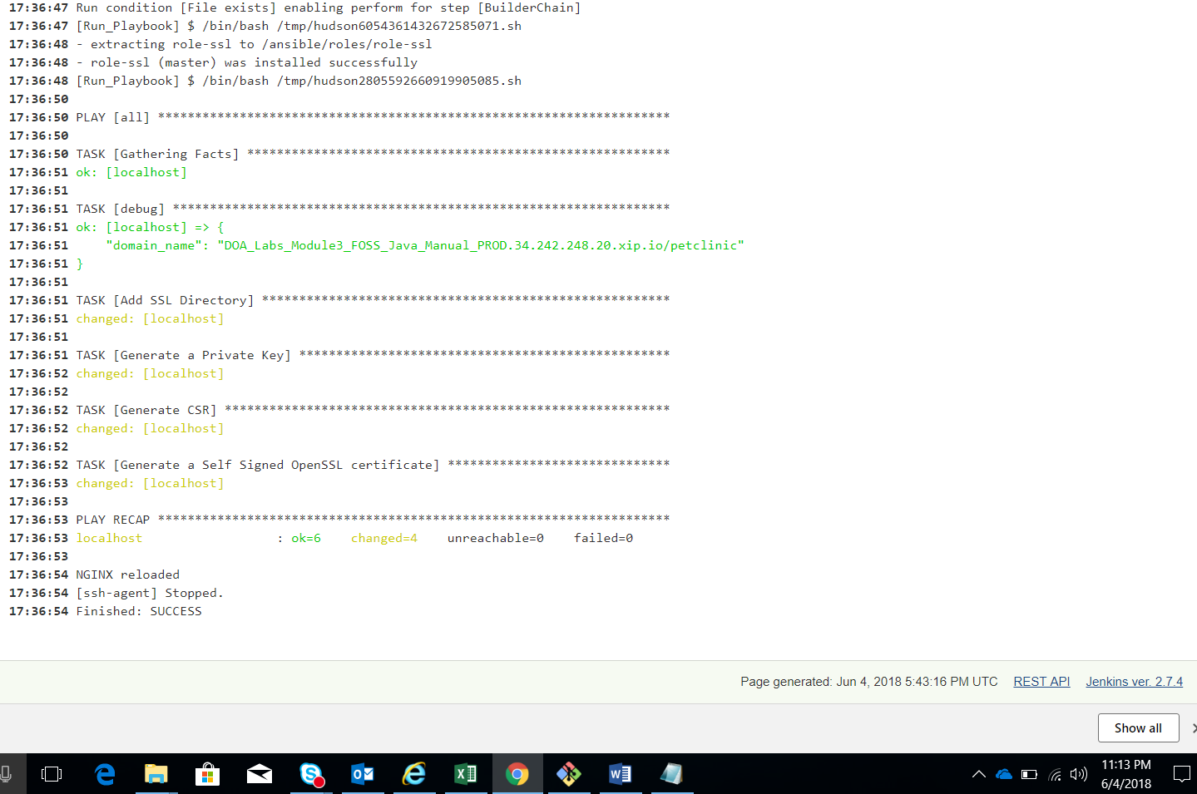

1. **Based on your browser settings you can proceed to load the page. The screen capture below is given for chrome browser where you can.** 
   1. **Click on ADVANCED link**
2. DOA_Labs_Module3_FOSS_Java_Manual_PROD.34.242.248.20.xip.io/petclinic

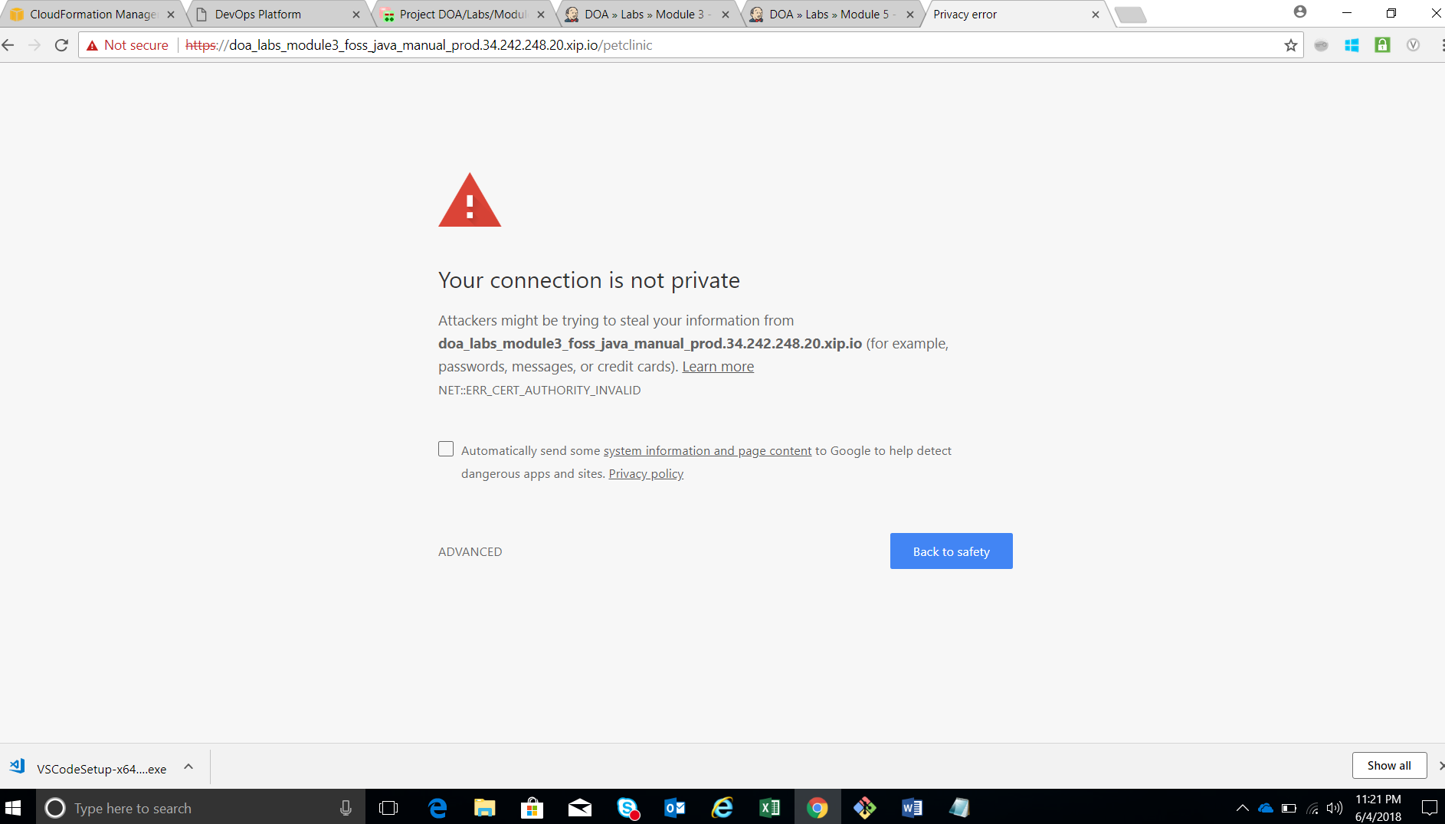

Then click on **Proceed to** link which has been marked as unsafe

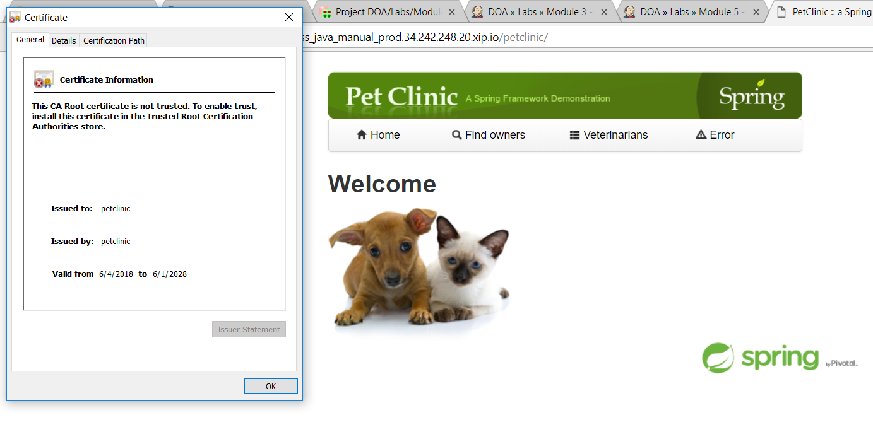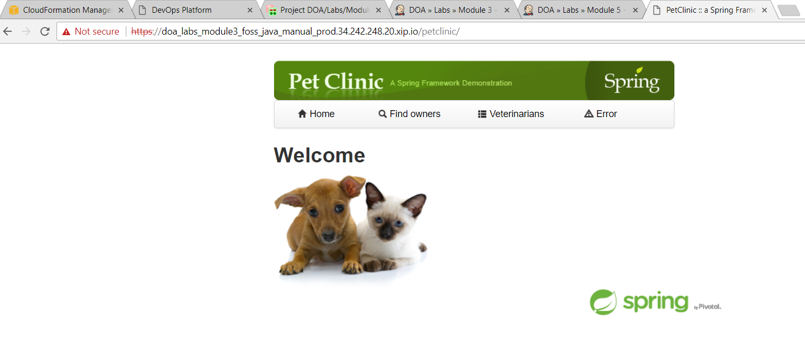

**Hope you would complete the above LAB activity successfully**

**If you have any queries you can reach out to us.**

**References**

**Best Link to use to format your YAML Code**

<https://jsonformatter.org/yaml-formatter>