**DevOps**

**Day 2**

**Activity 3: PAAS**

Table of Contents

Table of Contents 2

Activity: PAAS 3

Creating stack with Tomcat 7 4

Patching Tomcat Version(From Tomcat 7 to Tomcat 8) 6

Verify Patched Tomcat Version 7

Application Deployment 8

Troubleshooting 8

Activity: PAAS

The list of steps to be performed in this activity is given below:

|  | **Task Description** | **Target Date for Completion** | **Supporting Documents/Personnel** |
| --- | --- | --- | --- |
|  | Creating stack with Tomcat7 | Day 2 | Participants |
|  | Patching Tomcat Version | Day 2 | Participants |
|  | Verify Patched Tomcat version | Day 2 | Participants |
|  | Application Deployment | Day 2 | Participants |

**Activity Duration:** 30 minutes

**Activity Description:**

Activity Type: Individual

* Purpose: In this activity, only Tomcat 7 will be deployed as part of Platform as a service and updated the Tomcat instance with Tomcat 8 version. Also an web application will be deployed on Tomcat 8 version.

**Technical Overview:**

**Activity Inputs/Templates:** .pem file

**Activity Instructions:**

Creating stack with Tomcat 7

You will be creating Stack for deploying Tomcat 7 by following these steps.

**Prerequisite for Tomcat 7 stack creation:**

1. Locate "Tomcat_7.json" template file in Lab_Modules/Module_7 folder in the adop-doa-materials repository(adop-doa-materials unzipped folder used on Day1).
2. To assign custom defined Tomcat 7 instance name, follow the below steps:
   1. Open “Tomcat_7.json” in Wordpad/Notepad.
   2. The name of our instance will be governed by the text in the "Value" field of Tags section of "WebServerGroup" resource in our template file as shown below:
   3. Modify the Value(Academy-Module7-Tomcat7-**Urname**) to customize the instance name and save this file.

"Tags" : [

{

"Key" : "Name",

"Value" : "Academy-Module7-Tomcat7",

"PropagateAtLaunch" : "true“

}

]

1. Find out the VpcID and PublicSubnetID of your DevOps Academy stack created on Day1. Navigate to AWS-> Click on CloudFormation -> Select your stack and choose the "Resources" tab, then note down your stack’s "PublicSubnet" and "Vpc" details.
2. Find the availability zone of your stack(Day1) from AWS Dashboard (Services)-> AWS VPC -> Subnets, filtering using your VPC ID and find the availability zone and note down.

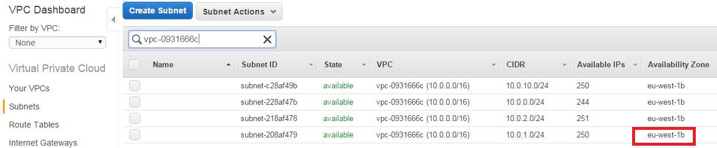

**Steps to be followed for Tomcat 7 Stack creation**

1. Log in to the AWS console and navigate to the CloudFormation service.
2. Click on "Create Stack" button.
3. In “Create New Stack” page, Select Upload template file and browse to the file "Tomcat_7.json", and then click on Next Step
4. On the next screen, enter the stack details as listed below
   1. Type a **unique text** in the **Stack Name** box to avoid conflicts with other stack
   2. Select the **same key-pair** that you have used to create your DevOps Academy stack
   3. Select the VpcID and PublicSubnetID of your DevOps Academy stack from the list of options
   4. Ensure that the availability zone of your current stack should be equivalent to the availability zone of your existing stack (Created on Day1).
5. Click Next
6. Tag the stack with "CreatedBy" key and then click on Next
7. On the Review screen, verify that all the settings are as you want them, and then click Create
8. After the status of our stack is updated as CREATE_COMPLETE, to obtain public Ip address of this stack, navigate to EC2 service page of AWS. We can get the DNS and Public IP address assigned to our instance by selecting it from the list of instances available in EC2.

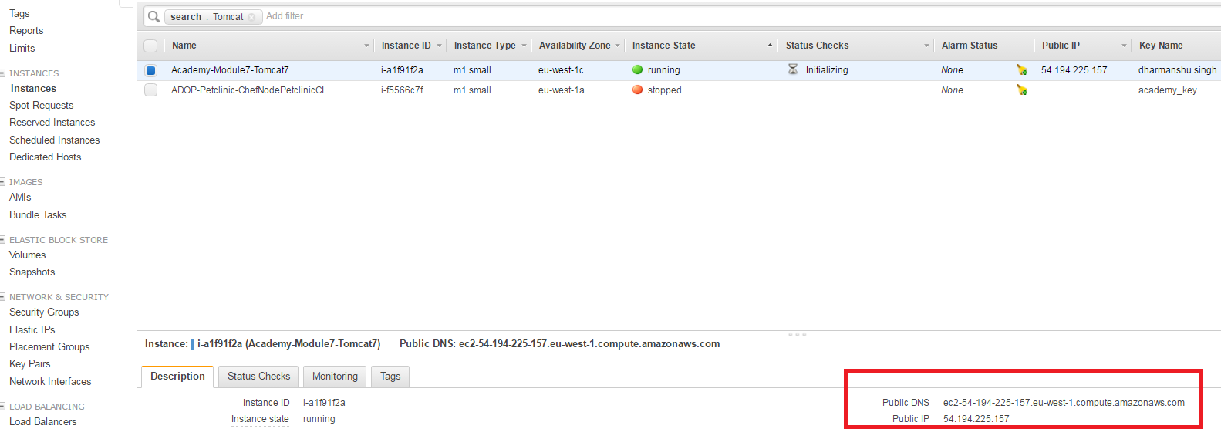

1. Verifying the newly created Tomcat 7 Instance by using its Public IP address
2. Hit the URL [**http://ipaddress**](http://ipaddress)in a browser and the default Tomcat 7 web page should be visible as shown below

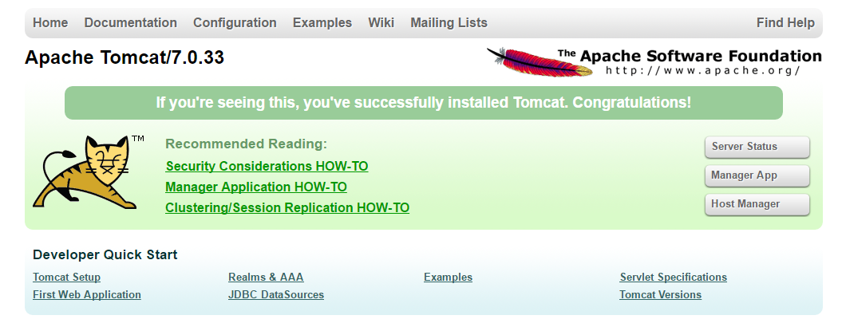

Patching Tomcat Version(From Tomcat 7 to Tomcat 8)

To update the stack from the AWS Management Console, follow the below steps:

1. Log in to the AWS CloudFormation console
2. In the AWS CloudFormation dashboard, Select the stack which you have created previously, and then select **“Update Stack”** option from Actions.
3. Select Upload template file and browse the modified template (Tomcat_8.json), and then click on Next Step
4. In the next page, leave the values as it is.
5. Click on Next Step (because the stack doesn't have a stack policy)
6. In the Review screen, verify that all the settings are filled as you want them, and then click on Update

Verify Patched Tomcat Version

1. When our stack is in the UPDATE_COMPLETE state, the changes are committed to AWS
2. Again hit the URL of the tomcat server(7), still Tomcat 7 home page will be displayed. There will not be any new change in the Tomcat instance.
3. Follow the below steps to start Tomcat 8 instance by destroying Tomcat 7 instance.
   1. Go to the EC2 service within the AWS console and stop the Tomcat instance that we previously created
      1. Search for Tomcat stack instance (Enter new tomcat stack instance)
      2. Right Click on Tomcat 7 instance and select Instance State -> Stop
   2. AWS auto-scaling facility will launch a new instance to replace it. (Wait for around 5-10 minutes to launch Tomcat 8 instance).
   3. We can verify if Tomcat 8 is running on our newly launched instance by using its Public IP address (IP address will be different for Tomcat 7 and 8).
   4. By hitting the URL, the default Tomcat 8 home page should be visible as shown below (Wait for around 5-10 minutes to complete Tomcat 8 creation).

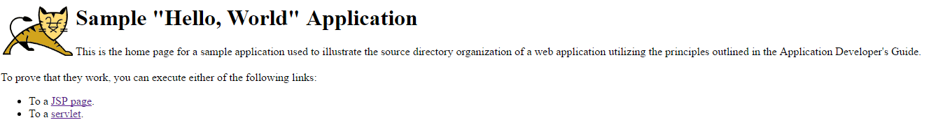

Application Deployment

1. When our stack is in the UPDATE_COMPLETE state, the changes are committed to AWS
2. Login to Jenkins
3. Navigate to the path 'DOA/Labs/ Module7_Module8_Labs/’ in Jenkins
4. Select the "Module_7_Deploy_to_Tomcat" job from the Jenkins dashboard
5. Click on "Build with Parameters" from the left hand pane
6. Click on "Add" button which exists next to SSH_KEY and Click on Jenkins.
7. Select "Secret file"(From list box) as your "Kind" of credential
8. Click on "Choose File" and select your .pem file (Faculty will share the same).
9. Ignore other fields and Click on "Add" button
10. In the "TOMCAT_IP" field, type Tomcat 8 public IP Address as shown in the below image and Click on "Build" button.

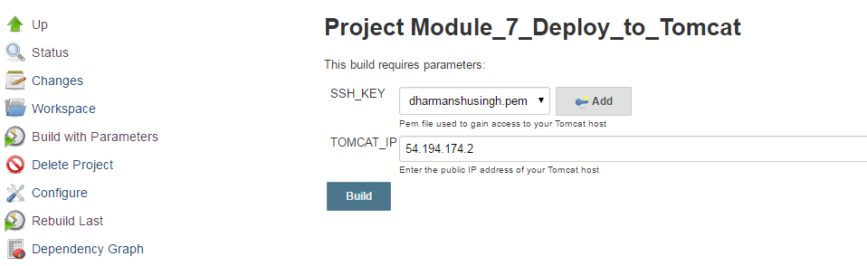

1. Verify deployment

Hit the below URL: **http://<public -ip of Tomcat 8>/petclinic**

Troubleshooting

If Tomcat7 stack creation status is updated as “Rollback_Complete”, then select the same stack. Navigate to **“Events”** tab and know about the reason behind the rollback of the stack. Reason might be one of these:

* 1. Availability zone of Tomcat 7 might be different from the availability zone of your existing stack.
  2. VPC Id and subnet Id might be different
  3. Mentioned Key Value pair might not be existing.

After finding the reason, delete the stack (if status is ROLLBACK_COMPLETE) and recreate the stack.