Centralized SOC Lab using Wazuh, Suricata and Fail2Ban
Author: Shiv Mukherjee
Project Type: SOC / Blue Team Cybersecurity Lab
Date: May 2026

1. Abstract
This project demonstrates the implementation of a centralized Security Operations Center (SOC) lab using Wazuh, Suricata, Fail2Ban, and DVWA. Multiple cyber attacks including Nmap reconnaissance, SQL Injection, and SSH brute-force attacks were simulated and monitored through a centralized SIEM environment.

2. Objectives
- Build a centralized SIEM environment.
- Integrate IDS and active response mechanisms.
- Detect and monitor cyber attacks in real time.
- Visualize logs and alerts using Wazuh Dashboard.
- Automate malicious IP blocking using Fail2Ban.

3. Architecture
Kali Linux (Attacker) → Ubuntu Victim VM (DVWA + Suricata + Fail2Ban + Wazuh Agent) → Wazuh SIEM Server

4. Tools Used
Tool | Purpose
Wazuh | SIEM/XDR monitoring
Suricata | Intrusion Detection System
Fail2Ban | Active response and IP banning
DVWA | Vulnerable web application
Nmap | Reconnaissance scanning
Hydra | SSH brute force
Sqlmap | SQL Injection testing

5. Attack Simulations and Detection

Nmap Scan Detection
Nmap reconnaissance scans were performed from the Kali Linux attacker VM. Suricata detected the scan activity and Wazuh generated related alerts.

SQL Injection Detection
SQL Injection attacks were simulated against DVWA using Sqlmap and manual payloads. The generated web logs were monitored through Wazuh.

SSH Brute Force and IP Ban
Hydra was used to perform SSH brute-force attacks. Fail2Ban detected the repeated authentication failures and automatically banned the IP.

6. Screenshots and Evidence
Screenshot 1
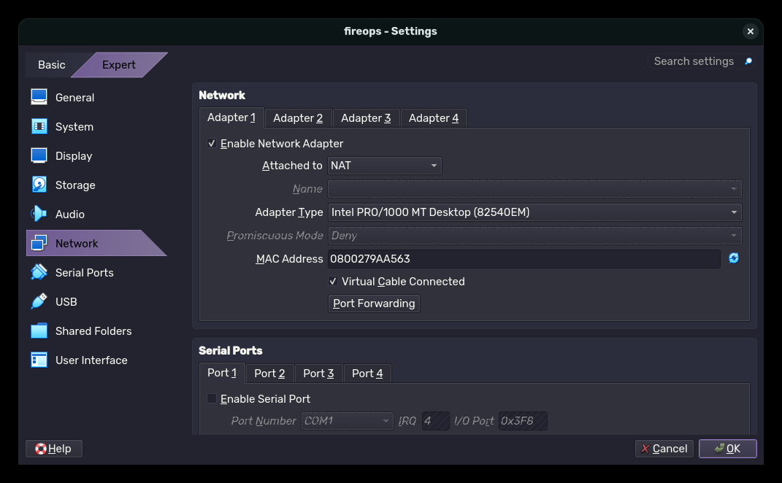
Screenshot 2
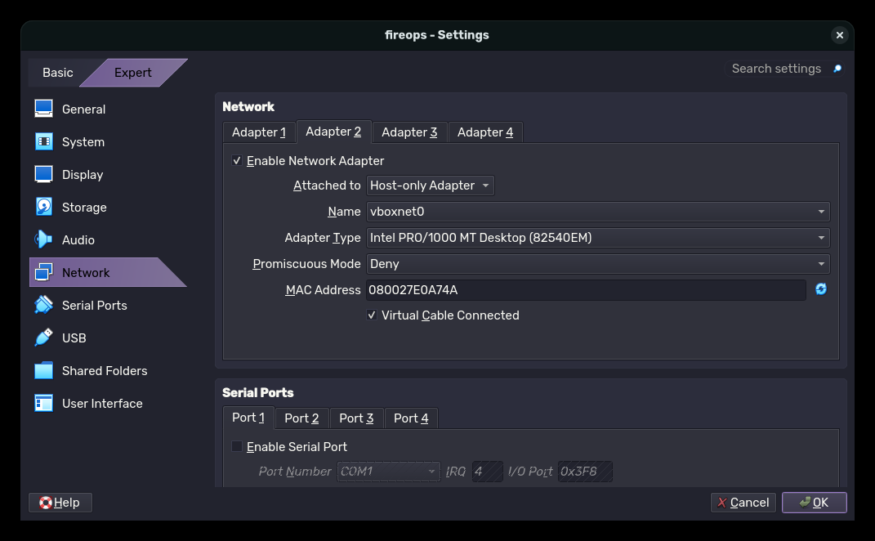
Screenshot 3
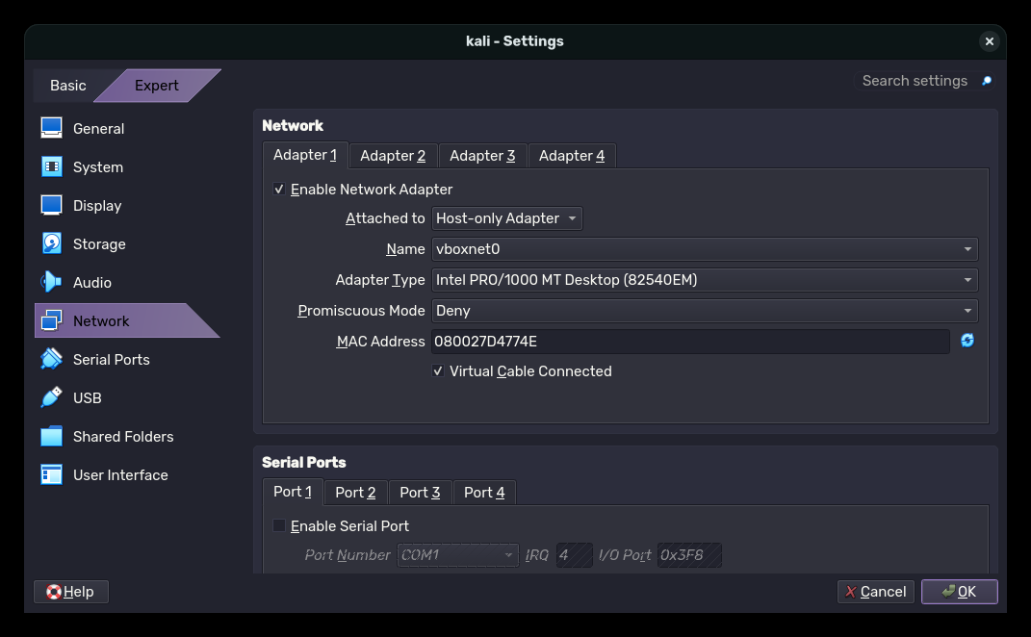
Screenshot 4
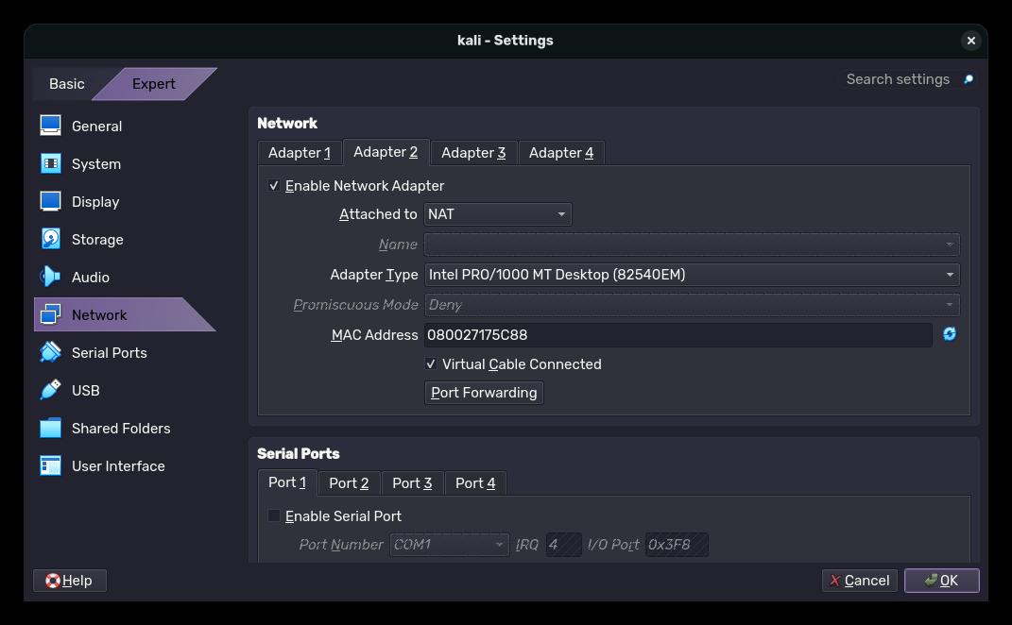
Screenshot 5
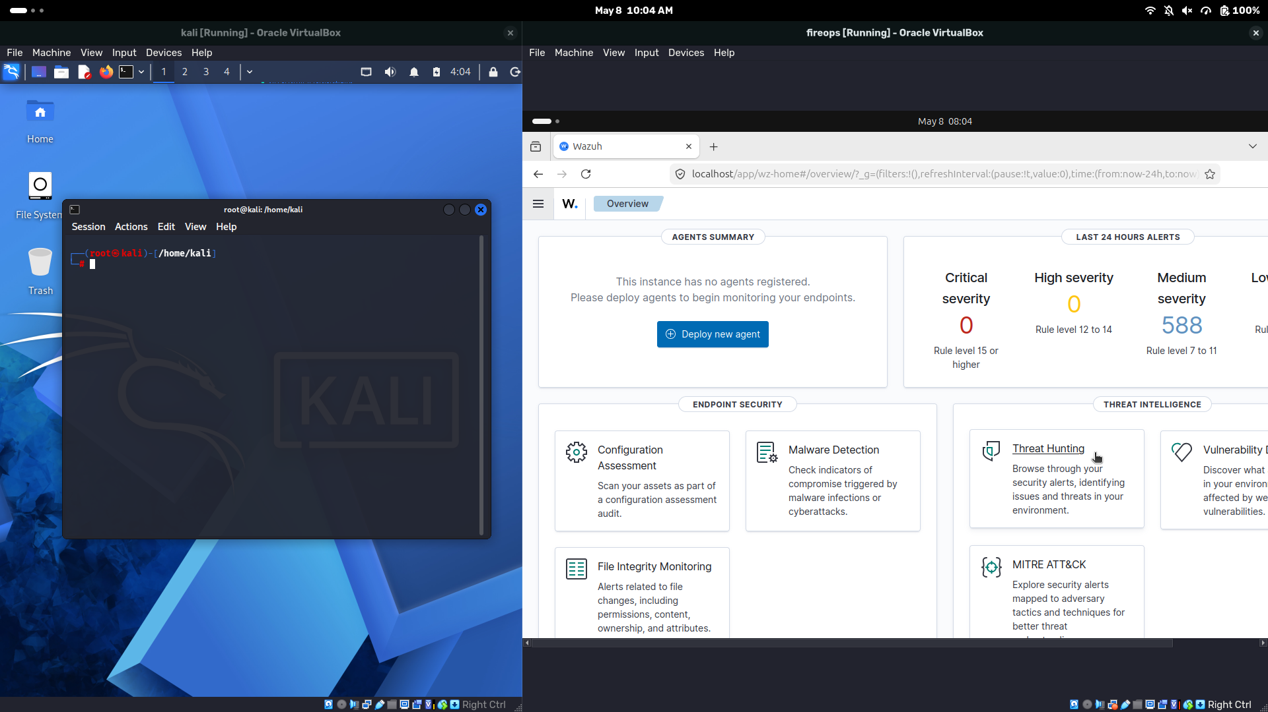
Screenshot 6
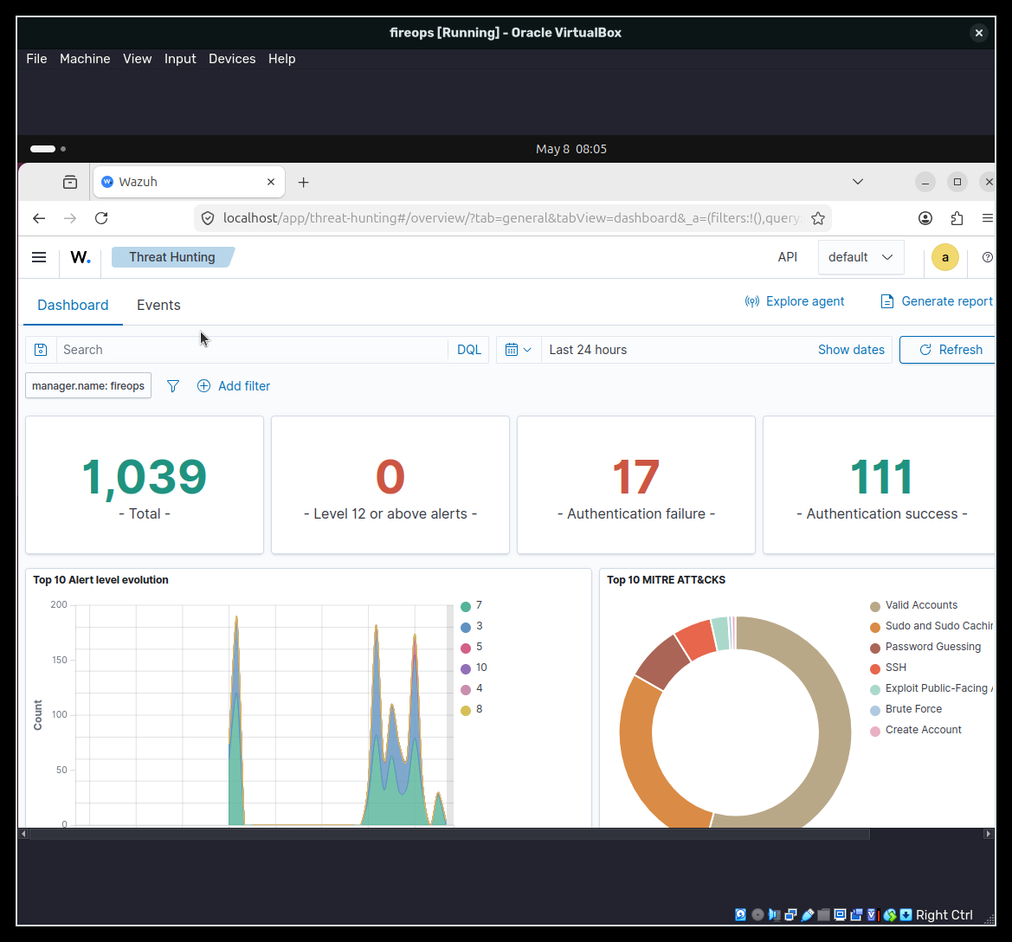
Screenshot 7
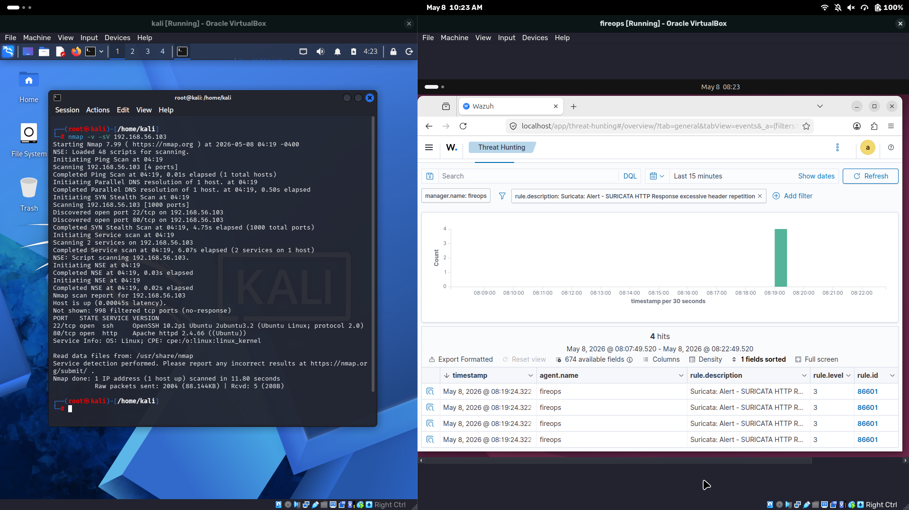
Screenshot 8
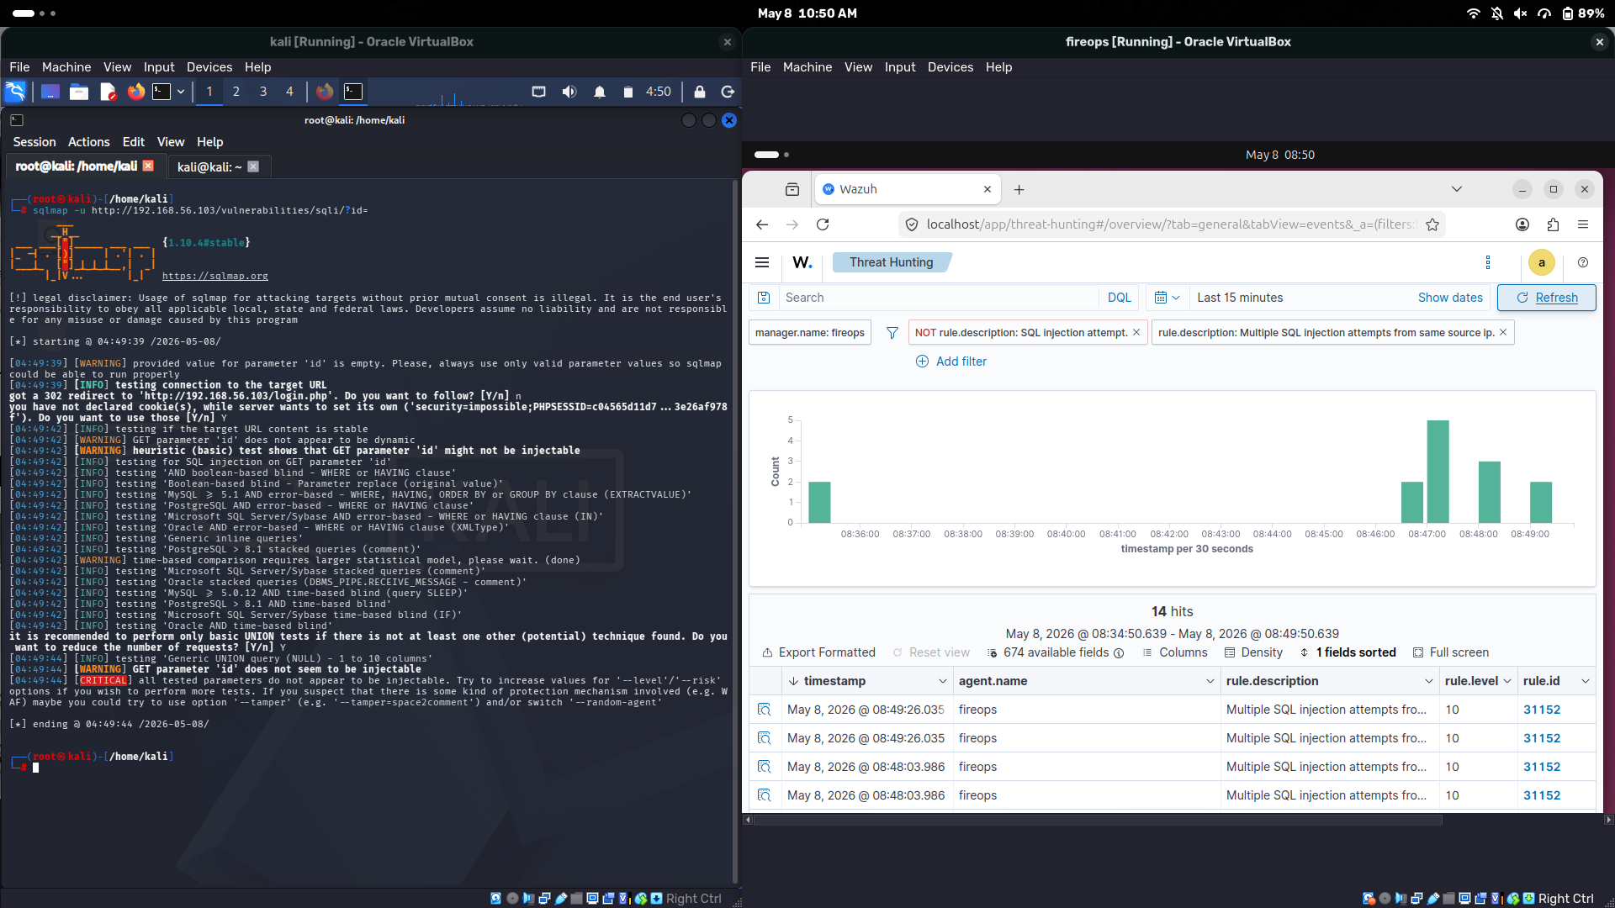
Screenshot 9
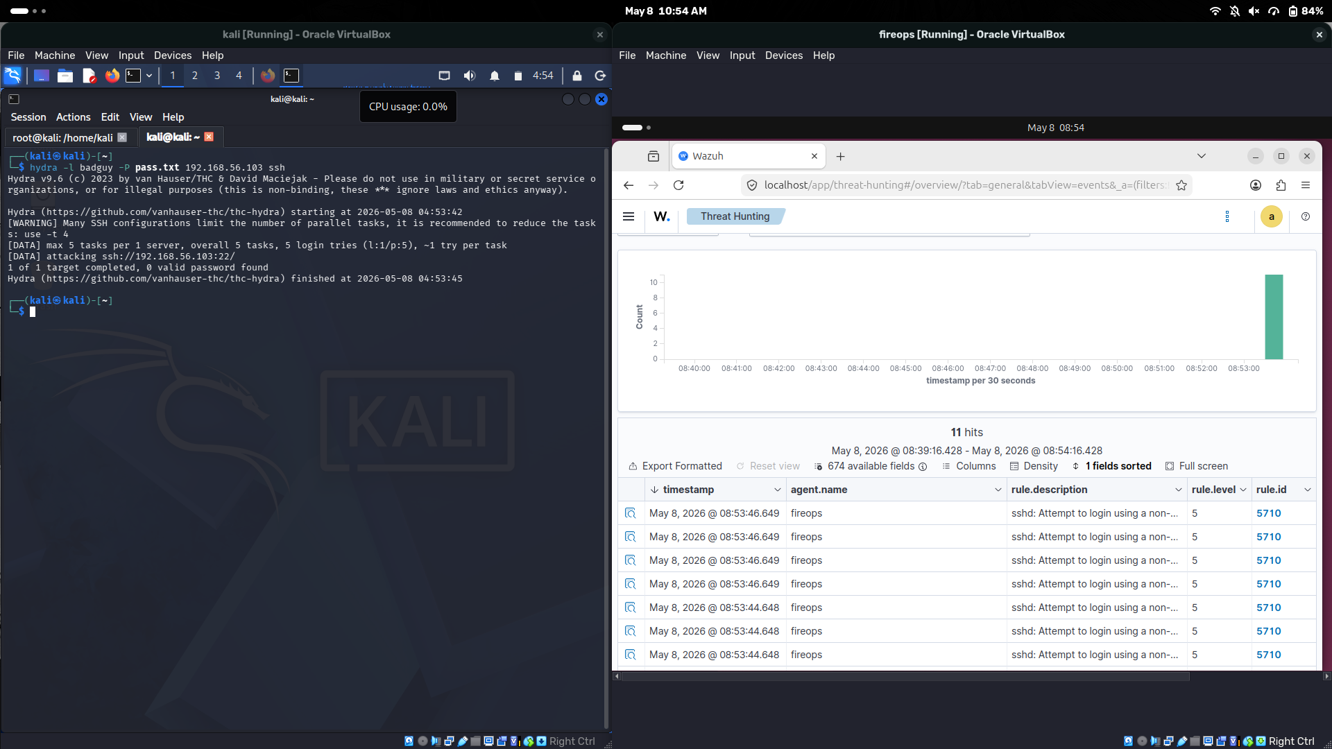
Screenshot 10
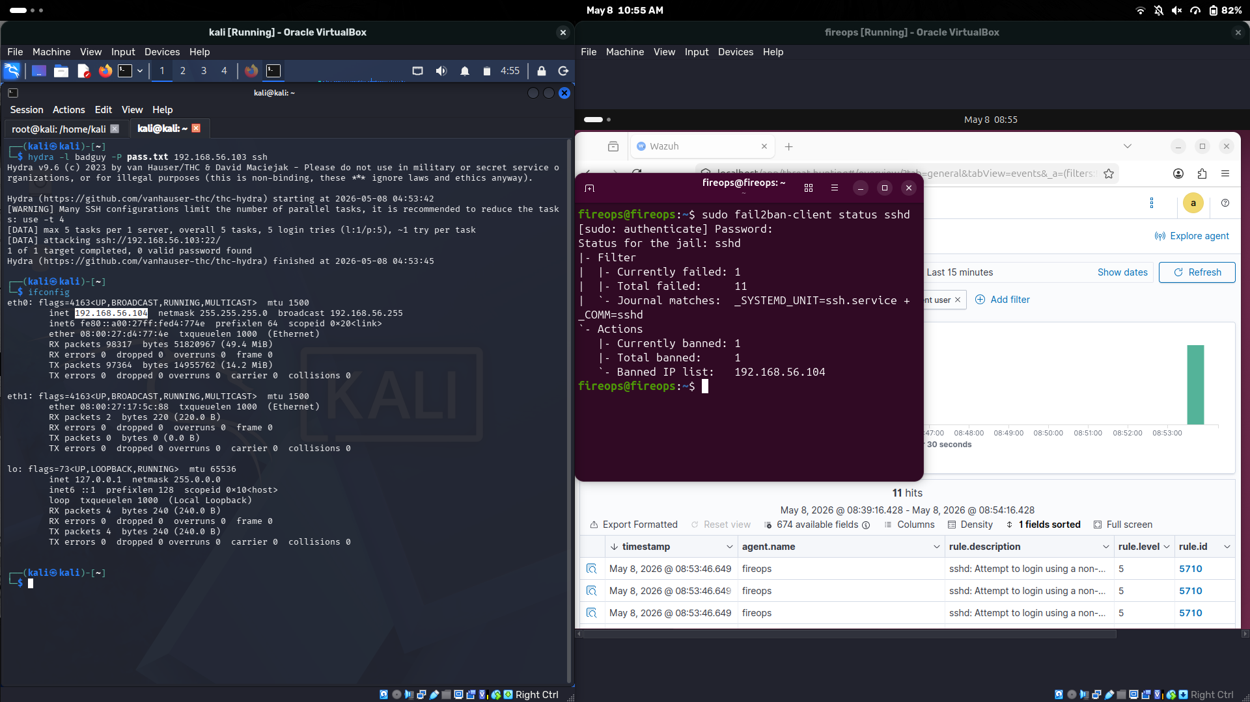

7. Log Analysis
The alerts generated by Suricata and Fail2Ban were forwarded to Wazuh for centralized analysis. The dashboard displayed attack source IP addresses, alert severity, timestamps, and triggered rules.

8. MITRE ATT&CK Mapping
Attack | Technique
Nmap Scan | T1046 - Network Service Discovery
SQL Injection | T1190 - Exploit Public-Facing Application
SSH Brute Force | T1110 - Brute Force

9. Conclusion
The project successfully demonstrated a real-world SOC environment capable of detecting, monitoring, and responding to cyber attacks using Wazuh, Suricata, and Fail2Ban.

