Magpie
Process capture for VMO2
The architecture as built
A walk through the system as it stands today — what runs, where state lives, how a single interview turn is processed, and which guarantees are enforced by code rather than by prompt.
Status | Running. Demonstrated. Pilot-ready, not yet deployed to production.
Stack | Next.js 14 · TypeScript · PostgreSQL · Anthropic API · one container
Codebase | ~7,000 lines across 38 library modules, 13 API routes and 7 pages; 217 unit and integration tests, 10 end-to-end
Quality gate | 12 facets, 40 elements, 3 interviewee personas — 9 of 9 consecutive passing runs
Document date | 5 August 2026

Contents
1. What Magpie is, and the problem it solves
2. The system at a glance
3. One turn of the interview — the central guarantee
4. The twelve facets and how coverage is decided
5. The data model
6. From interview to handover — analysis and the verification gate
7. How we know it works
8. Deployment, security and privacy
9. What is built, what is not, and what is next

1 · What Magpie is, and the problem it solves
VMO2's processes are tacit. They are held in the heads of the people who run them, and they differ from whatever was last written down. The conventional fix — a workshop, a consultant, a modeller with a notepad — does not scale past a handful of processes, and what it produces is one person's synthesis of several people's accounts.
Magpie is a structured interviewer. A person opens a link on their phone or laptop, is interviewed by an agent for twenty-five to forty minutes about how they actually do their job, reviews a playback of what was understood, and finishes. What comes out is an attributed, provenance-tagged process specification in Markdown — one per informant, per process — ready for a modeller to draft into ARIS.
Two faces, one application:
- Process user — opens a tokenised link at /i/{token}, self-identifies, is interviewed, reviews the playback. No account, no password, no training.
- Process architect — works in /console behind a password: creates campaigns, issues links, watches the register fill, downloads specifications and findings.
The five commitments the architecture exists to keep
These are not aspirations. Each is enforced by code, and each has tests that fail if it is weakened.
Commitment | What it means | How it is enforced
Model proposes, server disposes | The model never writes to the database and never invents document structure. It asks; our code decides. | All state changes go through six validated tool calls. Anything malformed is rejected and fed back.
Attribute everything, average nothing | Every statement is stored against the person who made it. Where two people disagree, both accounts survive. | Conflicts become findings for a human. Nothing is merged, averaged or overwritten — ever.
No silent gaps | Every one of the twelve facets ends in a definite state: answered, unknown to this person, or not applicable. | A session cannot complete while any facet is still pending or partial. “I don't know” is a valid, recorded answer.
Provenance is structural | Attribution and provenance are properties of the document, not something we asked the model to remember. | Emitted by the renderer in code. The model cannot omit them because it never writes them.
Privacy by design | Email addresses live in the register and never appear in a specification. There is no telemetry. | Enforced at the renderer. We capture statements about work, not behaviour about people.

2 · The system at a glance
One deployable. A container and a database — nothing else to operate.
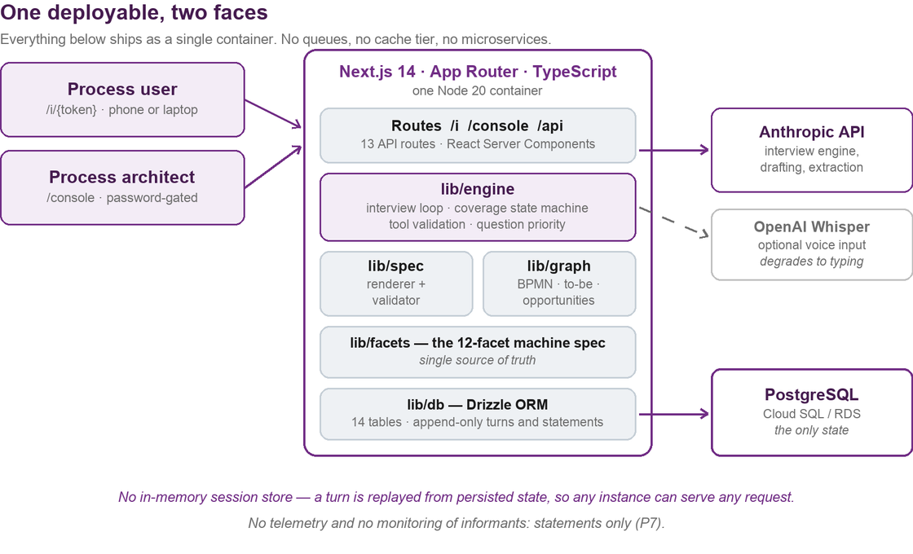
Figure 1 — Everything ships as a single Next.js container. The only state is Postgres.
The design constraint was deliberate minimalism: no queues, no Redis, no microservices, no background workers. Ten runtime dependencies in total. This is not austerity for its own sake — it is what makes the system possible for a small team to operate, and what lets it move between clouds in a day.
Layer | What it does
Routes /app | 13 API routes, a health endpoint and 7 pages. Both faces of the product served by one app.
lib/engine | The interview loop: assembling context, calling the model, validating what comes back, deciding what to ask next.
lib/facets | The twelve-facet machine specification — the single source of truth for what a complete interview means.
lib/spec | Deterministic Markdown renderer plus a validator. An invalid specification blocks completion.
lib/graph | Analysis: BPMN process maps, to-be change-sets, automation-opportunity labels, and the human verification gate.
lib/db | Drizzle ORM over 14 tables. Turns and statements are append-only.

On scaling: there is no in-memory session store. A turn is reconstructed by replaying persisted state, so any instance can serve any request and an interrupted interview resumes exactly where it stopped — including on a different server, or after a deployment. The pilot runs pinned to a single instance because it does not need more, not because it could not.
On the model: model identifier, temperature and token limits are configuration, not code. There is no model-specific logic anywhere in the application.

3 · One turn of the interview — the central guarantee
This is the most important diagram in the document. If you read one page, read this one.
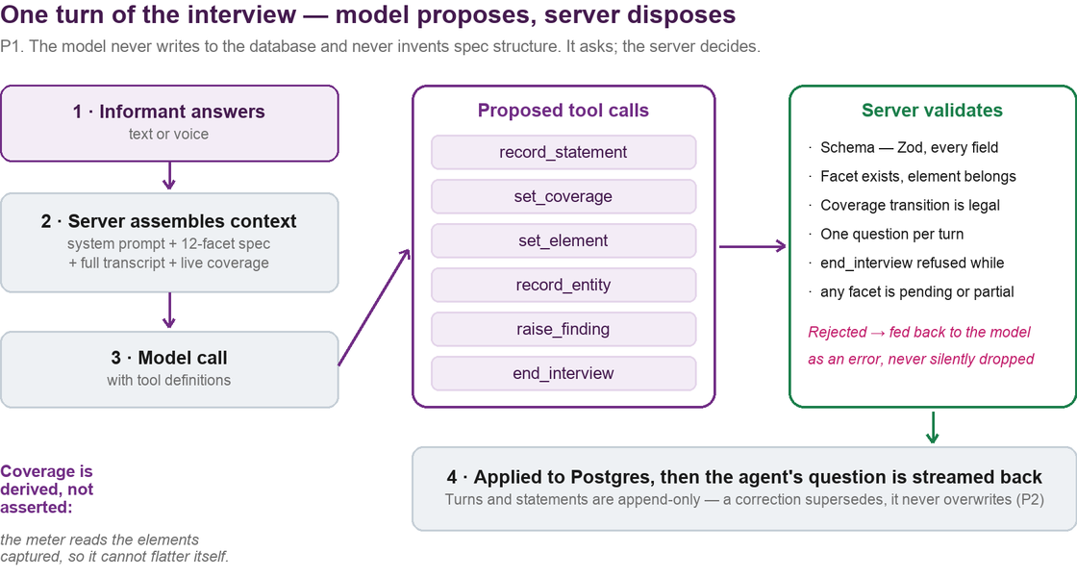
Figure 2 — The model proposes; the server disposes. Every state change is validated before it is applied.
The natural way to build this tool would be to ask a model to interview someone and write up the result. We did not build it that way, because that design cannot tell you which parts of the output a person actually said.
Instead the model has no writing privileges at all. It converses, and it proposes structured tool calls. Our code validates every one against the schema, against the facet definitions, and against the rules of the coverage state machine — and only then applies it. A malformed or illegal call is rejected and returned to the model as an error, never silently dropped.
What the server checks on every proposed call
- Schema. Every field validated with Zod. An unknown tool name is refused outright.
- Belonging. The facet must exist; a captured element must belong to the facet claimed.
- Legal transition. Coverage moves through a state machine. A facet cannot go backwards, and it cannot jump to a state the evidence does not support.
- One question per turn. Enforced by the server, because an agent that asks three questions at once gets one answer and quietly loses two.
- No premature ending. end_interview is refused while any facet is still pending or partial. The model cannot decide it has heard enough.
Two consequences worth stating plainly
Coverage is derived, not asserted. The progress meter is computed from the elements actually captured — it reads the evidence rather than taking the model's word for it. A model that believes it has covered a topic cannot make the meter agree.
Corrections supersede; they never overwrite. When someone changes their answer, we insert a new statement that supersedes the old one. Both survive. The record of what was said at each point in the conversation is intact — which is what makes the output defensible to anyone who later asks where a line came from.
4 · The twelve facets and how coverage is decided
A complete interview means all twelve facets are resolved. The facets are defined once, in code, and every other part of the system reads that definition: the interviewer's priorities, the progress rail the informant sees, the specification's section order, and the tests.
# | Facet | # | Facet
1 | Process identity & context | 7 | Data & information
2 | Stakeholders & resources | 8 | Technology & systems
3 | Triggers & events | 9 | Risk, controls & compliance
4 | Inputs & outputs | 10 | Variants & exceptions
5 | Workflow & activities | 11 | Performance
6 | Business rules & decisions | 12 | Bottlenecks & issues

Beneath the facets sit 40 named elements — the specific things a facet needs before it counts as answered. That granularity is what lets the tool tell an informant precisely what is still wanted, in plain language, rather than showing an opaque percentage.
The five terminal states
State | Meaning
pending | Not yet discussed.
partial | Some elements captured, others outstanding.
answered | Everything this facet needs has been captured.
unknown to informant | This person genuinely does not know. A legitimate, recorded outcome — not a gap.
not applicable | This facet does not apply to this process.

The last two matter more than they look. A tool that cannot record “I don't know” pressures people into guessing, and a guess recorded as fact is worse than an acknowledged gap — it is a defect that reaches ARIS and nobody can trace.

5 · The data model
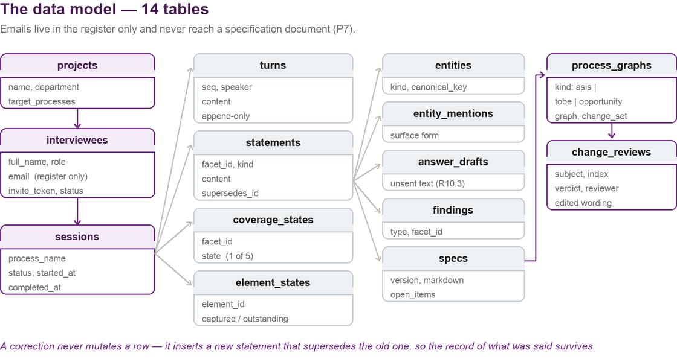
Figure 3 — Fourteen tables. The register holds identity; the specification never does.
Append-only where it matters. Turns and statements are never updated or deleted. A correction inserts a new row that supersedes its predecessor. This costs a little storage and buys a complete, auditable record of the conversation.
Identity is quarantined. Names and email addresses live in the interviewees table — the register the architect works from. Specifications carry the informant's name and role for attribution, and never their email address. That separation is in the renderer, so it cannot be forgotten.
Analysis is versioned against the specification it came from. Process graphs and change reviews are keyed by session and specification version, so a map can always be traced back to the exact document — and the exact statements — it was derived from.
6 · From interview to handover
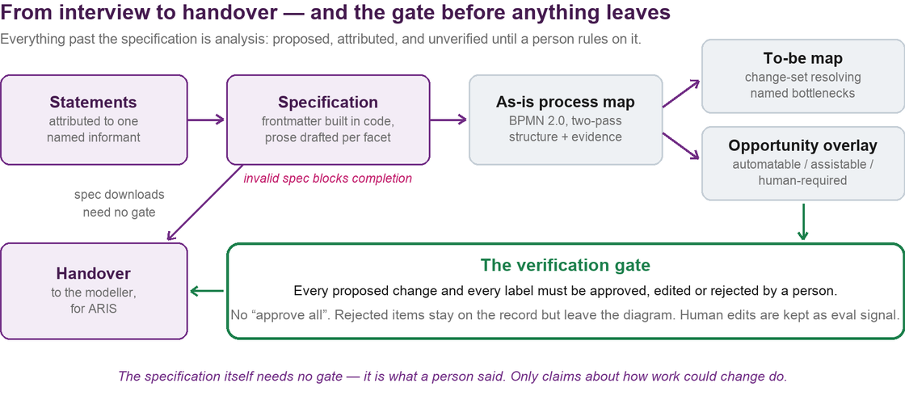
Figure 4 — Everything past the specification is a proposal, and stays unverified until a person rules on it.
The specification is testimony: it is what a person said about their own job, attributed to them. It needs no approval to be useful, and it is available to download as soon as the interview completes.
Everything after it is different in kind. A process map is an interpretation. A to-be map is a claim about how work should change. An automation label is a claim about somebody's job. These are proposals, and the architecture treats them as such — they are marked proposed and unverified, and they cannot reach a handover report until a person has ruled on every single one.
The verification gate
- Per item, never in bulk. There is deliberately no “approve all” button. Approving four changes and rejecting a fifth is the normal outcome, and a single button would turn the gate into a formality.
- Three verdicts. Approve, edit or reject. An edit changes the wording, never the link back to the evidence — rewording a proposal is legitimate, quietly re-pointing it at different evidence is not.
- Rejection is recorded, not erased. A rejected item leaves the diagram but stays on the record, because the fact that a reviewer disagreed is itself worth keeping.
- No confident claim without cited evidence. Every automation label must cite the facts that support it. Where the evidence will not carry a judgement, the tool must say so and explain what is missing — an honest “we do not know whether this system has an API” is actionable; a wrong confident label is not.
- Human edits are kept as signal. What was proposed, what the reviewer made of it, and why. That is the feedback that improves the generator.
7 · How we know it works
The tool interviews people about their jobs and produces documents others will act on. Asserting that it behaves well is not enough, so quality is measured by a harness rather than by inspection.
A simulated informant runs the real engine, end to end. Three personas — cooperative, rambling and terse — each with a known ground truth, are interviewed by the live system. Nine assertions then check the output: that every facet reached a terminal state, that statements are attributed correctly, that a stated threshold ladder survives into the specification intact, that a genuine “I don't know” is recorded as such rather than papered over, and that the specification validates.
The bar is three consecutive clean runs per persona. Not a best-of. The gate currently stands at nine passes from nine runs.
Check | Coverage
Unit and integration tests | 217 across 24 files — the state machine, tool validation, renderer, validators, graph extraction and the verification gate
End-to-end tests | 10 — both faces driven in a real browser, including data-loss protection and resume
Evaluation gate | 3 personas × 3 consecutive runs against the live model, all passing
Static checks | TypeScript strict, zero errors; lint clean

The honest limitation: this is measured against simulated informants with known ground truth. It tells us the engine behaves correctly and does not lose or invent information. It cannot tell us how a real VMO2 employee will respond to being interviewed by software — that is what the pilot is for.

8 · Deployment, security and privacy
What it takes to run
Runtime | Node 20 in a container. Builds and starts with two standard commands.
Database | PostgreSQL 16. Managed Postgres on any cloud — Cloud SQL, RDS, or equivalent.
Secrets | Model API key, database URL and console password, injected from the platform's secret store. Nothing is committed.
External calls | The model API, and optionally a speech-to-text service for voice input. Nothing else leaves the container.
Scaling | Stateless. Pinned to one instance for the pilot; horizontal scaling needs no code change.
Liveness | A /health endpoint for the platform to poll.

Security posture
- The console is password-gated with a hashed credential; sessions are signed cookies.
- Interview links are unguessable single-purpose tokens. A completed link cannot be reused.
- The interview face has no account system, so there are no informant credentials to leak.
- Rate limiting sits in front of the model-calling routes.
- No secret is committed to the repository, and the deployment guide provisions them from a secret manager.
Privacy
- Email addresses stay in the register and never enter a specification document.
- There is no telemetry, no analytics and no behavioural monitoring of informants. We record what people say about their work, not what they do.
- Statements are attributed by name and role, because a process specification is worthless without knowing whose account it is. Informants see this and see their own playback before finishing.
One item outstanding before real informants: a retention period is configurable but not yet enforced automatically. Interview content persists until deleted by hand. This must be resolved before the tool is used with live VMO2 staff, and it is a small piece of work — it is flagged here because it is the kind of thing that should be visible, not buried.
9 · What is built, what is not, and what is next
Area | Status
Interview engine, coverage machine, tool validation | Built and gated
Specification generation, validation and download | Built and gated
Console: campaigns, links, register, findings | Built
Checklist coverage rail and pick-list facets | Built
Draft protection, resume, question budget | Built
Voice input (optional, degrades to typing) | Built
As-is process map — BPMN 2.0 | Built
To-be map and change-set | Built, behind a feature flag
Automation-opportunity overlay | Built, behind a feature flag
Human verification gate for all analysis | Built
Migration from SQLite to PostgreSQL | Complete
Retention enforcement | Not built — required before live informants
Artefact ingestion (existing documents as interview input) | Not built — largest remaining item
Cloud deployment | Guide written and validated; deployment in progress

The two open decisions
- Hosting. The application is cloud-neutral by construction — a container and a Postgres database. Moving between providers is a day of deployment work, not an application change.
- The model behind it. Model settings are configuration, but the vendor is not: the architecture depends on validated tool calls, and the quality gate above was passed against a specific model. Changing vendor means re-passing that gate. This is covered in a separate note.
Magpie is running and has been demonstrated end to end. Neither open decision blocks the pilot — but both should be settled before the deployment is hardened.

