Magpie
Process capture for VMO2
Solution Design Document
Version 1.0 · for design review
Document | Solution Design Document (SDD)
System | Magpie — SME process-capture tool
Version | 1.0, describing the system as built on 5 August 2026
Status | For review. The system is running and demonstrated; not yet in production.
Audience | Design authority, cloud engineering, AI governance, security and data protection
Related documents | Magpie — the architecture as built (companion, illustrated)  Magpie — hosting on AWS, and the model behind it (decision note)  DEPLOY-GCP.md (runbook) · DECISIONS.md (70 recorded design decisions)
Author | Delivery team

Contents
1. Purpose, scope and audience
2. Requirements this design satisfies
3. Design principles and the constraints they impose
4. Solution overview
5. Detailed design — the interview engine
6. Detailed design — coverage and completeness
7. Detailed design — specification generation
8. Detailed design — analysis and the verification gate
9. Data design
10. Interface design
11. Non-functional design
12. Security design
13. Privacy and data protection design
14. Deployment and environments
15. Test strategy and evidence
16. Design decisions and alternatives considered
17. Risks, assumptions, issues and dependencies
18. Traceability

1 · Purpose, scope and audience
This document describes the design of Magpie as built. It is written to be reviewed: every significant decision is stated with the alternative that was rejected and the reason, so a reviewer can disagree with the reasoning rather than guess at it.
1.1 Problem statement
VMO2's operational processes are tacit. They live in the heads of the people who run them and diverge from whatever documentation exists. Capturing them by workshop does not scale, and produces one analyst's synthesis of several people's accounts — with no way to tell afterwards who said what.
1.2 In scope
- A conversational interview that captures one informant's account of one process, across twelve defined facets.
- A per-informant, per-process Markdown specification with structural attribution and provenance.
- A console for architects: campaigns, tokenised invitations, a register of progress, downloads.
- Analysis views: BPMN as-is map, to-be change-set, automation-opportunity overlay — each behind a human verification gate.
1.3 Out of scope
- Modelling in ARIS. Magpie produces the input a modeller drafts from; it does not write to ARIS.
- Reconciling several informants into one authoritative process. Conflicts are surfaced, never resolved automatically.
- Telephony or call-centre integration.
- Any monitoring, scoring or assessment of the individuals interviewed.
1.4 Definitions
Term | Meaning
Facet | One of twelve defined aspects of a process. The unit of interview coverage.
Element | A specific thing a facet needs before it counts as answered. 40 in total.
Informant | The person being interviewed. Also “process user”.
Campaign | A project grouping informants and target processes.
Statement | One captured fact, stored against the informant who said it.
Finding | A conflict or gap raised for a human to resolve. Never auto-resolved.
Specification | The Markdown output for one informant and one process.

2 · Requirements this design satisfies
Requirements come from two sources: the original build brief (FR-1 to FR-6) and a subsequent delta (R1 to R10). Both are traced in section 18.
Ref | Requirement | Design response | State
FR-1 | Console: campaigns, links, register | §4.2, §10.2 | Built
FR-2 | Interview entry by tokenised link | §4.2, §12.2 | Built
FR-3 | Interview engine and coverage | §5, §6 | Built
FR-4 | Review and completion | §5.5 | Built
FR-5 | Specification generation | §7 | Built
FR-6 | Brand and UX | §4.2 | Built
R1 | Completeness: transparency and tolerance | §6 | Built
R2 | Deterministic facets as pick-lists | §6.4 | Built
R3 | Artefact ingestion | — | Not built
R4 | Adaptive follow-ups | §5.4 | Built
R5 | Process visualisation (as-is, to-be, opportunity) | §8 | Built, flagged off
R6 | Process-template pre-fetch | — | Not built
R7 | Voice / call capture | §10.3 (partial: voice input only) | Backlog
R8 | Suggested response chips | — | Not built
R9 | Bounded interview and graceful finish | §5.6 | Built
R10 | Interview UX and data-loss protection | §10.2 | Built

3 · Design principles and the constraints they impose
These eight principles are treated as invariants. Each one costs something, and the cost is stated — a principle whose price is not written down tends to be traded away quietly.
Principle | Design constraint it imposes | What it costs
P1 · Model proposes, server disposes | All state changes arrive as validated tool calls. The model has no write path and cannot author document structure. | More engine code; the model cannot be given shortcuts.
P2 · Attribute everything, average nothing | Statements are stored per informant. Disagreements become findings for a human. | No single tidy answer per process. A human must reconcile.
P3 · No silent gaps | Every facet must reach a terminal state. A session cannot complete otherwise. | Longer interviews; “I don't know” must be modelled as a real answer.
P4 · Provenance is structural | Attribution is emitted by the renderer in code, not requested in a prompt. | The renderer, not the model, owns document shape.
P5 · Models are configuration | Model id, temperature and limits live in environment configuration; no model-specific logic in code. | Applies within a vendor. See §17 R-3.
P6 · Minimalism | Extend before adding. One deployable, ten runtime dependencies, no queues or cache tier. | Some scaling patterns deferred; each dependency needs justification.
P7 · Privacy by design | Email addresses stay in the register. No telemetry, no behavioural monitoring. | No usage analytics to draw on when tuning.
P8 · British throughout | UK dates, sentence case, £, plain confident voice, no emoji. | Nothing material.

4 · Solution overview
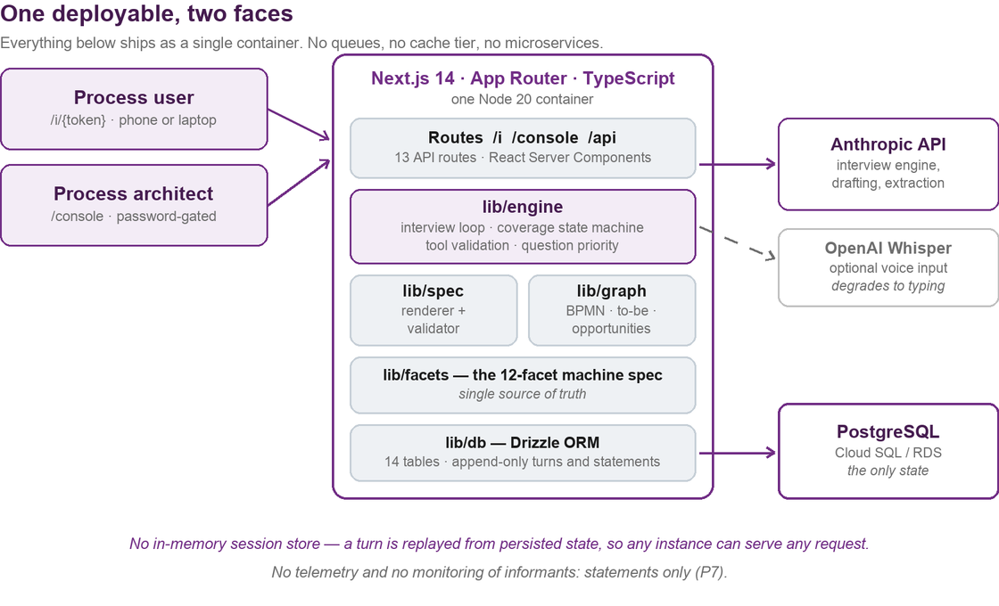
Figure 1 — Logical architecture. One container, one database, two external calls.
4.1 Architectural style
A single Next.js application serving both user faces and its own API, over a relational database. This is a deliberately conventional choice. The novel part of the system is the interview engine; spending novelty budget on the infrastructure as well would make it harder to operate and no better.
Statelessness is the one property worth calling out. There is no in-memory session store. Every turn is reconstructed by replaying persisted state, so any instance can serve any request, an interrupted interview resumes exactly where it stopped, and a deployment mid-interview loses nothing.
4.2 Component responsibilities
Component | Responsibility | Key constraint
app/(interview) | Tokenised entry, the interview surface, playback and review | No account system; nothing to leak
app/console | Campaigns, invitations, register, findings, downloads | Password-gated
app/api | 13 routes. All model-calling paths are rate-limited | Server-side only
lib/engine | Turn loop, context assembly, tool validation, question ranking | Owns all state transitions
lib/facets | The twelve-facet, forty-element machine specification | Single source of truth
lib/spec | Deterministic Markdown renderer and validator | Model never writes structure
lib/graph | Process graph, BPMN serialisation, to-be, opportunities, gate | All output is proposed
lib/db | Drizzle ORM over 14 tables | Turns and statements append-only

5 · Detailed design — the interview engine
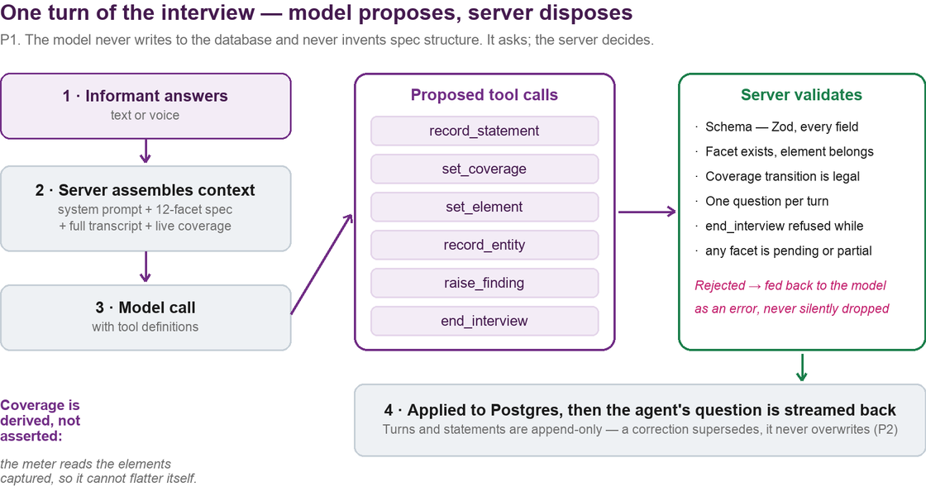
Figure 2 — One turn. Every proposed state change is validated before it is applied.
5.1 The turn loop
A turn proceeds in four steps: the informant's answer is persisted; the server assembles context (system prompt, facet specification, full transcript, live coverage); the model is called with tool definitions; the server validates and applies each proposed call, then streams back the agent's next question.
5.2 The tool surface — the only write path
Tool | Purpose | Server enforces
record_statement | Capture one fact against a facet | Schema; facet must exist
set_element | Mark a checklist element captured or N/A | Element must belong to the facet claimed
set_coverage | Move a facet to a terminal state | Only unknown_to_informant or not_applicable may be set directly, and only by a legal transition. answered and partial are derived, never asserted.
record_entity | Register a canonical entity (system, role, document) | Project-scoped canonical key
raise_finding | Flag a conflict or gap for a human | Never auto-resolved
end_interview | Request completion | Refused while any facet is pending or partial

A rejected call is returned to the model as an error, never silently dropped. Silent rejection is the failure mode that produces a confident interview with missing data — the model believes it recorded something and moves on.
5.3 Idempotency and resume
Turns are deduplicated on (session, sequence). If a reply already exists for a submitted turn it is returned without re-invoking the model — so a retry after a dropped connection costs nothing and cannot double-record. Resume replays persisted state; there is nothing in memory to lose.
5.4 Question selection
One question per agent turn, enforced server-side. An agent that asks three questions at once receives one answer and quietly loses two. The next question is chosen from a ranked shortlist of outstanding elements, with a per-facet follow-up cap so a single topic cannot consume the interview.
5.5 Review and completion
The informant sees a playback of what was understood and may correct it. Corrections are appended as superseding statements. Completion generates and validates the specification; an invalid specification blocks completion rather than producing a caveated document.
5.6 Bounded interview
A configurable question budget gives the interview a felt horizon. When it is spent the session moves to playback rather than grinding on — acceptable precisely because questions are asked in priority order, so what is truncated is the least valuable end. An informant may also finish early; the specification is generated regardless and states what is missing in its prose, not only its metadata.

6 · Detailed design — coverage and completeness
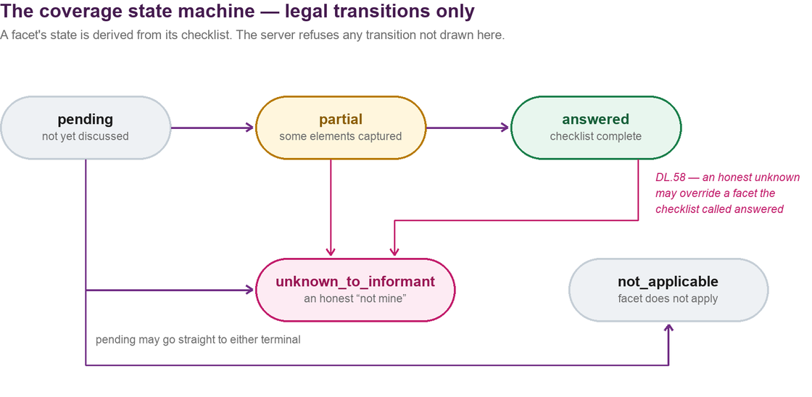
Figure 3 — The coverage state machine. Terminal states have no outgoing transitions.
6.1 Coverage is derived, not asserted
A facet's state is computed from its checklist: all elements closed means answered, some means partial, none means pending, all ruled out means not applicable. The model cannot set answered or partial directly. This is the design's answer to a model that believes it has covered a topic — belief does not move the meter.
6.2 The one deliberate exception
A facet may move from answered to unknown_to_informant. If the checklist derives “answered” but the informant then says the topic is not theirs to speak to, their word wins. Recorded as decision DL.58; discovered by an evaluation failure rather than reasoned in advance, which is why it is called out here.
6.3 Why “I don't know” is a first-class outcome
A tool that cannot record ignorance pressures people into guessing, and a guess recorded as fact is worse than an acknowledged gap: it reaches ARIS and nobody can trace it. Both unknown_to_informant and not_applicable are terminal, legitimate, and rendered explicitly in the specification.
6.4 Pick-list facets
Four facets whose answers are enumerable (systems, roles, documents and similar) are offered as pick-lists built from entities already registered in the campaign, each option carrying its source. Every pick-list keeps a free-text escape, because a closed list that cannot be escaped silently discards the case it did not anticipate. Selection is additive — there is no untick — so one informant cannot remove another's answer.
7 · Detailed design — specification generation
Generation is deliberately split so that the model contributes only prose:
- Frontmatter is built in code. Informant, role, process, dates, per-facet and per-element coverage, open items. The model never writes it, so it cannot omit or misstate it.
- Prose is drafted per facet, from that facet's statements only. A facet's section cannot be contaminated by material from another.
- The result is validated against a schema. An invalid specification is a hard failure that blocks completion — not a warning.
Provenance is structural (P4). Attribution markers are emitted by the renderer. We do not ask the model to remember to attribute statements, because a prompt is a request and this is a requirement.
Presentation and format are separate concerns. The specification renders as a formatted document in the console for reading, and downloads as the same Markdown for handover. One source, two presentations.
8 · Detailed design — analysis and the verification gate
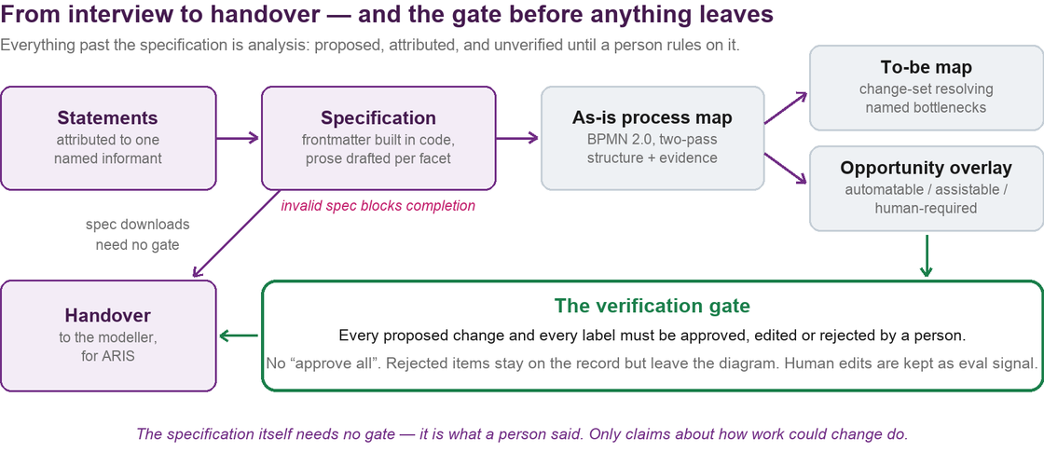
Figure 4 — The specification passes straight through. Every downstream claim is gated.
8.1 The distinction the design rests on
The specification is testimony — what a person said about their own job, attributed to them. It needs no approval to be useful. Everything downstream is interpretation: a process map is a reading, a to-be map is a claim about how work should change, and an automation label is a claim about somebody's job. These are proposals and the system marks them so.
8.2 Generation constraints
- Structure and evidence are extracted in two passes. A single pass reliably produced structure and no evidence; splitting them took a real specification from zero to fourteen evidenced annotations.
- Every to-be change must resolve an evidenced bottleneck. No evidence means an empty change-set and no model call at all — the system declines to invent improvements.
- No confident automation label without cited evidence. Only “unclassified” may cite nothing, and it must say what is missing. On failure the retry instructs the model to downgrade rather than fabricate a citation.
- Lineage is mandatory. Every graph element carries the facet it came from, so any node on any diagram traces back to a statement.
8.3 The verification gate
Rule | Rationale
Per item, never in bulk. No “approve all”. | Approving four and rejecting a fifth is the normal outcome. A single button makes the gate a formality.
Three verdicts: approve, edit, reject. | Reviewers need to reword without accepting wholesale.
An edit changes wording, never the evidence link. | Rewording is legitimate; quietly re-aiming a proposal at different evidence is a different change.
Rejected items leave the diagram, stay on the record. | The fact that a reviewer disagreed is itself evidence worth keeping.
Nothing unverified reaches a handover report. | One module owns the definition of “verified”, so UI, export and future reports cannot disagree.
Reviewer edits are retained as evaluation signal. | What was proposed against what a human made of it is the feedback that improves the generator.

Reviewer identity is honest about its limits. The console is a single shared login, so reviews are attributed to “console admin”. That is the true attribution available today rather than an invented name. Per-reviewer identity needs user accounts; the column exists and its shape does not change when they arrive.

9 · Data design
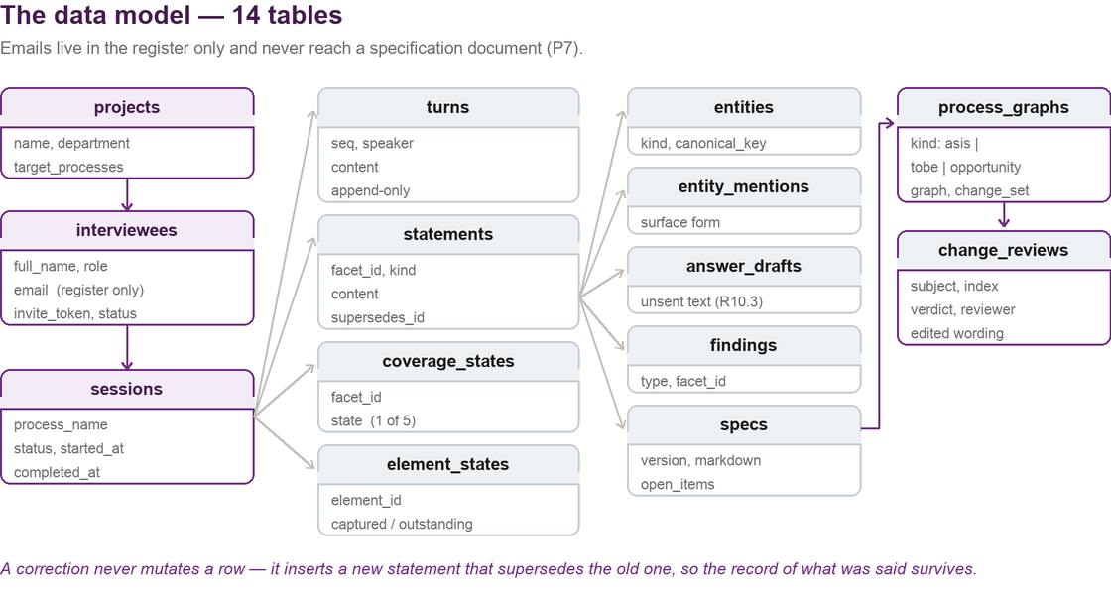
Figure 5 — Fourteen tables. Identity is quarantined in the register.
9.1 Design rules
- Append-only where it matters. Turns and statements are never updated or deleted; a correction inserts a superseding row. Costs storage, buys a complete auditable record.
- Identity is quarantined. Email addresses exist only in the interviewees register. Specifications carry name and role for attribution and never the email address, enforced in the renderer.
- Analysis is versioned against its source. Graphs and reviews are keyed by session and specification version, so a diagram always traces to the exact document it came from.
- One coverage row per session per facet, and one element row per session per element. State is relational, not a serialised blob, so it can be queried and constrained.
9.2 Portability
The schema is written to standard relational constructs. The system began on SQLite and was migrated to PostgreSQL; that migration is complete and the SQLite path has been removed. A non-Postgres connection string is now refused at startup with an explanatory error rather than failing obscurely at first query.
10 · Interface design
10.1 External interfaces
Interface | Direction | Notes
Model API | Outbound, server-side only | Interview turns, facet drafting, graph extraction, classification. Retries with backoff; a failed call returns 502 and the informant's answer is preserved.
Speech-to-text | Outbound, optional | Voice input only. Absent key means the microphone is not offered; the interview is fully usable by typing.
Database | Outbound | PostgreSQL over a private address. Small connection pool per instance.
Health | Inbound | GET /health for platform liveness polling.

10.2 Internal API surface
Thirteen routes. The interview write path is representative:
Aspect | POST /api/interview/{sessionId}/turn
Request | { seq: integer, content: string } — deduplicated on (session, seq)
Limits | 40 requests per minute per IP; 4,000 characters per message
200 | Agent reply, updated coverage, element state, question budget, review flag
400 / 404 | Malformed body or invalid sequence / unknown session
413 / 429 | Message too long / rate limited, with Retry-After
502 | Model call failed. The informant's answer is already persisted and the turn is retryable.

Rate limiting is currently in-process. This is correct only while the service runs as a single instance, which is the pilot posture; it is recorded as an issue for scale-out in §17.
10.3 User interfaces
- Interview: one question at a time, a coverage rail stating what is still wanted in words rather than a bare percentage, and an explicit question budget.
- Draft protection: an unsent answer survives a reload and returns with a banner. Discard requires confirmation and is undoable.
- Voice input is chunked rather than continuously streamed — a deliberate simplification, recorded as a deviation.
- Console: campaigns, register, findings, specification reader, downloads, and the analysis views behind a flag.
11 · Non-functional design
Attribute | Design position | Evidence / basis
Interview duration | 25–40 minutes, bounded by a configurable question budget | Measured: a complete simulated interview took 17 questions
Model cost | ≈ £2.37 per interview at list; ≈ £0.82 with prompt caching | Measured: 913k input and 18k output tokens for one full interview
Availability | Single instance for the pilot. No high-availability design yet. | Deliberate: capacity is not the pilot's risk
Scalability | Stateless application; horizontal scale needs no code change | Blocked only by in-process rate limiting (§17 I-1)
Durability | All state in managed Postgres; append-only history | Platform-managed backups
Resilience | Retries with backoff on model calls; a failed turn preserves the answer and is retryable | Added after observed transient connection failures
Recoverability | Interviews resume from persisted state after any interruption | Covered by end-to-end tests
Maintainability | ~7,000 lines, 38 modules, 10 runtime dependencies, TypeScript strict | 217 unit and integration tests, 10 end-to-end
Portability | One container, standard Postgres; cloud-neutral by construction | Migration between clouds is a runbook change

12 · Security design
12.1 Controls in place
- Console authentication by hashed password; sessions are signed cookies.
- Interview access by unguessable single-purpose token. A completed invitation cannot be reused.
- The interview face has no account system, so there are no informant credentials to compromise.
- Rate limiting in front of every model-calling route; message length capped.
- All model calls are server-side. No API key ever reaches the browser.
- Secrets are injected from the platform's secret store. Nothing sensitive is committed to the repository.
- The database has no public address in the documented deployment; the application reaches it over a private network path.
12.2 Known limitations, stated plainly
- Single shared console credential. There are no individual architect accounts, so review actions cannot be attributed to a named person (DL.64). Acceptable for a pilot with a small known team; it should not survive into wider use.
- In-process rate limiting does not hold across instances. See §17 I-1.
- No formal penetration test has been carried out. Recommended before live informants.
13 · Privacy and data protection design
Question | Design position
What personal data is held? | Name, work email address and job role of each informant, plus the content of what they say about their work.
Where does it live? | Email addresses exist only in the interviewees register. They never enter a specification document — enforced in the renderer, not by convention.
Is anyone monitored? | No. There is no telemetry, no analytics and no behavioural measurement. The system records statements about work, not behaviour about people.
Is the informant aware? | Yes. They self-identify, they are told the purpose, and they review a playback of what was understood before finishing.
Is anything automated about a person? | No decision is made about any individual. Automation labels apply to activities and are explicitly proposals requiring human approval.
Where is the data processed? | In the hosting region, plus the model provider for the duration of a call. Choice of provider affects this — see the accompanying decision note.
How long is it kept? | A retention period is configurable but NOT YET ENFORCED. See §17 I-2.

This is the design's most significant outstanding gap. Retention is configurable but nothing deletes on expiry, so interview content persists until removed by hand. It must be resolved before the tool is used with real VMO2 staff. It is small work and is flagged here rather than buried because a reviewer should not have to find it.

14 · Deployment and environments
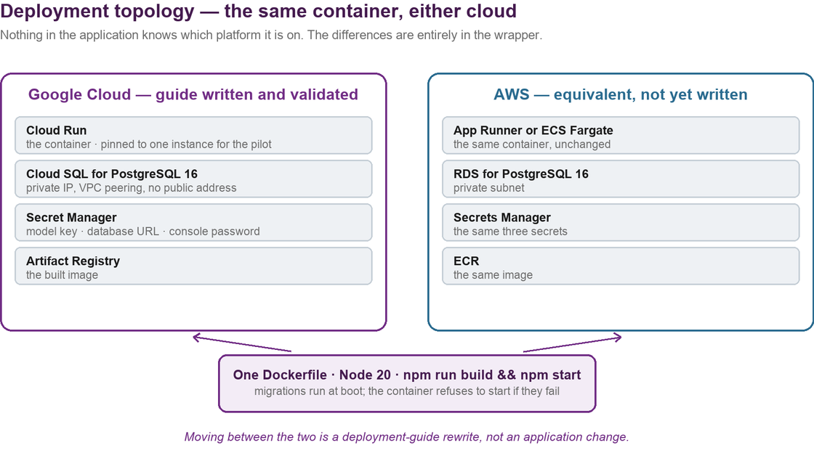
Figure 6 — The same image on either platform. Differences are confined to the wrapper.
14.1 Runtime
- Node 20 in a container. Standard build and start commands; a working Dockerfile is in the repository.
- Migrations run at boot and the container refuses to start if they fail — a half-migrated service is worse than one that does not start.
- Three secrets: model API key, database URL, console password.
- Feature flags gate the analysis views, so a pilot audience cannot mistake a proposal for an approved recommendation.
14.2 Environments
Environment | Purpose | Data
Local | Development. Containerised Postgres; a seed script and a simulated-interview script produce demo data. | Synthetic only
Test | Automated suites. In-process Postgres; the model is mocked for determinism. | Synthetic only
Evaluation | Live-model quality gate against simulated informants with known ground truth. | Synthetic only
Pilot | Managed container plus managed Postgres, one instance, private database path. | Real informants

14.3 Cloud position
The application is cloud-neutral by construction. Google Cloud has a written and validated runbook; the AWS equivalent is a direct mapping — App Runner or Fargate, RDS, Secrets Manager, ECR — and is a runbook rewrite rather than an application change, estimated at about one day. Neither the code nor the schema changes.
15 · Test strategy and evidence
The system interviews people about their jobs and produces documents others act on, so quality is measured by a harness rather than asserted by inspection.
Layer | Scope | Result
Static | TypeScript strict, lint | Zero errors, clean
Unit and integration | State machine, tool validation, renderer, validators, extraction, gate — 24 files | 217 passing
End-to-end | Both faces in a real browser, including resume and data-loss protection | 10 passing
Evaluation gate | Three personas × three consecutive live-model runs against known ground truth, nine assertions each | 9 of 9 passing

15.1 What the evaluation gate checks
That every facet reached a terminal state; that statements are attributed correctly; that a stated threshold ladder survives into the specification with every rung intact; that a genuine “I don't know” is recorded as such rather than papered over; and that the specification validates. The bar is three consecutive clean runs per persona — not a best-of.
15.2 The limitation of this evidence
This is measured against simulated informants with known ground truth. It demonstrates that the engine behaves correctly and neither loses nor invents information. It cannot demonstrate how a real VMO2 employee responds to being interviewed by software, whether they trust it, or whether they answer differently than they would to a colleague. That is what the pilot is for, and no amount of further automated testing substitutes for it.
16 · Design decisions and alternatives considered
Seventy decisions are recorded in DECISIONS.md, each with its reasoning. The ten most consequential are summarised here with the alternative that was rejected.
Decision | Alternative rejected | Reason
The model proposes; the server validates and applies | Let the model write the specification directly | A written-up document cannot tell you which parts a person actually said.
Coverage derived from a checklist | Let the model report its own coverage | A model that believes it has covered a topic would move the meter without evidence.
answered → unknown_to_informant permitted | Keep answered terminal | An informant disclaiming a topic must override a checklist that inferred otherwise (DL.58).
Statements append-only, corrections supersede | Update the row in place | Destroys the record of what was said and when. Storage is cheap; the audit trail is not.
Frontmatter built in code | Ask the model to emit frontmatter | A prompt is a request; provenance is a requirement (P4).
Structure and evidence extracted in two passes | One combined extraction pass | One pass produced structure and no evidence; splitting took a real spec from 0 to 14 annotations.
Verification gate is per item | A set-level approve-all | Approving four and rejecting a fifth is normal; one button makes the gate a formality.
No confident label without cited evidence | Allow uncited labels with a confidence score | A modeller can act on “we do not know”; they cannot act on a confident label that is wrong.
bpmn-js as a viewer | Build a renderer, or embed a full modeller | Standards-compliant rendering earns the dependency; a modeller invites editing we do not want (P6).
PostgreSQL, SQLite path removed | Keep SQLite with a Postgres option | Two supported databases means two behaviours to test. The pilot needs managed Postgres.

17 · Risks, assumptions, issues and dependencies
17.1 Issues — open and owned
Ref | Issue | Impact | Resolution
I-1 | Rate limiting is in-process, so it does not hold across instances | Correctness constraint on scaling out | Move to a shared store before running more than one instance
I-2 | Retention configurable but not enforced | Interview content persists indefinitely | Required before live informants. Small piece of work
I-3 | Single shared console credential | Review actions not attributable to a named person | Needs user accounts; schema already accommodates it
I-4 | No penetration test | Unknown residual security risk | Recommend before live informants

17.2 Risks
Ref | Risk | Likelihood / impact | Mitigation
R-1 | Informants disengage mid-interview or find it too long | Medium / medium | Bounded question budget; finishing early is a supported path; resume loses nothing
R-2 | Output quality differs with real informants versus simulated ones | Medium / high | Pilot deliberately scoped small; findings surface conflicts for humans rather than hiding them
R-3 | Mandated change of model vendor | Medium / high | Architecture depends on validated tool calls; the quality gate must be re-passed. See the decision note
R-4 | Model provider availability or latency | Low / medium | Retries with backoff; a failed turn preserves the answer and is retryable
R-5 | Analysis output mistaken for approved recommendation | Low / high | Verification gate plus feature flags; every proposal is labelled unverified

17.3 Assumptions
- Informants have a VMO2 email address and can open a link on a phone or laptop.
- A process architect reviews output before it is used. The system is designed around this, not despite it.
- Managed PostgreSQL 16 and container hosting are available in the chosen cloud.
- Interview content may be sent to a model provider under existing agreements — to be confirmed by the AI governance team.
17.4 Dependencies
- A model API, provisioned and governed. Vendor decision outstanding.
- Cloud hosting and a managed database. Platform decision outstanding.
- A speech-to-text service, optional — the system is fully usable without it.
- Ten runtime npm dependencies, each with a recorded justification.
18 · Traceability
Requirement | Design | Enforcement in code | Test evidence
P1 · Server disposes | §5.2 | Tool validation; no model write path | Tool validation suite; every illegal call rejected
P2 · Attribute, never average | §9.1 | Statements keyed to informant; conflicts become findings | Console end-to-end test surfaces a conflict
P3 · No silent gaps | §6 | Terminal-state machine; end_interview refused | Eval assertion; golden-path E2E ends 11 answered + 1 unknown
P4 · Structural provenance | §7 | Renderer emits attribution | Renderer unit tests; spec validator
P7 · Privacy | §13 | Email excluded at the renderer | Renderer unit tests
FR-3 · Engine | §5 | lib/engine | 217 unit and integration tests
FR-5 · Specification | §7 | lib/spec + validator | Invalid spec blocks completion (tested)
R1 · Completeness | §6 | Derived coverage from 40 elements | Eval assertions; coverage-rail E2E
R5.4 · To-be gate | §8.3 | lib/graph/verification.ts | Gate unit tests
R5.5 · Opportunities | §8.2 | lib/graph/opportunity.ts | Classifier unit tests, including the uncited-label refusal
R9 · Bounded interview | §5.6 | Question budget; early finish | Budget E2E test

End of document. Magpie is running and has been demonstrated end to end. The two open decisions — hosting platform and model vendor — do not block the pilot, but both should be settled before the deployment is hardened, and issue I-2 must be closed before any real informant is interviewed.

