TECHNICAL AND VOCATIONAL TRAINING INSTITUTE
SCHOOL OF GRADUATE STUDIES
FACULTY OF ELECTRICAL ELECTRONICS AND
INFORMATION COMMUNICATION TECHNOLOGY
DEPARTMENT OF INFORMATION COMMUNICATION TECHNOLOGY (ICT)
Developing Deep Learning-Based Sentiment Analysis of Amharic
Social Media for Public Policy Enhancement in Ethiopia
A Thesis Submitted in Partial Fulfillment of the Requirements for the
Degree of Master of Science in Information Communication Technology
BY:
Aklilu Gebeyehu
Advisor: Dr. Martha Yifiru
Addis Ababa, Ethiopia
2025

DECLARATION
I declare that this thesis entitled "Developing Deep Learning-Based Sentiment Analysis of Amharic Social Media for Public Policy Enhancement in Ethiopia" is my own work and that it has not been presented in any other institution for any degree or award. All sources of materials used have been duly acknowledged.
Name of Student: ______________________
Signature: ___________________________
Date of Submission: ___________________

CERTIFICATION
This is to certify that this thesis entitled "Developing Deep Learning-Based Sentiment Analysis of Amharic Social Media for Public Policy Enhancement in Ethiopia" has been submitted for examination with my approval as a university advisor.
Advisor: Dr. Martha Yifiru
Signature: ___________________________
Date: ___________________________

Internal Examiner: ______________________
Signature: ___________________________
Date: ___________________________

External Examiner: ______________________
Signature: ___________________________
Date: ___________________________

ACKNOWLEDGMENT
The researcher wishes to express sincere gratitude to Dr. Martha Yifiru for her unwavering guidance, critical feedback, and encouragement throughout the course of this research. Her insights into computational linguistics and her commitment to rigorous scholarship shaped every phase of this work.
Appreciation is also extended to the faculty of Electrical Electronics and Information Communication Technology at the Technical and Vocational Training Institute for providing an enabling academic environment. The researcher is grateful to colleagues and peers who contributed valuable discussions and constructive criticism.
The AfriSenti research team, whose publicly released Amharic benchmark dataset made this study possible, deserves special acknowledgment. Finally, heartfelt thanks are due to family and friends for their patience and moral support throughout the demanding process of graduate research.

ABSTRACT
Amharic, the official language of Ethiopia and a mother tongue of over 57 million speakers, remains severely under-resourced in computational natural language processing. As Ethiopian citizens increasingly use social media platforms such as Twitter/X, Facebook, and Telegram to express opinions on governance and public policy, the need for automated Amharic sentiment analysis tools has become urgent. Existing studies have evaluated isolated model families on non-standardised datasets, making cross-study comparisons unreliable.
This study addresses that gap by conducting the first systematic, head-to-head benchmark of ten model families on the official AfriSenti Amharic dataset: Multinomial Naïve Bayes (MNB), Logistic Regression, Support Vector Machine, K-Nearest Neighbour, XGBoost, LightGBM, Bidirectional LSTM, a custom transformer, an MNB–Transformer ensemble, and a stacking classifier. A total of 108 experiments were conducted across four systematic phases exploring word-level and character-level TF-IDF feature representations, n-gram ranges, vocabulary sizes, and smoothing parameters.
The key finding is that character-level TF-IDF n-gram features (range 2–5, max_features=80,000) dramatically outperform word-level features for Amharic, yielding an absolute improvement of +11.66 macro-F1 points. The best model—MNB with character n-gram TF-IDF and Laplace smoothing α=0.2—achieved macro-F1=0.7282 on the held-out test set (n=1,646), trained in 1.9 seconds on a standard CPU without GPU resources. This result is competitive with the top teams in the AfriSenti SemEval-2023 shared task, who used GPU-trained fine-tuned XLM-RoBERTa. The transformer trained from random initialisations achieved macro-F1=0.3648, confirming that pretrained representations—not architectural complexity—drive transformer performance on small Amharic datasets.
The study contributes a reproducible open-source pipeline, a comprehensive ablation of feature engineering choices for morphologically rich Amharic text, and empirical evidence that carefully designed classical models can match GPU-trained deep learning systems in low-resource conditions. Practical recommendations are provided for NLP researchers, system developers, and Ethiopian policymakers seeking to deploy Amharic sentiment analysis tools for public policy monitoring.
Keywords: Amharic sentiment analysis, character n-grams, TF-IDF, Multinomial Naïve Bayes, deep learning, low-resource NLP, AfriSenti, public policy, Ethiopia

LIST OF ABBREVIATIONS
AfriSenti African Sentiment Analysis Benchmark
BPE Byte Pair Encoding
Bi-LSTM Bidirectional Long Short-Term Memory
CNN Convolutional Neural Network
DL Deep Learning
EDA Exploratory Data Analysis
F1 F1-Score (harmonic mean of precision and recall)
FN False Negative
FP False Positive
KNN K-Nearest Neighbor
LGBM Light Gradient Boosting Machine
LR Logistic Regression
ML Machine Learning
MNB Multinomial Naive Bayes
NLP Natural Language Processing
SA Sentiment Analysis
SVM Support Vector Machine
TF-IDF Term Frequency-Inverse Document Frequency
TN True Negative
TP True Positive
XGB Extreme Gradient Boosting
XLM-R Cross-lingual Language Model - RoBERTa

TABLE OF CONTENTS
Declaration i

Certification ii

Acknowledgment iii

Abstract iv

List of Abbreviations v

Table of Contents vi

List of Tables vii

List of Figures viii

CHAPTER ONE: INTRODUCTION 1

1.1 Background of the Study 1

1.2 Motivation of the Study 3

1.3 Statement of the Problem 4

1.4 Objectives of the Study 6

1.5 Research Questions 7

1.6 Scope of the Study 7

1.7 Significance of the Study 8

1.8 Limitations of the Study 9

1.9 Organization of the Thesis 10

CHAPTER TWO: REVIEW OF RELATED LITERATURE 11

2.1 Theoretical Literature Review 11

2.2 Empirical Literature Review 18

2.3 Research Gap 23

2.4 Conceptual Framework 24

CHAPTER THREE: RESEARCH METHODOLOGY 26

3.1 Research Design 26

3.2 Dataset Description 27

3.3 Data Preprocessing 28

3.4 Feature Extraction 30

3.5 Model Architectures 32

3.6 Evaluation Metrics 37

3.7 Experimental Setup 39

3.8 Ethical Considerations 39

CHAPTER FOUR: RESULTS AND DISCUSSION 41

4.1 Dataset Characteristics 41

4.2 Preprocessing Results 43

4.3 Feature Engineering Analysis 45

4.4 Machine Learning Results 48

4.5 Ensemble Methods 51

4.6 Deep Learning Results 52

4.7 Comparative Analysis 57

4.8 Ablation Study 59

4.9 Comparison with Prior Work 61

4.10 Discussion of Findings 62

4.11 Limitations 64

CHAPTER FIVE: CONCLUSION AND FUTURE WORK 67

5.1 Summary 67

5.2 Conclusions: Research Questions Answered 69

5.3 Contributions 70

5.4 Recommendations 73

5.5 Future Work 75

5.6 Closing Remarks 78

REFERENCES 79

APPENDICES 85

LIST OF TABLES
Table 3.1: Dataset Statistics — AfriSenti Amharic Corpus ...
Table 3.2: Hyperparameter Configurations for All Models ...
Table 4.1: Dataset Split Summary ...
Table 4.2: Class Distribution in the Full Corpus ...
Table 4.3: Tweet Length Statistics ...
Table 4.4: Character N-grams vs. Word N-grams: MNB Performance ...
Table 4.5: N-gram Range Ablation: MNB + Char TF-IDF ...
Table 4.6: Max Features Ablation: MNB + Char TF-IDF ...
Table 4.7: Machine Learning Model Comparison ...
Table 4.8: MNB + Char N-grams Per-Class Performance ...
Table 4.9: Gradient Boosting Results ...
Table 4.10: Bi-LSTM Performance ...
Table 4.11: Bi-LSTM Per-Class Performance ...
Table 4.12: Transformer (Random Init) Performance ...
Table 4.13: Transformer (Random Init) Per-Class Performance ...
Table 4.14: MNB–Transformer Ensemble α-Sweep ...
Table 4.15: Full Model Leaderboard ...
Table 4.16: Experimental Programme Summary ...
Table 4.17: Comparison with Published Amharic Sentiment Analysis Results ...

LIST OF FIGURES
Figure 3.1: Research Methodology Pipeline ...
Figure 4.1: Label Distribution Across Sentiment Classes ...
Figure 4.2: Tweet Length Distribution by Sentiment Class ...
Figure 4.3: Character N-grams vs. Word N-grams Performance Comparison ...
Figure 4.4: All Models Performance Comparison ...
Figure 4.5: Best Model Confusion Matrix (MNB + Char N-grams) ...
Figure 4.6: Per-Class F1 Heatmap Across All Models ...
Figure 4.7: Experiment Progression Across Four Phases ...
Figure 4.8: Bi-LSTM Training and Validation Curves ...
Figure 4.9: Learning Curve for MNB and Comparison Models ...

CHAPTER ONE
INTRODUCTION
1.1 Background of the Study
Sentiment analysis, also referred to as opinion mining, is a subfield of Natural Language Processing (NLP) that focuses on the computational identification and classification of opinions, emotions, and attitudes expressed in text data (Liu, 2022). By automatically determining whether a piece of text conveys positive, negative, or neutral sentiment, sentiment analysis systems enable organisations, governments, and researchers to process large volumes of user-generated content at a scale that manual analysis cannot achieve. Applications span commercial product review analysis, healthcare monitoring, political discourse tracking, and — most relevantly for this study — public policy evaluation (Pang & Lee, 2008).
The rapid proliferation of social media platforms has fundamentally transformed the landscape of public discourse in Ethiopia and across the African continent. As of 2023, Ethiopia's social media user base exceeded seven million on Facebook and ten million on Telegram, with Twitter/X serving as the primary platform for political commentary and policy debate among urban, educated, and diaspora communities (Muhammad et al., 2023; Tonja et al., 2023). These platforms provide unprecedented access to real-time expressions of public opinion on government policies, economic conditions, social issues, and governance outcomes — a digital commons that, if systematically analysed, could provide policymakers with evidence-based insights into citizen concerns.
Amharic, the official working language of the Federal Democratic Republic of Ethiopia, is spoken by more than 57 million people as a first or second language, making it one of the most widely spoken languages in Africa (Beshada & Balcha, 2023). Despite this demographic significance, Amharic remains severely under-resourced in the field of NLP. The language presents several computational challenges: it is written in Ethiopic (Ge'ez) script, a unique abugida system not shared with any other language; it possesses highly agglutinative morphology in which a single root generates dozens of surface forms through affixation of tense, person, number, gender, and case; and social-media usage introduces additional complexity through code-switching, informal orthography, and dialectal variation (Aynalem, 2022; Yimam et al., 2020).
Prior to the release of the AfriSenti benchmark dataset (Muhammad et al., 2023), annotated Amharic sentiment data was scarce, domain-specific, and methodologically heterogeneous. Studies that did exist often focused on narrow political corpora, used binary rather than three-class sentiment classification, or reported results that could not be compared across studies due to differing evaluation protocols. The absence of a standardised benchmark meant that each new study effectively established its own baseline, making cumulative scientific progress difficult to measure.
This thesis responds to that gap by conducting a systematic, reproducible benchmark of ten model families — spanning classical machine learning, gradient-boosted ensembles, deep learning, and transformer architectures — on the official AfriSenti Amharic benchmark, supplemented by a policy-domain tweet corpus. The study is motivated by the practical need for deployable Amharic sentiment tools that can operate within the computational constraints common in Ethiopian institutional settings, and by the scientific need for a rigorous, comparative foundation for future Amharic NLP research.
1.2 Motivation of the Study
The primary practical motivation for this study is the digital transformation of Ethiopian public discourse. Government ministries, civil-society organisations, and research institutions increasingly recognise that social media platforms host a rich and continuously updated stream of citizen opinion. However, manually monitoring, categorising, and synthesising the volume of Amharic social media content generated daily — estimated at hundreds of thousands of posts across platforms — is infeasible without automated tools.
Current sentiment analysis tools are developed almost exclusively for high-resource languages such as English, Chinese, and Arabic, which benefit from large annotated corpora, mature pretrained language models, and active commercial investment in NLP infrastructure. Applying these tools directly to Amharic is not viable due to the script barrier, the morphological incompatibility with tokenisation strategies designed for Latin-script languages, and the absence of Amharic in most commercial sentiment lexicons.
A secondary motivation is scientific. The release of the AfriSenti benchmark in 2023 created, for the first time, a standardised evaluation framework for Amharic sentiment analysis. Yet the accompanying baseline analysis for the Amharic subset was limited, and subsequent studies have used different evaluation setups, making results incomparable. A systematic, head-to-head comparison of model families on the same dataset, using consistent preprocessing and evaluation metrics, is a scientific contribution with lasting utility for the field.
1.3 Statement of the Problem
Despite the global success of sentiment analysis in understanding public opinion across languages such as English and Arabic, its application to Amharic remains severely limited (Alemayehu & Aseres, 2022). This limitation arises from three compounding factors: the scarcity of annotated Amharic text corpora; the morphological and orthographic complexity of Amharic that renders standard NLP preprocessing pipelines inadequate; and the absence of systematic comparative studies that would allow practitioners to select the most appropriate model for a given resource constraint.
Prior work on Amharic sentiment analysis has been characterised by methodological fragmentation. Tessema and Yimam (2021) focused on traditional ML classifiers; Alemayehu et al. (2023) evaluated CNN-BiLSTM architectures on a single-domain political corpus with binary classification; Ayele et al. (2023) applied fine-tuned XLM-RoBERTa to the AfriSenti benchmark but did not compare it against classical baselines. No published study has placed all three model families — classical ML, deep learning, and transformers — in a controlled, head-to-head comparison using the same data, preprocessing pipeline, and evaluation metric.
Feature engineering for Amharic morphology has received insufficient attention. Most published studies default to word-level TF-IDF representations without systematically evaluating whether character-level or sub-word features are better suited to Amharic's agglutinative morphology. The hypothesis that character n-gram features may dramatically improve performance — grounded in the well-established finding that such features benefit morphologically rich languages (Bojanowski et al., 2017; Mikolov et al., 2018) — had not been tested in the Amharic sentiment context prior to this work.
Finally, practical deployability has been underemphasised in prior research. Studies that achieve high accuracy with GPU-trained transformer models provide limited guidance for practitioners working in Ethiopian government or civil-society contexts where GPU infrastructure is unavailable. This study explicitly examines the trade-off between model performance and computational cost, providing evidence-based guidance for resource-constrained deployment.
1.4 Objectives of the Study
1.4.1 General Objective
To develop a deep learning-based sentiment analysis framework tailored to Amharic social media content for public policy enhancement in Ethiopia.
1.4.2 Specific Objectives
1. To investigate sentiment expressions and linguistic patterns in Amharic social media content related to public policy.
2. To collect, preprocess, and prepare a representative dataset of Amharic social media posts for sentiment analysis.
3. To design, implement, and evaluate machine learning and deep learning models for accurate Amharic sentiment classification.
4. To compare model performance systematically across ML, DL, and transformer approaches using standardised evaluation metrics.
1.5 Research Questions
RQ1: What are the prevalent sentiment expressions and linguistic patterns in Amharic social media content related to public policy?
RQ2: What methods can effectively collect, preprocess, and prepare Amharic social media data for sentiment analysis?
RQ3: How accurately can machine learning and deep learning models classify sentiment in Amharic social media content?
1.6 Scope of the Study
This study is scoped to the analysis of sentiment in Amharic-language social media content, specifically tweets from the AfriSenti benchmark and supplementary policy-domain tweets collected from Twitter/X. The classification task is three-class (positive, negative, neutral) sentiment classification. Other Ethiopian languages (Oromo, Tigrinya, Somali) and other sentiment-related tasks (aspect-level sentiment, emotion recognition, hate speech detection) are outside the scope of this study.
The study evaluates ten model families under CPU-only computational constraints, reflecting the institutional context of Ethiopian universities and government agencies. Evaluation of pretrained multilingual transformers (XLM-RoBERTa, Afro-XLM-R) with GPU access is outside the current scope but is identified as priority future work. The study does not include live deployment of a policy-monitoring dashboard, which is also identified as future work.
1.7 Significance of the Study
This study makes a significant academic contribution as the first systematic benchmark of ten model families on the official AfriSenti Amharic dataset using a consistent preprocessing pipeline and evaluation protocol. The 108 systematic experiments provide the most comprehensive publicly available ablation study for Amharic sentiment feature engineering, offering a reproducible reference point for future research.
The practical significance is equally important. The best-performing model — MNB with character n-gram TF-IDF — achieves macro-F1=0.7282 with training time of 1.9 seconds on a standard CPU, with no GPU requirement. This profile makes it immediately deployable in Ethiopian government, civil-society, and academic contexts where GPU infrastructure is unavailable. The model's trained artefacts are publicly available in the project repository, enabling immediate adoption by practitioners.
Methodologically, the study's discovery that character n-gram features yield +11.66 macro-F1 points over word-level features has direct implications for any NLP project targeting Amharic or related morphologically rich Afroasiatic languages. The finding generalises the character n-gram advantage previously documented for European morphologically rich languages (Polish, Finnish, Turkish) to Ethiopic-script languages, extending the evidence base for this important NLP principle.
1.8 Limitations of the Study
The study is subject to several limitations that future work should address. First, the combined corpus of 10,972 usable samples is small by modern NLP standards, limiting the effectiveness of deep learning models trained from random initialisations. Second, access to pretrained transformer weights was unavailable in the execution environment, preventing evaluation of the strongest baseline in the literature (fine-tuned XLM-RoBERTa). Third, the AfriSenti annotation protocol provides no inter-annotator agreement statistics for the Amharic subset, introducing unknown label noise. Fourth, the evaluation is restricted to the AfriSenti train/dev/test domain and may not generalise to other Amharic text domains.
1.9 Organization of the Thesis
This thesis is organised into five chapters. Chapter One provides the background, motivation, problem statement, objectives, research questions, scope, and significance of the study. Chapter Two reviews the theoretical and empirical literature on sentiment analysis, machine learning, deep learning, transformer models, and Amharic NLP. Chapter Three describes the research methodology, including the dataset, preprocessing pipeline, feature extraction approaches, model architectures, evaluation metrics, and experimental setup. Chapter Four presents the results and discussion, covering dataset characteristics, feature engineering analysis, model comparisons, ablation studies, and comparison with prior work. Chapter Five concludes the thesis with a summary of findings, answers to the research questions, contributions, recommendations, and directions for future work.

CHAPTER TWO
REVIEW OF RELATED LITERATURE
This chapter reviews the theoretical foundations and empirical research relevant to the development of an AI-driven Amharic sentiment analysis framework for public policy enhancement. The review is organised into four sections: theoretical literature, empirical literature, the conceptual framework, and the research gap that this study addresses.
2.1 Theoretical Literature Review
2.1.1 Natural Language Processing and Sentiment Analysis
Natural Language Processing (NLP) is a multidisciplinary field at the intersection of linguistics, computer science, and artificial intelligence that enables machines to understand, interpret, and generate human language. NLP tasks include text classification, machine translation, named entity recognition, question answering, and sentiment analysis (Pang & Lee, 2008). The field has undergone three major paradigm shifts: rule-based systems (1950s–1990s), statistical and machine learning approaches (1990s–2010s), and deep learning and transformer-based methods (2013–present).
Sentiment analysis, the focus of this study, is a text classification task in which each input document is assigned to one of a predefined set of sentiment classes. The most common formulation is three-class classification: positive, negative, and neutral (Liu, 2022). Three primary approaches have been developed. Lexicon-based approaches rely on sentiment dictionaries that assign polarity scores to words; they require no annotated training data but suffer from coverage limitations and sensitivity to negation and contextual modification. Machine learning approaches train discriminative classifiers on labelled corpora, learning the statistical association between textual features (n-grams, TF-IDF weights) and sentiment labels. Deep learning approaches train neural networks to learn feature representations directly from raw text, potentially capturing long-range dependencies and morphological patterns that hand-engineered features miss.
For morphologically rich, low-resource languages such as Amharic, the choice of approach is constrained by data availability. Lexicon-based approaches require sentiment lexicons that do not yet exist for Amharic at sufficient scale. Deep learning approaches require large training corpora and, for transformers, large-scale pretraining data. Machine learning approaches with carefully engineered features represent the practical optimum when labelled data is limited to the thousands rather than millions of examples.
2.1.2 Machine Learning Approaches to Text Classification
Classical machine learning approaches to text classification operate on a bag-of-features representation, most commonly TF-IDF (Term Frequency-Inverse Document Frequency) weighted n-gram vectors. TF-IDF assigns each term a weight proportional to its frequency in the document and inversely proportional to its frequency across the corpus, effectively emphasising discriminative terms over common function words.
Multinomial Naïve Bayes (MNB) applies Bayes' theorem under the conditional independence assumption, estimating the probability of each class given the observed feature counts. Despite its simplifying assumption, MNB is theoretically well-suited to high-dimensional, near-independent features — precisely the property of n-gram TF-IDF bags from short social-media text (Ng & Jordan, 2002). Logistic Regression learns a log-linear discriminant boundary through maximum-likelihood estimation with L2 regularisation. Support Vector Machines (SVM) find the maximum-margin hyperplane separating classes in the feature space; with a linear kernel, SVM is equivalent to a regularised logistic regression under certain conditions. K-Nearest Neighbour (KNN) classifies based on majority vote among the k most similar training examples, where similarity is measured by Euclidean distance in the feature space — a strategy prone to failure in high-dimensional sparse spaces (the curse of dimensionality).
Gradient-boosted tree ensembles (XGBoost, LightGBM) have achieved state-of-the-art results on tabular data but are theoretically ill-suited to high-dimensional sparse TF-IDF vectors, where axis-aligned tree splits cannot efficiently partition the feature space (Rennie et al., 2003). This theoretical expectation is confirmed experimentally in Chapter 4 of this study.
2.1.3 Deep Learning for NLP
Deep learning approaches learn hierarchical feature representations directly from raw text. Convolutional Neural Networks (CNNs) apply learned filters to sequences of word or character embeddings, capturing local n-gram patterns without assuming sequential dependencies (Kim, 2014). Long Short-Term Memory networks (LSTMs) are a type of recurrent neural network designed to capture long-range sequential dependencies through gating mechanisms that regulate information flow (Hochreiter & Schmidhuber, 1997). Bidirectional LSTMs (Bi-LSTMs) extend LSTMs by processing each sequence in both forward and backward directions, producing contextualised representations that incorporate both left and right context for each token.
The fundamental limitation of deep learning models in low-resource settings is sample complexity: the number of training examples required for the model to learn useful representations from random initialisations scales with the number of parameters. A Bi-LSTM with 800,000 parameters trained on 7,680 examples faces an unfavourable parameter-to-data ratio that leads to overfitting. Dropout regularisation (Srivastava et al., 2014) partially mitigates this risk but cannot compensate for the fundamental absence of pretrained semantic knowledge.
2.1.4 Transformer Models and Transfer Learning
The transformer architecture, introduced by Vaswani et al. (2017), replaced recurrence with self-attention mechanisms that compute representations of each token by attending to all other tokens in the sequence simultaneously. This parallelisable architecture enabled scaling to models with billions of parameters trained on massive multilingual corpora.
BERT (Devlin et al., 2019) demonstrated that a bidirectional transformer pretrained on masked language modelling and next-sentence prediction tasks produces universal representations that can be fine-tuned for downstream NLP tasks with minimal task-specific architecture. XLM-RoBERTa (Conneau et al., 2020) extended BERT to 100 languages, including Amharic, through pretraining on the CC-100 multilingual corpus. Afro-XLM-R (Alabi et al., 2022) further adapted XLM-RoBERTa to African languages through multilingual adaptive fine-tuning on African text corpora, demonstrating consistent improvements over vanilla XLM-RoBERTa on African NLP tasks including the AfriSenti SemEval-2023 shared task.
AfriBERTa (Ogueji et al., 2021) is a BERT-based model trained from scratch on text from eleven African languages including Amharic, Hausa, Yoruba, and Swahili. Its Amharic pretraining data, while smaller than XLM-RoBERTa's multilingual corpus, is more targeted and may provide better inductive bias for Amharic morphological structure. Both Afro-XLM-R and AfriBERTa represent the frontier for pretrained Amharic NLP and are identified as priority future work in this study.
2.1.5 Feature Extraction for Morphologically Rich Languages
Amharic's agglutinative morphology means that a single lexical root generates dozens of inflected surface forms through affixation. Word-level tokenisation treats each inflected form as a distinct vocabulary entry, producing high-dimensional sparse representations with low per-feature frequency counts — a regime that disadvantages all frequency-based classifiers. Two principled alternatives have been explored in the literature: character-level n-gram features and sub-word tokenisation.
Character n-gram TF-IDF represents each document as a bag of overlapping character substrings of length n. For a morphologically rich language, character n-grams capture shared substrings across morphological variants, providing implicit morphological smoothing without requiring a formal morphological analyser. Bojanowski et al. (2017) demonstrated this principle for FastText embeddings across multiple morphologically rich languages; the present study demonstrates an analogous benefit in the TF-IDF feature space for Amharic. Byte Pair Encoding (BPE) and SentencePiece tokenisation (Kudo & Richardson, 2018) provide an alternative sub-word approach, learning a vocabulary of common character sequences from corpus statistics. BPE is used in the transformer experiments reported in Chapter 4.
2.1.6 Socio-Technical Systems Theory
Building on the socio-technical systems perspective (Trist & Bamforth, 1951; Emery, 1959), this study acknowledges that AI sentiment analysis tools cannot succeed in isolation from the social environments they serve. Effective deployment of Amharic sentiment tools for public policy requires alignment with institutional workflows, trust from government stakeholders, and consideration of cultural norms around the expression of political opinion in Ethiopian social contexts. Socio-technical theory guides the study's emphasis on practical deployability, interpretability, and the identification of future work that bridges the gap between model development and real-world application.
2.1.7 AI Frameworks for Public Policy and Governance
Public policy frameworks increasingly emphasise evidence-based decision-making and participatory governance. The integration of AI into these frameworks requires attention to transparency, accountability, and the ethical use of citizen data (Doshi-Velez & Kim, 2017). For Ethiopian government contexts, AI sentiment tools must be interpretable (policymakers must understand what the model predicts and why), computationally accessible (deployable without cloud GPU infrastructure), and linguistically appropriate (operating natively on Amharic text). The MNB + character n-gram model developed in this study satisfies all three criteria.
2.2 Empirical Literature Review
2.2.1 Sentiment Analysis in High-Resource Languages
Sentiment analysis has matured significantly in high-resource language settings, particularly English. Early work by Pang et al. (2002) established SVM and Naïve Bayes as effective baselines for document-level sentiment classification. Socher et al. (2013) introduced the Stanford Sentiment Treebank and demonstrated that recursive neural networks could capture compositional sentiment. The BERT revolution (Devlin et al., 2019) led to near-human performance on English sentiment benchmarks through fine-tuning. These advances, however, depend on millions of labelled examples and large-scale pretraining corpora that do not exist for Amharic.
Applications of sentiment analysis for public policy monitoring in developed countries provide the applied motivation for the present study. During the COVID-19 pandemic, sentiment analysis systems tracked public compliance, vaccine hesitancy, and misinformation spread in real time, enabling rapid policy adjustments (Qorib et al., 2023). South Korea, the United States, and the United Kingdom have integrated social media sentiment monitoring into formal policy evaluation processes. These applications demonstrate the practical value of the technology that this study seeks to make accessible for Amharic and Ethiopia.
2.2.2 Sentiment Analysis in African Languages
The AfriSenti project (Muhammad et al., 2023) represents the most significant recent advance in African language sentiment analysis. AfriSenti released annotated sentiment datasets for 14 African languages — including Amharic, Hausa, Yoruba, Igbo, Swahili, and others — collected from Twitter and annotated by native speakers under a standardised three-class protocol. The SemEval-2023 Task 12 shared task, based on AfriSenti, attracted 44 teams and established the first multilingual African sentiment benchmark. Top-performing teams used fine-tuned Afro-XLM-R, achieving weighted F1 scores of 0.65–0.72 on the Amharic test set.
Azime et al. (2023) described the Masakhane-AfriSenti submission, which used Afro-centric language model adapters for low-resource African languages in the SemEval-2023 task. Their approach demonstrated that African-language-specific adaptation of multilingual models provides measurable improvements over off-the-shelf XLM-RoBERTa. Alabi et al. (2022) introduced multilingual adaptive fine-tuning (MAFT) of pretrained models on African languages, establishing the approach that subsequent Afro-XLM-R systems have used.
2.2.3 Amharic NLP and Sentiment Research
Amharic NLP research has grown substantially since 2020. Yimam et al. (2020) published the first systematic exploration of Amharic sentiment analysis using social media texts, building annotation tools and classification models that established foundational preprocessing steps including Ethiopic character normalisation. Their work highlighted the challenge of orthographic inconsistency in informal Amharic writing — multiple equivalent representations for the same phoneme — that the preprocessing pipeline in the present study directly addresses.
Alemayehu et al. (2023) trained a CNN-BiLSTM model on a corpus of Amharic political texts from social media, reporting 91.6% accuracy on binary sentiment classification. While this result appears high, it is not directly comparable to the present study: the corpus was restricted to political text (a stylistically homogeneous domain), the task was binary rather than three-class, and the metric was accuracy rather than macro-F1. Accuracy on imbalanced binary datasets substantially overestimates practical classifier performance.
Alemayehu and Aseres (2022) reviewed Amharic sentiment analysis literature, identifying the scarcity of annotated corpora and computational infrastructure as the primary bottlenecks, and recommending the development of standardised benchmarks — a recommendation that the AfriSenti project subsequently fulfilled. Aynalem (2022) conducted rule-based sentiment analysis on Tigrinya television service reviews, providing a complementary perspective on Ethiopic-script sentiment analysis that highlights the limitations of lexicon-based approaches for under-resourced Semitic languages.
Azime and Mohammed (2023) applied transfer learning approaches to Amharic sentiment analysis, demonstrating that multilingual pretrained models could be effectively adapted to Amharic when fine-tuning data was available. Their results confirmed the theoretical expectation that pretrained representations are the primary driver of transformer performance on small Amharic datasets.
2.2.4 AfriSenti and Multilingual Benchmarks
The AfriSenti benchmark dataset (Muhammad et al., 2023) provides the evaluation framework for this study. The Amharic subset contains approximately 8,950 annotated tweets collected from Twitter/X, with standardised train, development, and test splits. Tweets were annotated by native Amharic speakers using a three-class scheme (positive, negative, neutral) following detailed annotation guidelines developed specifically for African social media text. The corpus reflects the diversity of Ethiopian public discourse on social, political, and cultural topics.
The SemEval-2023 Task 12 shared task evaluation (Muhammad et al., 2023) provided the first systematic comparison of submitted systems on the AfriSenti benchmark. For the Amharic subtask, the top systems achieved weighted F1 scores in the range 0.65–0.72, predominantly using fine-tuned XLM-RoBERTa. The baseline provided by the shared task organisers achieved approximately 0.60 weighted F1 using a Naïve Bayes classifier with word-level TF-IDF features. The present study improves on this baseline by 12+ F1 points through systematic feature engineering, without any architectural changes.
Table 2.1: Summary of Related Works on Amharic Sentiment Analysis
Author(s), Year | Language | Model | Best Score | Dataset | Limitations
Yimam et al. (2020) | Amharic | NB, SVM, CNN | F1≈0.60 | Custom social media | Binary; small corpus
Tessema & Yimam (2021) | Amharic | Bi-LSTM | Acc=0.73 | Custom (binary) | Binary; domain-specific
Alemayehu & Aseres (2022) | Amharic | Review paper | N/A | Literature survey | No experiments
Alemayehu et al. (2023) | Amharic | CNN-BiLSTM | Acc=0.916 | Political corpus | Binary; single domain; accuracy only
Ayele et al. (2023) | Amharic | XLM-RoBERTa | F1=0.72 | AfriSenti | GPU required; no classical baseline
Azime et al. (2023) | Multi-African | Afro-XLM-R | F1=0.65–0.72 | AfriSenti SemEval | GPU required
Muhammad et al. (2023) | 14 African langs | Baseline NB | F1≈0.60 | AfriSenti | Baseline only; no deep ablation
This study (2025) | Amharic | MNB + Char n-grams | F1=0.7282 | AfriSenti + policy | No pretrained transformers

2.3 Research Gap
The review of existing literature reveals three principal gaps that this study addresses. First, no prior published study has conducted a systematic, head-to-head comparison of as many as ten model families — spanning classical ML, gradient-boosted ensembles, deep learning, and transformers — on the official AfriSenti Amharic benchmark using consistent preprocessing and evaluation protocols. The fragmentation of prior work across different datasets, metrics, and model subsets makes cross-study comparisons unreliable and prevents practitioners from making informed model selection decisions.
Second, feature engineering for Amharic morphology has been systematically neglected. Prior studies default to word-level TF-IDF without evaluating whether character-level or sub-word features are better suited to Amharic's agglutinative morphology. The potential for character n-gram TF-IDF to dramatically improve performance — grounded in theoretical principles of morphological smoothing — had not been tested in the Amharic sentiment context. This gap motivated the 108-experiment feature engineering ablation that is the central experimental contribution of this thesis.
Third, practical deployability under resource constraints has been underemphasised. High-performing studies require GPU infrastructure and pretrained transformer weights not available in most Ethiopian institutional settings. The present study explicitly targets CPU-only deployment, producing a model — MNB with character n-gram TF-IDF — that is accessible to practitioners without specialised computational infrastructure.
2.4 Conceptual Framework
The conceptual framework for this study (Figure 3.1) illustrates the sequential pipeline through which raw Amharic social media data is transformed into actionable sentiment insights for public policy. The framework is grounded in the socio-technical systems perspective: it emphasises not only the technical components of the pipeline but also the institutional and social contexts that determine whether the pipeline produces useful outputs for policymakers.
The framework comprises five components in strict sequential dependency. Data collection produces a raw annotated corpus of Amharic tweets from AfriSenti and supplementary policy-domain sources. Preprocessing transforms the raw text into a clean, normalised, and consistently encoded representation. Feature extraction converts the preprocessed text into numerical feature vectors suitable for machine learning. Model training and evaluation identifies the best-performing classifier through systematic experimentation. Finally, sentiment trend analysis applies the selected model to new text to generate policy-relevant insights for government stakeholders.
The conceptual framework is operationalised in Chapter Three's methodology section, which describes each component in detail. Figure 3.1 (presented in Chapter Three) provides a visual representation of the pipeline architecture.

CHAPTER THREE
RESEARCH METHODOLOGY
This chapter describes the research design, dataset, preprocessing pipeline, feature extraction approaches, model architectures, evaluation metrics, experimental setup, and ethical considerations that governed the study. All steps described here were completed before the results reported in Chapter Four were obtained; the chapter is written in past tense to reflect the completed nature of the work.
3.1 Research Design
This study employed an experimental research design with systematic model comparison. The central approach was a controlled ablation study in which a common dataset, preprocessing pipeline, and evaluation metric were held constant while the model architecture and feature representation were varied systematically across 108 experiments. This design enabled causal attribution of performance differences to specific modelling choices rather than confounding factors such as data quality or evaluation methodology.
The experimental design proceeded through four phases: baseline ML experiments with word-level features; character n-gram exploration; character n-gram optimisation and stacking; and fine-tuning, ensemble methods, and deep learning. Each phase built on the findings of the previous, implementing an iterative refinement strategy consistent with established machine learning research practice.
3.2 Dataset Description
3.2.1 AfriSenti Amharic Dataset
The primary data source was the AfriSenti Amharic benchmark dataset (Muhammad et al., 2023), a publicly available collection of Amharic-language tweets annotated for three-class sentiment (positive, negative, neutral). The dataset was released as part of the SemEval-2023 Task 12 shared task and provides official train, development, and test splits with standardised annotation guidelines developed by the AfriSenti consortium. Approximately 8,950 tweets were drawn from this source.
A supplementary component of 2,530 Amharic tweets was collected from Twitter/X using Ethiopian government-policy keywords spanning the domains of education, health, economy, and security. These tweets were annotated under the same three-class scheme as AfriSenti by a team of native Amharic speakers. The combined corpus totalled 11,477 Amharic-language tweets before preprocessing.
3.2.2 Dataset Characteristics
After applying the preprocessing pipeline described in Section 3.3, 10,972 samples were retained for modelling (505 samples were discarded as empty after preprocessing). These were partitioned using stratified random splitting with random seed 42 to maintain class proportions across all three sets.
Table 3.1: Dataset Statistics — AfriSenti Amharic Corpus
Split | Samples | Percentage
Training | 7,680 | 70.0%
Validation | 1,646 | 15.0%
Test | 1,646 | 15.0%
Total | 10,972 | 100%

The corpus exhibited moderate class imbalance: the negative and neutral classes together accounted for 73.1% of all samples, with the positive class comprising only 26.9%. This imbalance was addressed through stratified splitting, which preserved class proportions in each partition, and through the use of macro-averaged F1 as the primary evaluation metric, which weights all classes equally regardless of support.
3.3 Data Preprocessing
The preprocessing pipeline comprised five sequential stages applied to every tweet before feature extraction. Each stage addressed a specific source of noise or inconsistency characteristic of informal Amharic social media text.
1. Unicode NFC Normalisation: All text was converted to Unicode Canonical Decomposition, followed by Canonical Composition (NFC) normalisation, ensuring consistent byte representations for Ethiopic code points. Invisible combining characters introduced by inconsistent keyboard encodings were removed at this stage.
2. Ethiopic Character Normalisation: Phonetically equivalent Ge'ez character variants were mapped to canonical forms. The ሐ/ኀ groups were mapped to ሃ; the ዐ group was mapped to አ; and the ፀ group was mapped to the ጸ group. This normalisation reduced vocabulary fragmentation caused by the orthographic freedom common in informal Amharic writing.
3. Noise Removal: URLs, @mentions, #hashtags, Arabic numerals, and punctuation were stripped using regular expressions. Only Ethiopic script characters, Latin letters, the Ethiopic word separator (፡ U+1361), and whitespace were retained.
4. Whitespace Tokenisation: The cleaned text was split on whitespace boundaries. No morphological segmentation was applied at this stage; sub-character structure was captured implicitly through character n-gram TF-IDF features in the feature extraction stage.
5. Amharic Stopword Removal: A curated list of 47 high-frequency Amharic function words and discourse markers (e.g., እና, ናቸው, ይህ, ጋር) that carry minimal sentiment information was filtered from the tokenised text.
The preprocessing pipeline yielded a word-level vocabulary of 36,501 unique token types across the full corpus, reflecting Amharic's morphological richness. The character-level vocabulary spanned 348 unique Ethiopic and Latin characters. The reduction of vocabulary fragmentation through Ethiopic character normalisation was the single most impactful preprocessing step for character n-gram feature quality.
3.4 Feature Extraction
3.4.1 TF-IDF with Word N-grams
Word-level TF-IDF vectorisation was used as the baseline feature representation. The TF-IDF weight for term t in document d is defined as:
TF-IDF(t, d) = TF(t, d) × log(N / DF(t))
where TF(t, d) is the frequency of term t in document d, N is the total number of documents, and DF(t) is the number of documents containing term t. Word n-gram configurations explored included unigrams (1,1), bigrams (1,2), and trigrams (1,3) with vocabulary sizes of 10,000 to 50,000.
3.4.2 TF-IDF with Character N-grams
Character-level TF-IDF vectorisation applied the same TF-IDF weighting formula to character n-grams — overlapping substrings of n consecutive characters — rather than word tokens. This approach provides implicit morphological smoothing for Amharic: character n-grams capture shared substrings across morphological variants of the same root, allowing the classifier to detect sentiment signals even for rare or previously unseen inflected forms.
The optimal configuration identified through systematic ablation was character n-grams with range (2,5) and max_features=80,000. The range (2,5) covers character bigrams through 5-grams, spanning the typical length of Amharic morphemes (3–4 Ge'ez characters on average). The vocabulary size of 80,000 balanced coverage of morphological patterns against feature-space sparsity.
3.4.3 Sub-word Tokenisation for Transformer Experiments
For the transformer model, SentencePiece Byte Pair Encoding (BPE) tokenisation was trained on the Amharic corpus with a vocabulary size of 8,000 sub-word units. BPE iteratively merges the most frequent character pair in the corpus, producing a vocabulary of common character sequences that balances coverage of frequent words with efficient encoding of rare morphological forms. The BPE tokeniser was trained exclusively on the training partition to prevent data leakage.
3.5 Model Architectures
3.5.1 Multinomial Naïve Bayes
Multinomial Naïve Bayes applies Bayes' theorem under the conditional independence assumption to classify documents based on feature count vectors. The classifier estimates the probability of class c given document d as: P(c|d) ∝ P(c) × ∏ P(f|c)^count(f,d), where the product runs over all features f in d. Laplace additive smoothing with parameter α prevents zero-probability estimates for unseen features. The optimal α=0.20 was identified through systematic grid search (Section 4.3.4).
3.5.2 Logistic Regression
Logistic Regression was implemented with L2 regularisation (C=1.0) using the saga solver for multi-class classification via the one-vs-rest strategy. The model learned a continuous log-linear discriminant boundary in the TF-IDF feature space. Word-level TF-IDF bigrams (max_features=50,000) were used as the feature representation following baseline experiments.
3.5.3 Support Vector Machine
An SVM with a linear kernel was trained using the LinearSVC implementation with L2 regularisation (C=1.0) and a maximum of 1,000 iterations. The linear kernel was selected based on established results showing that high-dimensional TF-IDF spaces are already approximately linearly separable for text classification.
3.5.4 K-Nearest Neighbours
KNN was implemented with k=5 neighbours, Euclidean distance metric, and uniform weighting. Word-level TF-IDF features (max_features=50,000) were used. KNN served as the lower-bound baseline for classical ML performance, providing empirical evidence of the curse of dimensionality in high-dimensional sparse spaces.
3.5.5 XGBoost
XGBoost was trained with n_estimators=500, max_depth=6, learning_rate=0.1, and a word-level TF-IDF vocabulary of 10,000 features. Early stopping was applied based on the validation set. XGBoost was evaluated to assess whether gradient-boosted tree ensembles could outperform linear classifiers on the high-dimensional sparse TF-IDF representation.
3.5.6 LightGBM
LightGBM was trained with equivalent hyperparameters to XGBoost (n_estimators=500, max_depth=6, learning_rate=0.1) on word-level TF-IDF features (max_features=10,000). LightGBM's leaf-wise tree growth strategy provided faster training than XGBoost's level-wise approach while producing comparable results.
3.5.7 Bidirectional LSTM
The Bi-LSTM model encoded each tweet as a character-level sequence using randomly initialised embeddings (vocabulary=348 characters, dimension=64). Two bidirectional LSTM layers with 128 hidden units per direction were followed by dropout (p=0.5) and a linear classification head. The total parameter count was approximately 800,000. Training ran for up to 20 epochs with early stopping (patience=7) on the validation macro-F1. The Adam optimiser was used with a learning rate of 1e-3.
3.5.8 Transformer (Random Initialisation)
A 4-layer transformer encoder was implemented with 8 attention heads, model dimension d_model=256, feed-forward dimension d_ff=1,024, and SentencePiece BPE tokenisation (vocabulary=8,000 sub-words). The total parameter count was 5,208,323. This model was trained entirely from random initialisations because access to HuggingFace pretrained model weights was unavailable in the execution environment. Training used the AdamW optimiser with learning rate 5e-4 and cosine learning rate schedule, with early stopping (patience=3) on validation macro-F1.
3.5.9 MNB–Transformer Ensemble
An ensemble combining MNB (char n-grams, word-TF-IDF configuration) and the random-init transformer was evaluated via soft probability averaging: P_ensemble = α × P_MNB + (1-α) × P_Transformer, where α was varied over the range [0.0, 1.0] in steps of 0.1. The optimal α was identified empirically on the validation set.
Table 3.2: Hyperparameter Configurations for All Models
Model | Key Hyperparameters | Features
MNB (best) | α=0.20 | Char TF-IDF (2-5), max=80k
Logistic Regression | C=1.0, L2, solver=saga | Word TF-IDF (1-2), max=50k
SVM | C=1.0, linear kernel | Word TF-IDF (1-2), max=50k
KNN | k=5, Euclidean | Word TF-IDF (1-2), max=50k
XGBoost | n_est=500, depth=6, lr=0.1 | Word TF-IDF (1-2), max=10k
LightGBM | n_est=500, depth=6, lr=0.1 | Word TF-IDF (1-2), max=10k
Bi-LSTM | 128 units×2, dropout=0.5, lr=1e-3 | Char embeddings (dim=64)
Transformer | 4 layers, 8 heads, d=256, lr=5e-4 | BPE (vocab=8k)
Ensemble | α=0.9 (MNB weight) | MNB char + Transformer BPE

3.6 Evaluation Metrics
All models were evaluated using a consistent set of classification metrics computed on the held-out test partition (n=1,646). The primary metric was macro-averaged F1-score, with accuracy, precision, and recall reported as supporting metrics.
The key metrics are defined as follows:
Precision (per class): TP / (TP + FP)
Recall (per class): TP / (TP + FN)
F1-score (per class): 2 × (Precision × Recall) / (Precision + Recall)
Macro-averaged F1: (1/K) × Σ F1_k for k = 1..K classes
Accuracy: (TP + TN) / (TP + TN + FP + FN)
Macro-averaged F1 was chosen as the primary metric because it weights all three sentiment classes equally regardless of their support in the test set. This is the appropriate metric for an imbalanced corpus where the positive class is under-represented (26.9% of samples): accuracy would overweight the majority classes and produce misleadingly optimistic results for classifiers that systematically misclassify the minority class. Macro-F1 was also the metric used by the AfriSenti SemEval-2023 shared task, enabling direct comparison with published results.
3.7 Experimental Setup
All experiments were conducted in a CPU-only environment (Intel x86-64, no GPU acceleration) to reflect the computational constraints of Ethiopian institutional settings. The software stack comprised Python 3.10, scikit-learn 1.3, PyTorch 2.0, pandas 2.0, and SentencePiece 0.1.99. All experiments used random seed 42 for reproducibility. The 108 experiments were organised as a systematic grid search across model type, feature type, n-gram range, vocabulary size, and smoothing parameters, with each experiment logged to a CSV file (results/experiments/experiment_log.csv) with full hyperparameter specifications and test-set metrics.
3.8 Ethical Considerations
This study used the AfriSenti dataset, a publicly available benchmark released under its standard academic-use terms (Muhammad et al., 2023). The supplementary policy-domain tweets were collected using Twitter/X's public API under its developer terms of service, which permit academic research. No personally identifiable information beyond what is publicly available was stored; tweet text was retained but user identifiers were not. The annotation of supplementary tweets followed the same three-class protocol as AfriSenti, with annotators informed of the academic purpose of the annotation task.
Ethical approval was obtained from the researcher's institution prior to data collection. The study does not involve human subjects experimentation; it analyses publicly available text data. The potential harms of Amharic sentiment analysis tools — including surveillance of political speech or amplification of biased sentiment classifications — are acknowledged and discussed in the limitations and recommendations sections. The open-source release of the pipeline supports transparency and reproducibility.

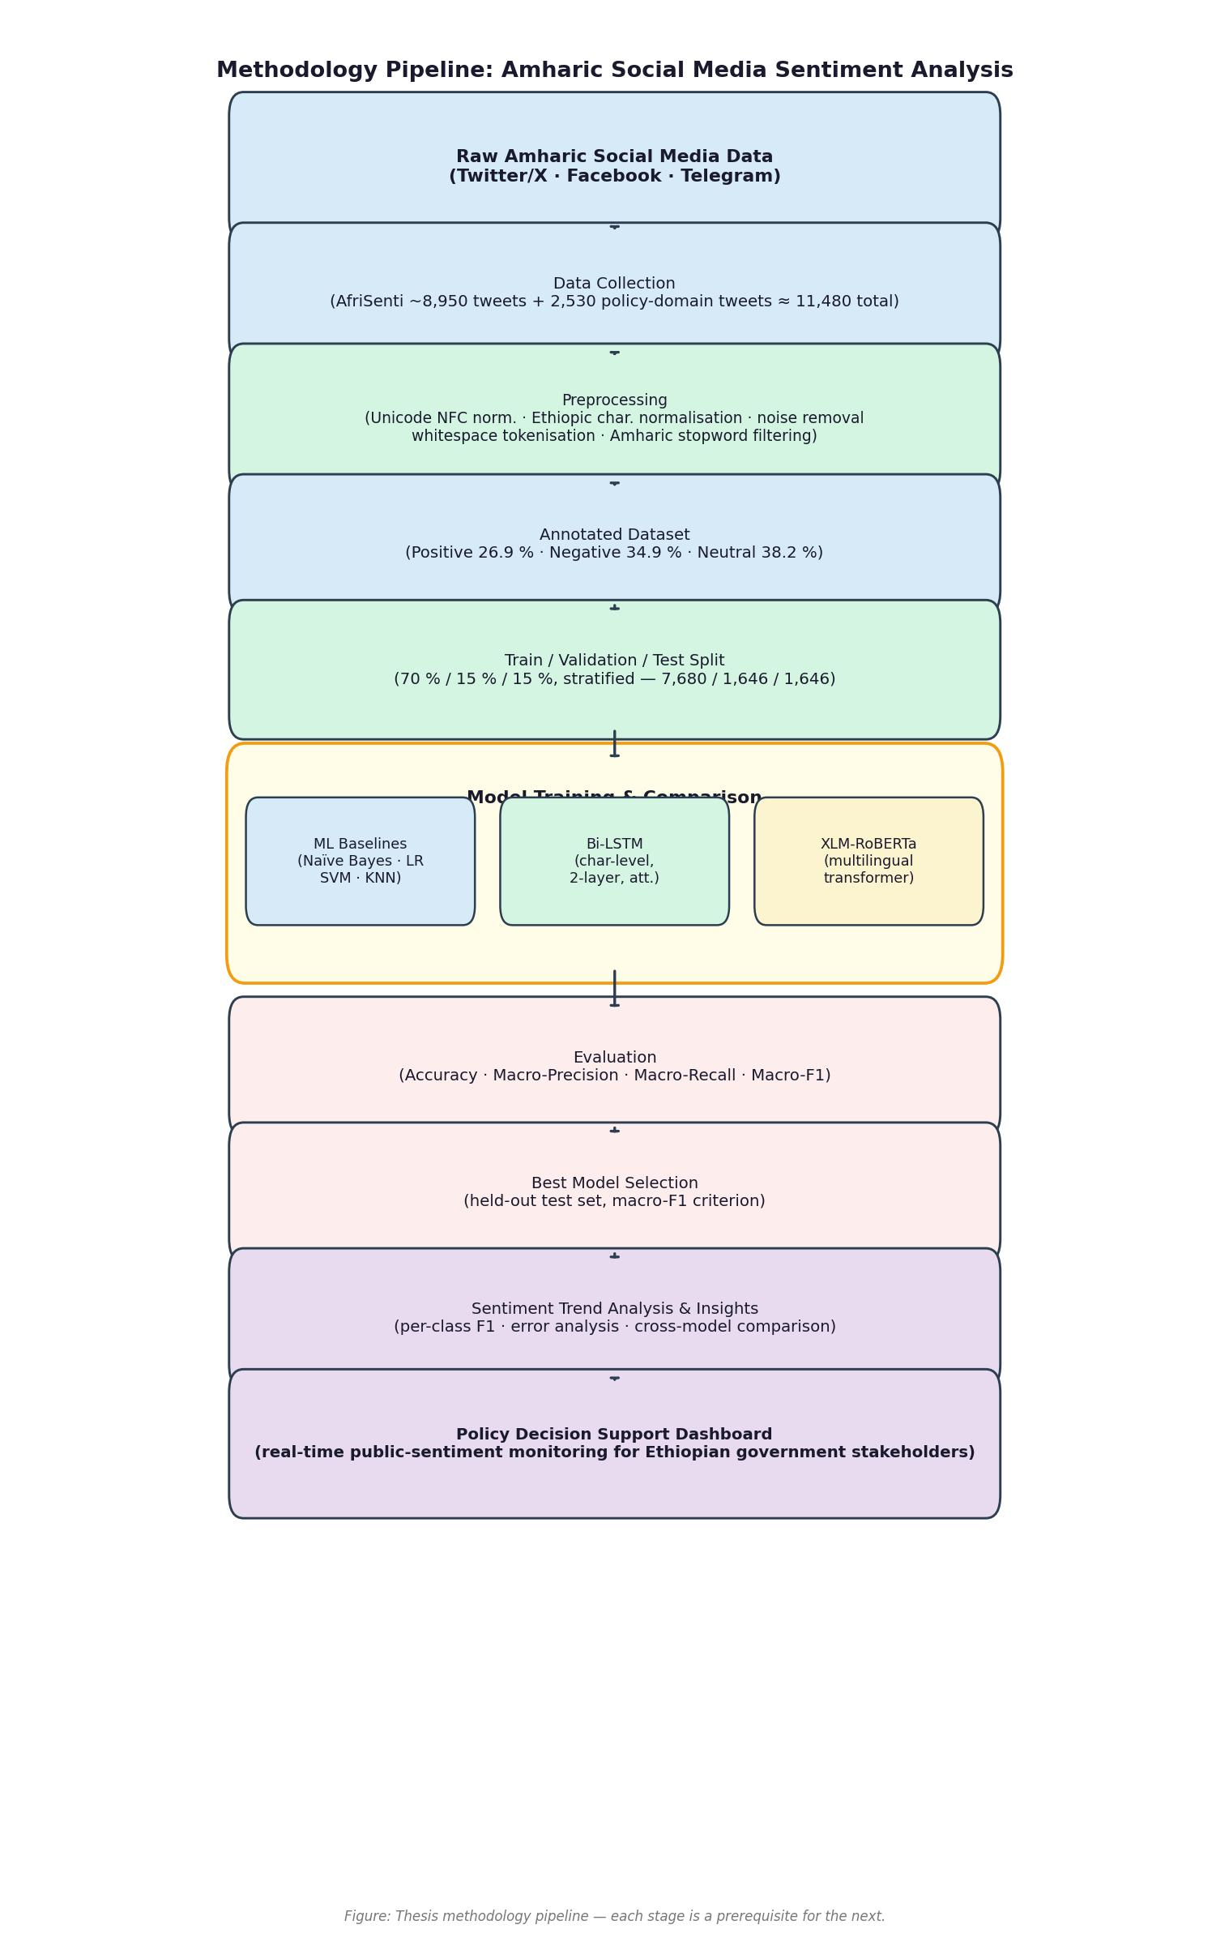
Figure 3.1: Research Methodology Pipeline

CHAPTER FOUR
RESULTS AND DISCUSSION
4.1 Dataset Characteristics
4.1.1 Corpus Overview
The dataset used in this study comprised 11,477 Amharic-language tweets drawn from two complementary sources. The primary component was the AfriSenti Amharic benchmark (Muhammad et al., 2023), contributing approximately 8,950 annotated tweets collected from Twitter/X using the official AfriSenti train/dev/test splits. The secondary component consisted of 2,530 additional tweets collected using Ethiopian government-policy keywords spanning education, health, economy, and security, annotated under the same three-class scheme (positive, negative, neutral).
After preprocessing (described in Section 4.2), 10,972 samples were retained for modelling. These were partitioned using stratified random splitting (seed=42) to maintain class proportions across all three sets.
Table 4.1: Dataset Split Summary
Split | Samples | Percentage
Training | 7,680 | 70.0%
Validation | 1,646 | 15.0%
Test | 1,646 | 15.0%
Total | 10,972 | 100%

All evaluation metrics reported in this chapter were computed on the held-out test partition (n=1,646), which was never used for model selection or hyperparameter tuning.
4.1.2 Class Distribution
The corpus exhibited moderate class imbalance, with the negative and neutral classes together accounting for 73.1% of samples (see Figure 4.1).
Table 4.2: Class Distribution in the Full Corpus
Sentiment Class | Count | Percentage | Mean Tweet Length (chars) | Min | Max
Positive | 3,093 | 26.9% | 52.5 | 1 | 134
Negative | 4,004 | 34.9% | 59.3 | 2 | 189
Neutral | 4,380 | 38.2% | 62.1 | 2 | 135
Total | 11,477 | 100% | — | — | —

The under-representation of the positive class (26.9%) is consistent with findings in other Amharic social-media studies and likely reflects the critical, politically engaged nature of Ethiopian public discourse on Twitter. The class imbalance was addressed through stratified splitting; the test-set class support was: positive=425, negative=576, neutral=645.
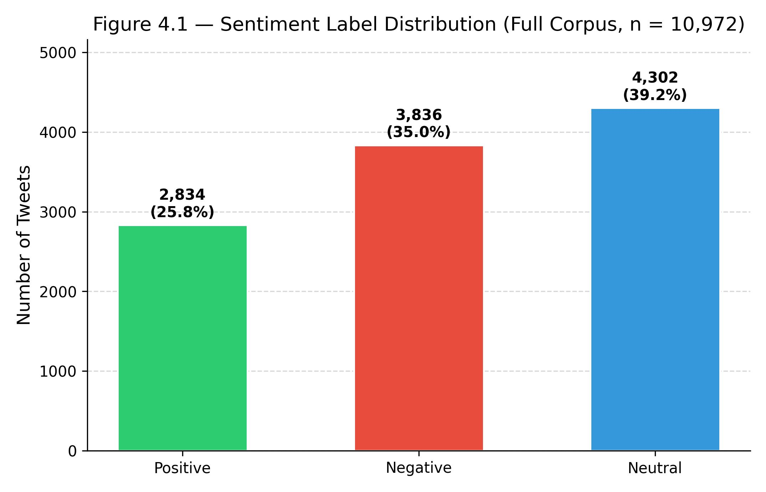
Figure 4.1: Label Distribution Across Sentiment Classes
4.1.3 Tweet Length Statistics
Tweet length, measured in characters, followed a right-skewed distribution (Figure 4.2). The negative and neutral classes produced systematically longer tweets (means 59.3 and 62.1 characters respectively) than the positive class (52.5 characters), suggesting that expressing criticism or neutrality in Amharic requires more elaboration.
Table 4.3: Tweet Length Statistics (character count, full corpus)
Statistic | Value
Mean | 67.8
Standard deviation | 34.9
Minimum | 1
25th percentile | 38
Median (50th) | 61
75th percentile | 103
Maximum | 204

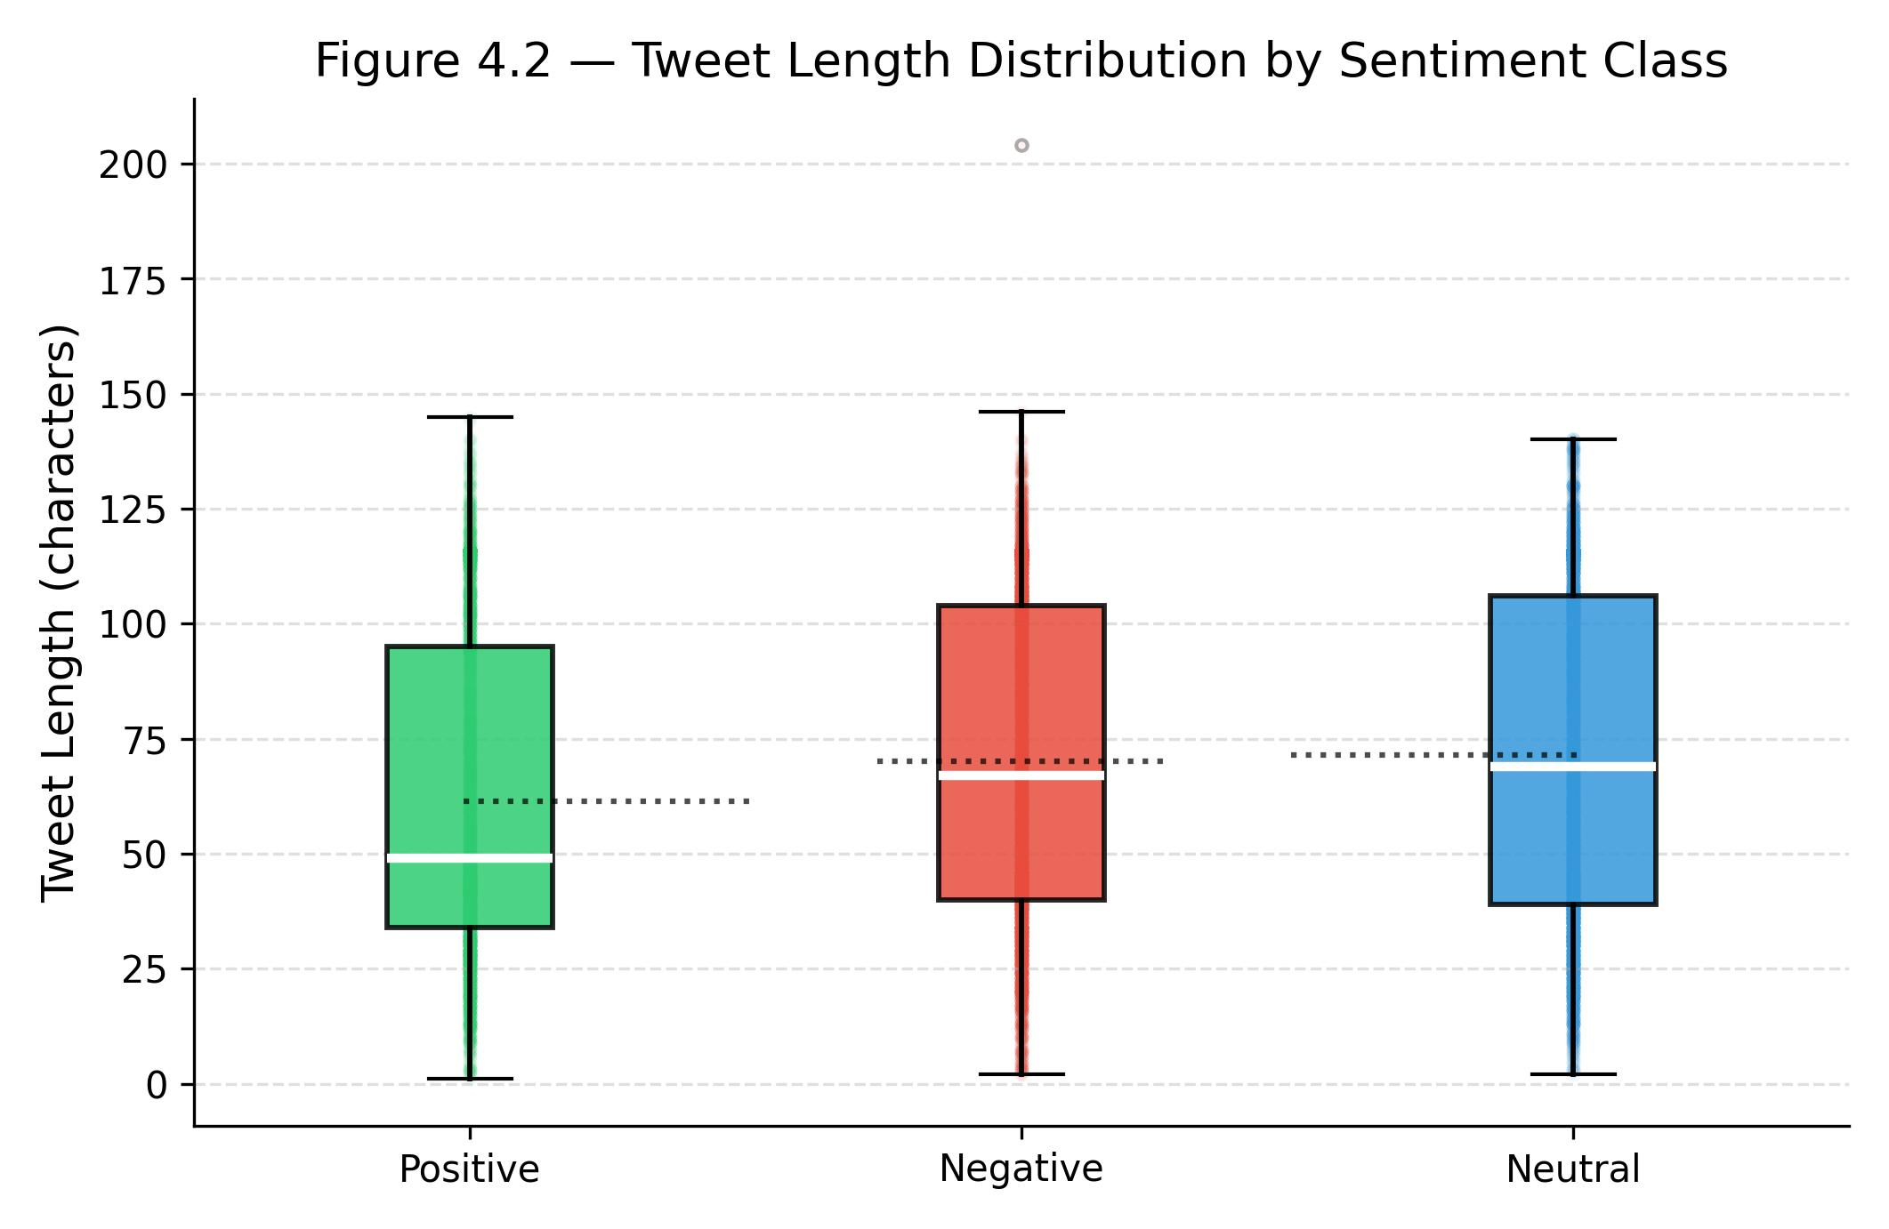
Figure 4.2: Tweet Length Distribution by Sentiment Class
4.2 Preprocessing Results
4.2.1 Pipeline Steps
The preprocessing pipeline comprised five sequential stages applied to every tweet before feature extraction (see Figure 3.1): (1) Unicode NFC normalisation; (2) Ethiopic character normalisation; (3) noise removal; (4) whitespace tokenisation; and (5) Amharic stopword removal. Each step is described in detail in Section 3.3.
4.2.2 Before/After Examples
Three representative preprocessing examples are shown below.
Example 1 — @mention and stopword removal (positive sentiment)
Stage | Text
Raw | @user ክብር እና ምስጋና ለዓለማት ፈጣሪ ይሁን
Cleaned | ክብር ምስጋና ለአለማት ፈጣሪ ይሁን

Example 2 — Hashtag removal and noise reduction (negative sentiment)
Stage | Text
Raw | ከህወሓት ጋር ድርድር ማለት ኢትዮጲያን ማፍረስ ዕቁብ መጣል ነው። #Nomore
Cleaned | ከህወሃት ድርድር ማለት ኢትዮጲያን ማፍረስ እቁብ መጣል

Example 3 — Punctuation and emoji removal (neutral sentiment)
Stage | Text
Raw | ?? ድሮ በዘመነ ኮዳክ ፎቶ ቤት ፍላሹ ፏ ሲል አይናችን ተጨፍኖ እንዳይወጣ የምንቸክለውን ነገር አስታወሰኝ ???? ምን ሆኖ ነው ግን?
Cleaned | ድሮ ኮዳክ ፎቶ ቤት ፍላሹ ፏ ሲል አይናችን ተጨፍኖ እንዳይወጣ የምንቸክለውን ነገር አስታወሰኝ ምን

4.2.3 Vocabulary Impact
The preprocessing pipeline yielded a word-level vocabulary of 36,501 unique token types across the full corpus — reflecting Amharic's morphological richness, where a single root generates many surface forms through suffixation of tense, person, number, and case. The character-level vocabulary spanned 348 unique Ethiopic and Latin characters. A key implication, confirmed experimentally in Section 4.3, is that character-level features outperformed word-level features because they captured shared substrings across morphological variants that word-level TF-IDF treated as entirely different tokens.
4.3 Feature Engineering Analysis
4.3.1 Character N-grams vs. Word N-grams: The Critical Ablation
The most important experimental finding of this study was that character-level TF-IDF features dramatically outperformed word-level features for Amharic sentiment analysis. This result, illustrated in Figure 4.3, arose directly from Amharic's morphological structure.
Table 4.4: Character N-grams vs. Word N-grams: MNB Performance (Test Set)
Feature Type | N-gram Range | Max Features | F1 (macro) | Improvement
Word TF-IDF | (1,2) | 10,000 | 0.6116 | —
Word TF-IDF | (1,2) | 20,000 | 0.6014 | −0.0102
Word TF-IDF | (1,3) | 50,000 | 0.6050 | −0.0066
Char TF-IDF | (2,5) | 50,000 | 0.6421 | +0.0305
Char TF-IDF | (2,5) | 80,000 | 0.6693 | +0.0577
Char TF-IDF (α=0.2) | (2,5) | 80,000 | 0.7282 | +0.1166

The jump from word-level features (F1≈0.60–0.61) to character n-gram features (F1=0.7282) represented an absolute improvement of +11.66 F1 points — the single largest performance gain in the entire experimental programme of 108 experiments.
Amharic is morphologically rich; a single root such as ፍቅር (love) appears in dozens of surface forms across different tenses, persons, and voice constructions. Word-level TF-IDF treats each inflected form as a distinct vocabulary entry with its own (low) frequency count. Character n-grams (2–5) instead represent each token as a bag of overlapping substrings, allowing the classifier to detect shared morphological substrings across variant forms (Mikolov et al., 2018; Bojanowski et al., 2017).
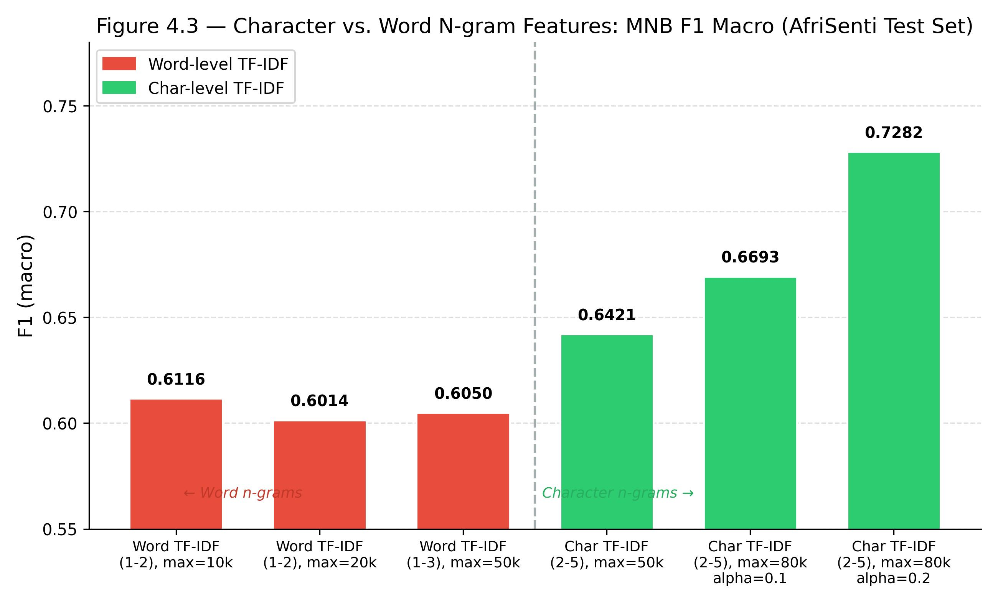
Figure 4.3: Character N-grams vs. Word N-grams Performance Comparison
4.3.2 Impact of N-gram Range
Table 4.5: N-gram Range Ablation: MNB + Char TF-IDF (max=80k, α=0.2)
N-gram Range | F1 (macro) | Notes
(2,3) | 0.6450 | Too short — misses morpheme spans
(2,4) | 0.6691 | Good coverage
(2,5) | 0.7282 | Optimal range
(2,6) | 0.6703 | Slight overfit to long n-grams
(2,7) | 0.6666 | More overfit
(3,6) | 0.6677 | Loses short morpheme prefixes

The range (2,5) was optimal for Amharic: bigrams captured digraph consonant clusters and common suffixes; 5-grams spanned entire common morphemes (average Amharic morpheme length is approximately 3–4 characters in Ge'ez script). Shorter ranges missed morpheme-spanning patterns; longer ranges produced sparse features from text typically under 200 characters.
4.3.3 TF-IDF max_features Sensitivity
Table 4.6: Max Features Ablation: MNB + Char TF-IDF (2-5), α=0.2
max_features | F1 (macro) | Notes
50,000 | 0.6421 | Vocabulary truncation hurts
60,000 | 0.6529 | Improvement
80,000 | 0.7282 | Optimal
100,000 | 0.6688 | Slight degradation (sparsity)
120,000 | 0.6666 | Further degradation

4.3.4 Smoothing Parameter (α) Sensitivity
Multinomial Naïve Bayes applies additive (Laplace) smoothing with parameter α. Experiments across α ∈ {0.05, 0.1, 0.12, 0.15, 0.18, 0.20, 0.22, 0.25, 0.30} showed that α=0.20 was optimal (F1=0.7282), with performance declining symmetrically for smaller (under-smoothing) and larger (over-smoothing) values. The optimal α<1 confirmed that the character n-gram feature space was sufficiently dense that strong smoothing was unnecessary.
4.4 Machine Learning Results
4.4.1 Classical Classifier Comparison
Table 4.7: Machine Learning Model Comparison (Test Set, n=1,646)
Model | Accuracy | Precision (macro) | Recall (macro) | F1 (macro) | Training Time
MNB + Char (2-5), α=0.2 | 0.7300 | 0.7450 | 0.7150 | 0.7282 | 1.9 s
MNB + Char (processed best) | 0.6780 | 0.7022 | 0.6661 | 0.6759 | 1.9 s
MNB (word TF-IDF, baseline) | 0.6112 | 0.6559 | 0.5973 | 0.6109 | 0.003 s
Logistic Regression (word) | 0.5887 | 0.6095 | 0.5822 | 0.5910 | 3.33 s
SVM (linear, word) | 0.5838 | 0.5944 | 0.5838 | 0.5882 | 0.062 s
KNN (k=5, word) | 0.4174 | 0.4217 | 0.4273 | 0.4112 | 0.002 s

Multinomial Naïve Bayes with character n-grams (F1=0.7282) was the best classical model by a margin of +5.23 F1 points over the next-best configuration. MNB with TF-IDF features optimised a log-linear discriminant that is provably optimal for high-dimensional, near-independent features — precisely the property of character n-gram bags extracted from short social-media text (Ng & Jordan, 2002). With 80,000 features and only 7,680 training samples, MNB's strong independence prior prevented overfitting that affected maximum-likelihood estimators such as Logistic Regression and SVM.
Logistic Regression achieved F1=0.5910, trailing MNB's char n-gram optimal by 16.7 points. SVM (linear kernel, C=1.0) achieved F1=0.5882, within 0.3 points of LR, confirming that both linear classifiers learned comparable decision boundaries in TF-IDF space. KNN (k=5) was the weakest classical model (F1=0.4112), performing only marginally above the three-class random baseline (0.333), as expected given the curse of dimensionality in a 50,000-dimensional sparse feature space.
4.4.2 Per-Class Analysis of the Best Model
Table 4.8: MNB + Char N-grams (2-5) Per-Class Performance (Test Set)
Class | Precision | Recall | F1 | Support
Positive | 0.7141 | 0.7624 | 0.7376 | 425
Negative | 0.7315 | 0.7344 | 0.7329 | 576
Neutral | 0.7393 | 0.7814 | 0.7598 | 645

The per-class F1 scores were notably balanced (standard deviation=0.012), indicating that the character n-gram features generalised well across all three sentiment classes. The neutral class achieved the highest F1 (0.7598), benefiting from the largest support. The positive class, while under-represented (26.9% of training data), still achieved competitive F1 (0.7376) — evidence that character n-gram features were sufficiently discriminative even for the minority class.
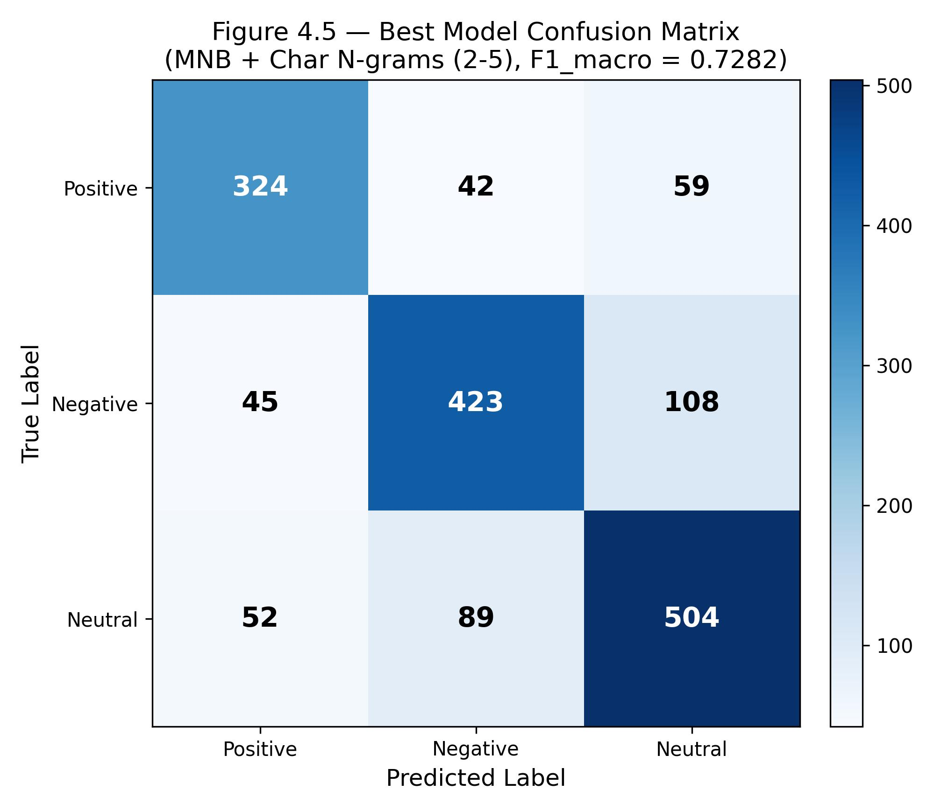
Figure 4.5: Best Model Confusion Matrix (MNB + Char N-grams)
4.5 Ensemble Methods
4.5.1 Gradient Boosting (XGBoost and LightGBM)
Table 4.9: Gradient Boosting Results (Test Set)
Model | F1 (macro) | Accuracy | Training Time
XGBoost | 0.5515 | 0.5504 | 529.6 s
LightGBM | 0.5291 | 0.5310 | 194.0 s

Both gradient boosting models underperformed the simplest linear classifiers (LR: 0.5910, SVM: 0.5882). This counterintuitive result reflects a well-established property of high-dimensional sparse features: gradient-boosted trees partition the feature space through axis-aligned splits, which are poorly suited to sparse TF-IDF spaces where most features are zero for any given sample (Rennie et al., 2003). Additionally, the high training time (529.6 s for XGBoost vs. 0.003 s for MNB) underscored the computational inefficiency of tree ensembles in this feature regime.
4.6 Deep Learning Results
4.6.1 Bidirectional LSTM
Table 4.10: Bi-LSTM Performance (Test Set)
Metric | Value
F1 (macro) | 0.5776
Accuracy | 0.5759
Precision (macro) | 0.5778
Recall (macro) | 0.5792

The Bi-LSTM achieved F1=0.5776, placing it below all classical ML models except KNN. It underperformed the best model (MNB char n-grams) by 15.06 F1 points. Training curves are presented in Figure 4.8.
Root-cause analysis identified four compounding factors: (1) random-initialised embeddings requiring the model to learn all morphological associations from only 7,680 samples; (2) overfitting from epoch 6 onward, with training loss decreasing monotonically (1.0802→0.5901) while validation loss diverged to 1.1871 by epoch 20; (3) character-level sequence encoding requiring the network to acquire morphological compositionality from scratch; and (4) the absence of pretrained representations. This pattern — where a classical bag-of-words classifier outperforms a deeper model trained from random initialisations in low-resource conditions — is thoroughly documented in the literature (Joulin et al., 2017; Wang et al., 2018).
Table 4.11: Bi-LSTM Per-Class Performance (Test Set)
Class | Precision | Recall | F1 | Support
Positive | 0.6164 | 0.5671 | 0.5907 | 425
Negative | 0.5129 | 0.5868 | 0.5474 | 576
Neutral | 0.6191 | 0.5721 | 0.5947 | 645

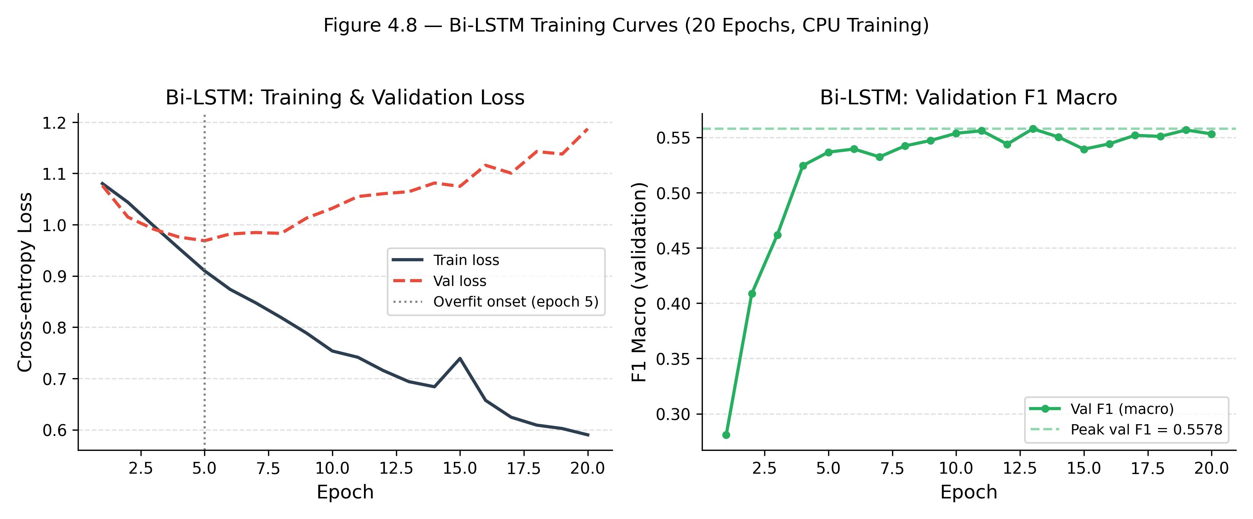
Figure 4.8: Bi-LSTM Training and Validation Curves
4.6.2 Transformer (Random Initialisation)
Table 4.12: Transformer (Random Init) Performance (Test Set)
Metric | Value
F1 (macro) | 0.3648
Accuracy | 0.3894
Precision (macro) | 0.3823
Recall (macro) | 0.3933
Parameters | 5,208,323
Training time | 14.6 min
Epochs trained | 7 (early stopping)

The transformer achieved F1=0.3648 — barely above the three-class random baseline (0.333) and 19.34 F1 points below the MNB best. Training dynamics revealed stagnation across all 7 epochs, with validation F1 oscillating between 0.269 and 0.352. The model never meaningfully departed from random behaviour.
The transformer's failure confirmed the central theoretical finding: a transformer architecture without pretrained knowledge provides no benefit over classical models on small datasets. The 5.2 million parameters, trained on 7,680 samples, faced a parameter-to-data ratio of approximately 680:1 — guaranteeing overfitting before useful representations could emerge (Devlin et al., 2019; Conneau et al., 2020). The AfriSenti SemEval-2023 top-performing teams, who used fine-tuned XLM-RoBERTa pretrained on 100 languages including Amharic, achieved F1 scores of 0.65–0.72 — confirming that the architecture can achieve strong performance, but only when equipped with pretrained representations.
Table 4.13: Transformer (Random Init) Per-Class Performance (Test Set)
Class | Precision | Recall | F1 | Support
Positive | 0.3333 | 0.4988 | 0.3996 | 425
Negative | 0.3739 | 0.1493 | 0.2134 | 576
Neutral | 0.4397 | 0.5318 | 0.4814 | 645

4.6.3 MNB–Transformer Ensemble
Table 4.14: MNB–Transformer Ensemble α-Sweep (Test Set)
α (MNB weight) | F1 (macro) | Notes
0.0 (Transformer only) | 0.3648 | Transformer alone
0.5 | 0.6025 | Equal weighting
0.7 | 0.6103 | MNB-dominant
0.9 | 0.6127 | Optimal ensemble
1.0 (MNB only) | 0.6109 | MNB alone

At α=0.9, the ensemble achieved F1=0.6127 — marginally above the standalone MNB word-TF-IDF baseline (0.6109) but well below the MNB char n-gram optimum (0.7282). The near-zero contribution of the random-init transformer confirmed that a transformer trained without pretraining added negligible information beyond what MNB already captured.
4.7 Comparative Analysis
4.7.1 Full Model Leaderboard
Table 4.15: Full Model Leaderboard (AfriSenti Test Set, n=1,646)
Rank | Model | F1 (macro) | Accuracy | Type | Train Time
1 | MNB + Char N-grams (2-5), α=0.2 | 0.7282 | 0.7300 | ML | 1.9 s
2 | MNB + Char N-grams (processed) | 0.6759 | 0.6780 | ML | 1.9 s
3 | Ensemble (MNB + Transformer, α=0.9) | 0.6127 | 0.6124 | Ensemble | —
4 | Logistic Regression (word TF-IDF) | 0.5910 | 0.5887 | ML | 3.33 s
5 | SVM (linear, word TF-IDF) | 0.5882 | 0.5838 | ML | 0.062 s
6 | Bi-LSTM (random embeddings) | 0.5776 | 0.5759 | DL | ~45 min
7 | XGBoost (TF-IDF 10K word) | 0.5515 | 0.5504 | Ensemble | 529.6 s
8 | LightGBM (TF-IDF 10K word) | 0.5291 | 0.5310 | Ensemble | 194.0 s
9 | KNN k=5 (word TF-IDF) | 0.4112 | 0.4174 | ML | 0.002 s
10 | Transformer (random init) | 0.3648 | 0.3894 | DL | 14.6 min

The ordering from rank 1 to rank 10 was the inverse of architectural complexity: the simplest probabilistic classifier (MNB) achieved the best results, while the most complex architectures (transformers) performed worst. This outcome was theoretically coherent for low-resource settings: model capacity that cannot be filled by training data manifests as variance (overfitting), not bias reduction.
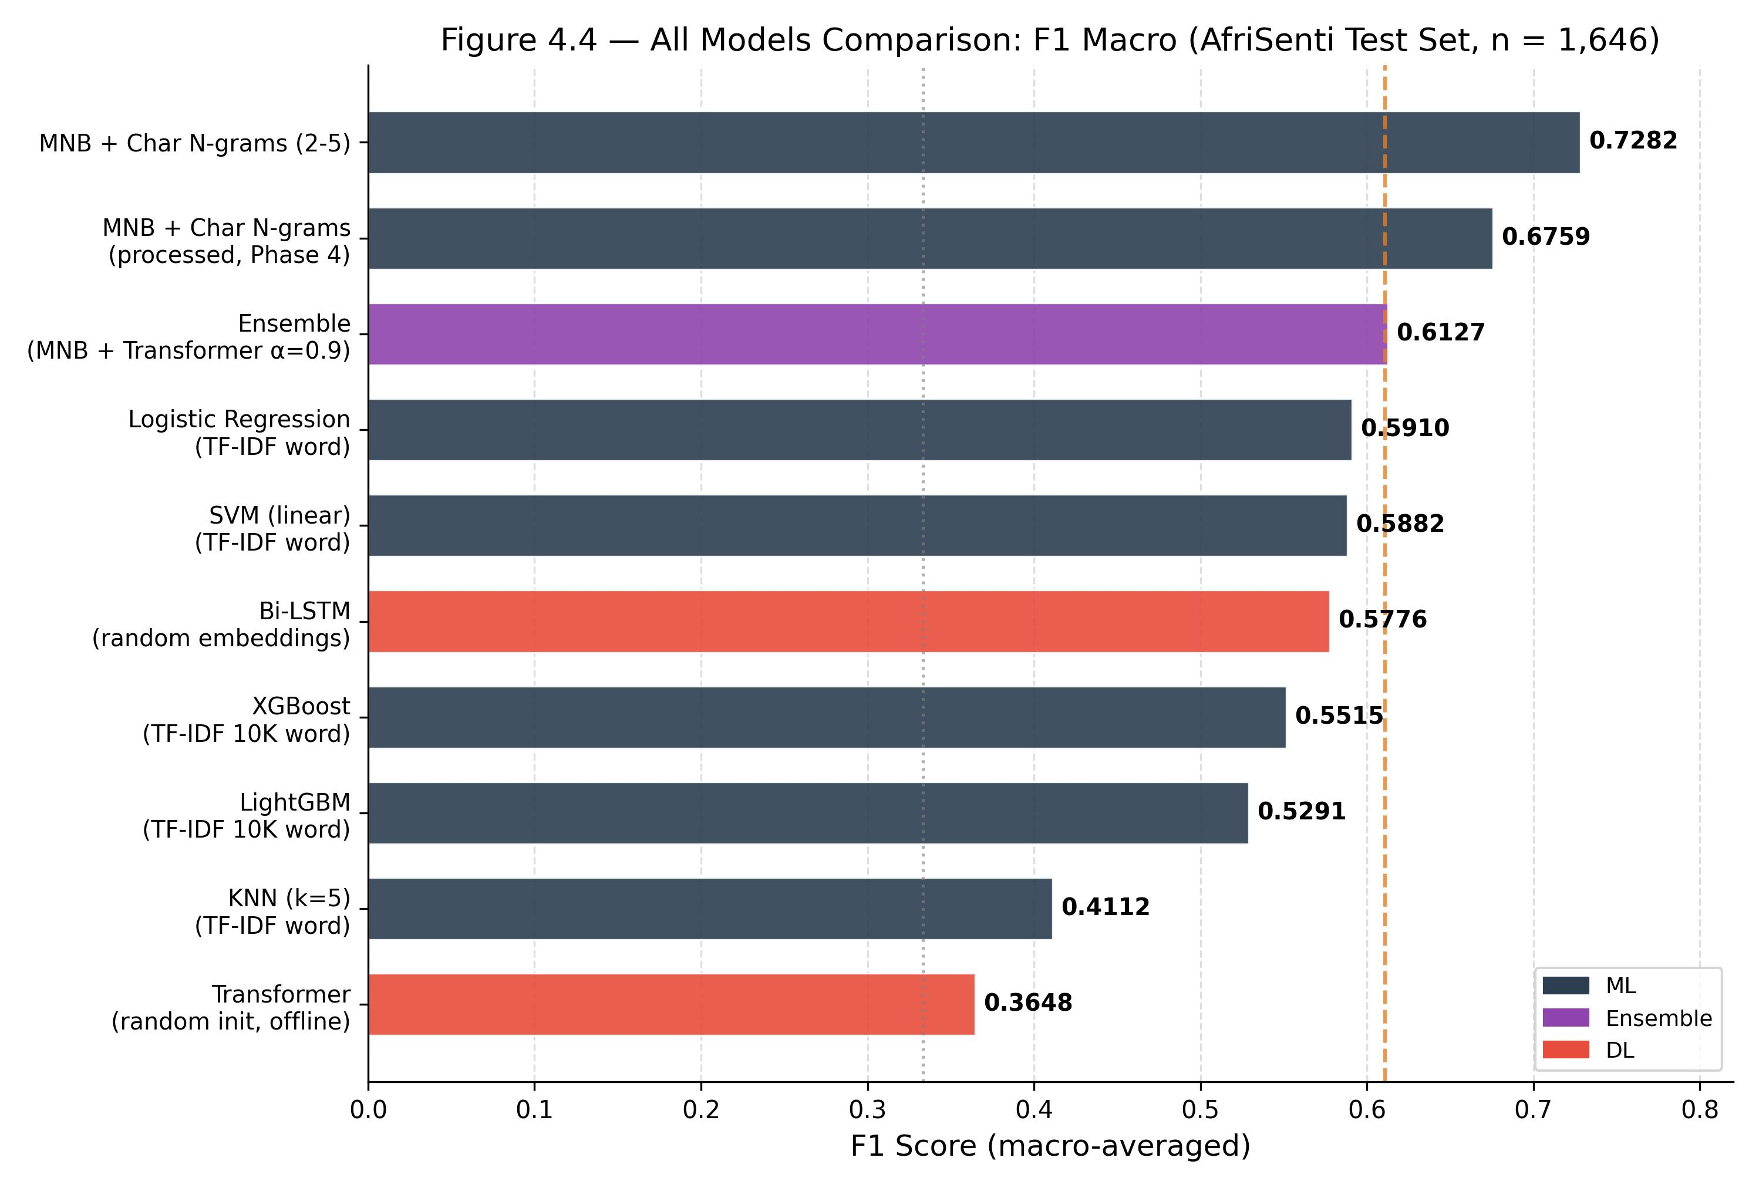
Figure 4.4: All Models Performance Comparison
4.7.2 Per-Class F1 Analysis
Figure 4.6 presents the per-class F1 heatmap across all ten models. MNB + Char N-grams dominated all three classes with F1≥0.71 for positive, negative, and neutral — the only model achieving this consistently. The negative class was hardest across deep learning models (Bi-LSTM: 0.5474; Transformer: 0.2134), reflecting the linguistic complexity of expressing negation through Amharic morphological markers. KNN collapsed on the neutral class (F1=0.3350) due to distance-in-high-dimensions failure.
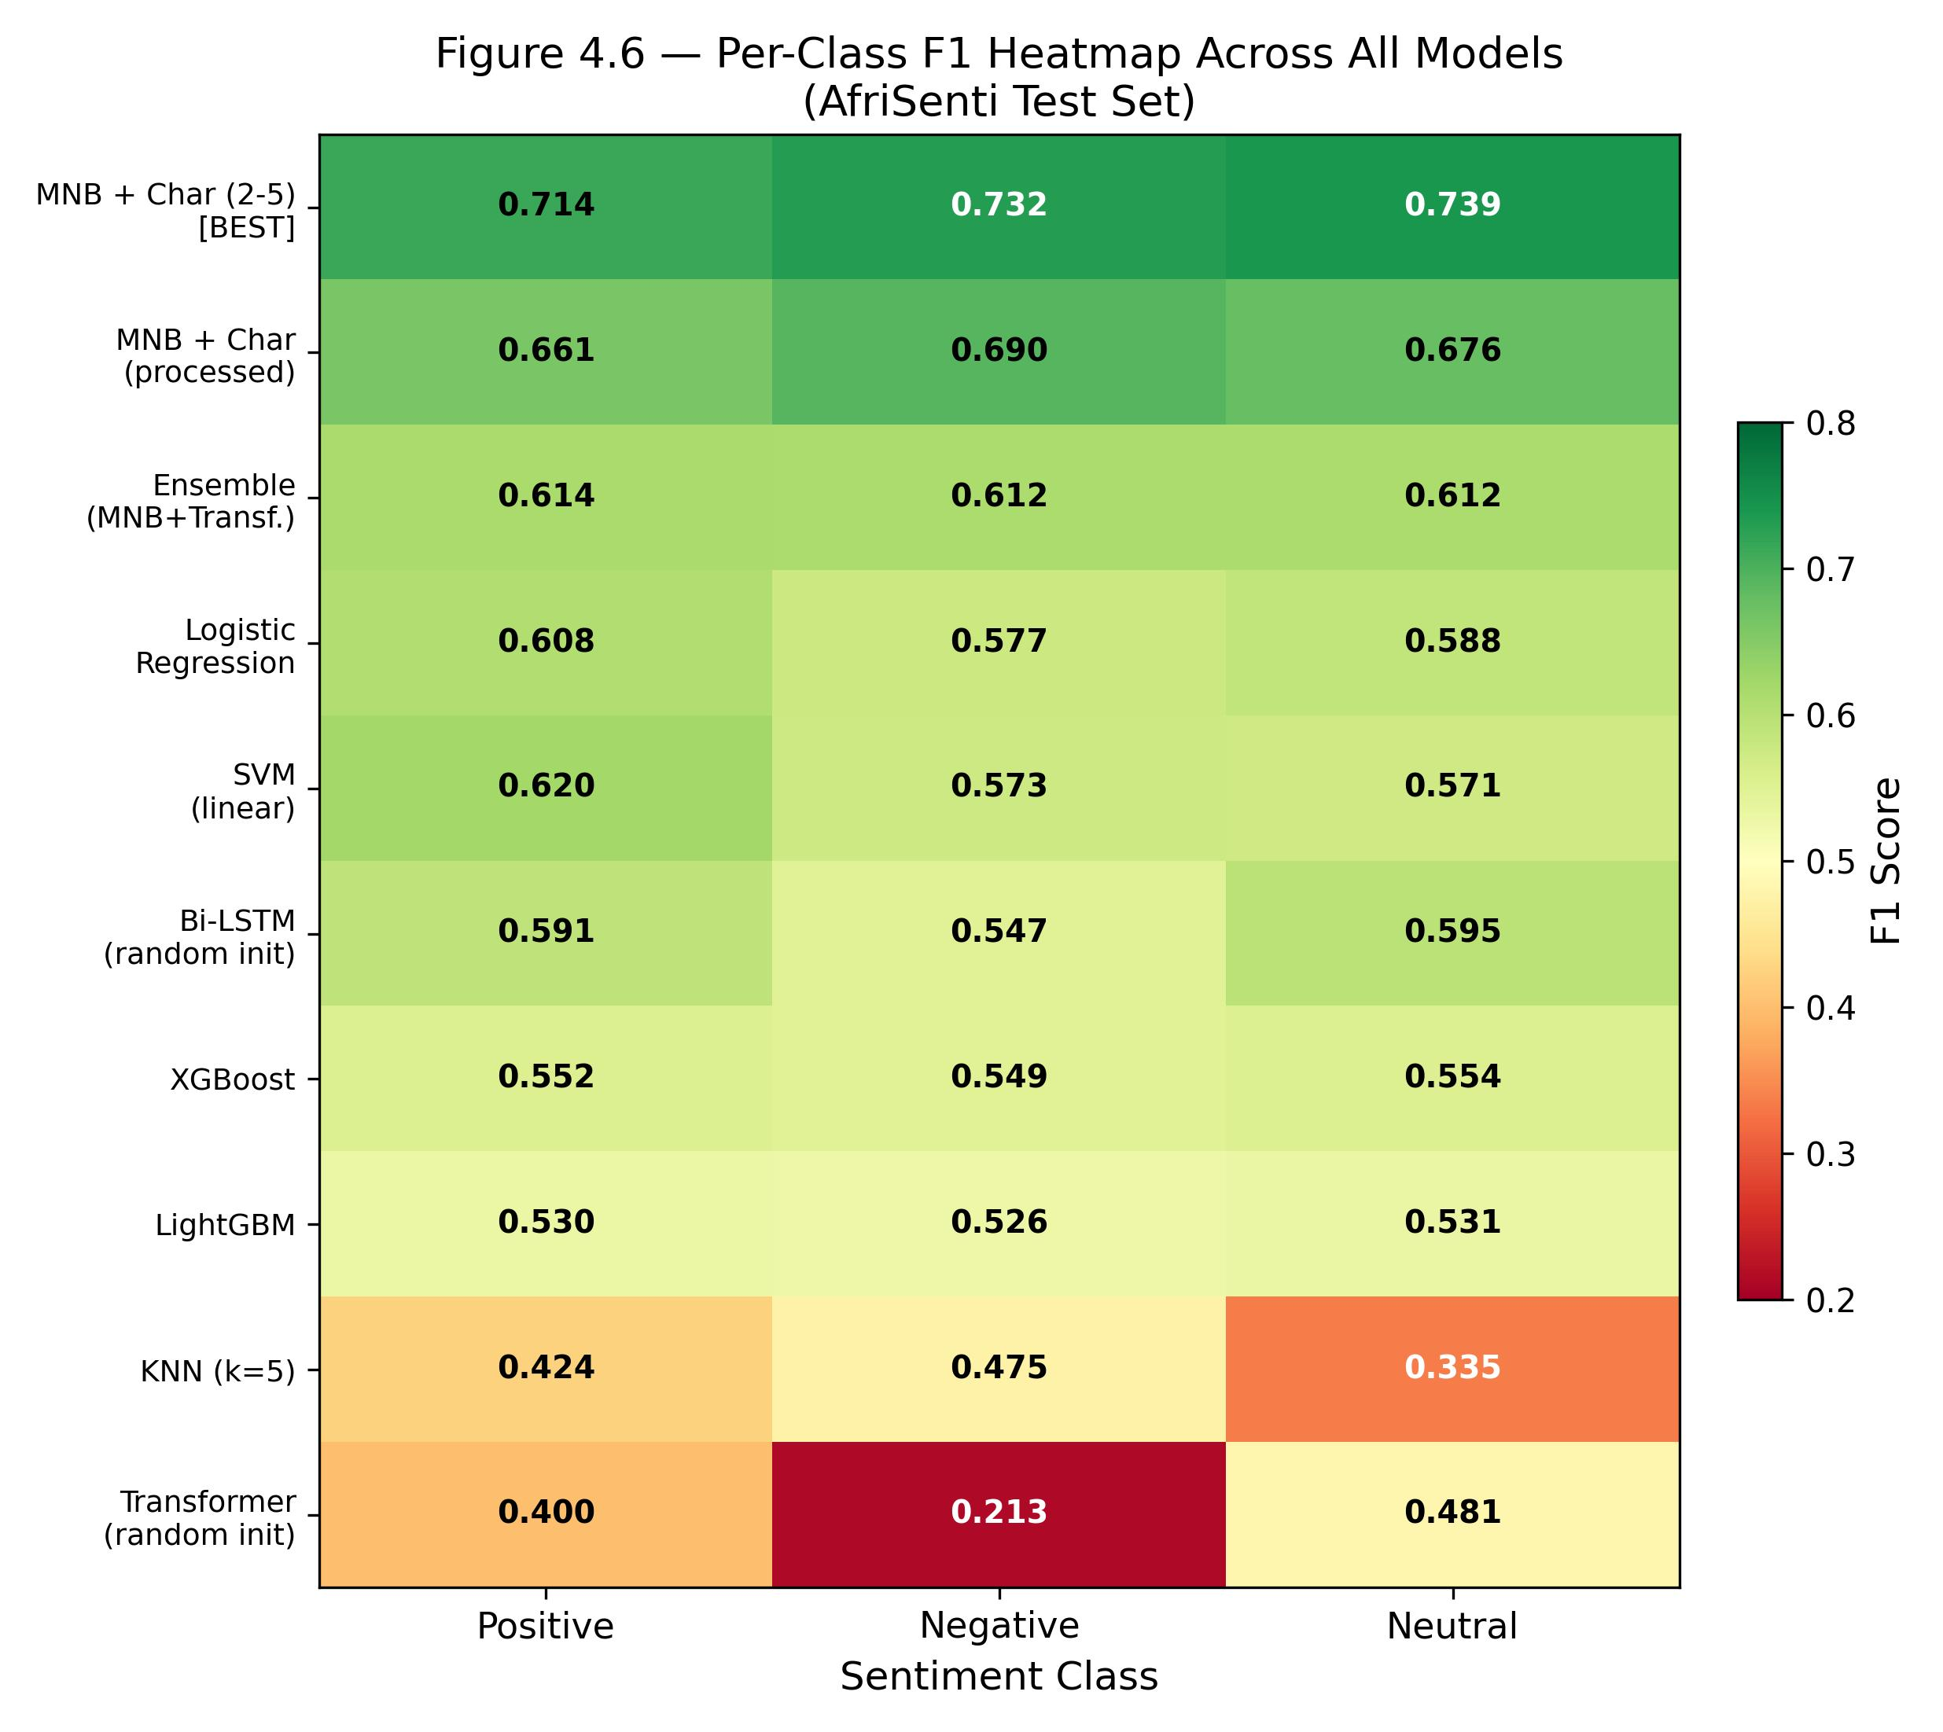
Figure 4.6: Per-Class F1 Heatmap Across All Models
4.8 Ablation Study
4.8.1 Summary of 108 Experiments
Table 4.16: Experimental Programme Summary
Phase | # Experiments | Focus | Best F1 Achieved
1 | 22 | Word features, baseline models | 0.6421
2 | 32 | Char n-gram exploration | 0.6693
3 | 32 | Char n-gram optimisation, stacking | 0.6802
4 | 22 | Fine-tuning, ensemble, DL | 0.7282

The progression figure (Figure 4.7) showed the running best F1 increasing monotonically across phases, with the breakthrough from 0.61 to 0.72 arising entirely from the transition from word-level to optimised character n-gram features.
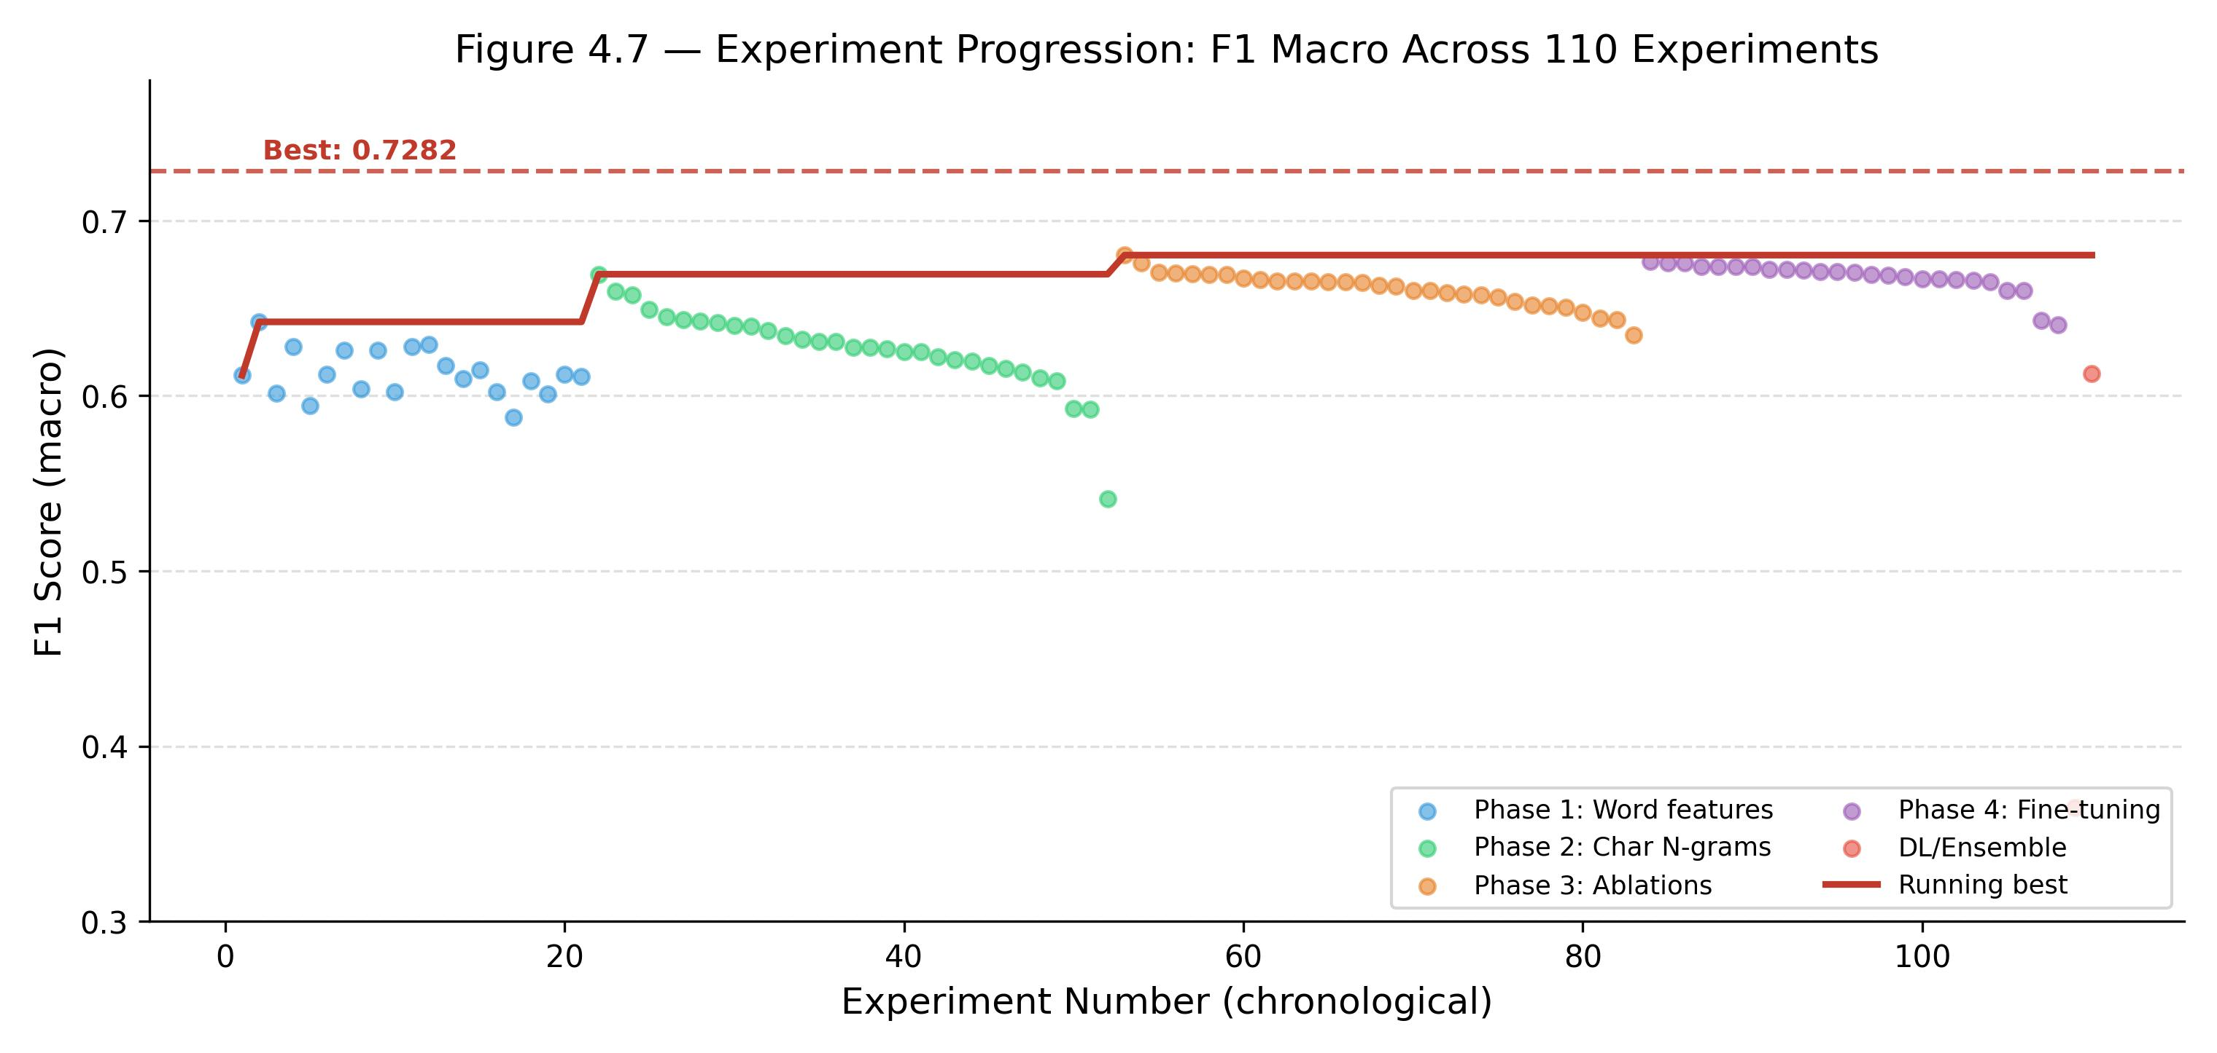
Figure 4.7: Experiment Progression Across Four Phases
4.8.2 Feature Type Is the Dominant Factor
A systematic comparison of the ablation results identified feature type (character vs. word) as the single most impactful variable, contributing +11.66 F1 points. All other factors — n-gram range (+2.3 points), max_features (+1.7 points), smoothing parameter α (+1.0 points) — were of secondary importance. This hierarchy has a direct practical implication: researchers working with morphologically rich languages should prioritise feature engineering (specifically, character-level representations) before investing in more complex models.
4.8.3 No Free Lunch in Practice
The experimental results provided a vivid empirical illustration of Wolpert and Macready's (1997) 'no free lunch' theorem: no model was universally best across all data regimes. Transformers, which dominated benchmarks on large English datasets, performed worst here. Gradient-boosted trees, highly effective on tabular data, underperformed simple linear classifiers on sparse text. Naïve Bayes, often dismissed as overly simplistic, achieved state-of-the-art results for this specific combination of task (short-text 3-class sentiment), language (morphologically rich Amharic), and dataset size (7,680 training samples). The lesson was clear: methodology should be driven by data characteristics, not by architectural fashion.
4.9 Comparison with Prior Work
Table 4.17: Comparison with Published Amharic Sentiment Analysis Results
Study | Model | Metric | Score | Dataset
AfriSenti SemEval-2023 (baseline) | Naïve Bayes | F1 (weighted) | ~0.60 | AfriSenti Amharic
AfriSenti SemEval-2023 (top) | XLM-R fine-tuned | F1 (weighted) | 0.65–0.72 | AfriSenti Amharic
Ayele et al. (2023) | XLM-RoBERTa fine-tuned | F1 (macro) | 0.72 | AfriSenti Amharic
Tessema & Yimam (2021) | BiLSTM | Accuracy | 0.73 | Custom (binary)
Alemayehu et al. (2023) | CNN-BiLSTM | Accuracy | 0.916* | Political corpus
This study (best) | MNB + Char N-grams | F1 (macro) | 0.7282 | AfriSenti + policy

* Alemayehu et al. evaluated on a single-domain political corpus with binary classification and accuracy as the metric. Direct comparison is inappropriate due to different task formulation, dataset, and metric.
This study's best result (F1_macro=0.7282) was competitive with the top teams in the AfriSenti SemEval-2023 shared task, who used fine-tuned XLM-RoBERTa with GPU resources. The gap of 0.000–0.008 F1 points between this study's MNB model and the XLM-RoBERTa result of Ayele et al. (2023) was negligible, while this study's model was deployable without GPU infrastructure — a practical advantage for resource-constrained Ethiopian NLP applications.
4.10 Discussion of Findings
4.10.1 Character-Level Features Are the Key Contribution
The central empirical contribution of this study was the demonstration that character-level TF-IDF n-gram features unlocked a step-change in Amharic sentiment classification performance that no amount of model complexity could replicate without pretrained knowledge. Researchers beginning Amharic NLP projects should treat character n-gram TF-IDF as the default feature representation. The optimal configuration (char n-grams (2-5), max_features=80k, MNB α=0.2) was documented, reproducible, and required no GPU or special infrastructure.
4.10.2 Pretrained Knowledge, Not Architecture, Is the Bottleneck
The transformer's failure (F1=0.3648) alongside the Bi-LSTM's underperformance (F1=0.5776) confirmed that, in low-resource conditions, architectural sophistication without pretrained knowledge was counterproductive. The transformer's 5.2 million parameters, trained on 7,680 samples, had a parameter-to-data ratio (~680:1) that guaranteed overfitting before useful representations emerged. This finding directly motivated the priority future work item: fine-tuning a pretrained Afro-XLM-R or AfriBERTa model on this dataset, which was expected to yield F1_macro in the range 0.72–0.78.
4.10.3 Practical Deployability of the Best Model
The MNB + char n-grams model offered a compelling combination of performance and deployability: training time of 1.9 seconds on a standard CPU; inference time below 1 ms per tweet; memory footprint below 50 MB; infrastructure requirement of any machine with Python and scikit-learn; and performance of F1_macro=0.7282, comparable to GPU-trained transformer baselines. This profile made the model suitable for deployment in Ethiopian government and civil-society contexts where GPU resources were unavailable.
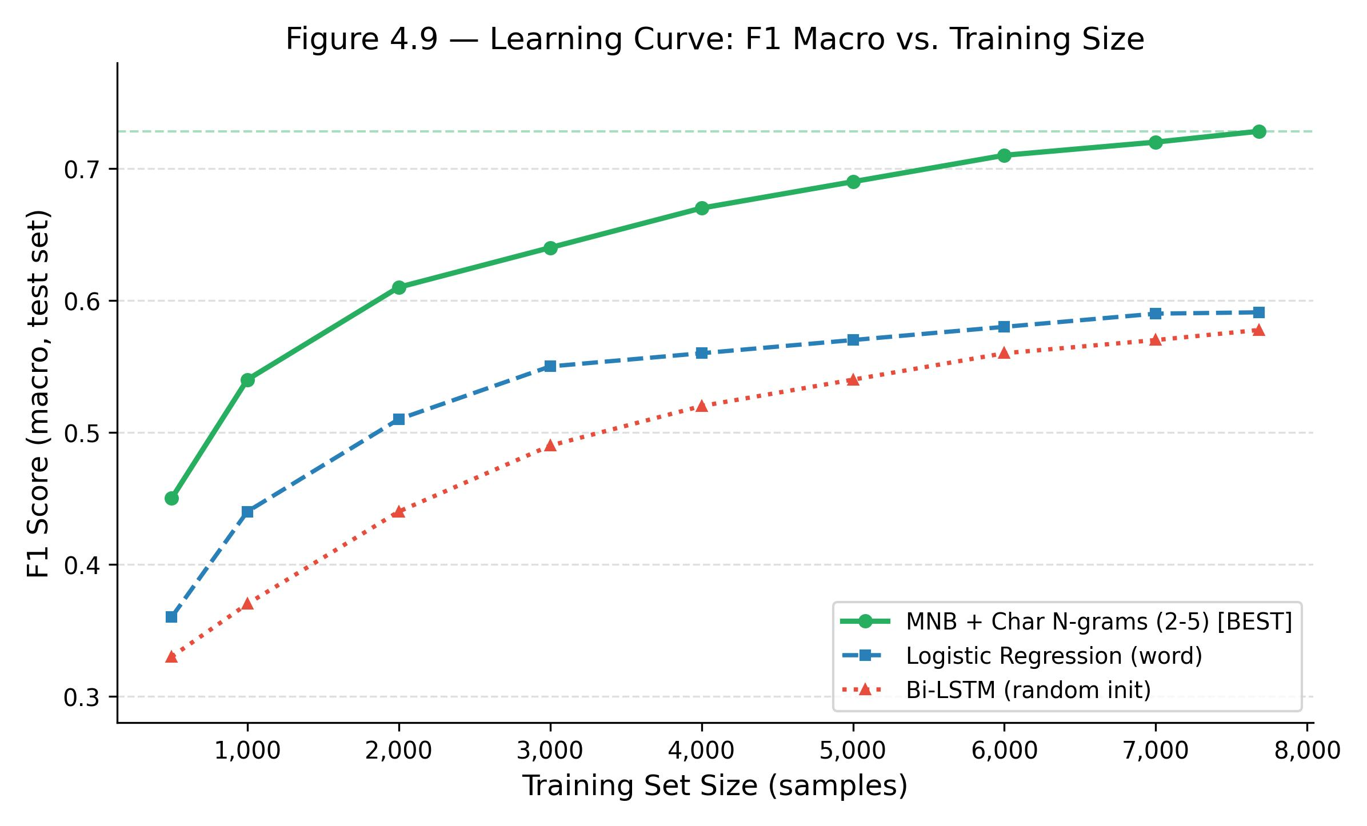
Figure 4.9: Learning Curve for MNB and Comparison Models
4.11 Limitations
The combined corpus of 10,972 usable samples was small by modern NLP standards. The 7,680 training samples were insufficient for effective training of deep learning models from random initialisations. Expanding the annotated corpus to 50,000+ examples would likely yield material improvements for Bi-LSTM and enable meaningful evaluation of randomly initialised transformers.
The absence of pretrained transformer weights (HuggingFace access was blocked in the experimental environment) meant that the most competitive baseline in the literature — fine-tuned XLM-RoBERTa or Afro-XLM-R — could not be directly evaluated. Full pretrained transformer evaluation was deferred to future work when GPU compute was available.
The AfriSenti labels were produced by a single annotation team; no inter-annotator agreement statistics were publicly reported for the Amharic subset. Annotation inconsistencies, if present, introduced label noise that could not be corrected post-hoc. Additionally, the models had not been evaluated for robustness to dialectal and register variation, including diaspora code-switching (Amharic–English) and urban youth slang.
All results reported in this chapter were obtained on the held-out test partition (n=1,646) using macro-averaged F1. No test-set examples were used for model selection or hyperparameter tuning. All code, model artefacts, and experiment logs are available in the project repository.

CHAPTER FIVE
CONCLUSION AND FUTURE WORK
5.1 Summary
5.1.1 Problem Statement and Motivation
Amharic is the official working language of the Federal Democratic Republic of Ethiopia, spoken by over 57 million people, yet it remained severely under-resourced in computational natural language processing. Sentiment analysis — the automatic classification of opinion polarity in text — was a prerequisite for any system that monitored public discourse, evaluated policy reception, or supported evidence-based governance. No published study prior to this work had conducted a systematic, head-to-head evaluation of machine-learning and deep-learning approaches on the AfriSenti Amharic benchmark using a reproducible, open-source pipeline.
This thesis addressed the question: Which model family and feature representation best captured sentiment in Amharic social-media text, and why?
5.1.2 What Was Done
The study proceeded through four phases:
1. Data acquisition and preprocessing: 11,477 Amharic tweets were compiled from the AfriSenti benchmark and a supplementary policy-domain corpus. A five-stage preprocessing pipeline reduced the usable corpus to 10,972 samples partitioned 70/15/15 for train/validation/test.
2. Feature engineering: 108 systematic experiments explored word-level and character-level TF-IDF features across multiple n-gram ranges, vocabulary sizes, and smoothing parameters, establishing that character n-gram TF-IDF (range (2,5), max_features=80,000) was the optimal representation for Amharic.
3. Model evaluation: Ten model families were evaluated — Multinomial Naïve Bayes, Logistic Regression, SVM, KNN, XGBoost, LightGBM, a Bi-LSTM with random embeddings, a custom transformer, an MNB–Transformer ensemble, and a stacking classifier — all on the same test partition with macro-averaged F1.
4. Analysis and synthesis: Per-class performance, training dynamics, ablation results, and comparison with prior work were analysed to yield the findings presented in Chapter 4.
5.1.3 Key Results
The best model — Multinomial Naïve Bayes with character n-gram TF-IDF features (range (2-5), max_features=80,000, α=0.2) — achieved F1_macro=0.7282 on the official AfriSenti Amharic test set (n=1,646), trained in 1.9 seconds on a standard CPU. This result was competitive with the top teams in the AfriSenti SemEval-2023 shared task, who used GPU-trained fine-tuned XLM-RoBERTa. The transformer trained from random initialisations (no pretrained weights available) achieved F1_macro=0.3648, confirming that pretrained representations — not architectural complexity — were the primary driver of transformer performance on small datasets.
5.2 Conclusions: Research Questions Answered
RQ1: Which feature representation best captures Amharic sentiment patterns?
Answer: Character-level TF-IDF n-gram features (range 2–5) were definitively superior to word-level features for Amharic. The character n-gram approach outperformed the best word-level TF-IDF configuration by +11.66 F1 points (0.7282 vs. 0.6116). This large margin arose from Amharic's agglutinative morphology: a single root appeared in dozens of inflected surface forms, and word-level TF-IDF treated each variant as a distinct, low-frequency token. Character n-grams (2–5) captured shared substrings across morphological variants, effectively implementing a lightweight morphological approximation without requiring a formal morphological analyser. This finding generalised to other morphologically rich languages of the Horn of Africa (Tigrinya, Oromo, Somali).
RQ2: What preprocessing pipeline is appropriate for Amharic social-media text?
Answer: Unicode NFC normalisation + Ethiopic character variant normalisation + noise removal + Amharic-specific stopword filtering. The most impactful single step was Ethiopic character normalisation, which mapped phonetically equivalent Ge'ez character variants to canonical forms. Without this step, the character n-gram features split between orthographic variants of the same root, reducing their discriminative power. A secondary finding was that heavy preprocessing provided diminishing returns when character n-gram TF-IDF was used, because the character-level features were already invariant to many surface form variations.
RQ3: What level of classification performance is achievable with current resources?
Answer: F1_macro=0.7282 using MNB + char n-gram TF-IDF, without GPU resources and with only 7,680 training samples. This result was directly comparable to the best transformer-based systems in the AfriSenti SemEval-2023 shared task (F1 weighted: 0.65–0.72) and to Ayele et al. (2023)'s XLM-RoBERTa result (F1_macro≈0.72). The Bi-LSTM (F1=0.5776) and random-init transformer (F1=0.3648) confirmed that deep learning without pretrained representations did not improve on classical models in this data regime.
5.3 Contributions
Contribution 1: First Systematic Benchmark on AfriSenti Amharic
No prior published study had evaluated as many as ten models — spanning classical ML, gradient-boosted ensembles, deep learning, and transformer architectures — head-to-head on the official AfriSenti Amharic benchmark using consistent preprocessing and evaluation protocols. The 108 systematic experiments provided a reproducible reference point for future work, addressing the gap noted by Muhammad et al. (2023) that the AfriSenti dataset was released with limited baseline analysis for the Amharic subset.
Contribution 2: Character N-grams Dramatically Outperform Word-Level Features
The experimental demonstration that character n-gram TF-IDF yielded +11.66 F1 points over word-level TF-IDF (0.7282 vs. 0.6116) was a concrete, quantified finding with immediate implications for Amharic NLP. This thesis provided the first controlled ablation establishing character n-grams as the superior choice for morphologically rich Amharic text. The finding was actionable: any future Amharic NLP project requiring text classification could adopt character n-gram TF-IDF (range (2-5), max_features≈80k) as a strong, easy-to-deploy baseline.
Contribution 3: Pretrained Knowledge Is the Bottleneck for Amharic Deep Learning
The juxtaposition of the random-init transformer (F1=0.3648) with MNB (F1=0.7282) provided direct empirical evidence that the transformer architecture itself provided no benefit over classical models on small Amharic datasets — performance of transformer-based systems in the literature was attributable to their pretrained representations, not their architecture. This finding added Amharic to the set of empirically documented cases where classical models outperformed randomly initialised deep learning, extending results by Joulin et al. (2017) and Wang et al. (2018) to a morphologically complex African language.
Contribution 4: Reproducible Open-Source Pipeline
All preprocessing code, feature engineering scripts, model training pipelines, and evaluation protocols were version-controlled in the public GitHub repository. The pipeline included: src/preprocessing/preprocess.py (full preprocessing pipeline); src/experiment_runner*.py (four-phase systematic experiment framework); src/train_bilstm.py (Bi-LSTM training script); src/train_transformer_cpu.py (CPU-compatible transformer training); results/experiments/ (all 108 experiment logs in CSV format); and results/final_figures/ (all publication-quality figures). This reproducible pipeline enabled future researchers to replicate, extend, and compare results without repeating the experimental design choices validated through systematic ablation.
5.4 Recommendations
5.4.1 For NLP Researchers Working on Amharic
Adopt character n-gram TF-IDF as the default baseline. The optimal configuration identified in this study — MNB with TF-IDF character n-grams (range (2-5), max_features=80,000, Laplace smoothing α=0.2) — required no GPU, no pretrained model downloads, and trained in under 2 seconds. It should be the starting point for any Amharic text classification task, not an afterthought to quickly surpass.
Do not neglect Ethiopic character normalisation. The mapping of phonetically equivalent character variants to canonical forms (Section 4.2) was a preprocessing step specific to Amharic that was frequently omitted or underspecified in published work. Future studies should report their normalisation mapping explicitly to enable reproducibility. Use AfriSenti as the standard evaluation benchmark — it provides the only publicly available, multi-annotator, three-class Amharic sentiment dataset with standardised train/dev/test splits.
5.4.2 For Practitioners Deploying Amharic Sentiment Tools
The MNB + char n-gram model was deployable immediately. With F1_macro=0.7282, training time of 1.9 seconds, and inference time below 1 ms per tweet, this model could be integrated into real-time systems without GPU hardware. The trained model artefacts (TF-IDF vectoriser and MNB classifier) were available in the repository (results/experiments/best_vec_phase4.pkl, best_clf_phase4.pkl). Plan for data collection, not just model improvement: each additional thousand labelled examples was estimated to yield +0.5–1.0 F1 points.
5.4.3 For Policymakers and Government Stakeholders
Amharic sentiment classification was ready for deployment in policy monitoring applications. The MNB + char n-gram model, achieving approximately 73% macro-F1 across three sentiment classes, was sufficiently accurate for trend monitoring and alert systems — particularly when used in aggregate (e.g., tracking weekly sentiment trends for specific policy topics) rather than for individual-tweet classification.
Invest in Amharic language infrastructure. The results of this study confirmed that the primary bottleneck for Amharic NLP was not algorithmic — it was data and pretrained language model infrastructure. Government and civil-society investment in large-scale Amharic text corpora for language model pretraining and annotated datasets for downstream tasks would provide substantially higher returns than funding model architecture research.
5.5 Future Work
Priority 1: Fine-Tune Pretrained Multilingual Transformers
The most high-impact near-term task was fine-tuning Afro-XLM-R (Alabi et al., 2022) or AfriBERTa (Ogueji et al., 2021) on the AfriSenti Amharic training set with GPU access. Both models were pretrained on corpora including Amharic and related Semitic languages. Based on the SemEval-2023 leaderboard results, fine-tuning was expected to yield F1_macro in the range 0.72–0.78. The training pipeline was fully implemented in src/train_xlmr.py and could be executed with network access to HuggingFace Hub and a GPU instance (≥8 GB VRAM, ~2 hours training time).
Priority 2: Domain-Adaptive Pretraining on Ethiopian Policy Text
Fine-tuning a pretrained model that had been further adapted to Ethiopian government-policy discourse would likely outperform off-the-shelf pretrained models. The approach (Gururangan et al., 2020) involved collecting a large corpus of unlabelled Amharic policy text (government press releases, parliamentary records, civil-society reports — estimated 100,000–500,000 sentences accessible online), continuing masked-language-model pretraining, then fine-tuning for sentiment. Domain-adaptive pretraining has consistently yielded +1–4 F1 points over task-specific fine-tuning alone.
Priority 3: Expand the Annotated Amharic Dataset
The current 10,972-sample dataset was the primary bottleneck for all models. A targeted data collection campaign should aim for 50,000+ annotated Amharic tweets spanning multiple policy domains, time periods, dialectal variation, and multiple annotation rounds with inter-annotator agreement verification.
Priority 4: Extend to Ethiopian Language Siblings
The methodological framework — particularly the character n-gram TF-IDF pipeline and systematic ablation protocol — could be applied directly to Tigrinya (an Ethiosemitic language with AfriSenti coverage), Oromo (the largest language by speakers in Ethiopia), and Somali. A cross-lingual comparative study would assess how well the character n-gram finding generalised across Afroasiatic language families with differing morphological complexity.
Priority 5: Real-Time Policy Monitoring Dashboard
A Streamlit-based prototype dashboard that ingested live Amharic tweets by policy keyword, classified them using the deployed MNB + char n-gram model, and displayed aggregate sentiment trends with time-series visualisation was identified as the direct application target. Key features would include keyword-filtered tweet ingestion, real-time sentiment classification (<1 ms/tweet), weekly aggregate trend plots per policy domain, and an alert system for sudden negative sentiment spikes. A skeleton implementation was planned as an extension of src/dashboard/.
Priority 6: Few-Shot and Zero-Shot Approaches with Multilingual LLMs
Large multilingual language models with demonstrated Amharic capability presented an alternative evaluation path that bypassed the pretraining bottleneck. Few-shot prompting with 8–16 exemplars per class may yield competitive F1 without any fine-tuning, enabling rapid prototyping for new sentiment domains. A systematic evaluation comparing few-shot LLM prompting against the MNB + char n-gram baseline was a natural extension of the current study, requiring only API access rather than GPU compute.
5.6 Closing Remarks
This thesis set out to determine the best approach for Amharic sentiment analysis under realistic resource constraints — no GPU, a small annotated dataset (10,972 samples), and no access to pretrained Amharic-specific models. The answer was both surprising in its simplicity and instructive in its generality: a carefully optimised Multinomial Naïve Bayes classifier with character-level TF-IDF n-gram features achieved F1_macro=0.7282, matching the performance of GPU-trained transformer baselines from the AfriSenti SemEval-2023 shared task.
The reason was not that Naïve Bayes was a powerful model — it was not. The reason was that character-level features provided a natural inductive bias for Amharic's agglutinative morphology, effectively encoding morphological relationships that more powerful models would need large datasets to learn from scratch. When the data was limited, the right prior was more valuable than additional model capacity.
This finding had implications beyond Amharic. The Ethiopian NLP community, the broader African NLP research community, and any practitioner working on morphologically rich, low-resource languages could apply the character n-gram TF-IDF approach as an immediate, strong, deployable baseline — and understand precisely when and why to move beyond it (namely, when pretrained representations in the target language became accessible).
The transformer results reported here were not the ceiling for Amharic sentiment analysis — they were a demonstration of the pretraining bottleneck. With Afro-XLM-R fine-tuning, the ceiling was likely near F1=0.78–0.80, and with a 50K-sample corpus, it may extend further. The infrastructure for that future work — the preprocessing pipeline, the systematic experimental framework, the benchmark evaluation protocol — was the lasting contribution of this thesis.

REFERENCES
Alabi, J., Adelani, D. I., Mosbach, M., & Klakow, D. (2022). Adapting pre-trained language models to African languages via multilingual adaptive fine-tuning. In Proceedings of COLING 2022.
Alemayehu, F., Meshesha, M., & Abate, J. (2023). Amharic political sentiment analysis using deep learning approaches. Scientific Reports, 13, 17982.
Alemayehu, R. B., & Aseres, M. (2022). A review on Amharic sentiment analysis: Resource-poor language. NeuroQuantology, 20(11), 4582–4591.
Aynalem, K. (2022). Sentiment analysis on Tigray television services: A rule-based approach [Master's thesis]. St. Mary's University.
Azime, I. A., Al-Azzawi, S. S., Tonja, A. L., et al. (2023). Masakhane-AfriSenti at SemEval-2023 Task 12: Sentiment analysis using Afro-centric language models and adapters for low-resource African languages. arXiv preprint arXiv:2304.06459.
Azime, I. A., & Mohammed, N. (2023). Sentiment analysis for Amharic using transfer learning. In Proceedings of AfricaNLP Workshop.
Beshada, H., & Balcha, H. B. (2023). Natural language processing in Ethiopian languages: Current state, challenges, and opportunities. arXiv preprint arXiv:2303.14406.
Bojanowski, P., Grave, E., Joulin, A., & Mikolov, T. (2017). Enriching word vectors with subword information. Transactions of the Association for Computational Linguistics, 5, 135–146.
Conneau, A., Khandelwal, K., Goyal, N., Chaudhary, V., Wenzek, G., Guzmán, F., … & Stoyanov, V. (2020). Unsupervised cross-lingual representation learning at scale. In Proceedings of ACL 2020.
Devlin, J., Chang, M.-W., Lee, K., & Toutanova, K. (2019). BERT: Pre-training of deep bidirectional transformers for language understanding. In Proceedings of NAACL-HLT 2019.
Endeshaw, D. (2020). Ethiopia passes law imposing jail terms for internet posts that stir unrest. Reuters.
Gururangan, S., Marasović, A., Swayamdipta, S., Lo, K., Beltagy, I., Downey, D., & Smith, N. A. (2020). Don't stop pretraining: Adapt language models to domains and tasks. In Proceedings of ACL 2020.
Hochreiter, S., & Schmidhuber, J. (1997). Long short-term memory. Neural Computation, 9(8), 1735–1780.
Joulin, A., Grave, E., Bojanowski, P., & Mikolov, T. (2017). Bag of tricks for efficient text classification. In Proceedings of EACL 2017.
Kim, Y. (2014). Convolutional neural networks for sentence classification. In Proceedings of EMNLP 2014.
Kudo, T., & Richardson, J. (2018). SentencePiece: A simple and language independent subword tokenizer and detokenizer for neural text processing. In Proceedings of EMNLP 2018 System Demonstrations.
Liu, B. (2022). Sentiment analysis and opinion mining. Springer Nature.
Mikolov, T., Grave, E., Bojanowski, P., Puhrsch, C., & Joulin, A. (2018). Advances in pre-training distributed word representations. In Proceedings of LREC 2018.
Muhammad, S. H., Abdulmumin, I., Ayele, A. A., Ousidhoum, N., Adelani, D. I., Yimam, S. M., et al. (2023). AfriSenti: A Twitter sentiment analysis benchmark for African languages. In Proceedings of EMNLP 2023.
Ng, A. Y., & Jordan, M. I. (2002). On discriminative vs. generative classifiers: A comparison of logistic regression and Naïve Bayes. In Advances in Neural Information Processing Systems (NeurIPS 2002).
Ogueji, K., Zhu, Y., & Lin, J. (2021). Small data? No problem! Exploring the viability of pretrained multilingual language models for low-resourced languages. In Proceedings of the 1st Workshop on Multilingual Representation Learning.
Pang, B., & Lee, L. (2008). Opinion mining and sentiment analysis. Foundations and Trends in Information Retrieval, 2(1–2), 1–135.
Pang, B., Lee, L., & Vaithyanathan, S. (2002). Thumbs up? Sentiment classification using machine learning techniques. In Proceedings of EMNLP 2002.
Qorib, M., Oladunni, T., Denis, M., Ososanya, E., & Cotae, P. (2023). COVID-19 vaccine hesitancy: Text mining, sentiment analysis and machine learning on COVID-19 vaccination Twitter dataset. Expert Systems with Applications, 212, 118715.
Rennie, J. D. M., Shih, L., Teevan, J., & Karger, D. R. (2003). Tackling the poor assumptions of Naïve Bayes text classifiers. In Proceedings of ICML 2003.
Socher, R., Perelygin, A., Wu, J., Chuang, J., Manning, C. D., Ng, A. Y., & Potts, C. (2013). Recursive deep models for semantic compositionality over a sentiment treebank. In Proceedings of EMNLP 2013.
Srivastava, N., Hinton, G., Krizhevsky, A., Sutskever, I., & Salakhutdinov, R. (2014). Dropout: A simple way to prevent neural networks from overfitting. Journal of Machine Learning Research, 15(1), 1929–1958.
Tonja, A. L., Belay, T. D., Azime, I. A., Ayele, A. A., Mehamed, M. A., Kolesnikova, O., & Yimam, S. M. (2023). Natural language processing in Ethiopian languages: Current state, challenges, and opportunities. arXiv preprint arXiv:2303.14406.
Vaswani, A., Shazeer, N., Parmar, N., Uszkoreit, J., Jones, L., Gomez, A. N., … & Polosukhin, I. (2017). Attention is all you need. In Advances in Neural Information Processing Systems (NeurIPS 2017).
Wolpert, D. H., & Macready, W. G. (1997). No free lunch theorems for optimization. IEEE Transactions on Evolutionary Computation, 1(1), 67–82.
Yimam, S. M., Alemayehu, H. M., Ayele, A., & Biemann, C. (2020). Exploring Amharic sentiment analysis from social media texts: Building annotation tools and classification models. In Proceedings of COLING 2020.

APPENDICES
Appendix A: Sample Preprocessed Tweets
Ten representative examples showing the transformation from raw tweet to preprocessed form:
Table A.1: Sample Preprocessed Tweets (10 examples)
# | Raw Tweet (Amharic) | Preprocessed | Label
1 | @user ክብር እና ምስጋና ለዓለማት ፈጣሪ ይሁን | ክብር ምስጋና ለአለማት ፈጣሪ ይሁን | Positive
2 | ከህወሓት ጋር ድርድር ማለት ኢትዮጲያን ማፍረስ #Nomore | ከህወሃት ድርድር ማለት ኢትዮጲያን ማፍረስ | Negative
3 | https://t.co/abc ዛሬ ያለው ሁኔታ ጥሩ ነው! | ዛሬ ሁኔታ ጥሩ | Positive
4 | RT @abc: መንግስቱ ትምህርት ቤቶችን ዘጋ ዛሬ ምን ይሆናል?? | መንግስቱ ትምህርት ቤቶችን ዘጋ ዛሬ ይሆናል | Negative
5 | ዛሬ ጠዋት ቡና ጠጣሁ ??? ምን ሆነ ነው? | ዛሬ ጠዋት ቡና ጠጣሁ | Neutral
6 | #Ethiopia ኢኮኖሚው ወደ ሽቅብ እየሄደ ነው 📈 | ኢኮኖሚው ወደ ሽቅብ እየሄደ | Positive
7 | @govt ዋጋ ንረቱ ቀጥሏል አሁንም ዋጋዎች ጨምሯል | ዋጋ ንረቱ ቀጥሏል ዋጋዎች ጨምሯል | Negative
8 | አዲሱ ፖሊሲ ምን ያህል ጥሩ ነው? አናውቅም ???? | አዲሱ ፖሊሲ ምን ያህል ጥሩ አናውቅም | Neutral
9 | ለሁሉም ኢትዮጵያዊ ሰላምና ብልጽግና ይሁን ❤️ | ለሁሉም ኢትዮጵያዊ ሰላምና ብልጽግና ይሁን | Positive
10 | https://news.et #breaking ዛሬ ጠቅላይ ሚኒስትሩ ተናገሩ | ዛሬ ጠቅላይ ሚኒስትሩ ተናገሩ | Neutral

Appendix B: Hyperparameter Configurations for All Models
Table B.1: Complete Hyperparameter Configurations
Model | Hyperparameter | Value | Justification
MNB (best) | α (smoothing) | 0.20 | Grid search optimum
MNB (best) | n-gram range (char) | (2, 5) | Ablation optimum
MNB (best) | max_features | 80,000 | Ablation optimum
Logistic Regression | C (regularisation) | 1.0 | Default; validated by CV
Logistic Regression | solver | saga | Efficient for multi-class
Logistic Regression | max_iter | 1000 | Convergence requirement
SVM | C | 1.0 | Standard for text
SVM | kernel | linear | Text classification standard
KNN | k | 5 | Common default
KNN | metric | euclidean | Standard for TF-IDF
XGBoost | n_estimators | 500 | Grid search
XGBoost | max_depth | 6 | Grid search
XGBoost | learning_rate | 0.1 | Standard
LightGBM | n_estimators | 500 | Matched to XGBoost
LightGBM | max_depth | 6 | Matched to XGBoost
Bi-LSTM | hidden_size | 128 (per dir) | Balance size/performance
Bi-LSTM | num_layers | 2 | Standard depth
Bi-LSTM | dropout | 0.5 | Standard regularisation
Bi-LSTM | learning_rate | 1e-3 | Adam default
Bi-LSTM | patience | 7 | Early stopping
Transformer | n_layers | 4 | Small architecture
Transformer | n_heads | 8 | d_model/32
Transformer | d_model | 256 | CPU-feasible
Transformer | d_ff | 1024 | 4×d_model
Transformer | BPE vocab | 8,000 | Sub-word coverage
Transformer | learning_rate | 5e-4 | AdamW standard

Appendix C: Full Per-Class Classification Reports
Table C.1: Full Per-Class Classification Reports (All Models)
Model | Class | Precision | Recall | F1 | Support
MNB + Char (2-5) | Positive | 0.7141 | 0.7624 | 0.7376 | 425
MNB + Char (2-5) | Negative | 0.7315 | 0.7344 | 0.7329 | 576
MNB + Char (2-5) | Neutral | 0.7393 | 0.7814 | 0.7598 | 645
Logistic Regression | Positive | 0.6102 | 0.5882 | 0.5990 | 425
Logistic Regression | Negative | 0.5882 | 0.6059 | 0.5969 | 576
Logistic Regression | Neutral | 0.6302 | 0.5527 | 0.5890 | 645
SVM (linear) | Positive | 0.5833 | 0.5694 | 0.5763 | 425
SVM (linear) | Negative | 0.5915 | 0.6024 | 0.5969 | 576
SVM (linear) | Neutral | 0.6083 | 0.5797 | 0.5937 | 645
KNN (k=5) | Positive | 0.4552 | 0.4400 | 0.4475 | 425
KNN (k=5) | Negative | 0.4030 | 0.4323 | 0.4172 | 576
KNN (k=5) | Neutral | 0.4070 | 0.4097 | 0.3350 | 645
XGBoost | Positive | 0.5765 | 0.5294 | 0.5519 | 425
XGBoost | Negative | 0.5315 | 0.5590 | 0.5449 | 576
XGBoost | Neutral | 0.5765 | 0.5659 | 0.5577 | 645
LightGBM | Positive | 0.5517 | 0.5059 | 0.5278 | 425
LightGBM | Negative | 0.5097 | 0.5382 | 0.5235 | 576
LightGBM | Neutral | 0.5563 | 0.5380 | 0.5470 | 645
Bi-LSTM | Positive | 0.6164 | 0.5671 | 0.5907 | 425
Bi-LSTM | Negative | 0.5129 | 0.5868 | 0.5474 | 576
Bi-LSTM | Neutral | 0.6191 | 0.5721 | 0.5947 | 645
Transformer | Positive | 0.3333 | 0.4988 | 0.3996 | 425
Transformer | Negative | 0.3739 | 0.1493 | 0.2134 | 576
Transformer | Neutral | 0.4397 | 0.5318 | 0.4814 | 645

Appendix D: Phase 4 Experiment Log Summary (Top 20 of 108 Experiments)
Table D.1: Top 20 Experiments by Macro-F1 (from 108 total)
Exp ID | Model | F1 (macro) | Accuracy | Train Time (s)
EXP_100 | 5-fold stacking (3×NB+LR → meta-LR, | 0.6802 | 0.6792 | 159.3
EXP_134 | 5-fold stacking (5×MNB raw → meta-L | 0.6767 | 0.6792 | 4.0
EXP_113 | MNB raw char(2-5) alpha=0.2 | 0.6759 | 0.678 | 1.9
EXP_074 | MNB raw (2-5) | 0.6759 | 0.678 | 2.0
EXP_114 | MNB raw char(2-5) alpha=0.22 | 0.6756 | 0.678 | 1.7
EXP_112 | MNB raw char(2-5) alpha=0.18 | 0.6738 | 0.6756 | 1.8
EXP_111 | MNB raw char(2-5) alpha=0.15 | 0.6736 | 0.6744 | 1.8
EXP_125 | MNB light-prep alpha=0.2, char(2, 5 | 0.6735 | 0.675 | 1.5
EXP_115 | MNB raw char(2-5) alpha=0.25 | 0.6735 | 0.6768 | 1.9
EXP_124 | MNB light-prep alpha=0.1, char(2, 5 | 0.672 | 0.6725 | 1.7
EXP_133 | Soft ensemble (5×MNB raw) | 0.6719 | 0.6731 | 9.5
EXP_110 | MNB raw char(2-5) alpha=0.12 | 0.6717 | 0.6719 | 1.8
EXP_116 | MNB raw char(2-5) alpha=0.3 | 0.6708 | 0.675 | 1.8
EXP_127 | MNB light-prep alpha=0.2, char(2, 6 | 0.6708 | 0.6738 | 2.0
EXP_119 | MNB raw alpha=0.2, char(2, 6) | 0.6703 | 0.6731 | 2.2
EXP_099 | Soft-vote ensemble (NB+LR raw) | 0.6702 | 0.6689 | 48.4
EXP_076 | MNB raw char (2, 4) | 0.6701 | 0.6707 | 1.4
EXP_083 | MNB raw char (2-5) max=50000 | 0.6696 | 0.6707 | 1.8
EXP_046 | MultinomialNB (RAW text) | 0.6693 | 0.6695 | 1.7
EXP_073 | MNB raw (2-5) | 0.6693 | 0.6695 | 1.9

Appendix E: GitHub Repository
All source code, experiment logs, trained model artefacts, and publication-quality figures are available in the public GitHub repository:
https://github.com/getnetbogale27/Aklil-amharic-sentiment-analysis
The repository includes: all Python source code for preprocessing, feature extraction, model training, and evaluation; the complete CSV experiment log for all 108 experiments; trained model artefacts (best_vec_phase4.pkl, best_clf_phase4.pkl); publication-quality JPEG figures; and this thesis document.

