ANNUAL OPERATING PLAN · FY2027
FY2027 Annual Operating Plan — Narrative and Assumptions
The revenue build line by line, the assumptions underneath each one, and what breaks if they are wrong

Finance & FP&A, reviewed with the CFO
Period: FY2027 (Jan–Dec 2027)
Companion document: FY27 AOP board pre-read (Report 42)
Version: v1 · July 2026
Internal planning document · Internal · Confidential — synthetic demo data
At a glance
$880M  FY27 REVENUE PLAN | +8%  ON THE FY25 BASE | ~15.0%  FY27 EBITDA TARGET | ~$150M  FY27 TRADE ENVELOPE

THE PREMISE
1 · How this plan is built
Bottom-up by brand off the FY25 actual base, with the FY26 variance carried as an explicit risk overlay rather than absorbed.
FY2026 has run behind plan every month. Q1 landed $181.1M against $191.2M of plan (-5.3%) and Q2 through May has run $123.1M against $127.5M (-3.4%). The monthly plan was straight-lined at $63.7M; actuals have run between $60.3M and $61.6M. Building FY2027 as a percentage on top of the FY2026 plan would embed a five-point miss into next year's starting point before a single decision was made.
So the FY2027 plan is built bottom-up from each brand off the FY2025 actual base, and adds only initiatives with a named owner, a stage-gate or a contract behind them. The FY2026 variance is carried as a named risk overlay in section 5, not netted into the build. There is no unallocated growth line in this plan.
What this means in practice
Any growth in this plan can be traced to a named brand initiative. If an initiative is cancelled or slips, the revenue comes out of the plan rather than being absorbed as 'productivity'.

THE BUILD
2 · Where $880M comes from
Five brands are asked to grow, one to decline, and the residual is adjacency and mix. Each block is owned by a brand or function leader who has signed up to the number in their own plan.
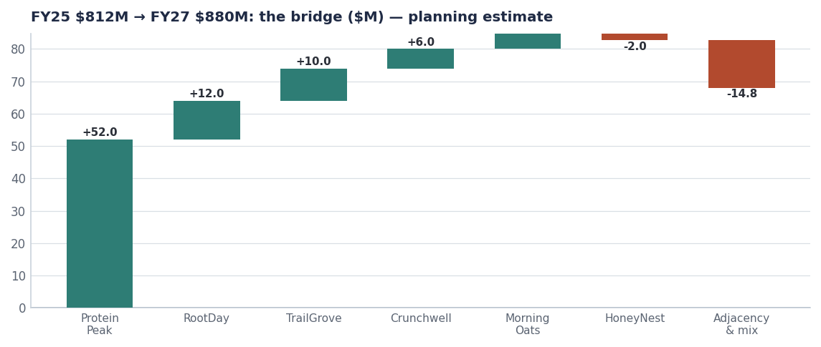
Movements off the $812M FY25 base. All forward blocks are plan targets.
Block | FY27 $M | Owner | What it depends on
FY25 actual base | 812.0 | Finance | Measured; per FACTS.md
ProteinPeak | +52.0 | Sage Park | Full-year PP005/PP006 plus Walmart and Kroger authorisation
RootDay | +12.0 | RootDay BM | Oat-milk distribution and the single-serve carton concept
TrailGrove | +10.0 | TrailGrove BM | Granola and bar distribution build
Crunchwell | +6.0 | Cory Whitman | Aug 15 2026 Pack Refresh; Louisiana recovery to 4.5% share
MorningOats | +4.8 | MorningOats BM | Single-serve cups, the +9.8% segment
HoneyNest | -2.0 | HoneyNest BM | Deliberate: harvest decision, three SKUs discontinued
Adjacency and mix | -14.8 | RGM Lead | Derived residual: non-brand revenue, pack mix, no list-price increase
FY2027 plan | 880.0 | CFO | All of the above

Source: FY25 brand base from seeds/skus.csv; FY27 brand targets per the FY27 AOP (Report 14); the adjacency line is the derived residual.
BY BRAND
3 · Brand-level plan and the logic of each number
Four of six brands are asked to grow; one is asked to decline; one is asked to grow substantially. The asymmetry is the plan.
3.1 · Where each brand sits today (Q1 FY2026)
Brand | Q1 plan | Q1 actual | Variance | Status
Crunchwell | $75.6M | $71.1M | -5.9% | Watch
TrailGrove | $38.1M | $37.5M | -1.7% | On track
MorningOats | $23.3M | $23.1M | -1.1% | On track
HoneyNest | $20.4M | $20.2M | -1.1% | On track
ProteinPeak | $17.4M | $13.0M | -25.4% | Action
RootDay | $16.4M | $16.3M | -0.4% | On track

Source: plan_vs_actual, Q1 FY2026.
3.2 · What each brand is being asked to deliver in FY2027
Brand | FY27 plan | Growth | The logic
Crunchwell | $318M | +2% | Pack Refresh plus Louisiana recovery. Stabilisation, not growth (Report 66).
TrailGrove | $162M | +7% | Distribution build in a granola segment growing +3.3%. Cheapest volume we have.
MorningOats | $92M | +6% | Single-serve cups segment is +9.8%; the rest of the line is flat.
HoneyNest | $92M | -2% | Harvest. Kids Sweet is −2.8% and structurally pressured.
ProteinPeak | $100M | +108% | Full-year launch SKUs plus Chocolate Almond plus distribution gains.
RootDay | $74M | +19% | Oat milk is +18.8%; we hold 3.8% share with room to run.

Source: Planning estimate. Segment growth from seed_category_market_size.
MARGIN
4 · The path to ~15.0%, and why it comes out of trade
Acme spends about $147M a year on trade promotion at a portfolio incrementality index of 0.51. That index means roughly half the promoted volume would have sold anyway. Moving the portfolio index from 0.52 to 0.60 is worth approximately 60 basis points of EBITDA, and it is the largest single margin lever available that does not touch A&P or headcount.
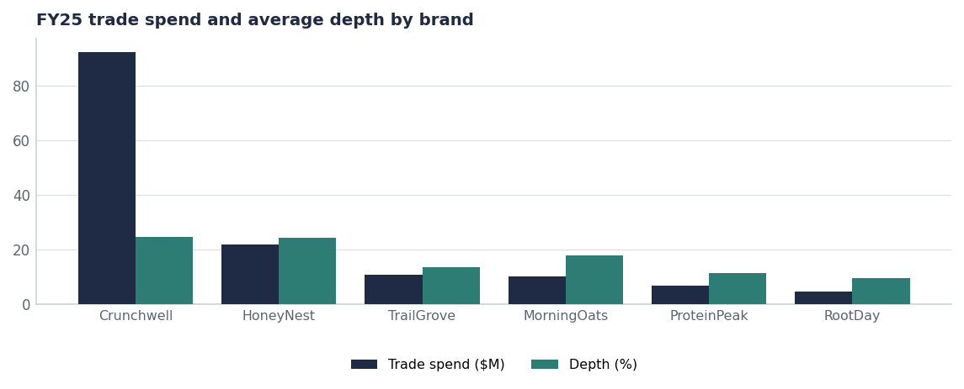
Trade spend and depth by brand. Crunchwell is both the largest line and the deepest discounter.
- Trade efficiency: +60 bps. Index 0.52 to 0.60 through fewer, better-timed events and a 0.45 incrementality floor on new events (Report 64).
- Mix: +20 bps. ProteinPeak and RootDay carry higher gross margin than the cereal core.
- Media efficiency: +10 bps. Reallocating retail media from a 0.40-ratio platform to a 1.20-ratio platform (Report 74).
- Cost inflation: −0.0 bps assumed net. Input costs are assumed flat in real terms; this is the most exposed assumption in the plan.

What we are not doing to make the margin
The plan does not cut A&P in absolute dollars, does not reduce R&D, and does not assume a list-price increase. If the trade-efficiency programme fails, the margin target fails with it — we are not holding a hidden A&P cut in reserve.

ASSUMPTIONS
5 · What has to be true
Assumption | Owner | If it is wrong
Fill rate holds at ~95% and OTIF at ~90%; no repeat of the Nov 2025 storm impact | VP Supply Chain | Service-driven share loss; see Report 73
Pack Refresh ships Aug 15 2026 and reaches 90% ACV by Q4 | Cory Whitman | −$7M FY27 revenue; Louisiana recovery loses its anchor
Wellness Protein segment growth stays in the mid-teens | Sage Park | −$6M on ProteinPeak if growth halves
Trade calendar rebuilt to a 0.60 index without base-volume loss | RGM Lead | −60 bps EBITDA; revenue unaffected
No list-price increase; mix and pack architecture only | RGM Lead | Revenue risk if competitors price up and we do not follow
Input costs flat in real terms | Procurement | Direct EBITDA exposure, roughly 30 bps per 1% of COGS
GLP-1 volume drag no worse than assumed | Strategy | −$5M revenue per additional point of category volume drag

Source: Assumption owners are accountable for reporting deviation monthly, not annually.
SENSITIVITIES
6 · The three cases
Case | FY27 revenue | FY27 EBITDA margin | What it assumes
Downside | $856M | 14.4% | Pack Refresh slips a quarter, protein growth halves, trade index stalls at 0.52
Plan | $880M | ~15.0% | All seven assumptions hold
Upside | $898M | 15.5% | Walmart protein authorisation lands early, Louisiana recovers past 5.0%, index reaches 0.62

Source: Cases are planning estimates, not modelled forecasts.
Recommendations & next steps
# | Action | Owner | When
1 | Approve the $880M FY27 revenue plan and the ~15.0% EBITDA target | Board | October 2026
2 | Approve the trade-efficiency programme as the primary margin lever | CFO / RGM Lead | October 2026
3 | Require monthly assumption-deviation reporting from each named owner | FP&A | From Jan 2027
4 | Re-baseline the FY27–FY29 long-range plan against this AOP | Strategy | July 2027

Approvals
Approver | Approving | Date
CFO | the FY27 revenue and margin plan | ________
CEO Gregory Whitfield | the initiative set and the stop list | ________
VP Sales NA, Diane Halverson | the brand and customer revenue commitments | ________

