LONG-RANGE PLAN · FY2027–FY2029
Three-Year Strategy Narrative
The argument for changing the portfolio mix rather than running the current mix harder

CEO Gregory Whitfield with Strategy
Horizon: FY2027–FY2029
Companion deck: Report 43
Version: v1 · July 2026
Internal strategy document · Internal · Confidential — synthetic demo data
At a glance
$1.02B  FY29 REVENUE TARGET | 16%  EBITDA MARGIN BY FY28 | 29%  FY29 REVENUE IN HIGH-GROWTH SEGMENTS | $150M  PROTEINPEAK FY29

THE ARGUMENT
1 · We do not have a growth problem. We have a mix problem.
Acme's portfolio is weighted into segments that grow about one percent a year. No amount of execution changes the arithmetic of that.
The RTE cereal category grew +1.3% in FY2025 to $8.35B. Inside that number, Wellness Protein grew +18.3% to $3M, Family Sweet — where Crunchwell lives — grew +1.4%, and Kids Sweet, HoneyNest's home, declined -2.8%. Outside cereal, oat milk grew +18.8% to $3M. Acme's revenue is concentrated in the slowest of those pockets.
Meanwhile our national share is stable: Acme all-brand value share has held around 7.91% for six quarters. We are holding our position in a slow race. The three-year job is to change which race we are in.
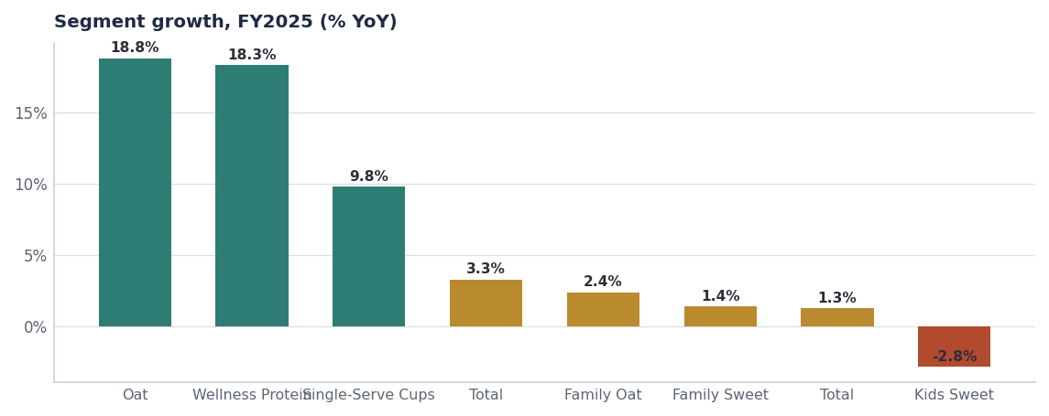
Where the category grows. Acme's revenue weight sits in the right-hand half of this chart.
THE FRAME
2 · What we are committing to by FY2029
Measure | FY25 actual | FY27 target | FY29 target
Net revenue | $812M | $880M | ~$1.02B
EBITDA margin | 14.2% | ~15.0% | 16.0%
Revenue in high-growth segments | 14% | 20% | 29%
ProteinPeak revenue | $48M | $100M | $150M
Portfolio trade incrementality index | 0.52 | 0.60 | 0.65
Retail-media modelled ratio | 0.65 | 0.85 | 1.00

Source: FY25 from company facts and seed tables; FY27 and FY29 are targets.
What a target is, in this document
Every FY27–FY29 figure here is a commitment the executive committee is signing up to, not a forecast of what the market will do. The gates in section 6 are how the committee holds itself to them.

BET 1
3 · Win Wellness Protein
Wellness Protein is a $3M segment growing +18.3% a year, and Acme holds 7.6% of it. ProteinPeak went from $48M in FY25 to a $62M estimate in FY26 on the back of two SKUs launched in April 2026, with 53% of launch volume new to Acme. The three-year commitment is $150M by FY29, which requires share in the mid-teens rather than the high single digits.
- Distribution before innovation. Cinnamon Crunch and Cocoa Almond sit at 38% and 28% national ACV. Getting both to the level of Vanilla Almond is worth more than any new SKU.
- Then innovation. Chocolate Almond (64% top-two-box, clears the 55% action standard) in FY27, ProteinPeak Bars 12g opening the $2.96B bar segment in FY28.
- Creator-led, not TV-led. The brand's social sentiment runs +0.44 against Crunchwell's −0.11. The mix that produced that is the mix we scale.
- Price discipline. $7.49 held, depth capped at 10%. A premium item trained to discount stops being a premium item.

BET 2
4 · Stabilise the Crunchwell core
Crunchwell is 38% of company revenue and has been flat for six quarters while the category grew. The equity data says why: Relevance fell 5.9 points while Trust rose. The three-year commitment is stabilisation in FY27, relevance recovery in FY28 and modest growth in FY29 — in that order, with a gate at each step (Report 66).
The reason this is a stabilisation commitment rather than a growth commitment is arithmetic. Family Sweet grows about 1.4% a year. A brand holding share in that segment grows 1.4%. Anything more has to come from share, and share has to come from relevance, and relevance takes more than one planning cycle to move.
BET 3 & 4
5 · Better-for-you adjacency and commercial efficiency
5.1 · Adjacency
TrailGrove in granola and RootDay in oat milk sit in segments growing +3.3% and +18.8% respectively, and between them they receive less A&P than Crunchwell spends on linear television. The FY27–FY29 plan raises their investment modestly and weights it to distribution rather than innovation (Report 51).
5.2 · Efficiency
The transition is funded from inside the P&L: trade incrementality from 0.52 to 0.65, retail-media modelled ratio from 0.65 to 1.00, and the stop list in section 7. None of the three requires incremental investment from the shareholder.
GATES
6 · How the committee holds this plan to account
Gate | When | Test | Consequence of failure
Gate 1 | Q4 FY26 | Pack Refresh in market; Louisiana share above 4.0% | Crunchwell moves to maintenance A&P; money to ProteinPeak
Gate 2 | Q4 FY27 | ProteinPeak above $100M run-rate with full Walmart and Kroger distribution | Re-plan the FY29 protein commitment downward
Gate 3 | FY28 planning | Trade index above 0.60 and retail-media ratio above 0.85 | Trade Finance takes calendar control; margin target re-cut
Annual | Every July | LRP re-baselined against the AOP | Plan is restated rather than quietly missed

Source: Gate tests use measures already reported in this repository, not new instrumentation.
THE STOP LIST
7 · What three years of discipline means
Stop or exit | Why | When | Freed resource
RootDay Coconut Blend, HoneyNest Granola Crunch, HoneyNest Cookie Dough | Sub-scale, low velocity, negative contribution | Q3 FY26 | ≈$1.5M trade plus shelf
Linear TV as Crunchwell's dominant channel | Reach without relevance | FY27 planning | ≈$8M to reallocate
Amazon Ads at current weight | Modelled incrementality ratio 0.40 | H2 FY26 | ≈$0.7M immediately
Kids Sweet innovation beyond LTOs | Segment −2.8%, mom-guilt trend 0.68 | FY27 plan | R&D capacity to protein
Defending under-indexed Northeast DMAs | 3.4–3.8% share, no structural advantage | FY27 plan | Trade and merchandising focus to the South

Source: seeds/innovation_pipeline.csv, seed_marketing_spend, seed_retail_media_spend_q1_2026, seed_macro_trends, seed_geographies.
CONTEXT
8 · The trends this plan is built against
Trend | Strength | Direction | Categories affected
High-protein cereal | 0.92 | Up | RTE Cereal
TikTok Shop grocery | 0.86 | Up | All Categories
Plant-based milk barista | 0.84 | Up | Plant-Based Milk
Cinnamon flavor renaissance | 0.81 | Up | RTE Cereal+Granola
GLP-1 / Ozempic appetite shift | 0.81 | Down (volume impact) | RTE Cereal+Bar+Hot Cereal
Sustainable packaging | 0.74 | Up | All Categories
Limited-time offers (LTO) acceleration | 0.74 | Up | RTE Cereal+Granola+Bar
Wellness-Hero pillar consolidation | 0.74 | Up | RTE Cereal+Bar+Plant-Based Mil

Source: seed_macro_trends, top eight by strength.
The trend that should worry us most
GLP-1 appetite shift runs at 0.81 strength with a downward volume direction across cereal, bars and hot cereal. It argues for smaller packs, higher protein and premium price-per-serving — which is what this plan does, but the pace of the shift is the biggest single uncertainty in the three-year frame.

Recommendations & next steps
# | Action | Owner | When
1 | Approve the FY27–FY29 frame: $880M FY27 → ~$1.02B FY29 at 16% margin, with the mix-shift target | Executive committee | July 2026
2 | Adopt the four gates and their stated consequences | CEO / CFO | July 2026
3 | Publish the stop list to the leadership team so it is visible, not implicit | Strategy | By Aug 15
4 | Add a GLP-1 volume sensitivity to the plan each July | Strategy / FP&A | Annually

Approvals
Approver | Approving | Date
CEO Gregory Whitfield | the three-year strategic frame | ________
CFO | the financial commitments and the gate consequences | ________

