REFORECAST MEMORANDUM
H2 FY2026 Reforecast — Memo to the Board
What has changed since the FY26 plan was set, what we are reforecasting, and what we are not changing

Finance & FP&A on behalf of the CFO
To: Acme Corp Board of Directors
Period: Q3–Q4 FY2026
Companion deck: Report 44
Version: v1 · July 2026
Internal board memorandum · Internal · Confidential — synthetic demo data
At a glance
$379M  H2 REFORECAST | −0.8%  VS ORIGINAL H2 PLAN | -3.4%  Q2 QTD VARIANCE | −$1.4M  NET RISK-ADJUSTED POSITION

SUMMARY
1 · The recommendation in one paragraph
We are recommending an H2 reforecast of $379M and no change to the full-year commitment.
Through May, FY2026 has delivered $304.2M against $318.7M of plan. The monthly gap has narrowed from -5.4% in February to -3.4% in May as the ProteinPeak launch shipped. Holding May's run-rate and adding the two known H2 events — the August 15 Pack Refresh and a full quarter of ProteinPeak distribution — produces an H2 landing zone of $379M against $382M of original plan. The $3M gap is being held as a management risk rather than closed with promotional volume, which is the discipline the board asked for last cycle.
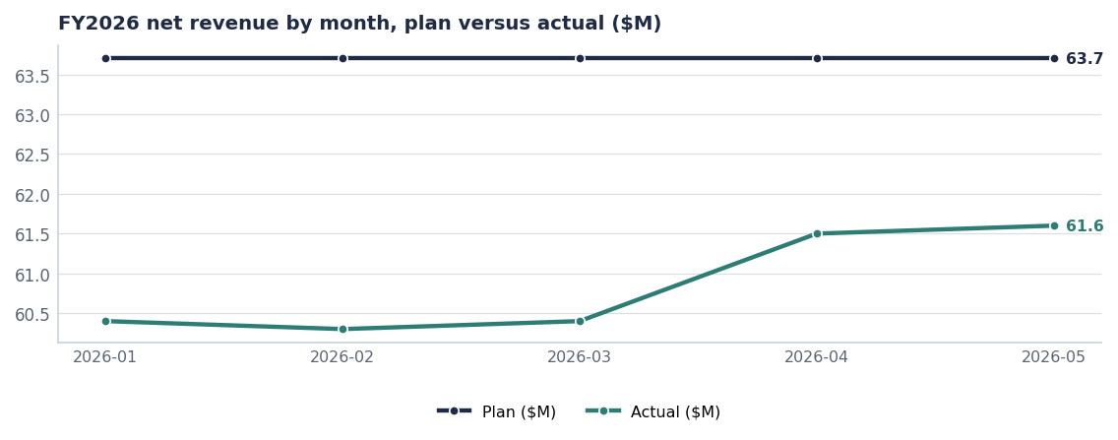
The gap narrows every month from February onward. The reforecast assumes it holds rather than continues to close.
METHOD
2 · How the number was built
- Base: May 2026 actual of $61.6M per month, held flat.
- Plus Pack Refresh pipeline fill in Q3 and consumption in Q4.
- Plus a full quarter of ProteinPeak distribution at current velocities.
- Less the three HoneyNest and RootDay SKUs discontinued in Q3.
- Less supply phasing during the Pack Refresh changeover in weeks 33–35.
- No assumption of Louisiana share recovery beyond the ~35 basis points already measured.

Step | H2 $M
Unconstrained demand forecast | 384.0
Less: Pack Refresh changeover phasing | −2.5
Less: ProteinPeak allocation at Walmart | −1.5
Less: HoneyNest and RootDay discontinuations | −1.6
Plus: retail-media reallocation upside | +0.6
H2 reforecast | 379.0

Source: Reconciliation agreed in the July S&OP cycle (Report 72).
LEDGER
3 · Risks and opportunities behind the number
Item | Type | H2 impact | Probability | Owner
Pack Refresh on-shelf Aug 15 as planned | Opportunity | +$6.0M | High | Cory Whitman
Walmart ProteinPeak full-line authorisation | Opportunity | +$4.5M | Medium | Marcus Boudreaux
Retail-media reallocation | Opportunity | +$1.6M | High | Tasha Brooks
Larksfield 14g line takes protein share | Risk | −$3.5M | Medium | Sage Park
Louisiana recovery stalls at 3.0% | Risk | −$2.5M | Medium | Marcus Boudreaux
Pack Refresh slips to Q4 | Risk | −$6.0M | Low | Cory Whitman
H-E-B Cinnamon Twist delist | Risk | −$1.8M | Medium | Marcus Boudreaux
Net risk-adjusted position | Net | −$1.4M | — | Finance

Source: seeds/innovation_pipeline.csv, seed_competitor_launches, seed_heb_cinnamon_twist_delist_risk. Dollar impacts are planning estimates.
NOT CHANGING
4 · What we are deliberately not reforecasting
- The full-year revenue commitment. The shortfall is being reallocated between quarters, not removed from the year.
- The FY26 A&P envelope. We are not funding the gap by cutting marketing; the media reallocation is inside the existing envelope (Report 74).
- The 16% FY28 EBITDA commitment. Nothing in the H2 picture changes the three-year margin path.
- The trade budget. We are changing the mix of events, not the total.

The one thing we are asking the board to note
Two of the three largest H2 opportunities — the retail-media reallocation and the Walmart protein authorisation — are within our control. If we deliver both, the H2 number is closer to $385M than $379M. The reforecast deliberately does not assume our own execution.

Risks & mitigations
Risk | Impact | Mitigation | Owner
Pack Refresh slips past Aug 15 | −$6.0M H2, LA recovery loses anchor | Weekly stage-gate from Jul 15; Q4 fallback plan agreed | Cory Whitman
2026 hurricane season repeats Nov 2025 | Service-driven share loss in the South | Pre-positioned inventory at Houston and Tyler from week 32 | VP Supply Chain
Larksfield escalates on both protein and Louisiana | Slower recovery on two fronts at once | Chocolate Almond into Q4 line reviews; LA media injection | Sage Park / Marcus Boudreaux

Recommendations & next steps
# | Action | Owner | When
1 | Note the H2 reforecast of $379M and the unchanged full-year commitment | Board | July 2026
2 | Approve the $700K retail-media reallocation | CFO | By Aug 1
3 | Note the four items we are deliberately not reforecasting | Board | July 2026

