POLICY DOCUMENT · REVENUE GROWTH MANAGEMENT
FY2027 Price-Pack Architecture and Trade Guardrails
The rules that govern everyday price, pack ladder and promotional depth from August 2026

RGM Lead with Trade Finance, approved by the CFO
Effective: August 1 2026
Applies to: all brands, all customers, North America
Companion deck: Report 45
Version: v1 · July 2026
Internal policy document · Internal · Confidential — synthetic demo data
At a glance
0.45  MINIMUM EVENT INDEX | 20%  MEGA DEPTH CAP | 0.51  PORTFOLIO INDEX TODAY | 0.60  FY27 TARGET

PURPOSE
1 · Why this policy exists
Acme spends approximately $147M a year on trade promotion. In Q1 FY2026 we ran 43 events costing $11.6M and generating $10.9M of modelled incremental revenue — an incrementality index of 0.52. Roughly half of the volume we paid to move would have moved anyway.
The pattern behind that number is consistent: our most elastic packs are the ones we discount hardest. Crunchwell Original Mega 18oz at Rouses carries an elasticity of -2.12. Deep, frequent discounting on that pack buys volume at a permanent cost to the reference price, which is the mechanism behind the Louisiana base erosion. This policy sets guardrails so that mechanism stops.
THE LADDER
2 · Everyday price and pack architecture
The pack ladder defines the role of each pack and the everyday price that supports it. Everyday price is defended; promotion happens around it, not instead of it.
Pack | Role | Everyday price | Max depth | Events per year
Crunchwell 13oz Multigrain | Entry / trial | $4.49 | 15% | 2
Crunchwell 14oz hero (post-refresh) | Core volume | $4.49 | 20% | 4
Crunchwell 18oz Mega | Value / pantry | $5.49 | 20% | 3
Crunchwell 36oz Mega Family (2027-Q1) | Value ceiling | $8.99 target | Launch support only | 1
ProteinPeak 12oz | Premium / growth | $7.49 | 10% | 3
ProteinPeak single-serve cup | Convenience | $9.99 | 0% | 0 (sampling instead)
TrailGrove granola and bars | Better-for-you volume | Per SKU | 15% | 4
RootDay 64oz oat milk | Growth adjacency | Per SKU | 12% | 3

Source: Everyday prices from seeds/skus.csv (avg_shelf_price_usd); 36oz Mega Family from seeds/innovation_pipeline.csv. Depth caps and event counts are the FY27 policy.
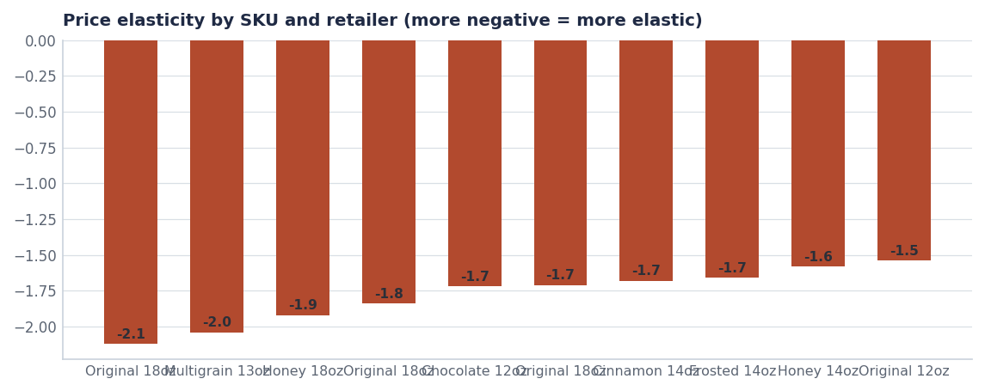
The packs we discount hardest are the most elastic — which is why depth erodes the base rather than building it.
GUARDRAILS
3 · The five rules
- Rule 1 — the 0.45 floor. No new promoted event may be approved with a modelled incrementality index below 0.45, unless it is defending a specific distribution commitment documented in the customer plan.
- Rule 2 — depth caps. Depth caps in the ladder above are maximums, not targets. Any exception requires Trade Finance sign-off and is logged.
- Rule 3 — no stacking. Acme depth may not be stacked with retailer-funded depth on the same item in the same week. Feature and display are the additive levers, not price.
- Rule 4 — premium items do not discount. ProteinPeak and single-serve packs use sampling, display and retail media. A premium item trained to discount stops being premium.
- Rule 5 — index is reported monthly. Portfolio and brand incrementality index appear alongside spend in the monthly commercial review, not in an annual post-event analysis.

What the 0.45 floor would have done to the Q1 calendar
Applied to Q1 FY2026, the floor removes the lowest-returning mechanics and frees roughly $2.4M for feature-and-display weight, which indexes higher on every brand we run it on. It does not reduce the trade budget.

BASELINE
4 · Where each brand starts from
Brand | FY25 trade spend | Average depth | Index | FY27 depth cap
Crunchwell | $92.4M | 24.4% | 0.57 | ≤20%
HoneyNest | $21.7M | 24.2% | 0.51 | ≤15%
TrailGrove | $10.8M | 13.5% | 0.52 | ≤15%
MorningOats | $10.2M | 17.8% | 0.59 | ≤15%
ProteinPeak | $6.9M | 11.5% | 0.45 | ≤10%
RootDay | $4.7M | 9.5% | 0.43 | ≤15%

Source: seed_trade_spend_fy25. Caps are the FY27 policy.
EXCEPTIONS
5 · How exceptions work
Exceptions exist because line reviews are negotiations. They are not, however, discretionary at the account level. Any deviation from the ladder or the caps requires written Trade Finance approval, states the distribution commitment it is defending, and carries an expiry date. Exceptions are reviewed quarterly and reported to the CFO in aggregate.
Exception type | Approver | Maximum duration | Reporting
Depth above cap for a line-review commitment | Trade Finance + RGM Lead | One event window | Monthly commercial review
Event below the 0.45 index floor | RGM Lead | One quarter | Quarterly to CFO
New pack price outside the ladder | CFO | Permanent (ladder amended) | At approval
Premium-item discount | CFO | One event window | Quarterly to CFO

Recommendations & next steps
# | Action | Owner | When
1 | Adopt the ladder and the five guardrails with effect from August 1 2026 | CFO | Aug 1 2026
2 | Rebuild the Q3 and Q4 FY26 calendars against the 0.45 floor | NAM team / Trade Finance | By Aug 15
3 | Add portfolio and brand index to the monthly commercial review pack | Trade Finance | From August
4 | Bring the 36oz Mega Family Pack forward into the FY27 innovation gate | Innovation / RGM Lead | Q4 FY26
5 | Review exception volume and index progress at the January 2027 commercial review | RGM Lead | January 2027

Approvals
Approver | Approving | Date
CFO | the policy and the exception process | ________
RGM Lead | the ladder and the depth caps | ________
Diane Halverson, VP Sales NA | customer-facing application of the caps | ________

