AGENCY BRIEF · CREATIVE PLATFORM
Crunchwell FY2027 Creative Platform Brief
The relevance problem, the evidence behind it, and what we need the platform to do about it

Cory Whitman, Brand Director — Crunchwell
To: creative and media agency partners
Brief date: July 2026 · Response due: September 2026
Companion deck: Report 46
Internal creative brief · Internal · Confidential — synthetic demo data
At a glance
-5.9 pp  RELEVANCE | +0.6 pp  TRUST | 48.8  MODERNITY TODAY | -0.11  SOCIAL SENTIMENT

THE JOB
1 · What we need the platform to do
Make Crunchwell wanted again. Not trusted — we already have that — wanted.
Crunchwell has held about 6.0% national value share for six quarters while the category grew and Larksfield's Field & Honey grew 7.4%. The equity tracker explains why. Across six waves, Relevance fell from 68.6 to 62.7 top-two-box, while Trust rose from 72.3 to 72.9 and Quality from 69.3 to 70.3. Modernity sits at 48.8, the weakest attribute in the set.
That combination has a specific meaning. Consumers believe the product is good and do not think it is for them right now. The platform's job is to close that gap without spending a dollar against attributes we already own.
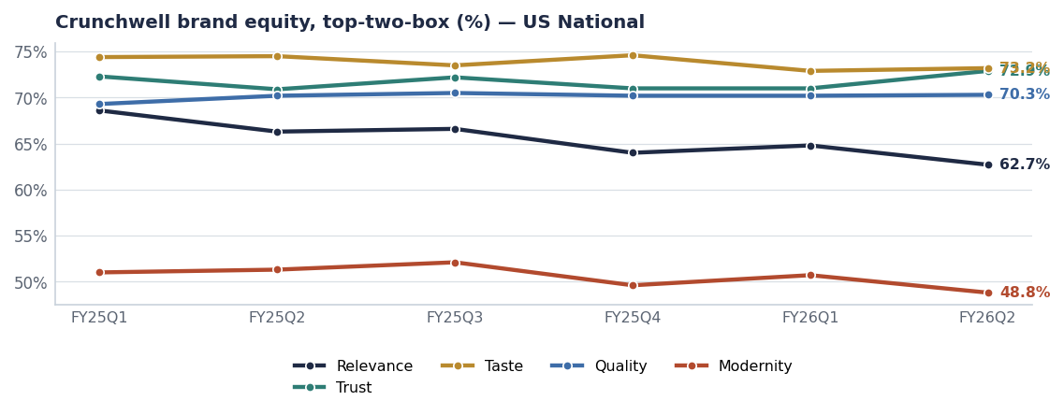
Six waves of equity data. Relevance is the line that moves; everything else holds.
THE EVIDENCE
2 · Four things we know
2.1 · The shopper base is turning over
Loyal-family household penetration moved from 47.9% to 46.6% while cereal-skipper households grew from 18.3% to 20.8%. We are losing breakfast occasions, not brand preference. Nobody is switching away from Crunchwell in anger; they are skipping the meal.
2.2 · This is not a price problem
Price-shopper penetration is flat at about 22.8% and measured price sensitivity is stable across waves. A value platform would spend against a problem we do not have.
2.3 · Louisiana is the acute case
In the Louisiana DMA, Relevance sits at 58.6 against 62.7 nationally, while Trust holds at 67.4. Eight weeks of empty shelf next to a competitor endcap is a relevance event as much as an availability event. Louisiana is where the platform gets tested first.
2.4 · The conversation is against us
Crunchwell social sentiment runs -0.11 on 316 mentions in 2026, while ProteinPeak — the same company, a different mix — runs +0.44.
THE PLATFORM
3 · Our recommendation, and what we will judge against
Our working platform is "Made for the morning you actually have" — a reframe from nostalgic family ritual to the compressed, chaotic weekday morning that the data says people are actually living. We are not wedded to the words. We are wedded to the target: Relevance and Modernity, without touching Trust or Taste.
We will judge the platform on | How | Standard
Does it move Relevance? | Kantar-shape tracker, quarterly waves | Relevance 62.7 → 65.5 by FY27Q4
Does it move Modernity? | Same tracker | Modernity 48.8 → 52
Does it protect Trust and Taste? | Same tracker | No decline beyond 1 point
Does it work in the South? | LA-DMA cut of the tracker plus share | LA share 3.0% → 4.5%
Does it work creator-first? | Social sentiment and earned reach | Sentiment from −0.11 to positive

Source: Measures from brand_equity_quarterly, syndicated_weekly, social_mentions.
THE ALTERNATIVES
4 · Four platforms we have already rejected, and why
- Value. Rejected. Price-shopper penetration is flat and price sensitivity is stable. There is no value problem to solve.
- Heritage. Rejected. Trust is already at 72.9 and rising. We would be paying to reinforce an asset we own.
- Health. Rejected. That is ProteinPeak's and TrailGrove's ground. Crunchwell competing there cannibalises the two brands that are actually growing.
- Kids. Rejected. Kids Sweet is a −2.8% segment and the mom-guilt trend runs at 0.68 strength. HoneyNest is being harvested for exactly this reason (Report 69).

MEDIA IMPLICATIONS
5 · The mix has to move with the message
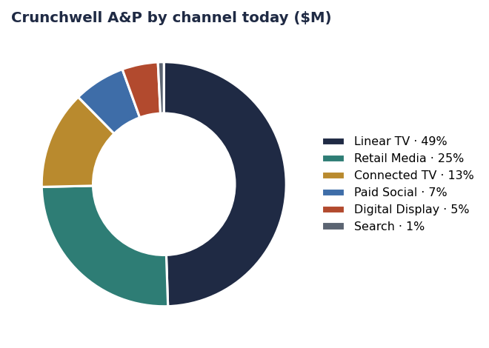
Today's mix is linear-TV-led — reach against a shrinking occasion.
Crunchwell's A&P runs about $48.7M with Linear TV as the largest single line. The FY27 recommendation holds total A&P flat and moves roughly a third of the TV line into CTV, creator and retail media, with Louisiana weighted at 2.2 times the portfolio ROI on the retail-media leg. Creative needs to be built for that mix from the start, not adapted into it.
PRACTICALITIES
6 · Timing, budget and non-negotiables
Item | Detail
Platform launch | With the Crunchwell Pack Refresh, on shelf August 15 2026
Working budget | ≈$18M FY27 A&P, total held flat versus FY26
Lead market | Louisiana DMA and the South region
Non-negotiable 1 | The pack and the message launch together, not three months apart
Non-negotiable 2 | Creator-first execution in the South; TV supports, does not lead
Non-negotiable 3 | No value or price messaging in the platform
Response due | September 2026, for FY27 production

One request about sequencing
In Louisiana, availability comes before message. Fourteen audited doors still sit below 70% on-shelf availability. Media into an empty shelf is wasted, so the local campaign flight follows the merchandising fix rather than leading it.

Recommendations & next steps
# | Action | Owner | When
1 | Agency response against this brief, including one deliberately uncomfortable option | Agency partners | September 2026
2 | Platform selection with VP Brand and the CFO | Cory Whitman | By Sep 30 2026
3 | Production against the Pack Refresh timing | Agency / Cory Whitman | Q4 FY26
4 | Add Relevance and Modernity to the reported brand scorecard | Insights | FY27Q1

