COMMITMENT MEMORANDUM
Crunchwell FY2027–FY2029 Turnaround — Commitment and Stop Conditions
What the brand team is committing to, year by year, and the conditions under which the committee should stop funding it

Cory Whitman, Brand Director — Crunchwell, with Finance
To: Crunchwell SteerCo
Horizon: FY2027–FY2029
Companion deck: Report 47
Version: v1 · July 2026
Internal commitment memorandum · Internal · Confidential — synthetic demo data
At a glance
-5.8%  FY26 VARIANCE TO PLAN | 4.16%  LOUISIANA SHARE | 62.7  RELEVANCE | $318M  FY27 COMMITMENT

THE COMMITMENT
1 · What we are and are not promising
FY2027 is a stabilisation year. We are not committing to growth until FY2029.
Crunchwell is $312M of FY2025 revenue running between -6.0% and -5.7% against plan every month of FY2026, with a 340 basis point hole in Louisiana and a five-point national relevance decline. Committing to growth in FY2027 would be a commitment we could not keep, and the SteerCo has been clear that it would rather have a hard commitment it can hold us to.
Year | Job | Revenue commitment | Lead measures | Gate
FY2027 | Stabilise | $318M (+1.9% on FY25 actual) | Louisiana share ≥4.5%; Pack Refresh 90% ACV; trade index ≥0.60 | Q4 FY27
FY2028 | Rebuild relevance | $326M (+2.5%) | Relevance ≥65; Modernity ≥52; Mega Family Pack in market | Q4 FY28
FY2029 | Grow | $336M (+3.1%) | Trade rate ≤22% of gross; two new SKUs at scale | FY30 planning

Source: Revenue commitments are targets; FY27 matches the AOP brand build (Report 14), measured against the FY25 actual from seeds/skus.csv.
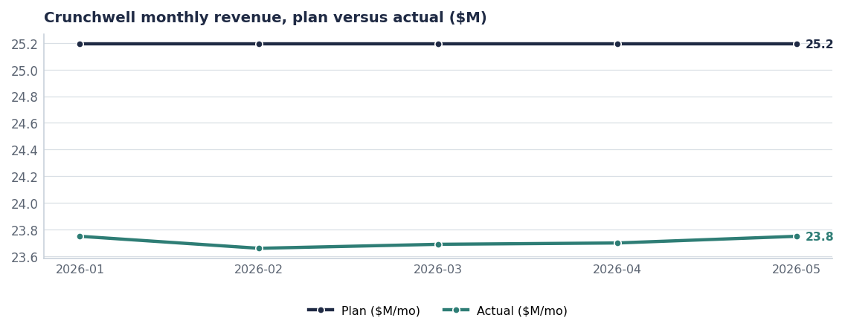
The consistency of the gap is the diagnosis: this is base erosion, not promotional timing.
YEAR ONE
2 · The four FY2027 workstreams
2.1 · Pack Refresh
Hero SKUs re-skinned, on shelf August 15 2026, $28M year-one revenue target at a confidence score of 0.82 — the largest near-term bet in the innovation pipeline. It is also the anchor of the Louisiana recovery, which is why the date matters more than the design.
2.2 · Louisiana
Louisiana share bottomed at 3.97% and has recovered to 4.16%. The recovery plan has three legs — facings, availability, demand — in that order, with named owners and a 12-week measurement point (Report 76).
2.3 · Relevance platform
A new creative platform launching with the pack, briefed against Relevance and Modernity rather than value or heritage (Report 65). Creator-first in the South, where the loss is concentrated.
2.4 · Trade reset
Crunchwell carries $92.4M of trade at 24.4% average depth for an index of 0.57. FY2027 caps Mega depth at 20%, reduces event count by about 15% and targets an index of 0.60 — without a list-price change, because Mega elasticity of −1.84 to −2.12 means price cuts buy volume and lose the reference price.
NOT DOING
3 · What we are explicitly not doing
- Not cutting list price. Elasticity data says it erodes the base permanently.
- Not adding Kids Sweet innovation. The segment is −2.8%; that is HoneyNest's problem and it is being harvested (Report 69).
- Not chasing protein with Crunchwell branding. ProteinPeak owns that ground and we would cannibalise the growth brand.
- Not defending every DMA. The under-indexed Northeast stays under-indexed in FY2027; the South is where the money goes.

GEOGRAPHY
4 · Where the brand is actually losing
Market | FY25 share | Q1 FY26 share | Δ bps | Tier
Louisiana DMA | 6.4% | 3.0% | -340 | Battlefield
New Orleans-Metairie MSA | 5.1% | 3.0% | -210 | Battlefield
Baton Rouge MSA | 5.8% | 4.2% | -160 | Battlefield
Lafayette LA MSA | 6.2% | 5.5% | -70 | Watch
Southeast US | 4.9% | 4.4% | -50 | Under-indexed and
Mississippi DMA | 5.3% | 4.9% | -40 | Watch
Texas | 6.3% | 6.0% | -30 | Mid-strong
Birmingham-Tuscaloosa-Anni | 5.7% | 5.4% | -30 | Leading-indicator

Source: seed_geographies.
Birmingham and Memphis
Both show the same early pattern Louisiana showed in Q4 2025: a 30 basis point drift with no local event to explain it. Weekly facing and OSA monitoring in both DMAs costs almost nothing and buys a quarter of warning. It is in the FY27 plan.

STOP CONDITIONS
5 · When the committee should stop funding this
These are agreed now, while everyone is calm, so that the conversation in eighteen months is about facts rather than intentions.
Condition | Measured at | Consequence
Louisiana share below 4.0% | Q4 FY2027 | Reallocate Louisiana trade and media to ProteinPeak and TrailGrove; Crunchwell to maintenance A&P
Pack Refresh ACV below 80% | Q4 FY2027 | No further pack investment before renegotiating at Q1 FY28 line reviews
Relevance below 63 | Q4 FY2028 | Stop the platform; move Crunchwell to a harvest plan
Trade index below 0.55 | Q4 FY2027 | Trade Finance takes calendar control from the NAM team

Source: Measures from syndicated_weekly, sku_authorization, brand_equity_quarterly, seed_trade_promo_events_q1_2026.
Decision log
Decision | Owner | Date | Status
Commit to stabilisation, not growth, in FY2027 | Cory Whitman | Jul 2026 | Action
Approve the four Year-1 workstreams and owners | SteerCo | Jul 2026 | Action
Agree the four stop conditions and consequences | SteerCo / CFO | Jul 2026 | Action
Report Year-1 lead measures monthly | Cory Whitman | Aug 2026 | On track

Recommendations & next steps
# | Action | Owner | When
1 | Approve the three-year staged commitment | SteerCo | July 2026
2 | Hold Pack Refresh at August 15 with weekly stage-gate reporting | Cory Whitman | From Jul 15
3 | Stand up Birmingham and Memphis early-warning monitoring | Jordan Hsu | By Aug 15
4 | Review against the four stop conditions at the Q4 FY27 SteerCo | SteerCo | Q4 FY2027

Approvals
Approver | Approving | Date
Cory Whitman, Brand Director | the commitments and lead measures | ________
CFO | the stop conditions and their consequences | ________
VP Brand | the platform and A&P mix shift | ________

