BRAND PLAN NARRATIVE · FY2027
ProteinPeak FY2027 Plan and Innovation Roadmap
A brand with a structural tailwind, a proven launch and a distribution problem at the two largest retailers in America

Sage Park, Brand Director — ProteinPeak
Period: FY2027, with a roadmap to FY2029
Companion deck: Report 48
Version: v1 · July 2026
Internal brand plan · Internal · Confidential — synthetic demo data
At a glance
+18.6%  SEGMENT GROWTH Q2 QTD | 8.4%  ACME SEGMENT SHARE | 53%  LAUNCH VOLUME NEW TO BRAND | $100M  FY27 REVENUE TARGET

THE OPPORTUNITY
1 · The only brand in the house with a tailwind
Wellness Protein grew +18.3% to $3M in FY2025 and is running +18.6% in Q2 FY2026. Acme's share of the segment moved from 7.6% to 8.4% on the back of the April 20 launch of Cinnamon Crunch (PP005) and Cocoa Almond (PP006). Every other brand in the portfolio is fighting its segment; this one is being carried by it.
Monthly performance tells the story cleanly. Q1 ran about $4.33M per month against a $5.80M plan — a deliberate pre-launch draw-down at -25.4%. April and May ran about $5.45M at -6.1%. The trough was planned; the recovery is real.
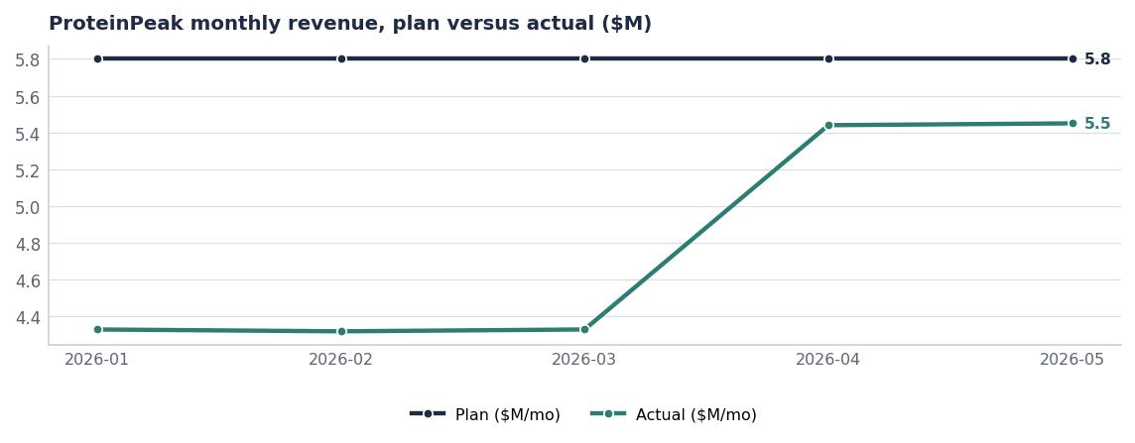
The Q1 trough is the pre-launch pipeline draw-down. April and May are the first months of the new base.
THE LAUNCH
2 · What the first four weeks told us
- Trial ran 110–113% of plan at Target and 77–78% at the Walmart pilot. Same items, same price, different shelf.
- Velocity was 17.5 units per store per week at Target against 9.2 at Walmart — the difference is an endcap and Roundel support, not assortment.
- 53% of volume was new to Acme, with 32% cannibalisation of the existing ProteinPeak line and 15% taken from competitors. That is a healthy line-extension profile.
- Week-2 repeat ran 1.2 times the Berry Crunch archive — the cleanest available signal that the product delivers against the claim.
- Social sentiment is +0.44 on about 496 mentions, the strongest in the portfolio.

THE CONSTRAINT
3 · We are under-distributed where the volume is
Acme holds 18.4% of Wellness Protein at Target and 5.2% at Walmart. Walmart is more than twice Target's size for Acme overall. The gap is not demand, price or product — it is assortment and merchandising.
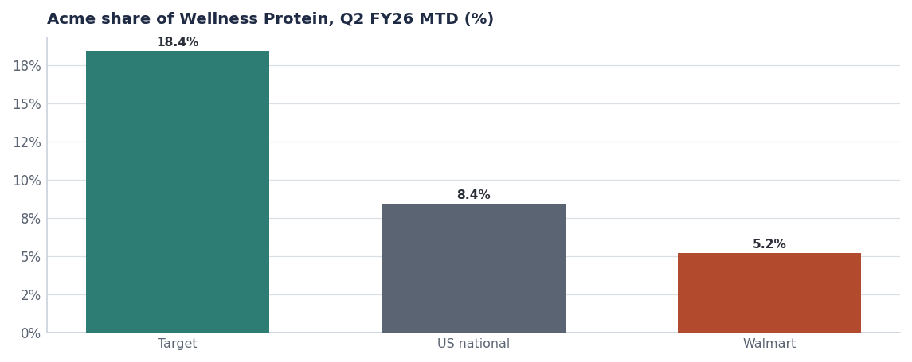
The same assortment performs three times better at one retailer than the other.
SKU | Shelf price | National ACV | FY25 revenue | Status
Vanilla Almond Original | $7.49 | 54% | $25.0M | Active
Chocolate Hazelnut | $7.49 | 42% | $11.5M | Active
Single-Serve Cups | $9.99 | 18% | $6.3M | Active
Berry Crunch | $7.49 | 28% | $5.2M | Active
Cinnamon Crunch | $7.49 | 38% | launch year | Active-Launch-Q2
Cocoa Almond | $7.49 | 28% | launch year | Active-Launch-Q2

Source: seeds/skus.csv.
The single highest-return action in this plan
Cinnamon Crunch sits at 38% national ACV and Cocoa Almond at 28%, four months after launch. Getting both to Vanilla Almond's 54% is worth more than any media dollar we could spend in FY2027, and it costs line-review negotiation rather than budget.

THE PLAN
4 · FY2027 on a page
Pillar | What we do | Investment | Success measure
Distribution | Full-line authorisation at Walmart and Kroger; Costco club pack | Line-review support | PP005 and PP006 ACV ≥55%
Innovation | Chocolate Almond through Q4 FY26 line reviews to Q1 FY27 shelf | Stage-gate funded | Top-two-box ≥55% held post-launch
Creator media | Athlete-anchored programme whitelisted into paid social and Roundel | ≈$9M | Sentiment ≥+0.40
Retail media | Weighted to Walmart Connect (1.20) and Kroger Precision (0.77) | ≈$6.5M | Blended modelled ratio ≥1.0
Price discipline | $7.49 held; maximum 10% depth; no stacking | — | Trade rate ≤13% of gross

Source: seed_marketing_spend, seed_retail_media_spend_q1_2026, seed_concept_test_chocolate_almond, seed_trade_spend_fy25. FY27 figures are targets.
ROADMAP
5 · FY2027 to FY2029
Concept | Stage | Planned launch | Year-1 revenue | Confidence
ProteinPeak Cinnamon Crunch | Stage-6 In-Market | 2026-04-20 | $14.0M | 0.74
ProteinPeak Cocoa Almond | Stage-6 In-Market | 2026-04-20 | $10.0M | 0.68
ProteinPeak Bars - 12g protein | Stage-1 Idea | 2028-Q2 | $8.0M | 0.28
ProteinPeak Mini Cups Six-Pack | Stage-2 Concept | 2027-Q4 | $3.4M | 0.41

Source: seeds/innovation_pipeline.csv.
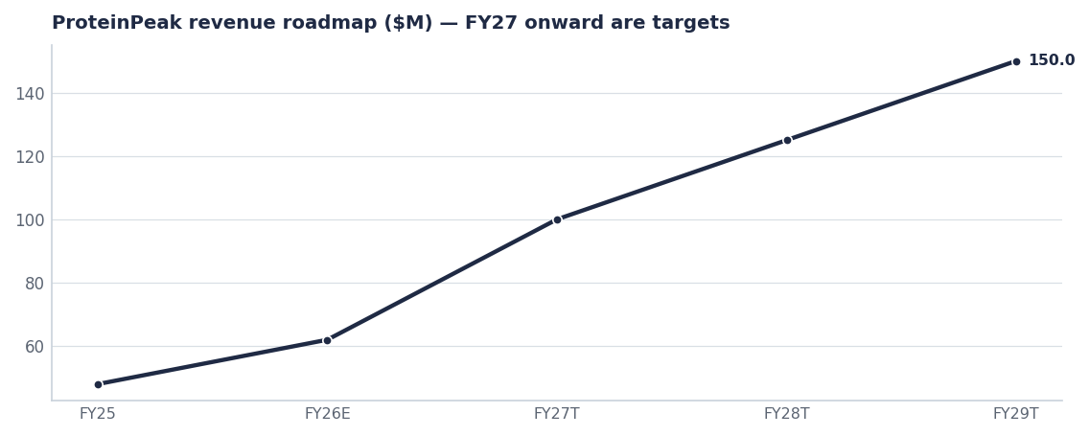
The roadmap: distribution in FY27, the bar segment in FY28, mid-teens segment share by FY29.
- FY2027 ($100M target): full distribution at Walmart and Kroger, Chocolate Almond in market. This is the AOP commitment (Report 14).
- FY2028 ($125M target): ProteinPeak Bars 12g opens the $2.96B granola-bar segment.
- FY2029 ($150M target): 12–14 SKUs at a mid-teens share of a segment we expect to reach roughly $1.45B.

COMPETITION
6 · Larksfield has already answered
Larksfield launched a 14 gram protein line extension (LF-FH-14P) on May 12 2026, escalating on both the protein and Louisiana fronts simultaneously. Our answer is Chocolate Almond — 64% top-two-box against a 55% action standard, clearing the 12 point substitutional cannibalisation gate at 8 points — taken to the Q4 FY26 line reviews. It is not a price response, and it should not become one.
Risks & mitigations
Risk | Impact | Mitigation | Owner
Larksfield escalates further in protein | Slows our share build in the best segment | Accelerate Chocolate Almond; hold Target endcap through Q3 | Sage Park
Walmart authorisation does not land | FY27 target unreachable on distribution alone | Escalate to the August line review as a joint growth case (Report 77) | Marcus Boudreaux
Cannibalisation of PP001–PP003 exceeds 8 points steady-state | Net revenue benefit of the launch is overstated | Re-read source of volume at week 13 post-Chocolate-Almond launch | Maya Chen
Premium price erodes through retailer-funded depth | Brand loses its premium position permanently | 10% depth cap enforced through the RGM policy (Report 64) | Trade Finance

Recommendations & next steps
# | Action | Owner | When
1 | Put ProteinPeak full-line authorisation on the Walmart August line-review agenda | Marcus Boudreaux | Aug line review
2 | Approve Chocolate Almond for the Q4 FY26 Walmart and Target line reviews | Innovation SteerCo | Aug 5 2026
3 | Weight FY27 retail media to Walmart Connect and Kroger Precision | Tasha Brooks | FY27 planning
4 | Hold $7.49 and the 10% depth cap through the launch year | Sage Park | FY2027
5 | Add velocity by retailer to the monthly brand scorecard | Sage Park | From August

