DECISION MEMORANDUM · INNOVATION STEERCO
ProteinPeak Chocolate Almond — Recommendation to Proceed
Concept test results against the action standard and the cannibalisation gate, and what we recommend the SteerCo decide

Maya Chen, Senior Insights Analyst (Innovation & Foresight)
To: Innovation SteerCo · Decision date: August 5 2026
Companion deck: Report 49
Version: v1 · July 2026
Internal decision memorandum · Internal · Confidential — synthetic demo data
At a glance
64%  TOP-TWO-BOX | 55%  ACTION STANDARD | 8pp  SUBSTITUTIONAL CANNIBALISATION | 12pp  STEERCO GATE

RECOMMENDATION
1 · What we are asking for
Both gates clear. We recommend Chocolate Almond proceeds to Stage-4 and into the Q4 FY2026 Walmart and Target line reviews.
Chocolate Almond scores 64% top-two-box purchase intent against an action standard of 55%. That is 6 points above the pretest for the SKUs we launched in April — which are themselves running at 110–113% of trial plan at Target — and 11 points above the five-year cereal-innovation benchmark. Substitutional cannibalisation against the existing ProteinPeak line is 8 points against a 12 point SteerCo gate.
METHOD
2 · Sample and design
Item | Detail
Sample size | n=1000
Field period | 2026-06-22 to 2026-07-11
Design | Standard Acme monadic cereal-innovation concept test
Action standard | 55% top-two-box
Cohort recuts | Protein-curious, lapsed-cereal, current-Crunchwell
Cannibalisation method | Stated-choice overlap decomposed into additive and substitutional

Source: seed_concept_test_chocolate_almond.
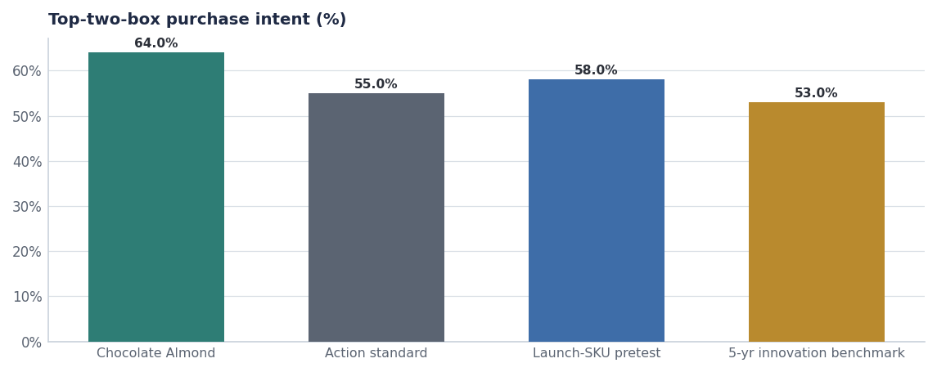
Topline result against the standard and the two available benchmarks.
COHORTS
3 · The concept works where we need it to
Cohort | Top-two-box | Read
Protein-curious | 71% | Strongest cell; purchase-intent mean 3.06/5
Lapsed-cereal | 66% | Clears comfortably; the occasion-recovery cohort
Current-Crunchwell | 52% | Below standard — and correctly so
Total sample | 64% | Clears the 55% standard

Source: seed_concept_test_chocolate_almond, cohort section.
The current-Crunchwell result is worth dwelling on. A 52% score there is not a weakness — this SKU is not built to convert the family-cereal base, and if it did we would be reading a cannibalisation problem rather than an incrementality one. The concept is doing exactly what a protein line extension should do.
The context supports it: chocolate as a breakfast flavour preference indexes 14 points higher in the protein-curious cohort per the April 2026 usage and attitude study, and the cinnamon flavour renaissance trend runs at 0.81 strength. We are riding two real preferences, not a novelty score.
CANNIBALISATION
4 · The gate that actually matters
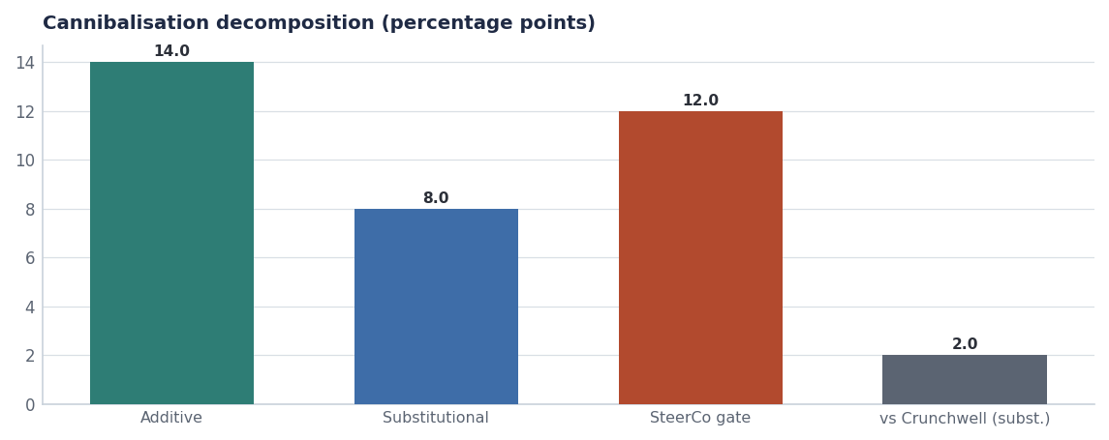
22% overlap with the launch SKUs decomposes into 14 points additive and 8 points substitutional, inside the 12 point gate.
- Versus the ProteinPeak launch SKUs: 22% stated overlap, 14 points additive, 8 points substitutional. Gate is 12 points. Passes.
- Versus Crunchwell: 6% overlap, 2 points substitutional. Negligible, as expected.
- Post-launch re-read committed: we will re-measure source of volume at week 13 and hold ourselves to the same 12 point standard on actual behaviour rather than stated choice.

The honest caveat
Stated-choice cannibalisation understates real substitution roughly as often as it overstates it. An 8 point result against a 12 point gate is a pass with four points of headroom, not a comfortable margin. The week-13 behavioural re-read is the control, and it should carry a consequence if it fails.

TIMING
5 · Why the decision cannot wait
Larksfield launched a 14 gram protein line extension on May 12 2026 and is escalating on the protein front. A Q1 FY2027 shelf date for Chocolate Almond requires authorisation at the Q4 FY2026 Walmart and Target line reviews. Missing those reviews costs two quarters and hands the flavour space to a competitor who has already shown they will take it.
Brand | SKU | Launch | Claim | Buzz d30
Crunchwell | CR009-PROPOSED | 2026-08-15 00:00:00 | New look. Same Crunchwell you love. | 0.45
Field & Honey | LF-FH-14P | 2026-05-12 00:00:00 | 14g protein per serving, made with whole | 0.84
ProteinPeak | PP005 | 2026-04-20 00:00:00 | 12g protein. Real cinnamon. 8g sugar. | 0.84
ProteinPeak | PP006 | 2026-04-20 00:00:00 | 12g protein. Cocoa + almond duo. | 0.62
Cheerios | GM-CHPB-12 | 2026-04-06 00:00:00 | Real peanut butter | 0.74
Field & Honey | LF-FHL-14 | 2026-03-30 00:00:00 | Limited edition spring lemon | 0.36

Source: seed_competitor_launches.
Decision log
Decision | Owner | Date | Status
Advance Chocolate Almond to Stage-4 Pre-Launch | Innovation SteerCo | Aug 5 | Action
Include in Q4 FY26 Walmart and Target line reviews | Marcus Boudreaux / Soo-jin Lee | Q4 FY26 | Action
Hold the 12pp substitution gate as a post-launch measure | Maya Chen | Q1 FY27 +13wk | On track
Brief creator and media plans off the protein-curious cohort | Sage Park | Sep 15 | On track

Recommendations & next steps
# | Action | Owner | When
1 | Approve Stage-4 progression | Innovation SteerCo | Aug 5 2026
2 | Authorise inclusion in the Q4 FY26 line reviews | Innovation SteerCo | Aug 5 2026
3 | Commit to the week-13 behavioural re-read with a defined consequence | Maya Chen | Q1 FY27 + 13 weeks
4 | Brief media and creator plans against the protein-curious cohort, not the general population | Sage Park / Hugo Lin | By Sep 15

