DECISION MEMORANDUM
HoneyNest — Portfolio Role and the Mascot Question
A well-executed brand in a structurally declining segment, and the two decisions that follow from that

HoneyNest Brand Manager with Consumer Insights and Finance
To: VP Brand and the CFO
Companion deck: Report 50
Version: v1 · July 2026
Internal decision memorandum · Internal · Confidential — synthetic demo data
At a glance
-1.1%  FY26 VARIANCE TO PLAN | -2.8%  KIDS SWEET SEGMENT GROWTH | $21.7M  FY25 TRADE SPEND | Harvest  RECOMMENDED ROLE

THE SITUATION
1 · Good management, wrong room
HoneyNest is one of the best-executed brands in the portfolio. That is the problem, not the consolation.
HoneyNest runs -1.1% against plan across FY2026 — better than every brand except RootDay. It does that inside a segment that fell from $3M to $3M, a decline of -2.8%. Two consecutive years of segment decline, with the mom-guilt trend at 0.68 strength and low-sugar pressure at 0.72, is not a cycle. It is a structural position.
We spend $21.7M of trade at 24.2% average depth for an incrementality index of 0.51. That is buying volume in a segment that is leaving, at a moment when Wellness Protein next door is growing +18.3% a year.
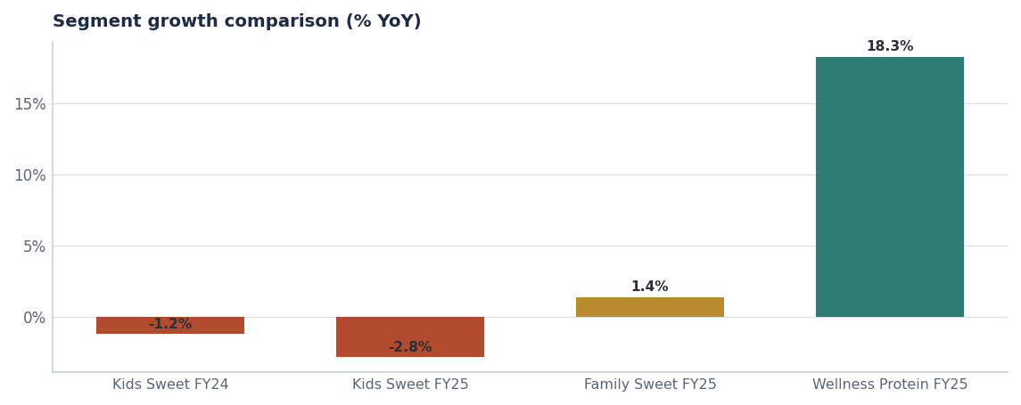
The same shelf space and trade dollars are worth far more one segment over.
THE OPTIONS
2 · Three ways to play it
Option | What it means | FY27–FY29 revenue | Investment | Verdict
A · Invest | Fund a kids-cereal relaunch, new mascot, media support | $92M → $96M → $99M | ≈$12M incremental A&P | Reject
B · Harvest | Hold distribution, A&P to maintenance, LTOs only, cut trade depth | $92M → $88M → $84M | ≈$1M A&P | Recommend
C · Reposition | Move the brand into Family Wholegrain with a whole-grain-plus line | $92M → $94M → $97M | ≈$5M plus R&D | Recommend as a bet inside B

Source: Revenue paths are planning estimates. Source: seed_category_market_size, seeds/innovation_pipeline.csv, seed_macro_trends.
Why Option A is rejected
A relaunch spends FY2027 growth money on the least favourable structural position in the portfolio, against a 0.68-strength parental-guilt trend. The same $12M behind ProteinPeak distribution or TrailGrove range extension returns more, with less execution risk.

THE MASCOT
3 · The second decision, and why it is separate
The mascot question has been raised repeatedly as though it were the brand's problem. It is not. Aided awareness of the portfolio's kid-facing assets is healthy and the equity data shows no meaningful trust or affection deficit. Retiring the mascot inside a harvest plan would spend real money — pack changeover, asset re-shoot, retailer re-listing — to solve something the data does not identify as a cause.
- Recommendation: retire the mascot only if Option C proceeds. A whole-grain repositioning needs a different visual language; a harvest does not.
- If Option B alone proceeds, keep the mascot and spend nothing on the change.
- Either way, do not run a mascot decision as a standalone project. It is a consequence of the portfolio role, not an alternative to choosing one.

EVIDENCE
4 · The trend backdrop
Trend | Strength | Direction | Categories
High-protein cereal | 0.92 | Up | RTE Cereal
GLP-1 / Ozempic appetite shift | 0.81 | Down (volume impact) | RTE Cereal+Bar+Hot Cereal
Sustainable packaging | 0.74 | Up | All Categories
Limited-time offers (LTO) acceleration | 0.74 | Up | RTE Cereal+Granola+Bar
Low-sugar reformulation pressure | 0.72 | Up | RTE Cereal+Granola

Source: seed_macro_trends, filtered to trends bearing on kids' cereal.
PIPELINE
5 · What HoneyNest has in the tank
Concept | Stage | Planned launch | Year-1 revenue | Status
HoneyNest Birthday Cake LTO | Stage-4 Pre-Launch | 2026-Q4 | $2.4M | On-Track
HoneyNest Plus Whole Grain - Heart Healt | Stage-1 Idea | 2028-Q1 | $4.0M | Pre-Stage-Gate
HoneyNest Granola Crunch - Discontinue | Stage-Final Discontinue | 2026-Q3 | — | Confirmed-Discontinue
HoneyNest Cookie Dough - Discontinue | Stage-Final Discontinue | 2026-Q3 | — | Confirmed-Discontinue

Source: seeds/innovation_pipeline.csv.
Decision log
Decision | Owner | Date | Status
Adopt Option B (managed harvest) as HoneyNest's portfolio role from FY2027 | VP Brand / CFO | FY27 plan | Action
Fund Option C as a single Stage-2 concept, not a relaunch | Innovation SteerCo | Q4 FY26 | Action
Confirm Q3 FY26 discontinuation of Granola Crunch and Cookie Dough | HoneyNest BM | Q3 FY26 | On track
Defer the mascot decision until the Option C gate | VP Brand | Q4 FY26 | Watch
Redirect ≈$8M of trade and A&P to ProteinPeak and TrailGrove | CFO | FY27 plan | Action

Recommendations & next steps
# | Action | Owner | When
1 | Approve Option B with Option C as a funded concept bet | VP Brand / CFO | FY27 planning
2 | Keep the Birthday Cake LTO as the one active FY27 innovation | HoneyNest BM | Q4 FY26
3 | Reduce promoted event count in line with the harvest decision | HoneyNest BM / Trade Finance | FY27 calendar
4 | Revisit the portfolio role if Kids Sweet returns to growth for two consecutive quarters | Category Insights | Quarterly

