STRATEGIC POINT OF VIEW
GLP-1 and the Cereal Category — What We Believe and What We Are Doing
A structural volume headwind, the evidence we have, the evidence we do not, and the four plan responses

Nina Ortega, VP Consumer Insights, with Strategy
Audience: executive committee and the FY27–FY29 planning process
Version: v1 · July 2026
Internal point of view · Internal · Confidential — synthetic demo data
At a glance
0.81  TREND STRENGTH | Down (volume i  DIRECTION | +2.5 pp  CEREAL-SKIPPER HOUSEHOLDS | 4  PLAN RESPONSES

THE POSITION
1 · What we believe
GLP-1 adoption is a slow, structural volume headwind for family-size cereal — not a demand shock, and not a reason to reprice the portfolio.
The GLP-1 appetite shift registers at 0.81 strength in our trend framework with a direction of "Down (volume impact)", affecting RTE Cereal+Bar+Hot Cereal. It sits alongside — and partly explains — the most important number in our panel data: cereal-skipper household penetration rose from 18.3% to 20.8% over six quarters, while loyal-family penetration fell from 47.9% to 46.6%.
We are deliberately not claiming a causal attribution. We cannot separate GLP-1 effects from broader occasion loss with the instruments we have. What we can say is that both point the same direction and both argue for the same set of responses, which is enough to plan against.
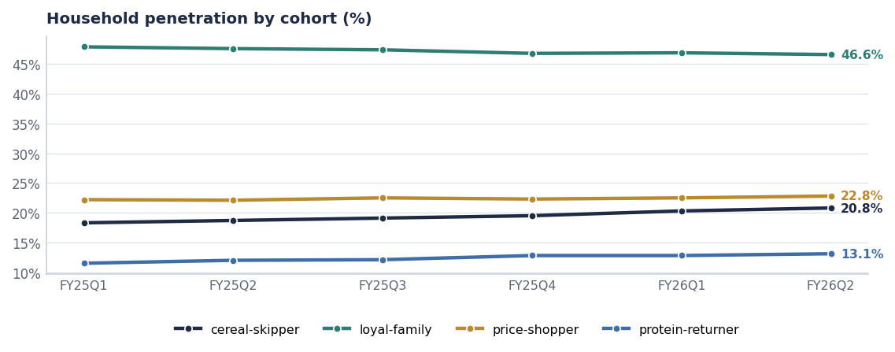
Cereal-skipper and protein-returner households grow; loyal-family erodes. The occasion is the battleground.
THE EVIDENCE
2 · What we have and what we do not
Evidence | What it shows | Confidence
Trend framework | GLP-1 at 0.81 strength, downward volume direction | Medium — directional, not quantified
Kantar-shape cohort panel | Cereal-skipper +2.5 pp over six quarters | High on the measure, low on the cause
Category size data | RTE total US growing on value (+1.3%) with softer unit growth | High
Segment mix | Wellness Protein +18.3%, single-serve cups +9.8% | High
Direct GLP-1 usage measurement | Not instrumented | None — this is the gap

Source: seed_macro_trends, kantar_worldpanel_cohort, seed_category_market_size.
The instrumentation gap we should close
We do not ask about GLP-1 use in the brand-health survey. Adding a single screening question would let us cut every tracker measure by GLP-1 status within two waves, and would cost almost nothing. It is the highest-value change available to the tracker.

IMPLICATIONS
3 · What it means for the category
- Volume pressure lands hardest on family-size packs. Smaller appetites mean fewer servings per household, which pressures the 18oz and larger formats first.
- Value can hold while volume falls. Premium price-per-serving formats — protein, single-serve, functional — can offset unit decline in revenue terms.
- Protein is the permission structure. A shrinking appetite raises the premium on nutrient density per serving, which is exactly ProteinPeak's proposition.
- Kids' cereal is doubly exposed — GLP-1 in the adult household plus the 0.68-strength parental-guilt trend. This is part of the HoneyNest harvest logic (Report 69).
- Promotion does not fix it. Discounting a pack size the household no longer needs buys pantry loading, not consumption.

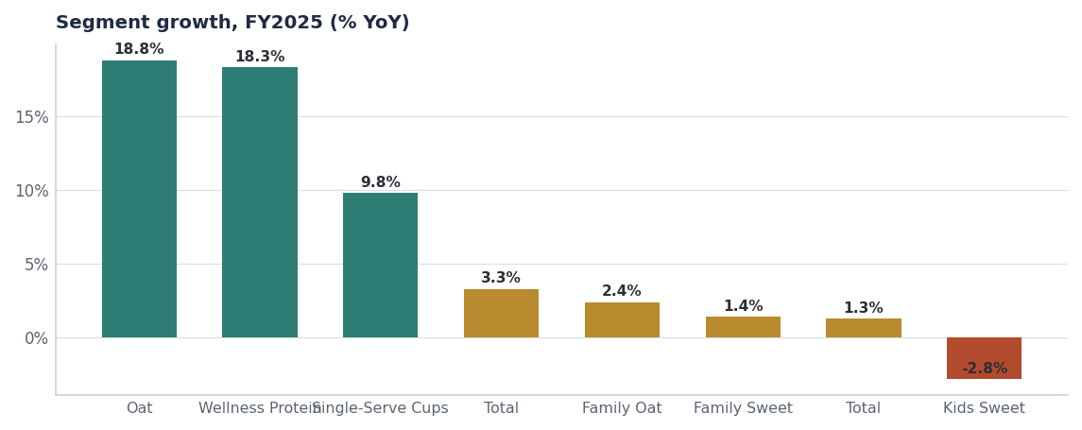
The segments growing fastest are the ones with the highest nutrient density or the smallest serving size — or both.
RESPONSES
4 · The four things already in the plan
Response | Where it sits | Owner
Fund protein ahead of family-size volume | FY27 AOP (Report 61); ProteinPeak plan (Report 67) | Sage Park / CFO
Build single-serve and convenience formats | MorningOats cups; RootDay single-serve carton (Report 51) | Brand teams
Pack architecture for smaller portions and higher price-per-serving | RGM policy (Report 64) | RGM Lead
Harvest, not relaunch, in Kids Sweet | HoneyNest decision (Report 69) | VP Brand

Note what is not on that list: a price response, a volume-chasing promotional response, or a new category entry. A slow structural headwind is answered with mix, not with depth.
WHAT WOULD CHANGE OUR MIND
5 · The falsification tests
- Cereal-skipper penetration flattens for three consecutive quarters while family-size volume recovers — that would suggest the occasion loss was cyclical.
- Single-serve and protein growth decelerates below category growth — that would suggest the nutrient-density thesis is wrong.
- A GLP-1 screening question shows no difference in cereal behaviour by usage status — that would falsify the mechanism directly, and it is the test we should build.

Recommendations & next steps
# | Action | Owner | When
1 | Add a GLP-1 usage screening question to the brand-health survey | Nina Ortega | Next wave
2 | Add a GLP-1 volume sensitivity to the FY27–FY29 long-range plan | Strategy / FP&A | Q4 FY26
3 | Report the cereal-skipper cohort as a standing KPI in the category review | Jordan Hsu | From August
4 | Re-issue this point of view annually with the falsification tests scored | Nina Ortega | July 2027

