FUNDING MEMORANDUM
H2 FY2026 Trade Spend Reallocation — The Case
Why we are moving $2.4M a quarter inside the trade budget rather than asking for more of it

RGM Lead with Trade Finance
To: CFO · cc VP Sales NA
Period: Q3–Q4 FY2026
Companion documents: Reports 54 and 64
Version: v1 · July 2026
Internal funding memorandum · Internal · Confidential — synthetic demo data
At a glance
$11.6M  Q1 TRADE SPEND | 0.52  INCREMENTALITY INDEX | $2.4M  QUARTERLY REALLOCATION | $0  INCREMENTAL BUDGET REQUESTED

THE ASK
1 · What we are asking you to approve
No new money. A different mix, with a floor under event quality and a cap over depth.
In Q1 FY2026 we ran 43 promoted events costing $11.6M and generating $10.9M of modelled incremental revenue — an incrementality index of 0.52. Applying a 0.45 index floor to that calendar would have removed the lowest-returning mechanics and freed roughly $2.4M a quarter for feature-and-display weight, which indexes higher on every brand we run it on. We are asking for approval of the reallocation and the guardrails, not for additional trade budget.
THE EVIDENCE
2 · Where the money currently goes to die
Mechanic | Events | Spend | Avg modelled lift | Index | Call
2.99 14oz | 5 | $3.7M | 25.4% | 0.57 | Keep
$0.50 off | 5 | $1.5M | 15.4% | 0.41 | Stop
$0.40 off | 5 | $0.9M | 11.8% | 0.38 | Stop
$0.45 off | 6 | $0.8M | 12.5% | 0.54 | Keep
Display + sample | 3 | $0.6M | 12.0% | 0.72 | Keep
Display + price | 4 | $0.6M | 13.2% | 0.60 | Keep
Display only | 2 | $0.6M | 10.0% | 0.67 | Keep
Buy 2 save $1 | 1 | $0.5M | 18.0% | 0.58 | Keep
All other mechanics (10) | 12 | $2.5M | 12.9% | 0.54 | Keep

Source: seed_trade_promo_events_q1_2026, grouped by mechanic.
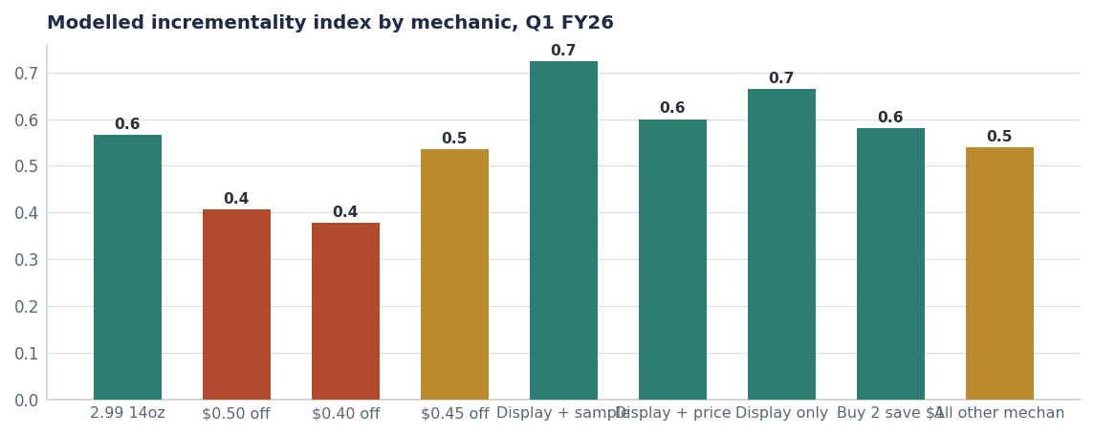
The spread between mechanics is wide enough that mix, not budget, is the lever.
THE MECHANISM
3 · Why depth is the wrong instrument for our packs
Our most promoted packs are also our most elastic. Crunchwell Original Mega 18oz at Rouses carries an elasticity of -2.12, and the next four most elastic points in the portfolio are all Crunchwell Mega and Multigrain packs at Rouses and Walmart — the two banners where Larksfield has been most aggressive on endcaps in Louisiana. Deep discounting on those packs buys volume at a permanent cost to the reference price, which is a mechanism in the Louisiana base erosion rather than a defence against it.
SKU | Retailer | Elasticity | Baseline price | Model confidence
Crunchwell Original Mega 18oz | Rouses | -2.12 | $5.49 | 0.66
Crunchwell Multigrain 13oz | Rouses | -2.04 | $4.49 | 0.62
Crunchwell Honey Nut Mega 18oz | Walmart | -1.92 | $5.69 | 0.83
Crunchwell Original Mega 18oz | Walmart | -1.84 | $5.49 | 0.84
HoneyNest Chocolate 12oz | Walmart | -1.72 | $4.39 | 0.78
Crunchwell Original Mega 18oz | Kroger | -1.71 | $5.49 | 0.81
Crunchwell Cinnamon Twist 14oz | Walmart | -1.68 | $4.59 | 0.62
HoneyNest Frosted Flakes 14oz | Walmart | -1.66 | $4.59 | 0.76

Source: seed_sku_elasticity_estimates.
THE MOVE
4 · Where the $2.4M goes
From | $M/quarter | To | $M/quarter | Expected index
Sub-0.45 mechanics across all brands | −2.4 | Feature-and-display weight, top-5 retailers | +1.5 | 0.62
 |  | Louisiana recovery trade at capped depth | +0.6 | 0.58
 |  | ProteinPeak display support (no depth) | +0.3 | 0.70
Net | −2.4 |  | +2.4 | Portfolio 0.52 → 0.60

Source: Planning estimate. Index expectations from comparable Q1 mechanics in seed_trade_promo_events_q1_2026.
What this is worth
Moving the portfolio index from 0.52 to 0.60 on a $146M annual trade base is worth approximately 60 basis points of EBITDA — the largest single margin lever in the FY27 plan that does not touch A&P, headcount or list price.

OBJECTIONS
5 · The three arguments against, answered
- "Cutting depth loses volume." It loses some promoted volume and keeps base volume. The index is precisely the measure of how much of the promoted volume was incremental — at 0.52, about half of what we lose was never ours to gain.
- "Retailers will not accept it." Feature and display are what retailers actually want in a category with declining units; both build category dollars. We are taking that case into the August Walmart line review (Report 77) as a joint growth argument.
- "We need the depth to defend Louisiana." Louisiana lost 340 basis points primarily because we lost facings, not because we lost price competitiveness. The recovery plan leads with shelf, not with depth (Report 76).

BASELINE
6 · Where each brand starts
Brand | FY25 trade spend | Average depth | Index | FY27 cap
Crunchwell | $92.4M | 24.4% | 0.57 | ≤20%
HoneyNest | $21.7M | 24.2% | 0.51 | ≤15%
TrailGrove | $10.8M | 13.5% | 0.52 | ≤15%
MorningOats | $10.2M | 17.8% | 0.59 | ≤15%
ProteinPeak | $6.9M | 11.5% | 0.45 | ≤10%
RootDay | $4.7M | 9.5% | 0.43 | ≤15%

Source: seed_trade_spend_fy25.
Recommendations & next steps
# | Action | Owner | When
1 | Approve the $2.4M/quarter reallocation inside the existing trade budget | CFO | By Aug 1
2 | Approve the 0.45 index floor and the depth caps as policy (Report 64) | CFO | Aug 1 2026
3 | Rebuild the Q3 and Q4 calendars against the floor | NAM team / Trade Finance | By Aug 15
4 | Report portfolio and brand index monthly alongside spend | Trade Finance | From August

Approvals
Approver | Approving | Date
CFO | the reallocation and the guardrails | ________
Diane Halverson, VP Sales NA | customer-facing execution of the caps | ________

