MEETING MINUTES & DECISION LOG
Q2 FY2026 S&OP / IBP Executive Cycle
Consensus number, constraints, decisions taken and actions carried forward

S&OP Lead (chair) · minuted by Demand Planning
Meeting: July 2026 executive S&OP review
Attendees: CFO, VP Supply Chain, VP Sales NA, VP Brand, Demand Planning, FP&A
Companion deck: Report 52
Internal meeting record · Internal · Confidential — synthetic demo data
At a glance
$379M  CONSENSUS H2 NUMBER | -3.4%  Q2 QTD VS PLAN | 94.7%  FILL RATE | 5  DECISIONS TAKEN

ATTENDANCE & PURPOSE
1 · Cycle summary
The July cycle reconciled the demand, supply and financial plans for Q3 and Q4 FY2026 and agreed a single consensus number. Two constraints were tabled and both were resolved within the cycle. No items were escalated beyond this meeting.
Review step | Owner | Outcome
Demand review | Demand Planning | Unconstrained forecast $384M for H2
Supply review | VP Supply Chain | Service fully recovered; changeover capacity flagged as the binding constraint
Product / innovation review | VP Brand | Three launches inside the horizon; Pack Refresh confirmed for Aug 15
Reconciliation | S&OP Lead | Consensus $379M; $3M gap held as management risk
Management review | CFO | Consensus accepted; five decisions taken

DEMAND
2 · Demand review
Q2 through May delivered $123.1M against $127.5M of plan (-3.4%), with the monthly gap narrowing from -5.4% in February to -3.4% in May. Demand Planning presented an unconstrained H2 forecast of $384M built off the May run-rate plus the Pack Refresh and full-quarter ProteinPeak distribution.
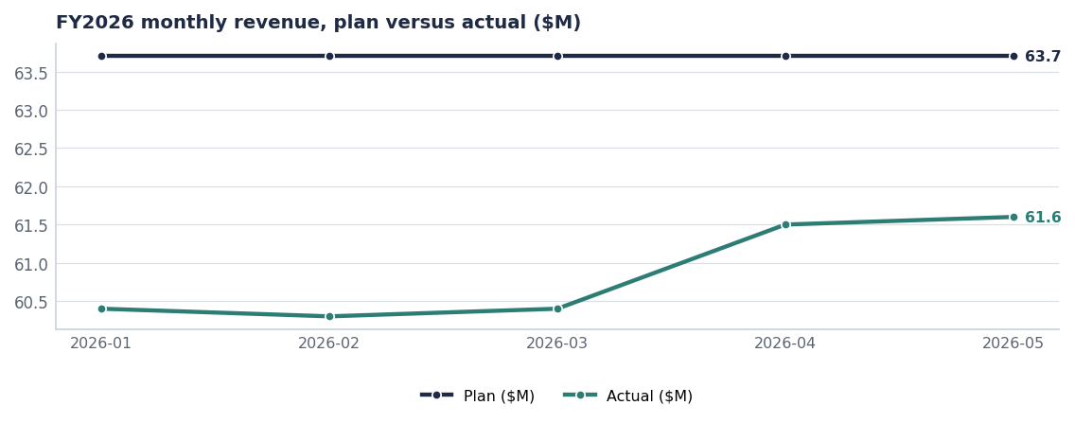
The basis for the H2 build: May's actual held flat, not the original plan.
Challenge from Finance: whether the forecast assumes Louisiana recovery. Response: it does not — no recovery beyond the ~35 basis points already measured in Q2 is built in. Accepted.
SUPPLY
3 · Supply review
Fill rate stands at 94.7% and OTIF at 93.9%, fully recovered from the November 2025 storm trough. The binding constraint for H2 is the Pack Refresh changeover in weeks 33 to 35, which consumes Battle Creek line capacity and will depress base-SKU fill for approximately two weeks.
Cut reason | Units cut | Fill on those lines | Order lines
No cut | 490.9K | 94.9% | 14,665
Storm | 192.8K | 53.7% | 450
Production_Lag | 17.7K | 83.6% | 127
Quality_Hold | 10.1K | 83.0% | 76
Launch_Allocation | 6.6K | 83.4% | 74

Source: shipments, order lines since October 2025.
Point raised by VP Sales NA
Launch_Allocation cuts are a deliberate choice to protect launch fill, but they currently surface to customers as a service miss. Agreed action: make them a visible line in the demand plan from the next cycle.

PRODUCT
4 · Innovation review
Concept | Brand | Stage | Planned launch | Year-1
Crunchwell Pack Refresh - Hero SKUs | Crunchwell | Stage-5 Launch Prep | 2026-08-15 | $28.0M
ProteinPeak Cinnamon Crunch | ProteinPeak | Stage-6 In-Market | 2026-04-20 | $14.0M
ProteinPeak Cocoa Almond | ProteinPeak | Stage-6 In-Market | 2026-04-20 | $10.0M
HoneyNest Birthday Cake LTO | HoneyNest | Stage-4 Pre-Launch | 2026-Q4 | $2.4M
MorningOats Cup Pumpkin Spice LTO | MorningOats | Stage-4 Pre-Launch | 2026-Q3 | $1.8M

Source: seeds/innovation_pipeline.csv.
RECONCILIATION
5 · From $384M to $379M
Step | H2 $M | Raised by
Unconstrained demand forecast | 384.0 | Demand Planning
Less: Pack Refresh changeover phasing | −2.5 | VP Supply Chain
Less: ProteinPeak allocation at Walmart | −1.5 | VP Supply Chain
Less: HoneyNest and RootDay discontinuations | −1.6 | VP Brand
Plus: retail-media reallocation upside | +0.6 | CFO
Consensus H2 number | 379.0 | S&OP Lead

Decision log
Decision | Owner | Date | Status
Adopt $379M as the H2 consensus number; hold the $3M gap as management risk | CFO | Jul 2026 | Action
Protect Pack Refresh changeover capacity ahead of base-SKU fill in weeks 33–35 | VP Supply Chain | Aug 1 | Action
Pre-agree the ProteinPeak allocation rule if Walmart authorises early | Supply Chain / Sage Park | Aug 15 | Action
Make Launch_Allocation cuts a visible demand-plan line | Demand Planning | Next cycle | Action
Release the $700K retail-media reallocation | CFO / Tasha Brooks | Aug 1 | Action

ACTIONS
6 · Carried forward to the August cycle
# | Action | Owner | Due
1 | Pre-build Pack Refresh hero SKUs in weeks 31–32 | VP Supply Chain | Jul 31
2 | Communicate changeover fill impact to top-10 customers | Customer Logistics | Aug 1
3 | Publish the allocation rule for ProteinPeak | Supply Chain | Aug 15
4 | Add Launch_Allocation to the demand-plan template | Demand Planning | Next cycle
5 | Report reallocation in-flight incrementality at week 8 | Hugo Lin | Oct 2026

