AFTER-ACTION REVIEW
Hurricane Tonya — Supply Disruption After-Action Review
What happened, what it cost us in share, what we did well and the five things we will do differently

VP Supply Chain with Customer Logistics and Category Insights
Event: November 2025 · Review completed July 2026
Scope: Houston, Thibodaux and Tyler DCs; Louisiana and Texas DMAs
Companion deck: Report 53
Internal after-action review · Internal · Confidential — synthetic demo data
At a glance
89.6%  FILL TROUGH (2025-11) | 2 quarters  TIME TO FULL RECOVERY | ≈12%  SHARE OF THE LA DECLINE ATTRIBUTED | 5  CHANGES COMMITTED

SUMMARY
1 · What happened
A two-week weather event produced a two-quarter service recovery and a permanent share loss. The recovery speed, not the event, is what we are reviewing.
Hurricane Tonya made landfall in November 2025. Fill rate across the affected network fell to 89.6% in 2025-11, driven by storm cuts at the Houston, Thibodaux and Tyler DCs, with production lag and quality-hold cuts compounding it over the following weeks. Service returned to normal levels — approximately 95% fill and 90% OTIF — by Q1 and Q2 FY2026, a recovery of roughly two quarters.
Over the same window, Crunchwell's Louisiana share fell from 6.06% to a trough of 3.97%. Root-cause attribution assigns approximately 12% of the 340 basis point decline to the supply event, behind the Walmart facing reset (≈55%) and Larksfield promotional intensity (≈20%). The supply event was not the largest cause, but it was the one entirely within our control.
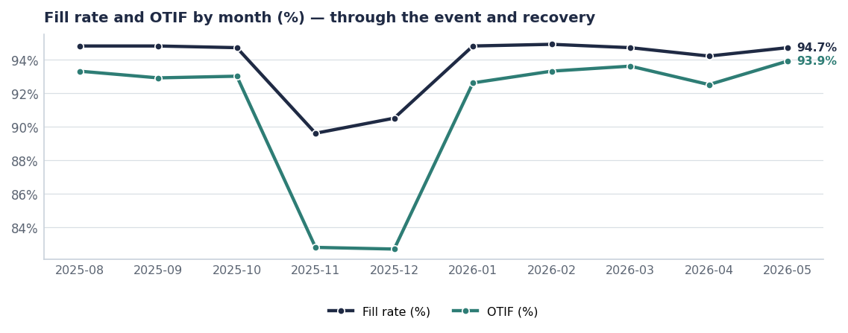
The trough is sharp; the recovery is slow. The slope on the right-hand side is what this review is about.
THE COST
2 · What it cost
Consequence | Measure | Source
Fill-rate trough | 89.6% in 2025-11 | shipments
Storm-cut units | 192.8K | shipments, Cut_Reason = Storm
Compounding cut reasons | Production_Lag and Quality_Hold both elevated post-event | shipments
Share attributed to supply | ≈12% of the 340 bps Louisiana decline | Root-cause attribution (Report 58)
Residual door-level effect | 7 audited Rouses doors still below 70% OSA in 2026 | seed_rouses_oos_by_door

The finding that matters most
Warehouse fill recovered months before store shelves did. Fourteen audited Louisiana doors were still below 70% on-shelf availability well into 2026, every one of them next to a Larksfield endcap. We measured our recovery at the DC and declared victory before the shelf agreed.

BY DC
3 · Where the damage concentrated
Retailer DC | Fill | OTIF | Order lines
Target Houston DC | 86.0% | 75.9% | 348
Brookshire's Tyler DC | 86.3% | 74.3% | 280
H-E-B Houston DC | 86.4% | 75.9% | 348
Walmart Houston DC | 86.4% | 73.9% | 272
Kroger Memphis DC | 86.5% | 75.6% | 348
Rouses Thibodaux DC | 86.5% | 74.6% | 382
Winn-Dixie Hammond DC | 86.8% | 74.7% | 288
Walmart Chicago DC | 94.3% | 94.3% | 314

Source: shipments, October 2025 onward, ranked by fill ascending.
WHAT WENT WELL
4 · Three things worth keeping
- Allocation discipline held. When capacity was short we protected the hero SKUs and the top-volume accounts rather than spreading the shortfall evenly. That was the right call and it is now the documented default.
- Cut-reason coding stayed clean throughout. Storm, Production_Lag and Quality_Hold were coded distinctly, which is the only reason this review can attribute anything at all.
- Cross-functional escalation worked in week one. Supply, Sales and Brand were in the same room within 48 hours of landfall.

WHAT DID NOT
5 · Four things that failed
- We measured recovery at the wrong level. DC fill returned to normal while store OSA did not, and nothing in our reporting surfaced the gap.
- Store-level recovery had no owner. Once fill recovered, the event was closed at the supply end and nobody owned the shelf.
- We did not contest the competitive response. Larksfield took endcap space during the outage and kept it. There was no plan for winning it back.
- No pre-positioning plan existed. The Houston and Tyler DCs serve a hurricane-exposed region and held no seasonal buffer.

EVIDENCE
6 · The door-level residue, months later
SKU | City | OSA | Q1 2026 OOS days | Larksfield endcap
Crunchwell Original Mega | Baton Rouge | 58% | 21 | Y
Crunchwell Original Mega | Houma | 60% | 19 | Y
Crunchwell Original Mega | Thibodaux | 62% | 18 | Y
Crunchwell Original Mega | Baton Rouge | 64% | 16 | Y
Crunchwell Original Mega | Metairie | 66% | 15 | Y
Crunchwell Original Mega | Slidell | 67% | 14 | Y
Crunchwell Original Mega | Lafayette | 69% | 12 | Y
Crunchwell Original Mega | New Orleans | 71% | 11 | Y
Crunchwell Original Mega | Rouses-LA-Total | 73% | 11 | Y

Source: seed_rouses_oos_by_door.
CHANGES
7 · The five commitments
# | Change | Owner | In place by
1 | Pre-position seasonal inventory at Houston and Tyler from week 32 each year | VP Supply Chain | Aug 15 2026
2 | Recovery is measured at store OSA, not DC fill; both reported until OSA recovers | Customer Logistics | Sep 1 2026
3 | Named store-recovery owner appointed at the start of any service event, separate from the supply owner | VP Supply Chain / VP Sales NA | Immediate
4 | Competitive shelf-response plan is part of the service-event playbook | Marcus Boudreaux | Sep 1 2026
5 | Alternate DC routing pre-agreed with the top five Southern customers | Customer Logistics | Oct 1 2026

Recommendations & next steps
# | Action | Owner | When
1 | Adopt the five changes as standing supply-chain policy | VP Supply Chain | By Sep 1
2 | Fund third-party merchandising in the 14 worst Louisiana doors for 12 weeks | Customer Logistics | From Aug 1
3 | Add store-level OSA to the monthly service scorecard for the top-100 volume stores | Customer Logistics | By Sep 1
4 | Re-run this review against the 2026 hurricane season | VP Supply Chain | January 2027

Approvals
Approver | Approving | Date
VP Supply Chain | the findings and the five changes | ________
Diane Halverson, VP Sales NA | the store-recovery ownership model | ________

