MEASUREMENT READOUT
H1 FY2026 Media Effectiveness and the H2 Reallocation
What modelled incrementality says about each platform, and the $700K we are moving because of it

Hugo Lin, Director — Performance Marketing, with Tasha Brooks
Period: Q1 FY2026 measured; H2 FY2026 recommended
Companion deck: Report 55 · Governance: Report 75
Version: v1 · July 2026
Internal measurement readout · Internal · Confidential — synthetic demo data
At a glance
$0.65  BLENDED INCREMENTAL PER $1 | 1.20  BEST PLATFORM RATIO | 0.40  WORST PLATFORM RATIO | $700K  RECOMMENDED MOVE

THE READ
1 · The average hides the decision
$0.65 of modelled incremental revenue per dollar is an acceptable blended number produced by two platforms subsidising two others.
Q1 FY2026 retail media spent $4.2M and returned $2.73M of modelled incremental revenue. Inside that, Walmart Connect returned 1.20 per dollar on $1.0M, while Amazon Ads returned 0.40 per dollar on $2.4M — more than twice the spend at less than a third of the return. This is the largest single efficiency leak in the marketing plan.
Platform | Spend | Modelled incremental | Reported ROAS | Modelled ratio | Call
Amazon Ads | $2.4M | $0.98M | 1.12 | 0.40 | Reallocate
Walmart Connect | $1.0M | $1.21M | 2.06 | 1.20 | Reinvest
Kroger Precision Marketing | $0.4M | $0.32M | 1.43 | 0.77 | Reallocate
Target Roundel | $0.4M | $0.22M | 1.16 | 0.50 | Reallocate
Total | $4.2M | $2.73M | 1.44 | 0.65 | Rebalance

Source: seed_retail_media_spend_q1_2026. Modelled incrementality governs budget decisions; platform-reported ROAS is shown for contrast only.
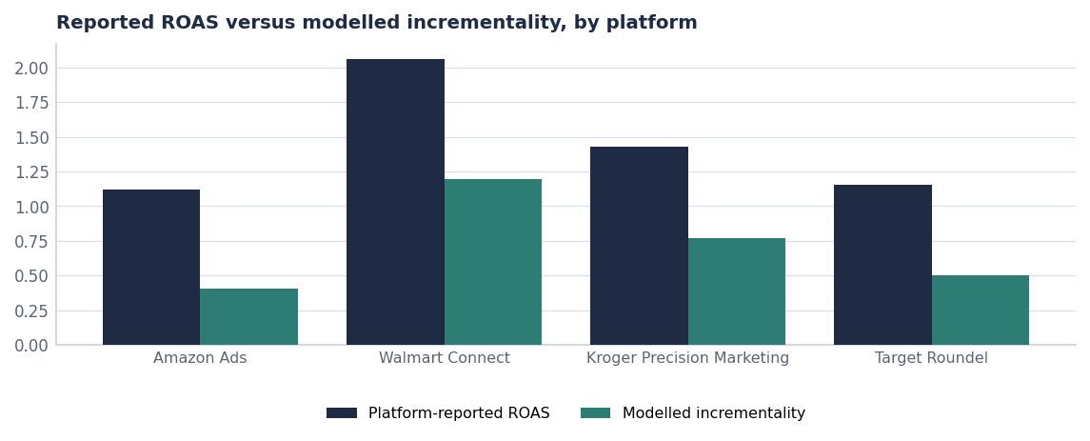
Every platform reports better than the model. The size of the gap is the useful signal.
WHY THE GAP
2 · Reported ROAS and modelled incrementality are different questions
Platform-reported ROAS answers "how much revenue is associated with exposure to this ad?" Modelled incrementality answers "how much of that revenue would not have happened otherwise?" The second question is the one a budget decision needs. Amazon shows the widest gap — reported 1.12 against modelled 0.40 — largely because a substantial share of exposed purchases are base purchases from customers who were already buying. Walmart Connect shows the narrowest gap and is the only platform above 1.0 on the modelled measure.
The governance point
This is not an accusation that platform numbers are wrong. They measure what they say they measure. The discipline we are adopting is that budget allocation uses modelled incrementality and platform dashboards are used for in-flight optimisation only (Report 75).

BY BRAND
3 · Which brands are getting value
Brand | Spend | Modelled incremental | Ratio
Crunchwell | $2.14M | $1.51M | 0.74
ProteinPeak | $1.20M | $0.75M | 0.82
MorningOats | $0.41M | $0.25M | 0.75
TrailGrove | $0.30M | $0.11M | 0.36
HoneyNest | $0.11M | $0.09M | 0.83
RootDay | $0.04M | $0.01M | 0.35

Source: seed_retail_media_spend_q1_2026, grouped by brand.
MIX
4 · Two brands, two philosophies
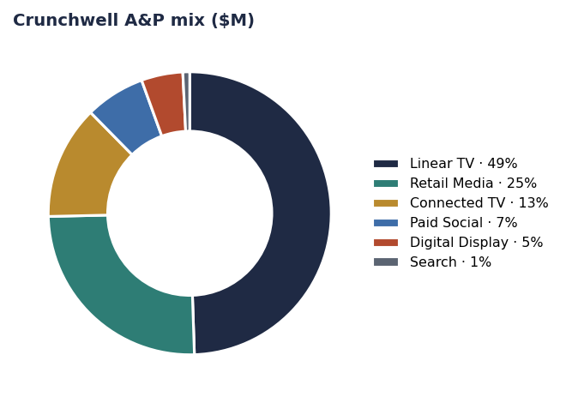
Crunchwell: $48.7M, linear-TV-led.
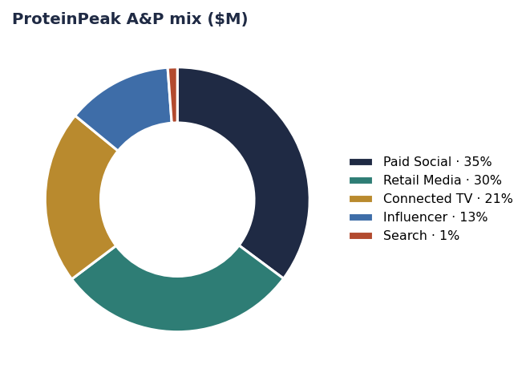
ProteinPeak: $22.2M, paid-social and creator-led.
The brand growing fastest runs the mix weighted to creator, paid social and retail media. The brand that has been flat for six quarters runs the mix weighted to linear television. That is not proof of causation, but combined with the sentiment gap (+0.44 versus −0.11) it is enough to justify moving a third of Crunchwell's TV line into CTV, creator and retail media in FY2027.
THE MOVE
5 · The H2 reallocation, platform by platform
Platform | Q1 spend | H2 change | Rationale
Amazon Ads | $2.4M | −$700K | Modelled ratio 0.40; the largest leak in the plan
Walmart Connect | $1.0M | +$350K | Modelled ratio 1.20; the only platform above 1.0
Kroger Precision Marketing | $0.4M | +$200K | Ratio 0.77 and improving; strong grocery overlap
Louisiana injection (cross-platform) | — | +$150K | 2.2x portfolio ROI on the recovery leg
Net | $4.2M | $0 | Reallocation, not incremental budget

Source: H2 figures are the recommended plan; Q1 spend from seed_retail_media_spend_q1_2026.
PHASING
6 · A secondary finding worth acting on
Period | A&P spend
2025-Q1 | $24.5M
2025-Q2 | $11.9M
2025-Q3 | $10.2M
2025-Q4 | $5.9M
2026-Q1 | $10.9M
2026-Q2 | $11.7M

Source: seed_marketing_spend by period.
Total A&P is lumpy — the quarterly range is wide in a category bought weekly. Smoothing phasing to match purchase behaviour is a free efficiency gain and is recommended for the FY2027 plan.
Recommendations & next steps
# | Action | Owner | When
1 | Approve the $700K reallocation out of Amazon Ads | CFO / Tasha Brooks | By Aug 1
2 | Adopt modelled incrementality as the single budget-governing metric | Hugo Lin | From Aug 1
3 | Move a third of Crunchwell's linear TV line into CTV, creator and retail media in FY27 | CMO / Cory Whitman | FY27 planning
4 | Smooth A&P phasing against weekly purchase behaviour | Hugo Lin | FY27 planning
5 | Re-read incrementality at week 8 and week 13 post-reallocation | Hugo Lin | Q4 FY26

