STANDARD · MEASUREMENT & GOVERNANCE
Retail Media Measurement and Governance Standard
Which number governs which decision, who owns each one, and what we stop reporting

Tasha Brooks, Director — eCommerce & Retail Media, with Hugo Lin
Effective: August 1 2026
Applies to: all retail-media platforms and agencies
Companion documents: Reports 55 and 74
Version: v1 · July 2026
Internal measurement standard · Internal · Confidential — synthetic demo data
At a glance
Modelled incrementality  THE GOVERNING METRIC | $0.65  CURRENT BLENDED RATIO | 1.00  FY29 TARGET RATIO | 4  PLATFORMS IN SCOPE

PURPOSE
1 · Why this standard exists
We run four retail-media platforms that each report a different number using a different attribution window, and we make budget decisions across all four. Without one governing metric, the platform with the most generous attribution wins the budget — which is precisely what has been happening. Q1 FY2026 shows Amazon Ads reporting 1.12 ROAS on a modelled incrementality of 0.40, against Walmart Connect at 2.06 reported and 1.20 modelled.
THE RULE
2 · One metric governs budget
- Budget allocation across platforms uses modelled incrementality ratio only. No exceptions.
- Platform-reported ROAS is used for in-flight optimisation — creative, bidding, keyword and audience decisions inside an already-approved budget.
- Cannibalised and undetermined revenue are reported explicitly, not netted into the incremental figure.
- Every platform is re-measured quarterly. A platform's ratio is a current estimate, not a standing property.
- Agencies are briefed on modelled incrementality, and their performance is assessed against it rather than against platform dashboards.

Decision | Governing metric | Owner | Cadence
Budget split across platforms | Modelled incrementality ratio | Tasha Brooks | Quarterly
Budget split across brands | Modelled incremental revenue by brand | Hugo Lin | Quarterly
Creative, bidding, audience | Platform-reported metrics | Agency | Weekly
Total retail-media envelope | Blended ratio versus target | CMO / CFO | Annual planning
Platform continuation | Two consecutive quarters below 0.50 ratio | Tasha Brooks | Quarterly

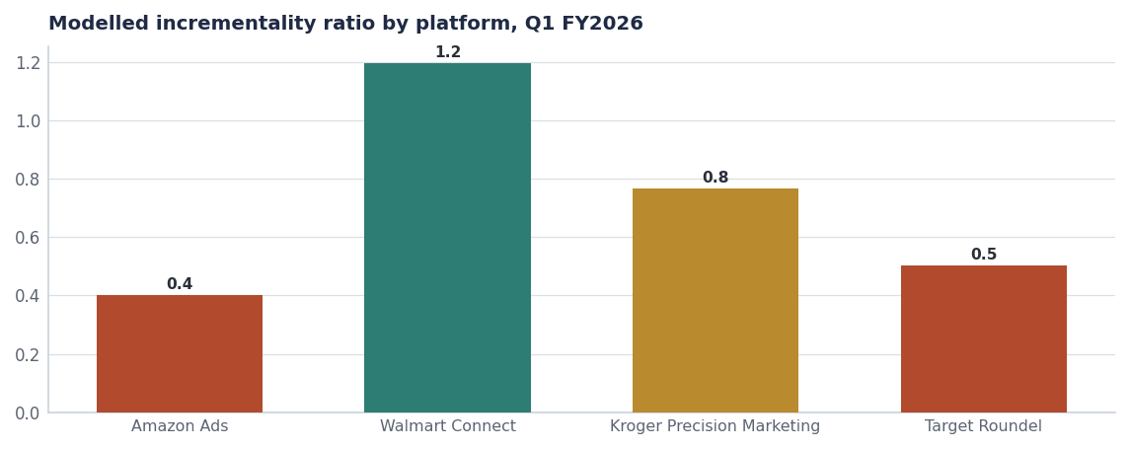
The current baseline. A platform below 0.50 for two consecutive quarters comes up for a continuation decision.
DEFINITIONS
3 · What each number means
Term | Definition | Source
Spend | Gross media spend committed to the platform in the period | Platform invoice
Platform-reported ROAS | Revenue attributed by the platform ÷ spend, on the platform's own attribution window | Platform dashboard
Modelled incremental revenue | Revenue the model attributes to the exposure that would not otherwise have occurred | Acme mix model
Cannibalised base | Exposed revenue the model attributes to already-planned purchase | Acme mix model
Undetermined | Exposed revenue the model cannot confidently classify | Acme mix model
Modelled incrementality ratio | Modelled incremental revenue ÷ spend | Derived

Source: Field names match seed_retail_media_spend_q1_2026 so the standard and the data stay in step.
REPORTING
4 · What we start and stop reporting
4.1 · Starts
- Monthly modelled incrementality ratio by platform and by brand, in the commercial review.
- Explicit cannibalised and undetermined lines alongside incremental revenue.
- A named confidence level on each platform's modelled figure.
- Louisiana and other priority-DMA cuts where spend is geo-weighted.

4.2 · Stops
- Platform-reported ROAS as a headline in any budget document.
- Blended ROAS across platforms — it averages incompatible attribution windows.
- Any comparison of one platform's reported number to another's.

The practical consequence
Under this standard, the Q1 FY2026 allocation would not have been approved. Amazon Ads at a 0.40 ratio would have been capped, and the H2 reallocation (Report 74) is the correction. The standard exists so the correction does not have to happen again annually.

BASELINE
5 · Where each brand starts
Brand | Q1 spend | Modelled incremental | Ratio
Crunchwell | $2.14M | $1.51M | 0.74
ProteinPeak | $1.20M | $0.75M | 0.82
MorningOats | $0.41M | $0.25M | 0.75
TrailGrove | $0.30M | $0.11M | 0.36
HoneyNest | $0.11M | $0.09M | 0.83
RootDay | $0.04M | $0.01M | 0.35

Source: seed_retail_media_spend_q1_2026.
Recommendations & next steps
# | Action | Owner | When
1 | Adopt the standard with effect from August 1 2026 | CMO / CFO | Aug 1 2026
2 | Re-brief all retail-media agencies against modelled incrementality | Tasha Brooks | By Aug 15
3 | Add the monthly incrementality report to the commercial review pack | Hugo Lin | From August
4 | Set the FY27 target blended ratio at 0.85 and the FY29 target at 1.00 | CMO | FY27 planning
5 | Review platform continuation for any platform below 0.50 for two quarters | Tasha Brooks | Quarterly

Approvals
Approver | Approving | Date
CMO | the standard and the governing metric | ________
CFO | the budget-decision rule | ________
Tasha Brooks | platform-level application and agency briefing | ________

