ACTION PLAN · 90 DAYS
Louisiana Recovery — 90-Day Action Plan
Three legs, fourteen doors, one line review, and the measures we will be judged on in twelve weeks

Marcus Boudreaux, Director Sales South, with Jordan Hsu (diagnostic)
Period: August–October 2026
Diagnostic: Report 58 · Brand plan: Report 66
Version: v1 · July 2026
Internal action plan · Internal · Confidential — synthetic demo data
At a glance
−340 bps  PEAK-TO-TROUGH SHARE | 4.16%  SHARE TODAY | 4.0%  12-WEEK TARGET | 14  FOCUS DOORS

THE PLAN
1 · Three legs, in order
Shelf first, availability second, demand third. Media into an empty shelf is wasted money.
Crunchwell's Louisiana share fell approximately 340 basis points from the Mass/Grocery peak to 3.0% in Q1 FY2026 and has recovered to 4.16% on the all-channel value-weighted measure. Root-cause attribution puts roughly 55% of the decline on the September 2025 Walmart modular reset, 20% on Larksfield promotional intensity at Rouses, 12% on the Hurricane Tonya supply event, and the balance on private label and shopper-mix shift. The sequence of this plan follows that attribution.
Leg | What we do | Investment | Owner | 12-week measure
1 · Shelf | Restore Crunchwell Mega to 8 facings in the Walmart LA modular; win one endcap per supercenter | Line-review ask | Marcus Boudreaux | Average facings ≥7.5; at least one endcap
2 · Availability | Third-party merchandising in the 14 worst doors; Rouses OSA recovery programme | ≈$0.4M | Customer Logistics | OSA ≥90% in audited doors
3 · Demand | Louisiana retail-media injection plus targeted Rouses trade at capped depth | ≈$1.1M | Tasha Brooks / NAM | LA Crunchwell share ≥4.0%

Source: Investment figures are the funded amounts; media leg ROI is 2.2x portfolio average per seed_retail_media_spend_q1_2026.
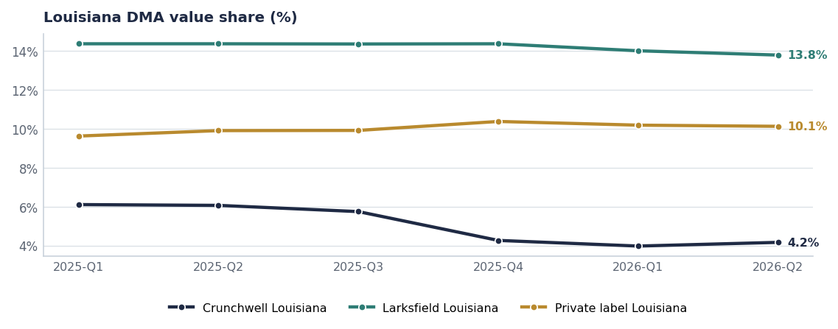
The trough and the partial recovery. The 12-week target is 4.0% on this measure.
LEG ONE
2 · Shelf — the August line review
The single most important action in this plan happens in one meeting. The September 2025 modular cut Crunchwell Mega from 8 facings to 6 across the Louisiana DMA. The audit shows Larksfield averaging 2.36 endcaps per store against Acme's 0.03, and Field & Honey holding 5.96 facings against Crunchwell Mega's 4.06.
City | Stores | CW Mega facings | F&H facings | Larksfield endcaps | Mega OOS
Baton Rouge | 14 | 4.57 | 5.64 | 2.57 | 29%
Burbank | 8 | 4.50 | 5.63 | 2.50 | 25%
Lafayette | 5 | 4.00 | 6.00 | 2.40 | 0%
Shreveport | 4 | 4.00 | 6.00 | 2.25 | 0%
Slidell | 4 | 4.00 | 6.00 | 2.00 | 0%
Monroe | 3 | 4.00 | 6.00 | 2.00 | 0%
Metairie | 3 | 4.00 | 6.00 | 2.00 | 0%
All other LA cities (10) | 21 | 4.00 | 6.00 | 2.43 | 0%

Source: seed_walmart_endcap_audit_la, 62 audited stores.
How we are framing the ask
Louisiana RTE category dollars are down 2.8%. Restoring Mega facings and winning one endcap per supercenter rebuilds category dollars, not just Acme share. We take it in as a joint growth case, not as a supplier complaint (Report 77).

LEG TWO
3 · Availability — the fourteen doors
7 audited Rouses doors sit below 70% on-shelf availability on Crunchwell Original Mega, with up to 21 out-of-stock days in Q1 2026, months after warehouse fill recovered. Every one of those doors has a Larksfield endcap. Third-party merchandising for 12 weeks costs approximately $0.4M and is the fastest measurable intervention in this plan.
SKU | City | OSA | Q1 OOS days | Promo response lift
Crunchwell Original Mega | Baton Rouge | 58% | 21 | 10%
Crunchwell Original Mega | Houma | 60% | 19 | 11%
Crunchwell Original Mega | Thibodaux | 62% | 18 | 12%
Crunchwell Original Mega | Baton Rouge | 64% | 16 | 11%
Crunchwell Original Mega | Metairie | 66% | 15 | 13%
Crunchwell Original Mega | Slidell | 67% | 14 | 13%
Crunchwell Original Mega | Lafayette | 69% | 12 | 14%
Crunchwell Original Mega | New Orleans | 71% | 11 | 15%
Crunchwell Original Mega | Rouses-LA-Total | 73% | 11 | 15%

Source: seed_rouses_oos_by_door.
LEG THREE
4 · Demand — and why it comes last
The Louisiana retail-media injection returns approximately 2.2 times the portfolio ROI, which makes it the most efficient media money available to us. It is nonetheless the third leg, because driving trips to a shelf that is 60% in stock converts our media spend into Larksfield's endcap sales. The media flight starts once the merchandising programme is in place, which is week three of the plan.
Trade support at Rouses is targeted and depth-capped at 20% per the RGM policy (Report 64). We are not buying share back with depth; the elasticity data says that erodes the reference price and makes the next recovery harder.
SCHEDULE
5 · Week by week
Weeks | What happens | Owner
1–2 | Merchandising contracts signed; door list confirmed; line-review pack built | Customer Logistics / Marcus Boudreaux
3–4 | Merchandising live in 14 doors; Walmart August line review held | Customer Logistics / Marcus Boudreaux
4–6 | Retail-media flight begins; Rouses trade events execute at capped depth | Tasha Brooks / NAM
6–8 | First OSA re-audit; facing compliance check in Walmart LA stores | Jordan Hsu
9–12 | Share re-read; decide whether leg 3 scales or stops | Jordan Hsu / Marcus Boudreaux

EARLY WARNING
6 · The next two dominoes
Market | FY25 share | Q1 FY26 share | Δ bps
Louisiana DMA | 6.4% | 3.0% | -340
New Orleans-Metairie MSA | 5.1% | 3.0% | -210
Baton Rouge MSA | 5.8% | 4.2% | -160
Lafayette LA MSA | 6.2% | 5.5% | -70
Southeast US | 4.9% | 4.4% | -50
Mississippi DMA | 5.3% | 4.9% | -40
Texas | 6.3% | 6.0% | -30
Birmingham-Tuscaloosa-Anni | 5.7% | 5.4% | -30

Source: seed_geographies.
Birmingham and Memphis show the same 30 basis point drift Louisiana showed in Q4 2025, with no local event to explain it. Weekly facing and OSA monitoring in both DMAs costs almost nothing and buys a quarter of warning. It starts with this plan, not after the next alarm.
Risks & mitigations
Risk | Impact | Mitigation | Owner
Line review does not restore facings | Leg 1 fails; recovery ceiling drops to ~3.6% | Escalate to the FY27 JBP as a category-dollar case; hold endcap ask separately | Marcus Boudreaux
Merchandising does not lift OSA above 90% | Leg 2 fails; media leg stays paused | Switch to direct-store-delivery support in the worst five doors | Customer Logistics
Larksfield escalates promotional intensity | Recovery slows even with shelf restored | Hold depth cap; compete on display and availability, not price | NAM
2026 hurricane season repeats | Supply-driven relapse | Pre-positioned inventory from week 32 (Report 73) | VP Supply Chain

Recommendations & next steps
# | Action | Owner | When
1 | Fund the merchandising programme in the 14 focus doors for 12 weeks | CFO | By Aug 1
2 | Take facing restoration into the Walmart August line review as a non-negotiable | Marcus Boudreaux | Aug line review
3 | Release the Louisiana retail-media injection from week 3, not week 1 | Tasha Brooks | By Aug 15
4 | Stand up weekly facing and OSA monitoring in Birmingham and Memphis | Jordan Hsu | By Aug 15
5 | Re-read share, facings and OSA at week 12 and decide whether leg 3 scales | Jordan Hsu | Late October 2026

