NEGOTIATION BRIEF · INTERNAL
Walmart August 2026 Line Review — Negotiation Brief
Our four asks, what we are prepared to give, the buyer's likely position, and our walk-away points

Marcus Boudreaux, Director Sales South
Meeting: Walmart August 2026 line review
Internal only — not for distribution outside Acme
Companion deck: Report 59 · Recovery plan: Report 76
Internal negotiation brief · Internal · Confidential — synthetic demo data
At a glance
$184M  ACME REVENUE AT WALMART | 5.2%  OUR PROTEIN SHARE HERE | 18.4%  THE SAME NUMBER AT TARGET | 4  ASKS

THE SITUATION
1 · Where we stand going in
Walmart is $184M of Acme revenue at 21.4% ACV weight — more than twice our next-largest customer. Two issues dominate this review. First, our Wellness Protein position here is 5.2% against 18.4% at Target on identical assortment and identical shelf price. Second, the September 2025 Louisiana modular cut Crunchwell Mega from 8 facings to 6, and Louisiana category dollars have fallen -2.8% since.
Both are framed as joint growth problems in the room. Neither is framed as a complaint. The buyer's incentive is category dollars per linear foot, and both asks improve that number.
THE ASKS
2 · Four asks, in priority order
# | Ask | Why it works for Walmart | Our fallback
1 | Full ProteinPeak line authorisation, including PP005 and PP006 | Wellness Protein is the fastest-growing pocket in the category (+12.0% here); we are under-assorted against demand | Two-SKU authorisation in the top two-thirds of stores by ACV
2 | Crunchwell Mega restored to 8 facings in the Louisiana DMA modular | Louisiana category dollars are -2.8%; the reset moved space to a lower-velocity assortment | 7 facings plus committed endcap in two windows
3 | One endcap per Louisiana supercenter across two windows | Display drives category dollars; our audit shows Larksfield holding the display and the category still shrinking | One window plus joint OSA programme
4 | Chocolate Almond authorisation at the Q4 review | 64% top-two-box, clears our action standard by 9 points; extends the fastest-growing segment | Q1 FY27 authorisation with a Q4 commitment letter

Source: seed_category_market_size retailer cuts, seed_walmart_endcap_audit_la, seed_concept_test_chocolate_almond.
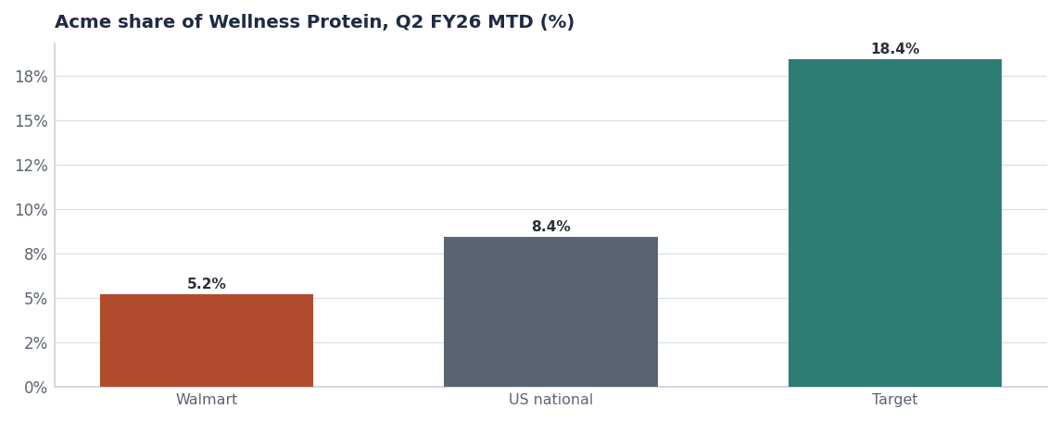
The chart we lead with. Same items, same price, one third of the share.
WHAT WE GIVE
3 · What we are prepared to put on the table
- Pack Refresh readiness. Modular-ready planograms and pre-built inventory for the August 15 2026 Crunchwell Pack Refresh, so the reset costs Walmart nothing in service.
- Trade calendar quality. FY27 calendar rebuilt to a 0.60 incrementality floor — fewer, better-timed events. Q1 ran 3 events at $2.5M and an index of 0.57.
- Feature-and-display weight instead of depth. A 30% increase in feature-and-display support, funded from the depth reduction, which builds category dollars rather than discounting them.
- Back-to-school scale. This account carries the highest kids-household cereal share of any retailer; we will scale the BTS programme to match.
- Joint OSA programme in the 14 lowest-performing Louisiana doors, with Acme funding third-party merchandising.

THEIR POSITION
4 · What we expect from the buyer
Likely buyer position | Our response
"Your Crunchwell velocity does not justify 8 facings" | Velocity is depressed by out-of-stocks, not demand: audited Mega OOS runs at 29% in the worst city. Fix availability and the velocity case changes.
"Protein is a premium item; our shopper is price-led" | Target's shopper is not three times more premium than yours. The difference is display and assortment, not demographics — and protein grew +12.0% in this account.
"We need deeper promotions to move the category" | Our Q1 index of 0.57 says half of promoted volume was not incremental. Feature and display index higher on every brand we run them on.
"Endcap space is committed" | One window plus the joint OSA programme is our fallback; we will take a written commitment for the second window in the FY27 JBP.
"Prove the Pack Refresh will not disrupt service" | Pre-build in weeks 31–32 and a named changeover plan (Report 72).

WALK-AWAY
5 · Our limits
- We do not fund facings with depth. The RGM policy caps Mega depth at 20% and prohibits stacking with retailer funds (Report 64). This is not negotiable in the room.
- We do not discount ProteinPeak beyond 10%. A premium item trained to discount stops being a premium item, and this account would set the reference price for every other.
- We do not accept a Louisiana endcap commitment without a facing commitment. Display without shelf presence produces one good week and no base recovery.
- We do not trade Chocolate Almond exclusivity for depth. If exclusivity is on the table, the price is distribution breadth, not price investment.

One risk to raise before they do
H-E-B has Crunchwell Cinnamon Twist at a 0.88 delist-risk score with a review on 2026-09-15 00:00:00. If Walmart raises portfolio rationalisation, we should be first to name the SKUs we ourselves are discontinuing (Report 69) rather than defending everything.

SCORECARD
6 · What we ask to review quarterly
Measure | Today | FY27 target
Acme revenue at Walmart | $184M | $196M
Acme Wellness Protein share | 5.2% | ≥9%
Crunchwell Mega facings, Louisiana | 4.1 | 8.0
Louisiana Crunchwell share | 3.0% | ≥4.5%
Trade incrementality index | 0.57 | ≥0.60

Source: seed_retailers, seed_category_market_size, seed_walmart_endcap_audit_la, seed_trade_promo_events_q1_2026. Targets are the FY27 proposal.
Recommendations & next steps
# | Action | Owner | When
1 | Lead with the protein share gap, not the Louisiana facings | Marcus Boudreaux | In the meeting
2 | Hold the depth caps regardless of the facing outcome | Marcus Boudreaux | In the meeting
3 | Secure a written commitment for the second endcap window if the first is refused | Marcus Boudreaux | In the meeting
4 | Report outcomes against the four asks within 48 hours | Marcus Boudreaux | Post-meeting

