PREPARATION BRIEF
Kroger November 2026 Line Review — Preparation Brief
The switching data, the division picture, and the three questions we need answered before we build the pack

Priya Raman, Category Manager — Kroger
Meeting: Kroger November 2026 line review
Pack due: October 2026 · This brief: July 2026
Companion documents: Reports 59 and 64
Internal preparation brief · Internal · Confidential — synthetic demo data
At a glance
$93M  ACME REVENUE AT KROGER | -5.4%  Q1 VS PLAN | 0.77  KROGER PRECISION RATIO | 3  OPEN QUESTIONS

PURPOSE
1 · What this brief is for
The November line-review pack is due in October. This brief sets out what we already know, what the switching study tells us, and the three analytical questions that need answering before the pack is built — so that we are not doing the analysis in the last week, which is what happened last cycle.
THE ACCOUNT
2 · Where Kroger sits
Measure | Value | Read
Acme FY25 revenue | $93M | Second-largest customer
ACV weight | 10.8% | Grocery National
Q1 FY26 revenue vs plan | -5.4% | In line with the portfolio
Q1 trade events | 3 | $1.5M spend
Trade incrementality index | 0.57 | Above portfolio average
Kroger Precision modelled ratio | 0.77 | Second-best platform
Account NAM | Jasmine Watkins | Tier 1

Source: seed_retailers, plan_vs_actual, seed_trade_promo_events_q1_2026, seed_retail_media_spend_q1_2026.
THE SWITCHING STUDY
3 · Where our volume is going inside Kroger
Segment | From | To | Switch rate % | Share pt shift | Division
Protein-Forward | Traditional family cereal | (segment shift) | — | +2.3 | Kroger-National
Sugar-Reduced | Traditional family cereal | (segment shift) | — | +2.3 | Kroger-National
Ancient-Grain | Traditional family cereal | (segment shift) | — | +2.3 | Kroger-National
All | Crunchwell+other | Larksfield Field & Honey | 19.1 | +2.1 | Kroger-South
All | Crunchwell+other | Larksfield Field & Honey | 17.1 | +1.4 | Kroger-National
All | Crunchwell | Simple Truth | 14.3 | +0.8 | Kroger-National
Protein segment | (category) | Simple Truth | — | +0.8 | Kroger-National
Family Sweet | Crunchwell | Larksfield Field & Honey | 14.4 | +0.4 | Kroger-National
Protein | Crunchwell | Simple Truth | 15.3 | +0.4 | Kroger-Cincinnati
Wholegrain | Crunchwell | Simple Truth | 16.2 | +0.4 | Kroger-National

Source: seed_kroger_simple_truth_switching.
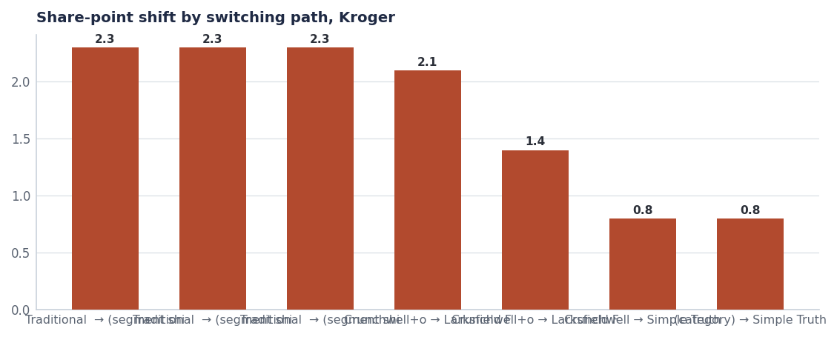
The largest single path is traditional family cereal into segment shift — occasions leaving the aisle, not brands losing a head-to-head.
- The largest shifts are segment shifts, not brand switches: traditional family cereal into protein-forward, sugar-reduced and ancient-grain positions.
- Where it is a brand switch, Larksfield Field & Honey is the destination — strongest in the Kroger-South division, which is consistent with the Louisiana picture.
- Simple Truth takes a meaningful slice of Crunchwell volume nationally. That is private label competing on positioning, not on price.
- Implication for the pack: we lead with segment growth, not with a defensive Crunchwell argument.

THREE QUESTIONS
4 · What we need before the pack is built
# | Question | Who answers it | By when
1 | How much of the Kroger-South Field & Honey shift is explained by the same facing and OSA mechanism we found in Louisiana? | Jordan Hsu with Category Insights | By Sep 5
2 | What is the incremental value of full ProteinPeak line authorisation at Kroger, using the Target-versus-Walmart gap as the analogue? | Maya Chen / Sage Park | By Sep 15
3 | Does a 0.60-index trade calendar hold volume at Kroger, where our index is already 0.57 — better than the portfolio? | Trade Finance | By Sep 20

Why question 1 matters most
If the Kroger-South shift has the same mechanism as Louisiana — lost facings and poor on-shelf availability rather than shopper preference — then the November ask is a shelf ask and the analysis is already largely done. If it is genuinely preference, the ask is an assortment ask and the pack looks completely different.

THE LIKELY ASKS
5 · What we expect to take in
- Full ProteinPeak line authorisation, on the same growth case we are taking to Walmart (Report 77).
- Chocolate Almond for Q1 FY2027, subject to the Q4 line reviews and the SteerCo gate (Report 68).
- Crunchwell Pack Refresh planograms for the FY27 reset, with pre-built inventory.
- Kroger Precision Marketing weight increase, funded from the Amazon Ads reallocation — Kroger Precision runs at a 0.77 modelled ratio (Report 74).
- TrailGrove distribution gaps in granola and bars, which is the cheapest incremental volume available in this account.

WHAT WE BRING
6 · The give side
What we bring | Value to Kroger
FY27 trade calendar at a 0.60 incrementality floor | Fewer, better-timed events; higher category dollars per promoted week
Feature-and-display weight funded from depth reduction | Display support that builds the category rather than discounting it
Kroger Precision investment increase | Retail-media revenue at a proven ratio
Pack Refresh readiness with pre-built inventory | No service risk at the reset
Segment-growth analysis by division | Category insight Kroger does not have to build

Recommendations & next steps
# | Action | Owner | When
1 | Commission the three analytical questions now, not in October | Priya Raman | By Aug 1
2 | Reuse the Walmart protein growth case rather than building a new one | Priya Raman | By Sep 15
3 | Fund the Kroger Precision increase from the Amazon reallocation | Tasha Brooks | By Aug 1
4 | Build the pack around segment growth, not Crunchwell defence | Priya Raman | October 2026

