CHANNEL STRATEGY MEMORANDUM
Club Channel FY2027 Strategy — Costco and Sam's
Two accounts, one pack architecture question, and why the club channel is where GLP-1 will show up first

Club Sales with RGM
Accounts: Costco, Sam's Club
Period: FY2027 with FY29 implications
Companion documents: Reports 64 and 70
Version: v1 · July 2026
Internal channel strategy · Internal · Confidential — synthetic demo data
At a glance
$80M  ACME CLUB REVENUE FY25 | 2  CLUB ACCOUNTS | 18oz+  THE PACKS AT RISK | 0.81  GLP-1 TREND STRENGTH

THE ARGUMENT
1 · Club is the leading indicator, not the laggard
If smaller appetites are going to change cereal, they will change club packs first.
Acme's club business is approximately $80M across Costco, Sams Club. The channel's economics depend on large pack sizes and high units per trip, which is exactly the demand pattern most exposed to the GLP-1 appetite shift — a trend running at 0.81 strength with a downward volume direction (Report 70). The FY2027 strategy therefore has two jobs: grow the channel in the near term and start restructuring the pack architecture before the exposure becomes a decline.
Account | Channel | ACV weight | FY25 revenue | NAM | Tier
Costco | Club | 4.1% | $52.0M | Frank Calabrese | Tier 1
Sams Club | Club | 2.4% | $28.0M | Frank Calabrese | Tier 2

Source: seed_retailers.
PERFORMANCE
2 · Where club sits against the rest of the book
Retailer | Q1 plan | Q1 actual | Variance
Walmart | $48.4M | $45.8M | -5.3%
Kroger | $24.6M | $23.3M | -5.4%
Target | $18.0M | $17.0M | -5.3%
Costco | $13.7M | $13.0M | -5.4%
Albertsons | $13.7M | $13.0M | -5.3%
Amazon | $11.6M | $10.9M | -5.3%
H-E-B | $8.4M | $7.9M | -5.5%
Publix | $7.7M | $7.3M | -5.5%
Sams Club | $7.3M | $6.9M | -5.5%
Meijer | $5.6M | $5.3M | -5.4%

Source: plan_vs_actual, Q1 FY2026, top ten retailers by plan.
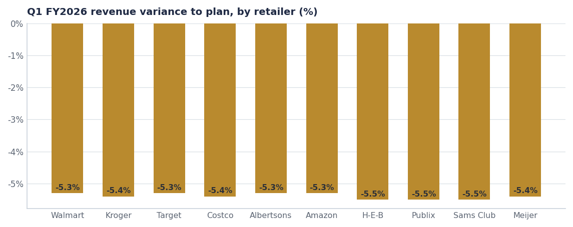
Club performs in line with the book. The strategic issue here is structural, not current-year performance.
PACK ARCHITECTURE
3 · The question the channel forces
Club needs a value equation the shopper can see at the shelf, which historically means the largest pack at the lowest price per ounce. Two things now cut against that. First, the elasticity data says our large packs are our most elastic, so club pricing pressure transmits directly into the reference price everywhere else. Second, if serving demand shrinks, the largest pack becomes the least attractive rather than the best value.
- Crunchwell 36oz Mega Family Pack (Stage-3, 2027-Q1, $8.5M year-one) is the club-ready answer to the value equation and should be positioned as club-first.
- But it should launch with a defended price — $8.99 target, launch support only, no depth — precisely because it sets the price-per-ounce anchor for the whole ladder (Report 64).
- ProteinPeak club pack is the higher-margin opportunity: premium price per serving, growing segment, and a shopper who is buying nutrient density rather than volume.
- Single-serve multipacks are the GLP-1 hedge — they convert a shrinking-serving trend into a higher price per ounce rather than a volume loss.

SKU | Brand | Pack | Shelf price | Price/oz | FY25 revenue
Crunchwell Original Family | Crunchwell | 14oz | $4.29 | $0.31 | $68.4M
Crunchwell Honey Nut | Crunchwell | 14oz | $4.49 | $0.32 | $61.7M
Crunchwell Original Mega | Crunchwell | 18oz | $5.49 | $0.30 | $52.1M
Crunchwell Honey Nut Mega | Crunchwell | 18oz | $5.69 | $0.32 | $41.8M
Crunchwell Cinnamon Twist | Crunchwell | 14oz | $4.59 | $0.33 | $18.4M
RootDay Oat Milk Original | RootDay | 32oz | $4.99 | $0.16 | $18.4M
RootDay Oat Milk Barista | RootDay | 32oz | $5.49 | $0.17 | $12.7M
HoneyNest Mega | HoneyNest | 16oz | $5.39 | $0.34 | $12.4M
RootDay Oat Milk Vanilla | RootDay | 32oz | $4.99 | $0.16 | $8.4M

Source: seeds/skus.csv, packs of 14oz and above.
FY27 PLAN
4 · What we do in each account
Account | FY27 priority | What we ask for | Risk
Costco | Club-first launch of the 36oz Mega Family Pack at a defended price | One national item slot plus a road-show window | Price-per-ounce anchor leaks into grocery
Sam's Club | ProteinPeak club multipack and a TrailGrove club item | Two new items; club-exclusive pack graphics | Cannibalisation of 12oz ProteinPeak at grocery
Both | Single-serve multipack test as the GLP-1 hedge | Test-and-learn window in H2 FY27 | Low volume in year one

Source: seeds/innovation_pipeline.csv (36oz Mega Family, 2027-Q1); FY27 plan is the proposal.
The one thing not to do
Do not fund club growth with depth on the 18oz Mega. It is the most elastic pack in the portfolio at −1.84 to −2.12, and club pricing on it transmits to every grocery banner within a quarter. Grow the channel with new pack sizes, not with lower prices on existing ones.

CONTEXT
5 · The trends that bear on club
Trend | Strength | Direction | Categories
High-protein cereal | 0.92 | Up | RTE Cereal
GLP-1 / Ozempic appetite shift | 0.81 | Down (volume impact) | RTE Cereal+Bar+Hot Cereal
Sustainable packaging | 0.74 | Up | All Categories
Limited-time offers (LTO) acceleration | 0.74 | Up | RTE Cereal+Granola+Bar
Low-sugar reformulation pressure | 0.72 | Up | RTE Cereal+Granola

Source: seed_macro_trends, filtered to club-relevant trends.
Recommendations & next steps
# | Action | Owner | When
1 | Position the 36oz Mega Family Pack as a club-first launch at a defended $8.99 | Club Sales / RGM Lead | Q4 FY26 gate
2 | Develop a ProteinPeak club multipack for Sam's FY27 review | Sage Park / Club Sales | By Q1 FY27
3 | Run a single-serve multipack test in H2 FY27 as the GLP-1 hedge | Club Sales | H2 FY27
4 | Hold the no-depth rule on the 18oz Mega in club | RGM Lead | FY27 policy
5 | Report club price-per-ounce against grocery quarterly to catch anchor leakage | Trade Finance | Quarterly

