COMPETITIVE RESPONSE PLAYBOOK
Larksfield Field & Honey — Response Playbook
What the aggressor has done, what it is likely to do next, and our pre-agreed responses on each front

Competitive Intelligence with Category Insights
Competitor: Larksfield Foods (Field & Honey)
Fronts: protein, Louisiana, private-label-adjacent value
Version: v1 · July 2026
Internal competitive playbook · Internal · Confidential — synthetic demo data
At a glance
14.10%  F&H NATIONAL SHARE | 13.78%  F&H LOUISIANA SHARE | 3  LAUNCHES SINCE MID-2025 | 3  ACTIVE FRONTS

THE COMPETITOR
1 · Who we are dealing with
Larksfield Foods' Field & Honey holds approximately 14.10% national value share against Crunchwell's 5.97%, and has been the share gainer nationally through the period. In the Louisiana DMA it holds about 13.78%. It is not the largest competitor in the category, but it is the one taking our volume, and it is doing so on three fronts simultaneously.
Brand | SKU | Launch date | Claim | Buzz d30 | Status
Field & Honey | LF-FH-14P | 2026-05-12 00:00:00 | 14g protein per serving, made with who | 0.84 | Live
Field & Honey | LF-FHL-14 | 2026-03-30 00:00:00 | Limited edition spring lemon | 0.36 | Pre-Launch
Field & Honey | LF-FHA-14 | 2025-09-08 00:00:00 | Made with whole grain almonds and a hi | 0.78 | Live

Source: seed_competitor_launches.
THE FRONTS
2 · Three attacks, one pattern
2.1 · Protein
The 14 gram protein line extension (LF-FH-14P) launched May 12 2026 with a whole-grain almond and seed blend claim at $4.79 for 12oz — materially below ProteinPeak's $7.49. This is a value-protein attack on the segment we are betting the portfolio on. Our answer is Chocolate Almond into the Q4 line reviews and distribution breadth, not a price response (Reports 67 and 68).
2.2 · Louisiana
The Almond launch in September 2025 coincided with the Walmart modular reset. The endcap audit shows Larksfield averaging 2.36 endcaps per store against Acme's 0.03, and Field & Honey holding more facings than Crunchwell Mega in every audited city. Our answer is the three-leg recovery plan, led by shelf (Report 76).
2.3 · Value-adjacent positioning
Field & Honey sits between branded and private label on price while claiming better ingredients. The Kroger switching study shows Crunchwell volume moving to Field & Honey at 19.1% in the South division. That is a positioning loss, not a price loss.
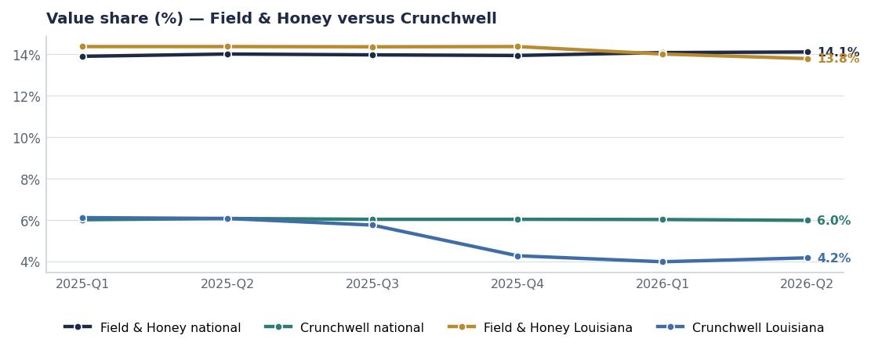
The gap widens nationally and dramatically in Louisiana.
THE EQUITY PICTURE
3 · They are winning the attribute we are losing
Attribute | Field & Honey (FY26Q2) | Crunchwell (FY26Q2) | Gap
Relevance | 80.9 | 62.7 | +18.2
Trust | 66.0 | 72.9 | -6.9
Taste | 73.5 | 73.2 | +0.3
Quality | 76.1 | 70.3 | +5.8
Modernity | 83.5 | 48.8 | +34.7

Source: brand_equity_quarterly, US-NAT, latest wave.
The equity comparison is the strategic heart of this playbook. Crunchwell still leads on the attributes that took decades to build. Field & Honey leads, or is closing, on the attribute that determines whether anyone buys the category this week. That is why our answer is a relevance platform rather than a price or heritage response (Report 65).
PRE-AGREED RESPONSES
4 · What we do when, decided in advance
If Larksfield does this | We do this | We do not do this | Owner
Extends the 14g protein line to more flavours | Accelerate Chocolate Almond; push distribution breadth at Walmart and Kroger | Cut ProteinPeak price or exceed the 10% depth cap | Sage Park
Takes further endcap space in the South | Contest at the line review with the category-dollar case; fund merchandising in the worst doors | Buy display with incremental depth | Marcus Boudreaux
Launches into oat milk or granola adjacency | Accelerate RootDay single-serve and TrailGrove distribution | Enter a price war in a segment where we are the smaller player | Brand teams
Prices below private label on a hero item | Hold everyday price; increase feature-and-display weight | Match on price — Mega elasticity makes it unrecoverable | RGM Lead
Wins a national kids-cereal position | Nothing — Kids Sweet is being harvested (Report 69) | Defend a −2.8% segment out of pride | VP Brand

The discipline this playbook is really about
Every response above is the same shape: compete on shelf presence, availability, distribution and relevance — never on price. Field & Honey's price position is structurally below ours, so a price fight is one we lose slowly and then permanently.

MONITORING
5 · What we watch, and how often
Signal | Source | Cadence | Trigger
F&H national and DMA value share | syndicated_weekly | Weekly | 50 bps move in any priority DMA
New launches and claims | seed_competitor_launches | Monthly | Any protein or oat-milk entry
Endcap and facing presence, South region | Store audits | Monthly | Any facing loss on a hero SKU
Buzz index at day 30 on new items | seed_competitor_launches | Per launch | Buzz above 0.80
Equity attributes, Relevance and Modernity | brand_equity_quarterly | Quarterly | F&H Relevance overtaking Crunchwell
Switching paths at Kroger | seed_kroger_simple_truth_switching | Semi-annual | South division switch rate above 20%

Recommendations & next steps
# | Action | Owner | When
1 | Adopt the pre-agreed response table so responses are not improvised under pressure | VP Brand / VP Sales NA | By Aug 15
2 | Add Field & Honey to the standing equity tracker read | Nina Ortega | Q3 FY26
3 | Escalate any hero-SKU facing loss in the South within one week of detection | Marcus Boudreaux | Standing
4 | Re-issue this playbook each half-year with the monitoring triggers scored | Competitive Intelligence | January 2027

