# EXPERIMENT NO.1

**Q. Introduction to UI life cycle and UI tools.**

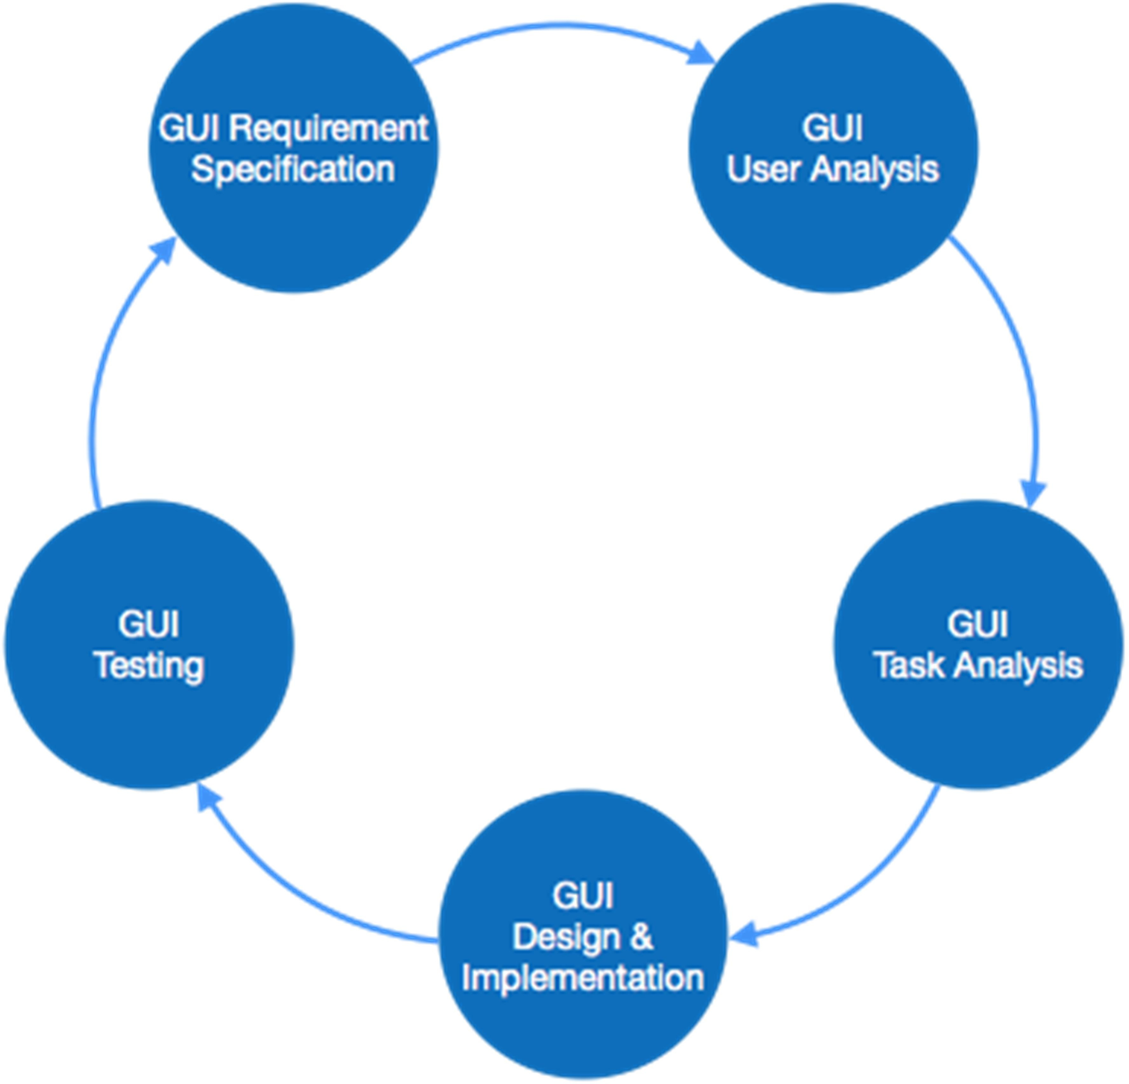

### UI Tools:

1. **InVision**: InVision is a web-based prototyping tool popular with both UX and UI designers alike. You can upload static design files and quickly turn them into high-fidelity, interactive prototypes.
2. **Sketch**: The digital design app that every UI pro needs: Sketch. This is a vector-based tool, so you can easily resize anything that you draw without losing sharpness.
3. **Figma**: Discover the very first in-browser interface design tool, Figma. With powerful editing tools and loads of handy features, Figma is a one-stop shop for designing, prototyping and gathering feedback. UI designers especially can take advantage of constraints feature, which adapts your designs when the screen size changes. With the components feature, it’s also extremely easy to reuse elements across your designs.
4. **Flinto**: Flinto is an interactive prototyping app for Mac which offers pretty much everything you need to bring your designs to life. Design micro-interactions and screen transitions, add video layers simply by dragging video or GIF files straight into your designs, incorporate UI sound effects and customizable scrolling—the list goes on.
5. **Adobe XD**: Adobe XD is a vector-based tool for designing and prototyping user experiences for web, mobile, and even voice! If you’re already familiar with the Adobe Creative Cloud suite, you’ll feel right at home in Adobe XD—an extremely versatile tool which offers a whole host of features for designing, prototyping, sharing, collaborating, and creating a complete design system. XD natively supports Windows 10 and macOS, and is also available as a mobile app for both Android and iOS.

**Q. Project Proposal and Requirement Gathering (Introduction of Project).**

INTRODUCTION

Most of times patients may feel lethargic to visit the medical shop at the time of medicines needed. This leads to improper body conditions that makes them suffer lot which may cause late recovery from the disease/illness. So, it is necessary to take proper medicines in proper quantity at proper time. In the system, we introduce an Android based application for the patients. This android application will provide a smooth user experience for purchasing medicines.

AUDIENCE INSIGHTS:

The application results in time and cost saving to reach to people. Time saving for persons of remote places for their medicine search and also provides the convenience of searching for medicine anywhere at any point of time through the user-friendly interface.

OBJECTIVES

The online medical purchasing app “**Medley’s Medical**” is an online mobile application for a medical shop. It is a virtual showcase for different types of medicine like health care, baby care, and home need products. Main aim of this project is to develop 24*7 medical service for users through online application.

**Q. Logo Designing.**

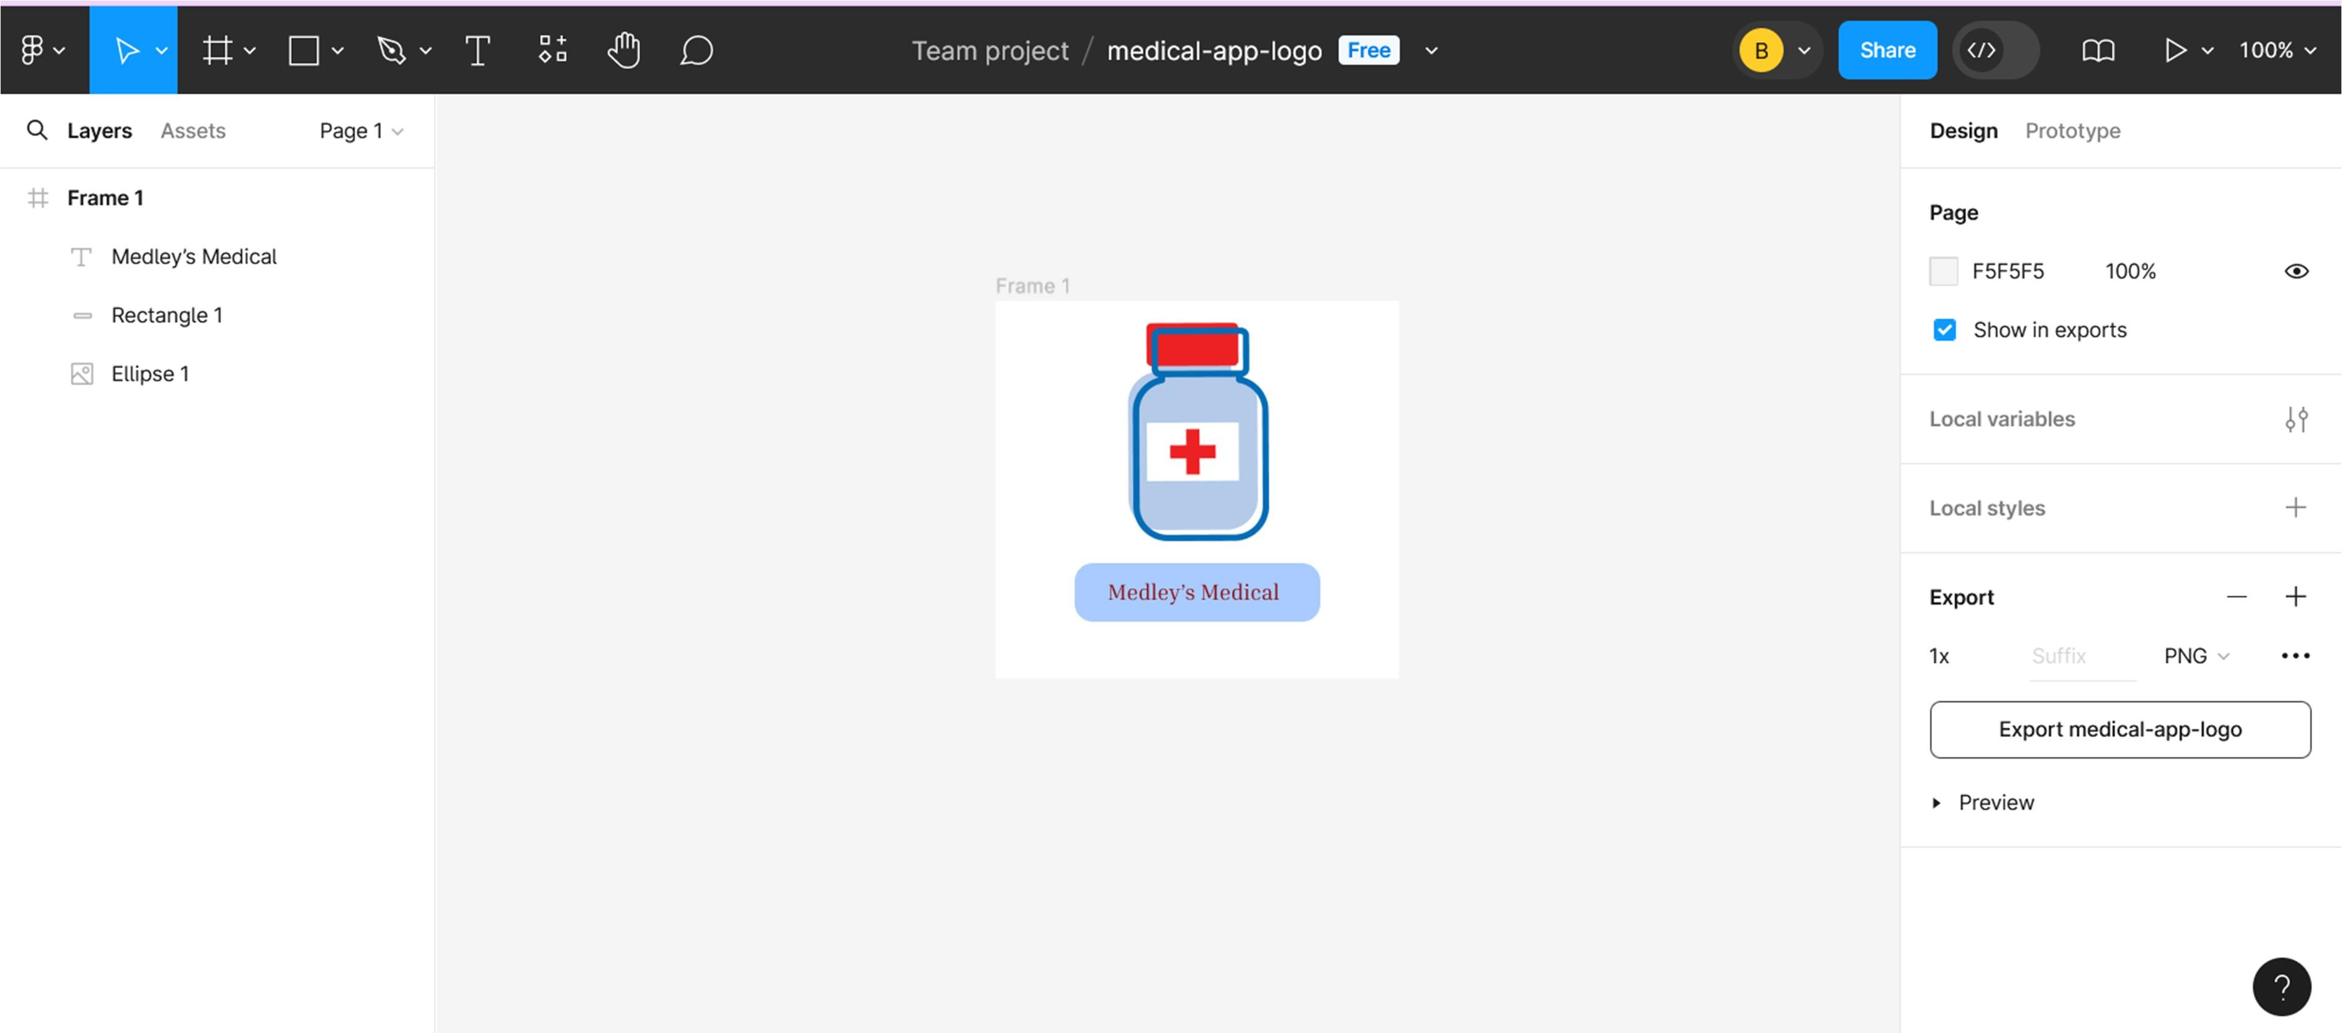

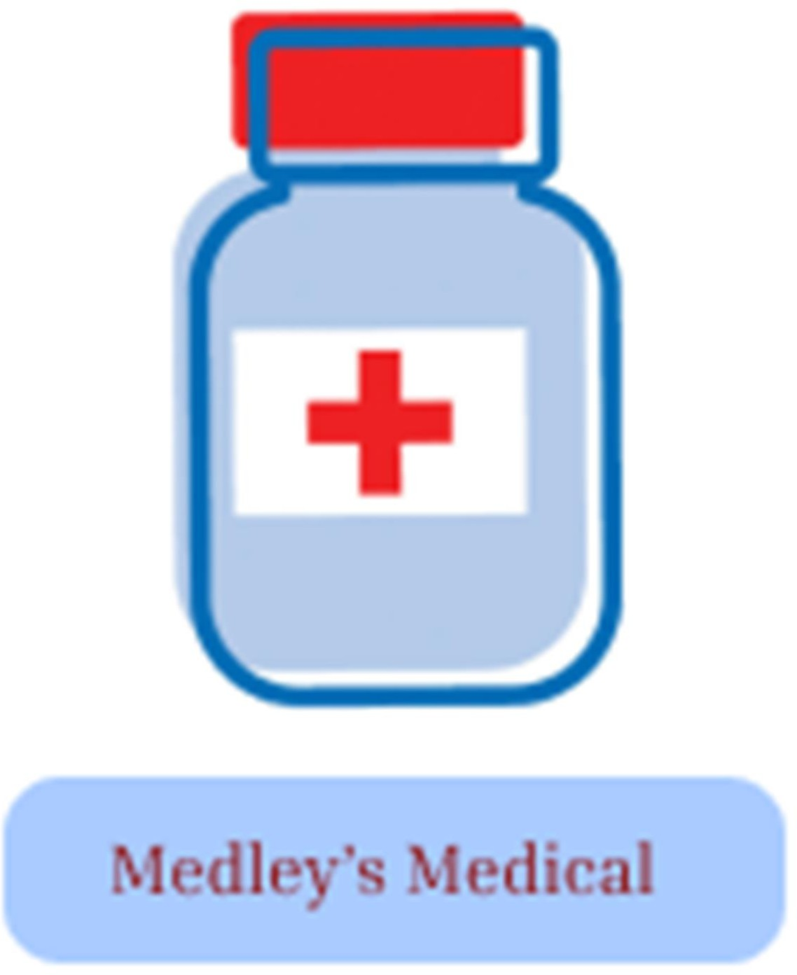

**Q. Problem Statement: System Concept Statement.**

### Project Name: Medley’s Medical

Most of times patients may feel lethargic to visit the medical shop at the time of medicines needed. This leads to improper body conditions that makes them suffer lot which may cause late recovery from the disease/illness. So, it is necessary to take proper medicines in proper quantity at proper time. In the system, we introduce an Android based application for the patients. This android application will provide a smooth user experience for purchasing medicines.

The Online Medical purchasing application is an online application for a medical shop. It is a virtual showcase for different types of medicine like health care, baby care, & home need products. Main aim of this project is to develop 24*7 medical service for users through online application. The application results in time and cost saving to reach to people. Time saving for persons of remote places for their medicine search and also provides the convenience of searching for medicine anywhere at any point of time through the user-friendly interface.

**Q. Design a user persona.**

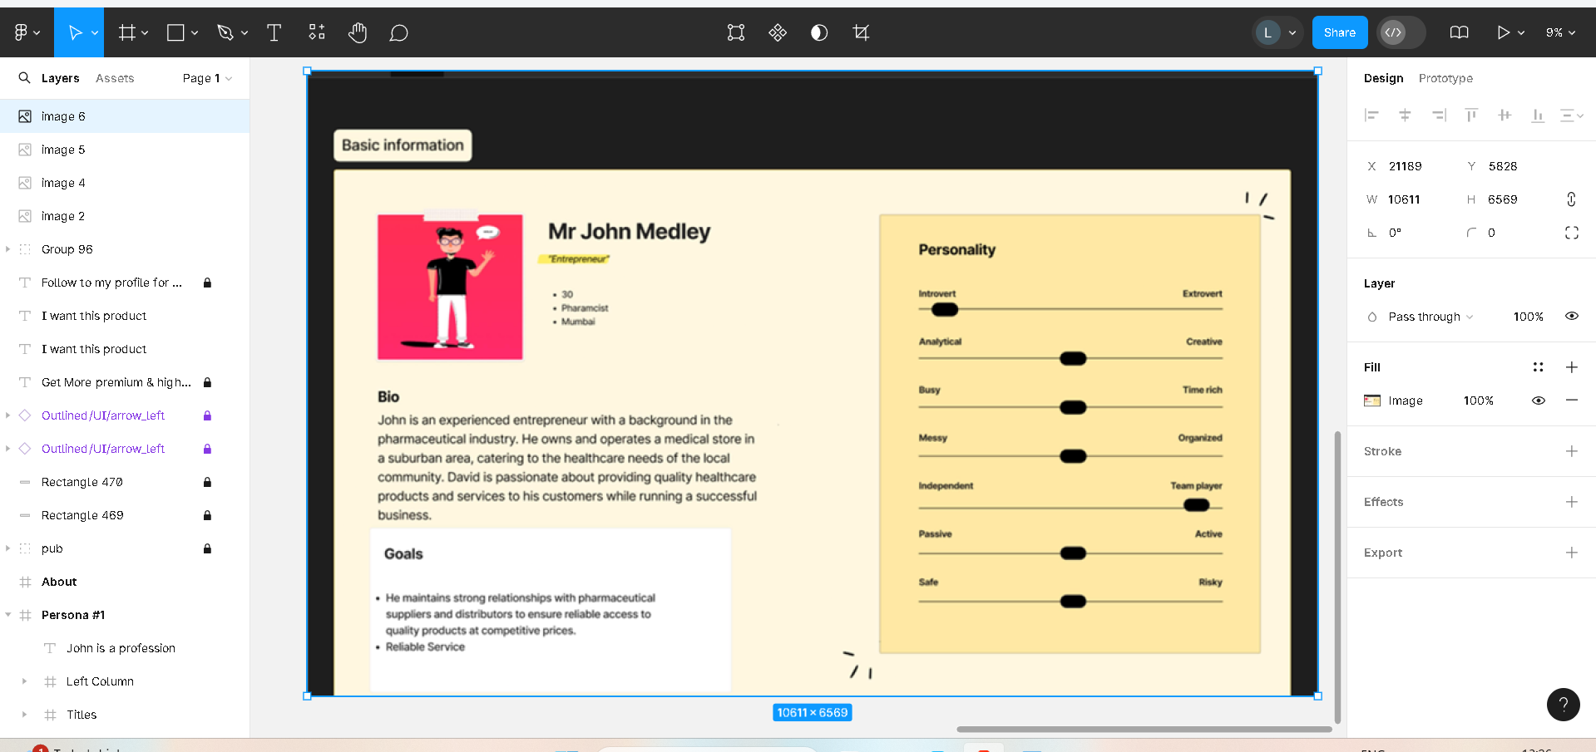

**Q. Design a Customer Journey Map.**

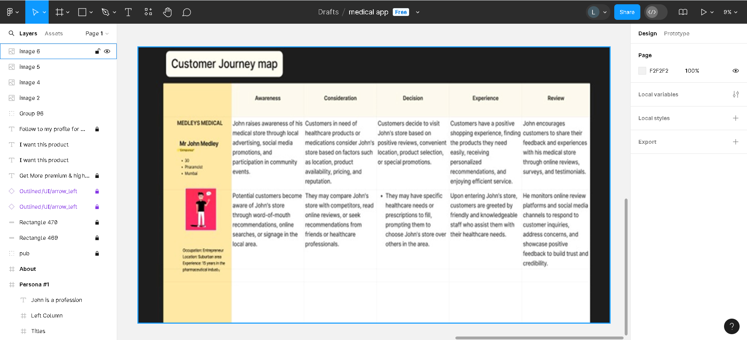

# EXPERIMENT NO. 7

**Q. ER (Entity Relationship) Diagram.**

The Entity-Relationship Diagram (ERD) for the cinema-related system visually represents the logical structure of the database. It helps to systematically analyse data requirements to produce a well-designed database. The ERD is created based on three basic concepts: entities, attributes, and relationships.

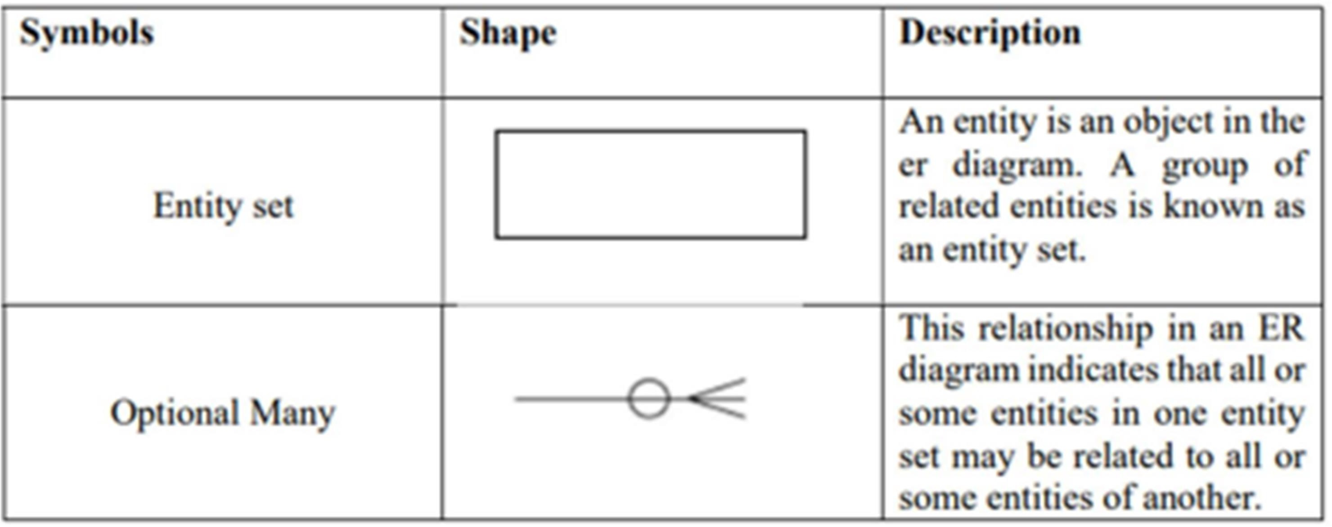

### Following are the types of Entity relationship:-

**One-to-One (1:1) Relationship:** Each entity in the relationship will have exactly one related entity.

**One-to-Many (1) Relationship:** An entity on one side of the relationship can be associated with multiple entities on the other side.

**Many-to-One (M: 1) Relationship:** Multiple entities on one side of the relationship are associated with a single entity on the other side. This is essentially the reverse of the One-to- Many relationship.

**Many-to-Many (M) Relationship**: Entities on both sides of the relationship can have multiple associations with entities on the other side.

**E-R DIAGRAM: MEDLEY’S MEDICAL**

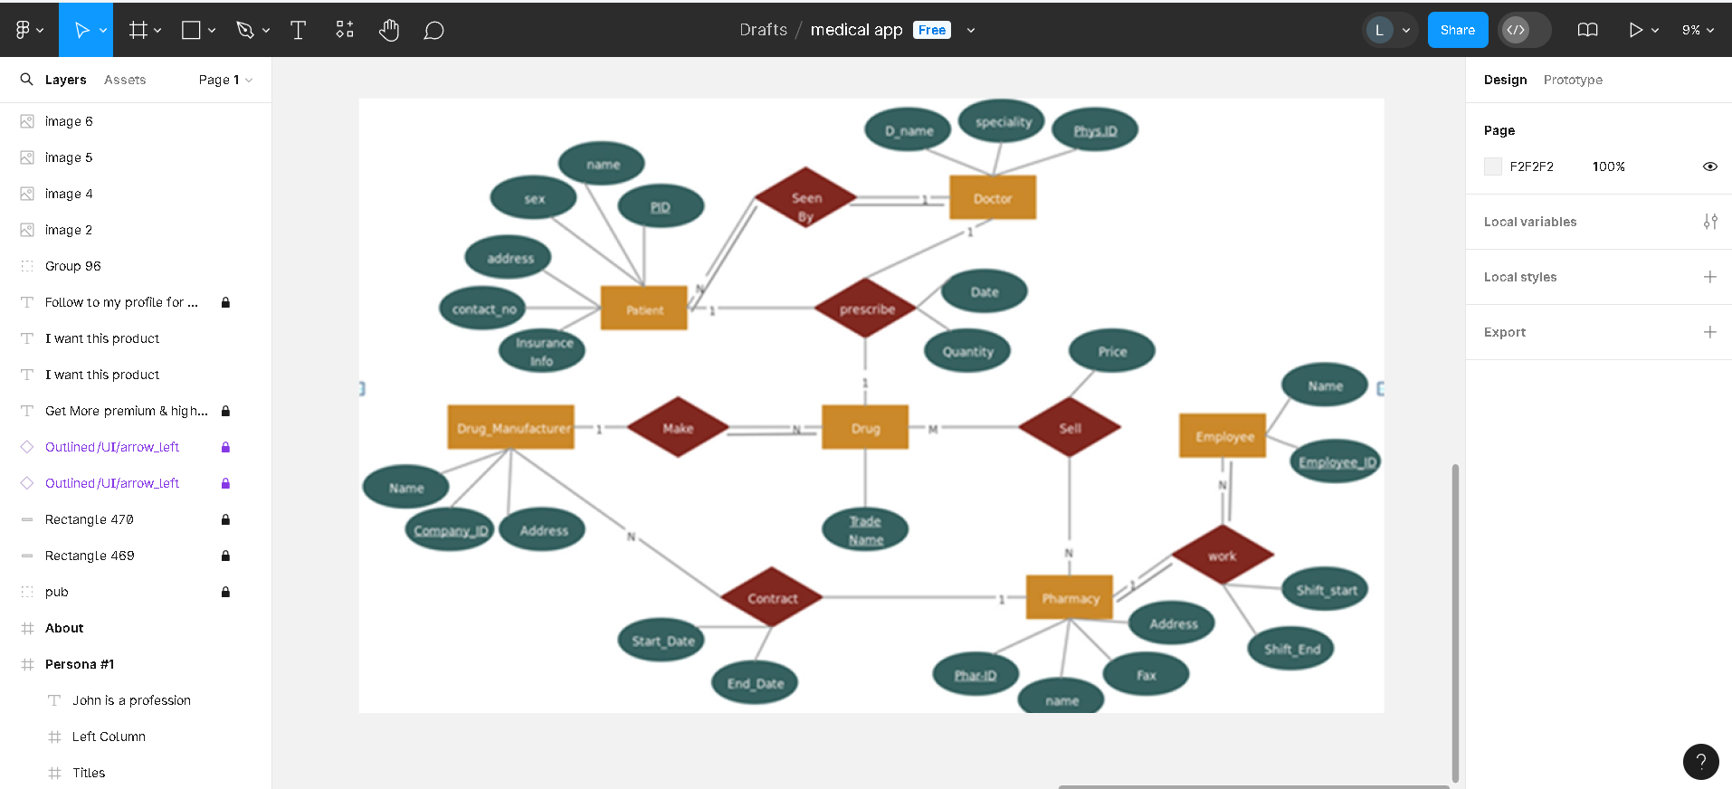

**Q. Creation of scenario – Story Board.**

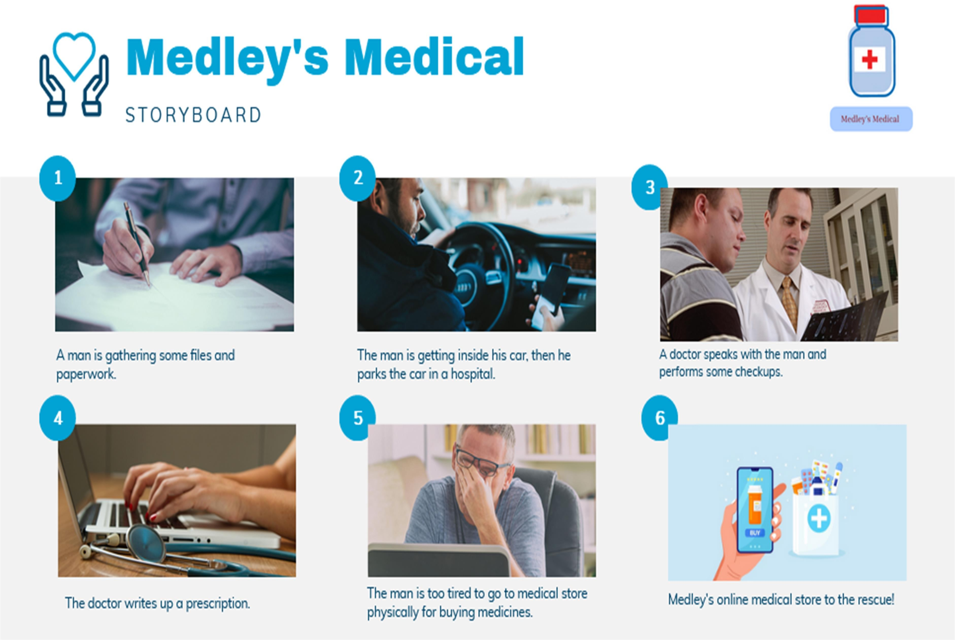

**Q. Create Wire framing:**

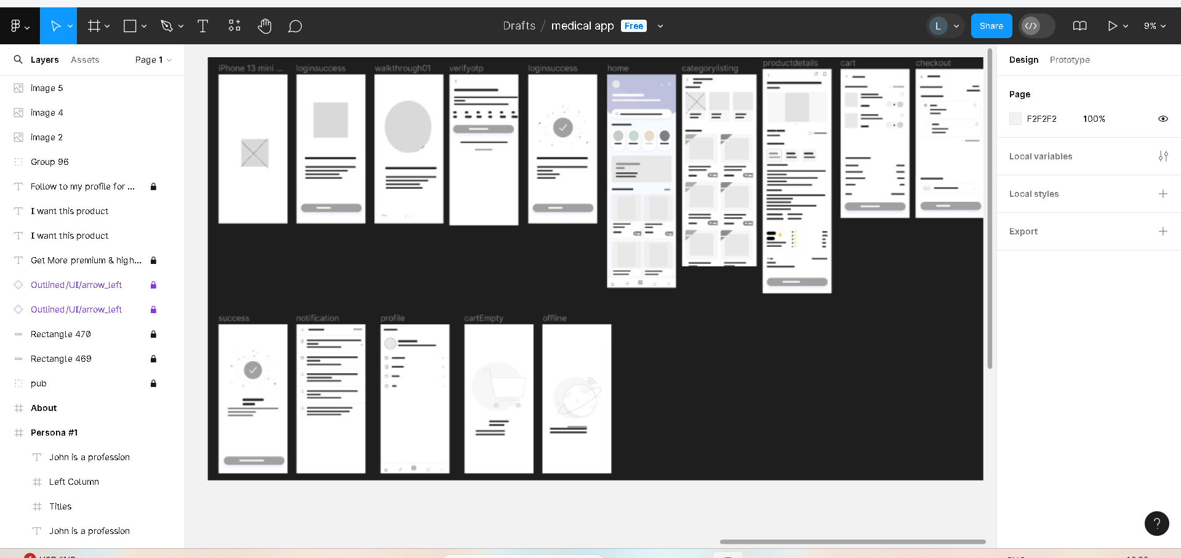

**Q. Create Prototyping:**

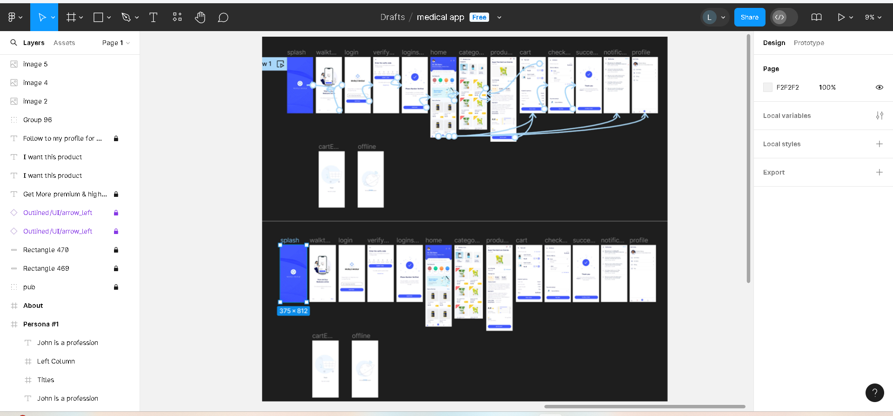

## EXPERIMENT NO. 11

**Q. Usability Evaluation of the Design. Testing of User Interface from third party (Test scripts).**

Testing is the process of executing a program to find errors. To make our software perform well it should be error-free. If testing is done successfully it will remove all the errors from the software.

### Types of Testing:

1. **Unit Testing:**

It focuses on the smallest unit of software design. In this, we test an individual unit or group of interrelated units. It is often done by the programmer by using sample input and observing its corresponding outputs.

### Integration Testing:

The objective is to take unit-tested components and build a program structure that has been dictated by design. Integration testing is testing in which a group of components is combined to produce output.

### Regression Testing:

Every time a new module is added leads to changes in the program. This type of testing makes sure that the whole component works properly even after adding components to the complete program.

### Smoke Testing:

This test is done to make sure that the software under testing is ready or stable for further testing. It is called a smoke test as the testing of an initial pass is done to check if it did not catch the fire or smoke in the initial switch on.

### Alpha Testing:

This is a type of validation testing. It is a type of acceptance testing which is done before the product is released to customers. It is typically done by QA people.

### Beta Testing:

The beta test is conducted at one or more customer sites by the end-user of the software. This version is released for a limited number of users for testing in a real-time environment

### System Testing:

This software is tested such that it works fine for the different operating systems. It is covered under the black box testing technique. In this, we just focus on the required input and output without focusing on internal working.

### Stress Testing:

In this, we give unfavourable conditions to the system and check how they perform in those conditions.

### Performance Testing:

It is designed to test the run-time performance of software within the context of an integrated system.

### Acceptance Testing:

Acceptance testing is done by the customers to check whether the delivered products perform the desired tasks or not, as stated in requirements

|  |  |  |  |  |  |  |  |
| --- | --- | --- | --- | --- | --- | --- | --- |
| Sr.  No | Action | Input | Expected  Output | Actual  Output | Test Result | Test  Comment |  |
| 1 | Launch  Application | Click on Start  With Us | Login page | Login page | Pass | Successful |
| 2 | Enter Correct Username and  Password | Username: abc,  Password: * | Home Page | Home Page | Pass | Homepage will Display |
| 3 | If username and password are incorrect | Username: abc, Password: * | login failed” | Login Failed” | Fail | Invalid Username and  password |
| 4 | If email is not in correct format | Enter email in incorrect  format | “Invalid Email” | “Invalid Email” | Fail | Unsuccessful |
| 5 | If email is in  correct format | Enter Email  Id | No error  message | No error  message | Pass | Successful |  |
| 6 | View Medicines | Click on  ‘search bar' | Medicine  List Page | Medicine  List Page | Pass | Successful |  |
| 7 | Select a medicine to purchase | Choose a medicine | Medicine Selection  Confirmation | Medicine Selection  Confirmation | Pass | Successful |
| 8 | Dummy Payment Gateway | Proceed to payment | Payment Confirmation  Page | Payment Confirmation  Page | Pass | Successful |
| 10 | Purchase button | Click on the button to redirect from medicine info page to payment  gateway | Redirects to payment gateway | Redirects to payment gateway | Pass | Successful |
| 11 | Payment Submit button | Click on pay button | Payment should be  accepted | Payment is accepted | Pass | Successful |
| 12 | Opening Medicine page | Click on icon to open a medicine page and view  contents | Redirects to medicine page and displays info | Redirects to medicine page and displays info | Pass | Successful |
| 13 | Opening My Orders page | Click on My orders icon to see the order  which user has purchased | Redirects to My orders and displays  user’s orders info | Redirects to My orders and displays  user’s orders info | Pass | Successful |
| 14 | Settings button | Click on  settings button on the | Settings  should be displayed | Settings is displayed | Pass | Successful |

|  |  |  |  |  |  |  |
| --- | --- | --- | --- | --- | --- | --- |
|  |  | user profile |  |  |  |  |
| 15 | View User Profile | Click on  'Profile' | User Profile  Page | User Profile  Page | Pass | Successful |
| 16 | Logout | Click on  'Logout' | Login Page | Login Page | Pass | Successful |

## EXPERIMENT NO. 12

**Q. 10 Questions to be ask to future user:**

* What challenges or problems do you currently face in your daily tasks or activities?
* How do you currently address or solve these challenges?
* What features or functionalities are most important to you in a product like this?
* Can you describe a typical day in your life, particularly related to [specific area related to the product]?
* How do you usually discover new products or services?
* What are your favourite products or services in this category, and why?
* What frustrates you the most about the current solutions available?
* How do you prefer to receive support or assistance with a product?
* What would make you recommend a product like this to a friend or colleague?
* What are your concerns or reservations about using a new product or service in this category?