**DAY1**

**Goal:**

* Create a splash screen
* Create a dashboard with grid (These grid items will be the navigation items to further screens)
* Create a navigation drawer
* Create floating action bar

**You will Learn:**

* Android Studio basics
* Android project structure
* Android emulator
* Android Activity
* Android Fragments
* Android Adapters
* Android Layouts (grid , various layouts)

## Create an Android Studio Project

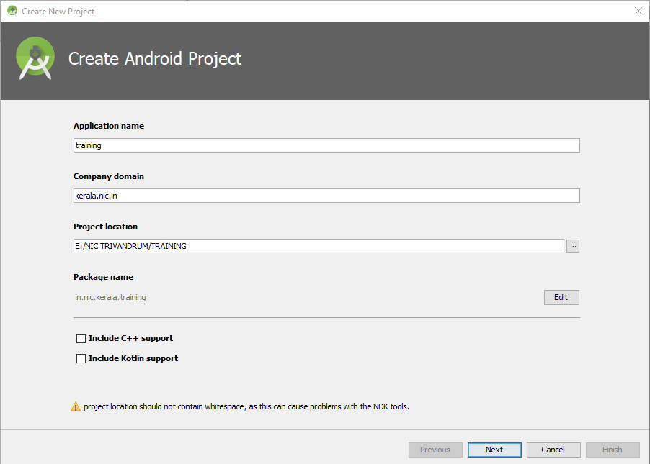

**Step 1**Provide the project details .Notice the package name *training.kerala.nic.in*

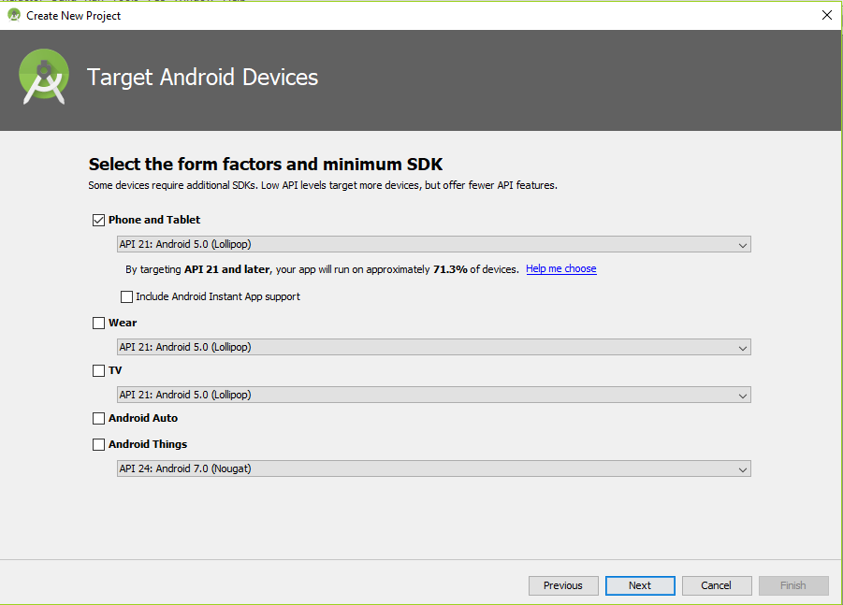

**Step 2**Target the minimum android version support which your application is providing. This is important for a reach of big audience.

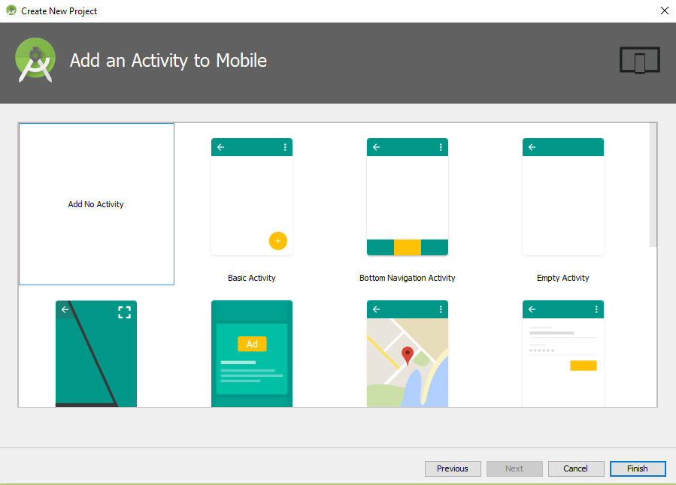

**Step 3**Start with an empty project as shown in the picture. Click on **finish**, you can see the project structure as shown below

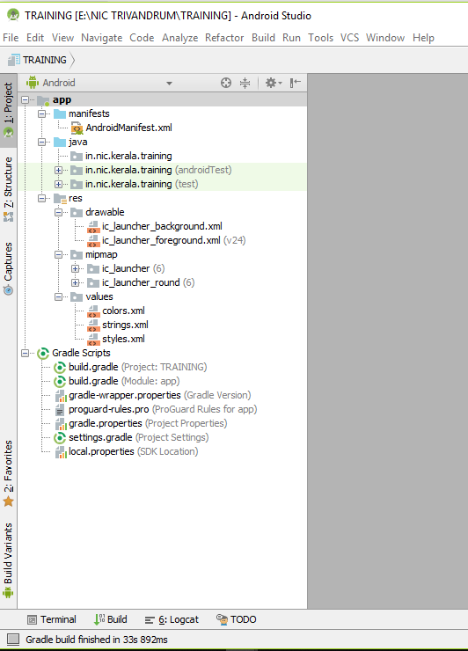

Project dependency and build configurations

Launcher  
ICON

Your resources  
Images  
Vectors  
Fonts etc

Your java packages

Android project configuration file

## Resource Setup

1. Extract the resources.zip folder
2. Copy the resource files from resources/drawable to the res/drawable folder of your project.
3. Copy the styles.xml from resources/values to res/values folder of your project

## splashCreate a Splash screen

Create a new activity by right clicking the project and selecting **New>Activity>Empty activity**

Before starting this session, you may verify the following files in your project

1. AndroidManifest.xml
2. build.gradle (Module: app)
3. proguard-rules.pro

You are about to create a splash screen as shown in the picture

The splash will appear for some time and then navigates user to dashboard

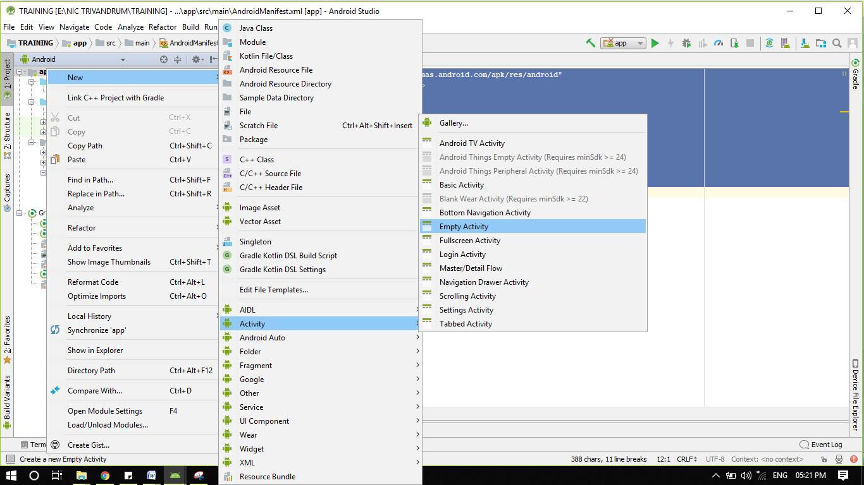

Provide activity name as SplashActivity, layout name as activity_splash

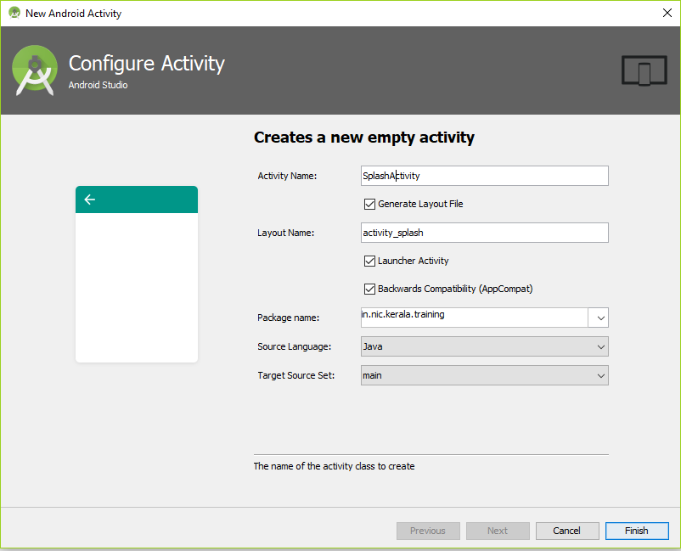

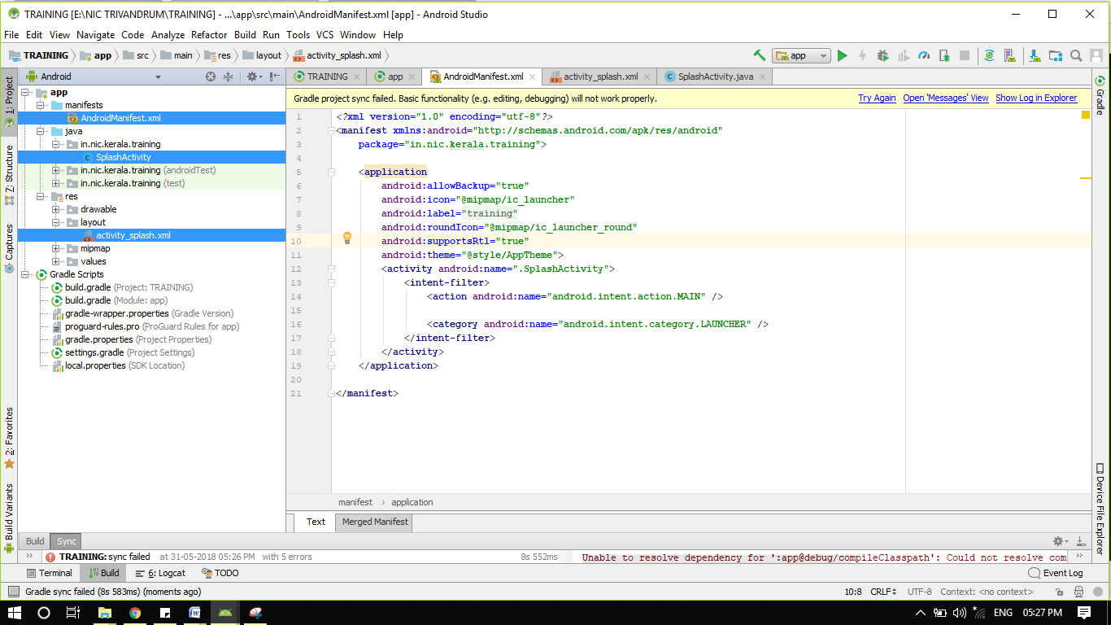

a. Add below code in activity_splash.xml file.

*<?***xml version="1.0" encoding="utf-8"***?>*<**RelativeLayout xmlns:android="http://schemas.android.com/apk/res/android"  
 android:orientation="vertical" android:layout_width="match_parent"  
 android:layout_height="match_parent"  
 android:background="#87CEFA"**>  
  
 <**TextView  
 android:layout_width="wrap_content"  
 android:layout_height="wrap_content"  
 android:layout_centerInParent="true"  
 android:text="Android Training Programme"  
 android:layout_centerHorizontal="true"  
 android:textSize="20dip"  
 android:textStyle="bold"** />  
  
 <**LinearLayout  
 android:id="@+id/in"  
 android:layout_width="fill_parent"  
 android:layout_height="49dp"  
 android:layout_alignParentBottom="true"  
 android:background="@drawable/fooo"  
 android:orientation="horizontal"** />  
</**RelativeLayout**>

b. Add below code in SplashActivity.java file.

Note: Before doing this step, please go through the present code in the same file. Now overwrite the contents as

**package** in.nic.kerala.training;  
  
**import** android.content.Intent;  
**import** android.os.Bundle;  
**import** android.os.Handler;  
**import** android.support.annotation.Nullable;  
**import** android.support.v7.app.AppCompatActivity;  
  
**public class** SplashActivity **extends** AppCompatActivity{  
 @Override  
 **protected void** onCreate(@Nullable Bundle savedInstanceState) {  
 **super**.onCreate(savedInstanceState);  
 setContentView(R.layout.***activity_splash***);  
 **new** Handler().postDelayed(**new** Runnable() {  
  
 @Override  
 **public void** run() {  
 Intent in = **new** Intent(SplashActivity.**this**, **DashboardActivity.class**);  
 startActivity(in);  
  
  
 finish();  
 }  
 }, 2*1000);  
  
 }  
  
 @Override  
 **protected void** onDestroy() {  
 **super**.onDestroy();  
 }  
}

Above code is self explanatory, which creates a handler which executes after the mentioned period of time. (Like a Timer). On timeout it calls the dashboard activity which will be home screen of our application.

c. Changes in manifest file

Open **AndroidManifest.xml** file and add the following property to the Splash activity configuration

android:theme="@style/AppTheme.NoActionBar"

So it looks like

<**activity  
 android:name=".SplashActivity"** android:theme="@style/AppTheme.NoActionBar">  
 <**intent-filter**>  
 <**action android:name="android.intent.action.MAIN"** />  
  
 <**category android:name="android.intent.category.LAUNCHER"** />  
 </**intent-filter**>  
</**activity**>

## Create dashboard screen

You might have noticed that lot of android applications presents a sliding panel menu to navigate between the major modules of the application. Previously these types of UI were done using some third-party libraries wherein a list view and some swiping gestures are used to achieve this. But now android itself officially introduced sliding panel menu by introducing a newer concept called Navigation Drawer in which we combine [DrawerLayout](https://developer.android.com/reference/android/support/v4/widget/DrawerLayout.html) and [NavigationView](https://developer.android.com/reference/android/support/design/widget/NavigationView.html) to achieve the desired output. Android studio will create the layout contents for you, which you can override.

Create a **Navigation Drawer Activity** for the dashboard screen.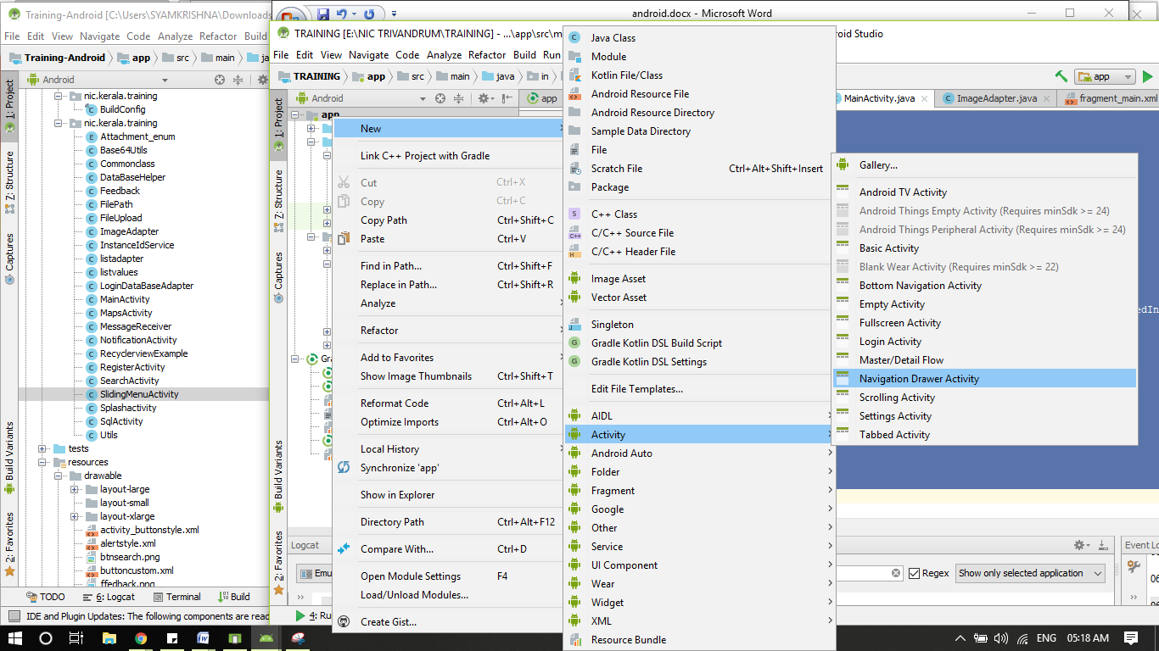

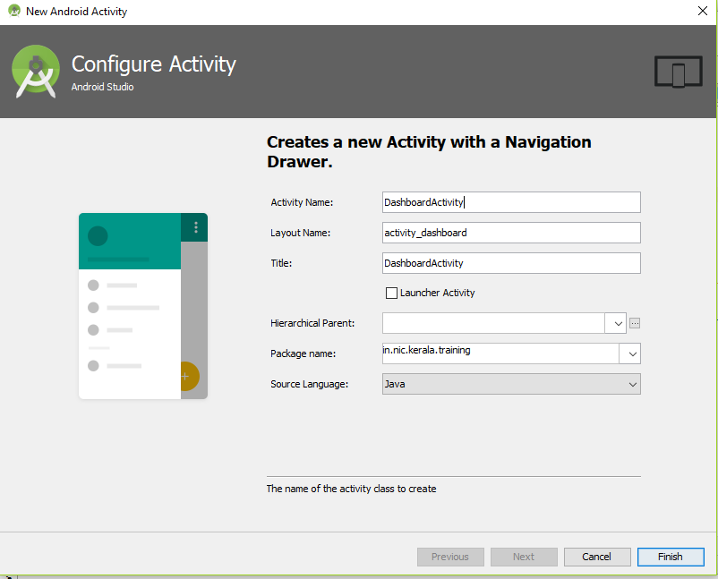

Provide details as shown in the image and click Finish. This creates the following files in the project:

* DashboardActivity.java
  + The activity class, an entry is created in the AndroidManifest.xml
* activity_dashboard.xml
  + Overall layout file for the dashboard view
* app_bar_dashboard.xml
  + Main dashboard layout
* content_dashboard.xml
  + Main content area
* menu/dashboard.xml
  + App menu
* nav_header_dashboard.xml
  + Header area of the side drawer
* menu/activity_dashboard_drawer.xml
  + Navigation side drawer menu

Change Navigation side drawer menu contents

Open **res/menu/activity_dashboard_drawer.xml** file and remove all contents and paste following contents

*<?***xml version="1.0" encoding="utf-8"***?>*<**menu xmlns:android="http://schemas.android.com/apk/res/android"**>  
 <**group android:checkableBehavior="single"**>  
 <**item  
 android:id="@+id/search"  
 android:title="Search"** />  
 <**item  
 android:id="@+id/Recyclerview"  
 android:title="Recyclerview"** />  
 <**item  
 android:id="@+id/fileupload"  
 android:title="File Upload"** />  
 <**item  
 android:id="@+id/feed"  
 android:title="Enter Feedback"** />  
 </**group**>  
 <**item android:title=""**>  
 <**menu**>  
 <**item  
 android:id="@+id/Map"  
 android:title="Load Map"** />  
 <**item  
 android:id="@+id/noti"  
 android:title="Notification"** />  
 <**item  
 android:id="@+id/sql"  
 android:title="SQL"** />  
 </**menu**>  
 </**item**>  
</**menu**>

Update DashboardActivity class

Now open **DashboardActivity.java** file from java folder and update the contents of the function **onNavigationItemSelected** as

**public boolean** onNavigationItemSelected(MenuItem item) {  
 *// Handle navigation view item clicks here.* **int** id = item.getItemId();  
  
 **if** (id == R.id.***search***) {  
 *// Handle the camera action* } **else if** (id == R.id.***Recyclerview***) {  
  
 } **else if** (id == R.id.***fileupload***) {  
  
 } **else if** (id == R.id.***feed***) {  
  
 } **else if** (id == R.id.***Map***) {  
  
 } **else if** (id == R.id.***noti***) {  
  
 }  
 **else if** (id == R.id.***sql***) {  
  
 }  
  
 DrawerLayout drawer = (DrawerLayout) findViewById(R.id.***drawer_layout***);  
 drawer.closeDrawer(GravityCompat.***START***);  
 **return true**;  
}

Add the following variables and functions in the DashboardActivity

**int navItemIndex** = 0;  
**private void** loadHomeFragment() {  
 MainFragment fragment = **new** MainFragment();  
 FragmentTransaction fragmentTransaction = getSupportFragmentManager().beginTransaction();  
 fragmentTransaction.setCustomAnimations(android.R.anim.***fade_in***,  
 android.R.anim.***fade_out***);  
 fragmentTransaction.replace(R.id.***frame***, fragment);  
 fragmentTransaction.commitAllowingStateLoss();  
}

Load the home fragment in the OnCreate event

@Override  
**protected void** onCreate(Bundle savedInstanceState) {

. . .

. . .

*//Load home fragment*  
 **if** (savedInstanceState == **null**) {  
 **navItemIndex** = 0;  
 loadHomeFragment();  
 }

}

Update main content area

Open **res/layout/content_dashboard.xml** and replace with the following code

*<?***xml version="1.0" encoding="utf-8"***?>*<**FrameLayout android:id="@+id/frame"  
 android:layout_width="match_parent"  
 android:layout_height="match_parent"  
 app:layout_behavior="@string/appbar_scrolling_view_behavior"  
 xmlns:android="http://schemas.android.com/apk/res/android"  
 xmlns:app="http://schemas.android.com/apk/res-auto"**>  
  
</**FrameLayout**>

Create a new Fragment

A Fragment represents a behavior or a portion of user interface in an Activity. You can combine multiple fragments in a single activity to build a multi-pane UI and reuse a fragment across multiple activities. You can think of a fragment as a modular section of an activity, which has its own lifecycle, receives its own input events, which you can add or remove while the activity is running (like a "sub activity" that you can reuse in different activities).

Create a blank fragment by right clicking the project. **New>Fragment>Fragment (Blank)**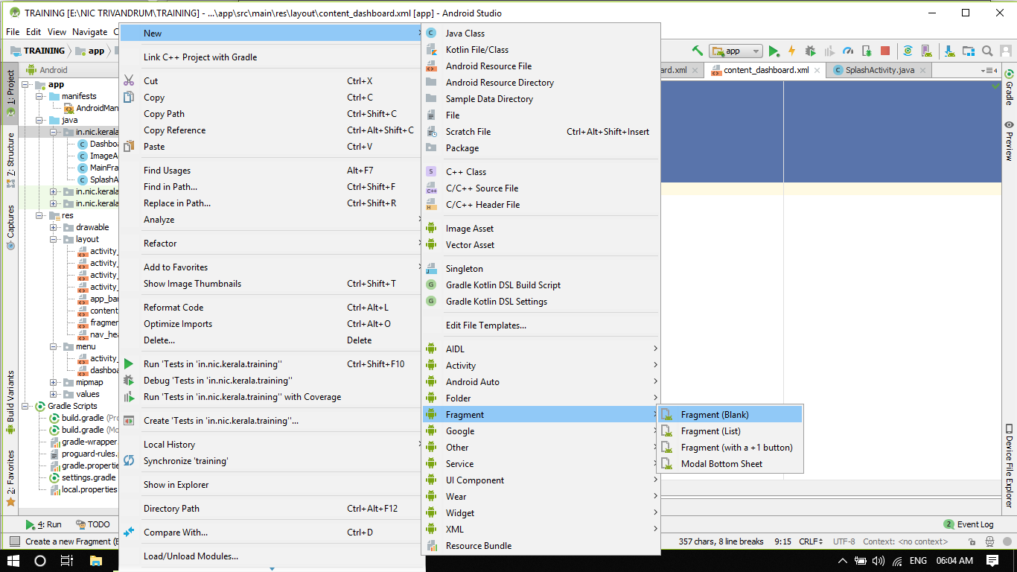

Provide fragment name as **MainFragment**

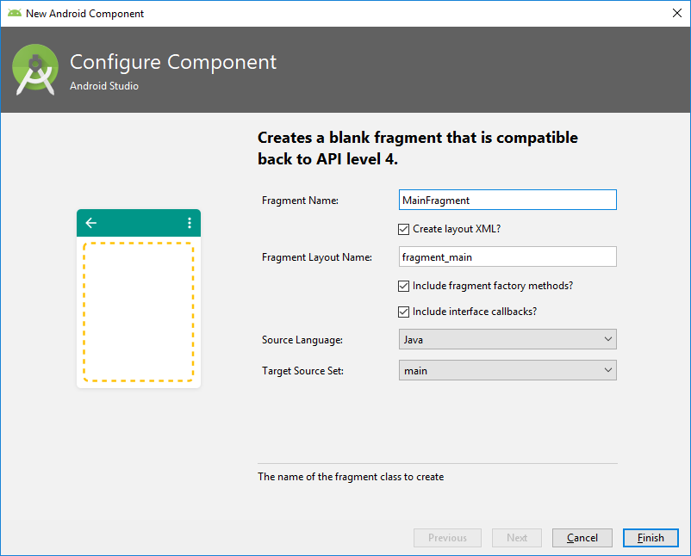

Update the contents of MainFragment.java

**package** in.nic.kerala.training;  
**import** android.support.annotation.Nullable;  
**import** android.support.v4.app.Fragment;  
**import** android.os.Bundle;  
**import** android.view.LayoutInflater;  
**import** android.view.View;  
**import** android.view.ViewGroup;  
**import** android.widget.GridView;  
  
**public class** MainFragment **extends** Fragment {  
 GridView **grid**;  
  
 @Nullable  
 @Override  
 **public** View onCreateView(LayoutInflater inflater, @Nullable ViewGroup container, Bundle savedInstanceState) {  
  
 View view = inflater.inflate(R.layout.***fragment_main***, container, **false**);  
 **grid**=(GridView)view.findViewById(R.id.***grid***);  
 **grid**.setAdapter(**new** ImageAdapter(getActivity()));  
 **return** view;  
 }  
}

Modify contents of fragment_main.xml

*<?***xml version="1.0" encoding="utf-8"***?>*<**RelativeLayout xmlns:android="http://schemas.android.com/apk/res/android"  
 xmlns:app="http://schemas.android.com/apk/res-auto"  
 xmlns:tools="http://schemas.android.com/tools"  
 android:layout_width="match_parent"  
 android:layout_height="match_parent"  
 tools:context=".MainFragment"**>  
 <**include  
 android:id="@+id/ti"  
 android:layout_height="wrap_content"  
 android:layout_width="fill_parent"  
 layout="@layout/activity_title"** />  
 <**LinearLayout  
 android:layout_width="fill_parent"  
 android:layout_height="fill_parent"  
 android:layout_below="@+id/ti"**>  
 <**GridView  
 android:id="@+id/grid"  
 android:layout_width="wrap_content"  
 android:layout_height="wrap_content"  
 android:layout_gravity="center"  
 android:numColumns="2"** />  
 </**LinearLayout**>  
 <**LinearLayout  
 android:id="@+id/in"  
 android:layout_width="fill_parent"  
 android:layout_height="49dp"  
 android:layout_alignParentBottom="true"  
 android:background="@drawable/fooo"  
 android:orientation="horizontal"** />  
</**RelativeLayout**>

Create layout for showing title in dashboard view

Create an XML layout named **activity_title.xml** under res/layout and paste following code. To create an XML layout, right click on project **New>XML>Layout XML file**

*<?***xml version="1.0" encoding="utf-8"***?>*<**RelativeLayout xmlns:android="http://schemas.android.com/apk/res/android"  
 android:orientation="vertical" android:layout_width="match_parent"  
 android:layout_height="wrap_content"  
 android:background="#B2DCF8"**>  
  
 <**TextView  
 android:id="@+id/txthead"  
 android:layout_width="wrap_content"  
 android:layout_height="30dp"  
 android:text="Android Training"  
 android:textSize="20dp"  
 android:layout_centerVertical="true"  
 android:textColor="#000000"  
 android:layout_alignParentLeft="true"** />  
 <**TextView  
 android:id="@+id/txttitile"  
 android:layout_width="wrap_content"  
 android:layout_height="wrap_content"  
 android:textSize="20dp"  
 android:layout_centerVertical="true"  
 android:textColor="#000000"  
 android:layout_alignParentRight="true"**/>  
  
</**RelativeLayout**>

Loading dynamic data to grid

Create a class named ImageAdapter.java and with following code. An adapter class is used for feed dynamic data to a GridView.

**package** in.nic.kerala.training;  
  
**import** android.content.Context;  
**import** android.content.Intent;  
**import** android.view.LayoutInflater;  
**import** android.view.View;  
**import** android.view.ViewGroup;  
**import** android.widget.BaseAdapter;  
**import** android.widget.ImageView;  
**import** android.widget.ListAdapter;  
**import** android.widget.TextView;  
  
  
**class** ImageAdapter **extends** BaseAdapter {  
  
 **private** Context **context**;  
 **private int** [] **imageId**={R.drawable.***search***,R.drawable.***feedback***,R.drawable.***fileupload***,R.drawable.***map***,R.drawable.***notification***,R.drawable.***sql***};  
 **private** String[]**mobileValues**=**new** String[]{**"Search"**,**"Feedback"**,**"File Upload"**,**"Map"**,**"Notification"**,**"SQL"**};  
 *// Constructor* **public** ImageAdapter(Context c){  
 **this**.**context** = c;  
  
 }  
  
 @Override  
 **public int** getCount() {  
 **return mobileValues**.**length**;  
 }  
  
 @Override  
 **public** Object getItem(**int** position) {  
 **return mobileValues**[position];  
 }  
  
 @Override  
 **public long** getItemId(**int** position) {  
 **return** 0;  
 }  
  
 @Override  
 **public** View getView(**final int** position, View convertView, ViewGroup parent) {  
 LayoutInflater inflater = (LayoutInflater) **context** .getSystemService(Context.***LAYOUT_INFLATER_SERVICE***);  
  
 View gridView;  
  
 **if** (convertView == **null**) {  
  
 gridView = **new** View(**context**);  
  
*// get layout from mobile.xml* gridView = inflater.inflate(R.layout.***layout_custom***, **null**);  
  
*// set value into textview* TextView textView = (TextView) gridView  
 .findViewById(R.id.***grid_item_label***);  
 textView.setText(**mobileValues**[position]);  
  
*// set image based on selected text* ImageView imageView = (ImageView) gridView  
 .findViewById(R.id.***grid_item_image***);  
  
 imageView.setImageResource(**imageId**[position]);  
 gridView.setOnClickListener(**new** View.OnClickListener() {  
  
 @Override  
 **public void** onClick(View v) {  
  
 */*  
 if(position==0)  
 {  
 Intent in1 = new Intent(context, SearchActivity.class);  
 context.startActivity(in1);  
  
 }else if(position==1){  
 Intent in2 = new Intent(context, FeedbackActivity.class);  
 context.startActivity(in2);  
  
 }  
 else if(position==2){  
 Intent in2 = new Intent(context, FileUploadActivity.class);  
 context.startActivity(in2);  
  
 }else if(position==3){  
 Intent in2 = new Intent(context, MapActivity.class);  
 context.startActivity(in2);  
  
 }  
 else if(position==4){  
 Intent in4 = new Intent(context, NotificationActivity.class);  
 context.startActivity(in4);  
  
 }  
 else{  
 Intent in4 = new Intent(context, SqlActivity.class);  
 context.startActivity(in4);  
 }  
 */* }  
 });  
  
 } **else** {  
 gridView = (View) convertView;  
 }  
  
 **return** gridView;  
 }  
  
}

Create a custom layout for main dashboard view

Create an XML layout named **layout_custom.xml** under res/layout and paste following code. To create an XML layout, right click on project **New>XML>Layout XML file**

*<?***xml version="1.0" encoding="utf-8"***?>*<**LinearLayout xmlns:android="http://schemas.android.com/apk/res/android"  
 android:layout_width="wrap_content"  
 android:layout_height="wrap_content"  
 android:orientation="vertical"  
 android:padding="5dp"**>  
  
  
 <**ImageView  
 android:id="@+id/grid_item_image"  
 android:layout_width="80px"  
 android:layout_height="80px"  
 android:layout_gravity="center"  
 android:layout_marginBottom="5dp"  
 android:layout_marginTop="5dp"**></**ImageView**>  
  
 <**TextView  
 android:id="@+id/grid_item_label"  
 android:layout_width="wrap_content"  
 android:layout_height="wrap_content"  
 android:layout_gravity="center"  
 android:layout_marginBottom="5dp"  
 android:layout_marginTop="5dp"  
 android:text="TextView"  
 android:textSize="15dp"  
 android:textStyle="bold"**></**TextView**>  
  
</**LinearLayout**>

## Final Step

Add intent to start other activities from dashboard by wiring the other activities (will be created in future chapters). The code may be added and uncommented when the activities are implemented.

**DashboardActivity.java**

**package** in.nic.kerala.training;  
  
**import** android.content.Intent;  
**import** android.os.Bundle;  
**import** android.support.design.widget.FloatingActionButton;  
**import** android.support.design.widget.Snackbar;  
**import** android.support.v4.app.FragmentTransaction;  
**import** android.view.View;  
**import** android.support.design.widget.NavigationView;  
**import** android.support.v4.view.GravityCompat;  
**import** android.support.v4.widget.DrawerLayout;  
**import** android.support.v7.app.ActionBarDrawerToggle;  
**import** android.support.v7.app.AppCompatActivity;  
**import** android.support.v7.widget.Toolbar;  
**import** android.view.Menu;  
**import** android.view.MenuItem;  
  
**public class** DashboardActivity **extends** AppCompatActivity  
 **implements** NavigationView.OnNavigationItemSelectedListener {  
  
 **int navItemIndex** = 0;  
 **private void** loadHomeFragment() {  
 MainFragment fragment = **new** MainFragment();  
 FragmentTransaction fragmentTransaction = getSupportFragmentManager().beginTransaction();  
 fragmentTransaction.setCustomAnimations(android.R.anim.***fade_in***,  
 android.R.anim.***fade_out***);  
 fragmentTransaction.replace(R.id.***frame***, fragment);  
 fragmentTransaction.commitAllowingStateLoss();  
 }  
  
 @Override  
 **protected void** onCreate(Bundle savedInstanceState) {  
 **super**.onCreate(savedInstanceState);  
 setContentView(R.layout.***activity_dashboard***);  
 Toolbar toolbar = (Toolbar) findViewById(R.id.***toolbar***);  
 setSupportActionBar(toolbar);  
  
 FloatingActionButton fab = (FloatingActionButton) findViewById(R.id.***fab***);  
 fab.setOnClickListener(**new** View.OnClickListener() {  
 @Override  
 **public void** onClick(View view) {  
 Snackbar.*make*(view, **"Replace with your own action"**, Snackbar.***LENGTH_LONG***)  
 .setAction(**"Action"**, **null**).show();  
 }  
 });  
  
 DrawerLayout drawer = (DrawerLayout) findViewById(R.id.***drawer_layout***);  
 ActionBarDrawerToggle toggle = **new** ActionBarDrawerToggle(  
 **this**, drawer, toolbar, R.string.***navigation_drawer_open***, R.string.***navigation_drawer_close***);  
 drawer.addDrawerListener(toggle);  
 toggle.syncState();  
  
 NavigationView navigationView = (NavigationView) findViewById(R.id.***nav_view***);  
 navigationView.setNavigationItemSelectedListener(**this**);  
  
  
 *//Load home fragment*

**if** (savedInstanceState == **null**) {  
 **navItemIndex** = 0;  
 loadHomeFragment();  
 }  
 }  
  
 @Override  
 **public void** onBackPressed() {  
 DrawerLayout drawer = (DrawerLayout) findViewById(R.id.***drawer_layout***);  
 **if** (drawer.isDrawerOpen(GravityCompat.***START***)) {  
 drawer.closeDrawer(GravityCompat.***START***);  
 } **else** {  
 **super**.onBackPressed();  
 }  
 }  
  
 @Override  
 **public boolean** onCreateOptionsMenu(Menu menu) {  
 *// Inflate the menu; this adds items to the action bar if it is present.* getMenuInflater().inflate(R.menu.***dashboard***, menu);  
 **return true**;  
 }  
  
 @Override  
 **public boolean** onOptionsItemSelected(MenuItem item) {  
 *// Handle action bar item clicks here. The action bar will  
 // automatically handle clicks on the Home/Up button, so long  
 // as you specify a parent activity in AndroidManifest.xml.* **int** id = item.getItemId();  
  
 *//noinspection SimplifiableIfStatement* **if** (id == R.id.***action_settings***) {  
 **return true**;  
 }  
  
 **return super**.onOptionsItemSelected(item);  
 }  
  
 @SuppressWarnings(**"StatementWithEmptyBody"**)  
 @Override  
 **public boolean** onNavigationItemSelected(MenuItem item) {  
  
  
  
  
*// Handle navigation view item clicks here.* **int** id = item.getItemId();  
  
 **if** (id == R.id.***search***) {  
 **Intent i=new Intent(DashboardActivity.this,SearchActivity.class);  
 startActivity(i);**  
  
  
  
 }  
 **else if** (id == R.id.***Recyclerview***) {  
  
 **Intent i=new Intent(DashboardActivity.this,RecyclerviewExample***Activity***.class);  
 startActivity(i);**  
  
  
 }  
 **else if** (id == R.id.***feed***) {  
  
 **Intent i=new Intent(DashboardActivity.this,Feedback***Activity***.class);  
 startActivity(i);**  
 }  
 **else if** (id == R.id.***fileupload***) {  
 **Intent i=new Intent(DashboardActivity.this,FileUpload***Activity***.class);  
 startActivity(i);**  
  
  
 }  
 **else if** (id == R.id.***Map***) {  
 **Intent i=new Intent(DashboardActivity.this,MapsActivity.class);  
 startActivity(i);**  
  
  
 }  
 **else if** (id == R.id.***sql***) {  
  
 **Intent i=new Intent(DashboardActivity.this,SqlActivity.class);  
 startActivity(i);**  
 }  
 **else if** (id == R.id.***noti***) {  
 **Intent i=new Intent(DashboardActivity.this,NotificationActivity.class);  
 startActivity(i);**  
  
  
 }  
  
 DrawerLayout drawer = (DrawerLayout) findViewById(R.id.***drawer_layout***);  
 drawer.closeDrawer(GravityCompat.***START***);  
 loadHomeFragment();  
 **return true**;  
  
  
  
 }  
}

Here we are yet to create other activities (shown in red colour), so they may show errors.

**app_bar_dashboard.xml**

*<?***xml version="1.0" encoding="utf-8"***?>*<**android.support.design.widget.CoordinatorLayout xmlns:android="http://schemas.android.com/apk/res/android"  
 xmlns:app="http://schemas.android.com/apk/res-auto"  
 xmlns:tools="http://schemas.android.com/tools"  
 android:layout_width="match_parent"  
 android:layout_height="match_parent"  
 tools:context=".DashboardActivity"**>  
  
 <**android.support.design.widget.AppBarLayout  
 android:layout_width="match_parent"  
 android:layout_height="wrap_content"  
 android:theme="@style/AppTheme.AppBarOverlay"**>  
  
 <**android.support.v7.widget.Toolbar  
 android:id="@+id/toolbar"  
 android:layout_width="match_parent"  
 android:layout_height="?attr/actionBarSize"  
 android:background="?attr/colorPrimary"  
 app:popupTheme="@style/AppTheme.PopupOverlay"** />  
  
 </**android.support.design.widget.AppBarLayout**>  
  
 <**include layout="@layout/content_dashboard"** />  
  
 <**android.support.design.widget.FloatingActionButton  
 android:id="@+id/fab"  
 android:layout_width="wrap_content"  
 android:layout_height="wrap_content"  
 android:layout_gravity="bottom|end"  
 android:layout_margin="@dimen/fab_margin"  
 app:srcCompat="@android:drawable/ic_dialog_email"** />  
  
</**android.support.design.widget.CoordinatorLayout**>

**content_dashboard.xml**

*<?***xml version="1.0" encoding="utf-8"***?>*<**FrameLayout android:id="@+id/frame"  
 android:layout_width="match_parent"  
 android:layout_height="match_parent"  
 app:layout_behavior="@string/appbar_scrolling_view_behavior"  
 xmlns:android="http://schemas.android.com/apk/res/android"  
 xmlns:app="http://schemas.android.com/apk/res-auto"**>  
  
</**FrameLayout**>

**nav_header_dashboard.xml**

*<?***xml version="1.0" encoding="utf-8"***?>*<**LinearLayout xmlns:android="http://schemas.android.com/apk/res/android"  
 xmlns:app="http://schemas.android.com/apk/res-auto"  
 android:layout_width="match_parent"  
 android:layout_height="@dimen/nav_header_height"  
 android:background="@drawable/side_nav_bar"  
 android:gravity="bottom"  
 android:orientation="vertical"  
 android:paddingBottom="@dimen/activity_vertical_margin"  
 android:paddingLeft="@dimen/activity_horizontal_margin"  
 android:paddingRight="@dimen/activity_horizontal_margin"  
 android:paddingTop="@dimen/activity_vertical_margin"  
 android:theme="@style/ThemeOverlay.AppCompat.Dark"**>  
  
 <**ImageView  
 android:id="@+id/imageView"  
 android:layout_width="wrap_content"  
 android:layout_height="wrap_content"  
 android:contentDescription="@string/nav_header_desc"  
 android:paddingTop="@dimen/nav_header_vertical_spacing"  
 app:srcCompat="@mipmap/ic_launcher_round"** />  
  
 <**TextView  
 android:layout_width="match_parent"  
 android:layout_height="wrap_content"  
 android:paddingTop="@dimen/nav_header_vertical_spacing"  
 android:text="@string/nav_header_title"  
 android:textAppearance="@style/TextAppearance.AppCompat.Body1"** />  
  
 <**TextView  
 android:id="@+id/textView"  
 android:layout_width="wrap_content"  
 android:layout_height="wrap_content"  
 android:text="@string/nav_header_subtitle"** />  
  
</**LinearLayout**>