***Session 1 - Assignment 1***

***Problem Statement:***

*To Install Jupyter Notebook and begin python coding to run the first program and share the screen shot.*

***Solution:***

*To code using python via Jupyter notebook we need to install Python. The best recommended way of getting python is from Anaconda Navigator. This helps in getting relevant packages by default in the setup tools.*

***Below is the screen shot to install Anaconda Navigator 5.1***

1. ***Anaconda 5.1 for windows installer***

Go to link <https://anaconda.org/anaconda/python> and click on Download Anaconda to install python version 3.6, 64-Bit or 32-Bit installer respectively.

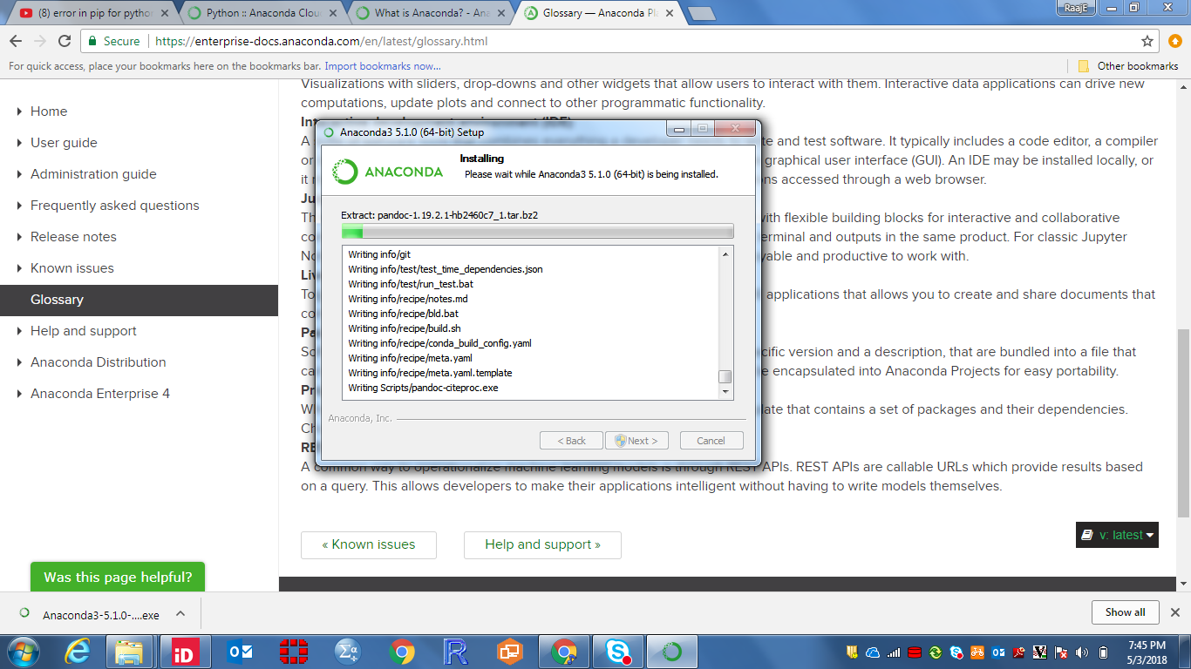

1. ***Successfully installed Anaconda Navigator, through which we can access various notebooks to code / work on python***

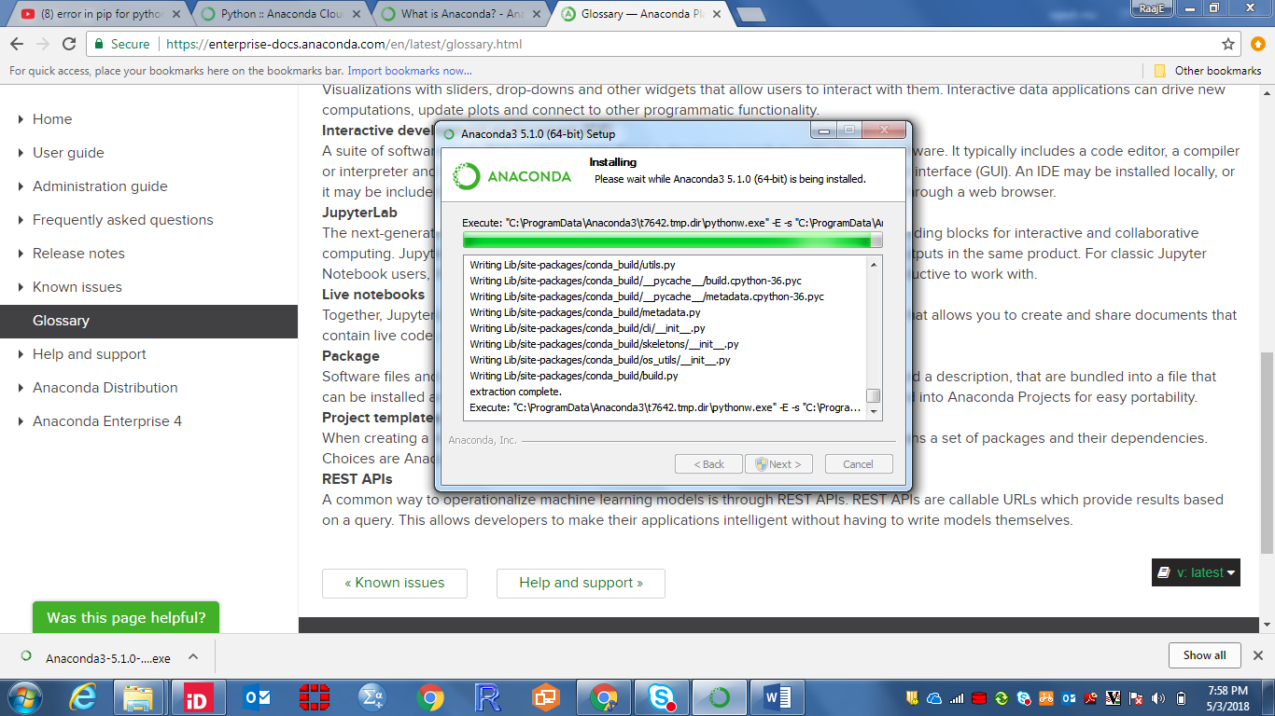

1. ***Click on start and click on Anaconda Navigator to launch Python notebooks (Jupyter, Spider.etc) and other utilities***

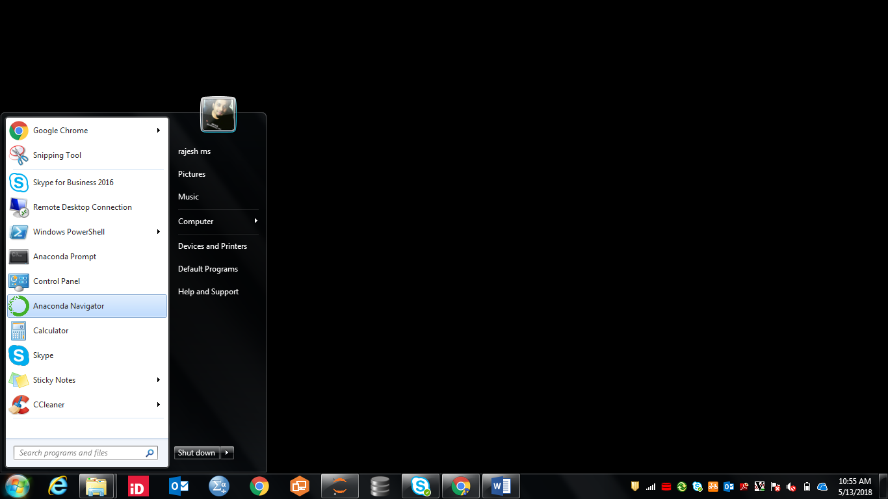

1. ***This is Anaconda Navigator, click on Jupyter launch to start first program in python using Jupyter notebook.***

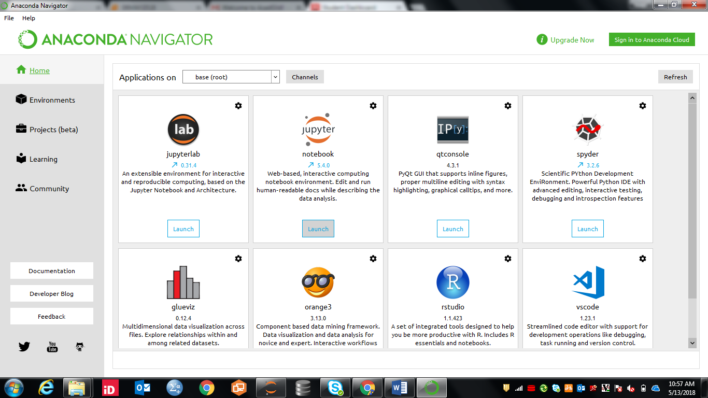

1. ***Below is the first program to estimate the sample size required for a clinical trial.***

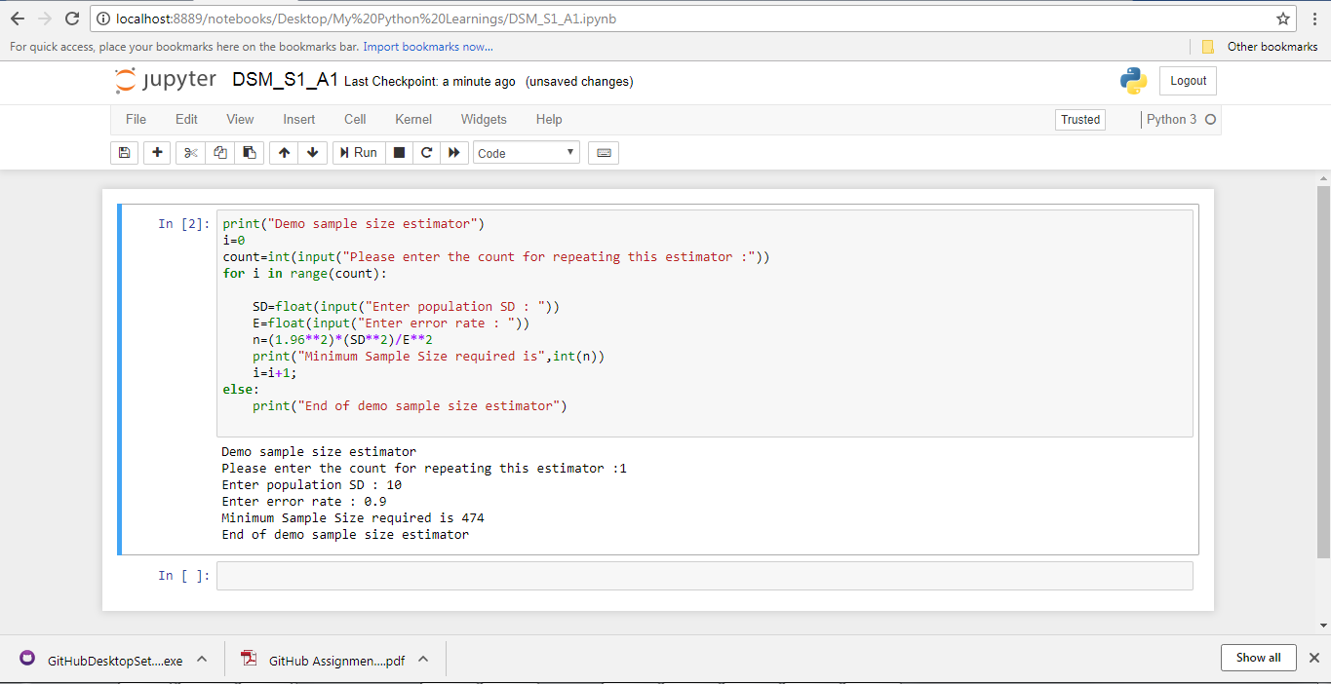

***Conclusion:*** *We have written first program i.e. the general method to estimate sample size for a clinical trial study, using python via Jupyter notebook.*